



**SENTIMENT ANALYZER**





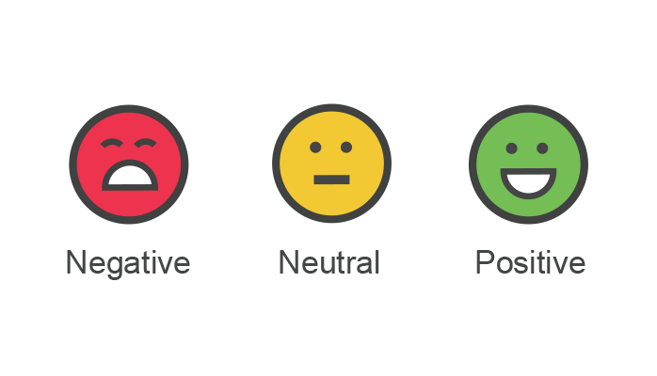

**-By Shivam Kumar Giri**

**OBJECTIVE**

To build a custom **sentiment analyzer** that works on movie reviews and effectively categorizes sentiments around them.



**ABSTRACT**

The large movie view dataset contains a collection of 50,000 reviews from IMDB. The dataset contains an even number of positive and negative reviews. Sentiment analysis (also known as opinion mining or emotion AI) refers to the use of natural language processing, text analysis, computational linguistics, and biometrics to systematically identify, extract, quantify, and study affective states and subjective information. Hence, we are building a custom **sentiment analyzer** that works on movie reviews and effectively categorizes sentiments around them.

**DATA**

Use a publicly available dataset consisting of 50,000 reviews from IMDB. The dataset has three columns. The first column specifies a sequential number of the record. The second column has a text which is the review and the third column is a class denoting the sentiment of the reviewer. The class has value 1 if the sentiment is positive and 0 if the sentiment is negative.

Our objective is to build a custom sentiment analyzer that can classify sentiment (positive or negative) of reviewers out of their movie reviews. a sentiment analyzer is build based on first 25,000 reviews and validate your classifier using other 25,000 reviews.

**METHODOLOGY**

***Step 1: Import the Libraries***

The following libraries are used:

**tabulate:** to tabularize the final output

**pandas**: to create dataframe and manipulate data

**numpy**: for numerical computations

**time:** for getting the time measurements for training and predictions

**re**: for Regular Expressions

**nltk**: for natural language processing

**sklearn**: features various classification, regression and clustering algorithms

**matplotlib**: for plotting and visualizing the data

***Step 2: Import the DataSet***

df=pd.read_csv('./**movie_review_data.csv'**,sep=",", names=['sentiment','reviews'])

create a dataframe from data imported in **movie_review_data.csv.**

***Step 3: Basic data exploration***

Explore various features of dataset like shape and descriptions:

df.shape

(50001, 2)

***Step 4: Splitting csv into testing and training data***

Here Data is splited into set of training data and test data, the training data is trained by decision tree while test data is validated for accuracy.

Here We used 50% of data of 25000 entries for training and rest 50% for testing, which is recommended ratio of splitting.

***Step 5: Setup functions for tokenizing and lemmetizing***

**Tokenization** is the process of tokenizing or splitting a string, text into a list of tokens. One can think of token as parts like a word is a token in a sentence, and a sentence is a token in a paragraph. **Lemmatization** reduces the inflected words properly ensuring that the root word belongs to the language. In Lemmatization root word is called Lemma. A lemma (plural lemmas or lemmata) is the canonical form, dictionary form, or citation form of a set of words.

***Step 5: Transform to feature vector and convert to sentiments***

we can create our model using our training data. In creating the model, we used the TF-IDF as the vectorizer and the Stochastic Gradient Descend algorithm, Ridge Penalty and SVM as the classifier.

***Step 6: Setup for dictionary of vocabulary***

vectorizer.vocabulary_ is used to setup the dictionary for vocabulary.

***Step 7: Setup for test sentiments and vectorize test reviews***

Here, we used the TF-IDF as the vectorizer that is used for vectorize test reviews.

***Step 8: Using Stochastic gradient descent Classifier***

The class SGDClassifier implements a plain stochastic gradient descent learning routine which supports different loss functions and penalties for classification. Here we are measuring the time in training as well as prediction

***Step 9: Measuring the Accuracy, printing Confusion Matrix and report***

Confusion matrix:

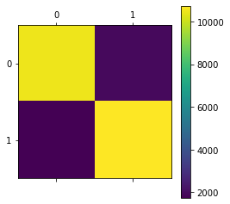

SGDClassifier Report

precision recall f1-score support

Positive 0.86 0.84 0.85 12500

Negative 0.84 0.86 0.85 12500

accuracy 0.85 25000

macro avg 0.85 0.85 0.85 25000

weighted avg 0.85 0.85 0.85 25000

***Step 10: Using Ridge Classifier***

RidgeClassifier() works differently compared to LogisticRegression() with l2 penalty. The loss function for RidgeClassifier() is not cross entropy. Here we are measuring the time in training as well as prediction

***Step 11: Measuring the Accuracy, printing Confusion Matrix and report***

Confusion matrix:

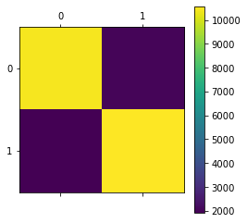

RidgeClassifier Report

precision recall f1-score support

Positive 0.85 0.84 0.84 12500

Negative 0.84 0.85 0.84 12500

accuracy 0.84 25000

macro avg 0.84 0.84 0.84 25000

weighted avg 0.84 0.84 0.84 25000

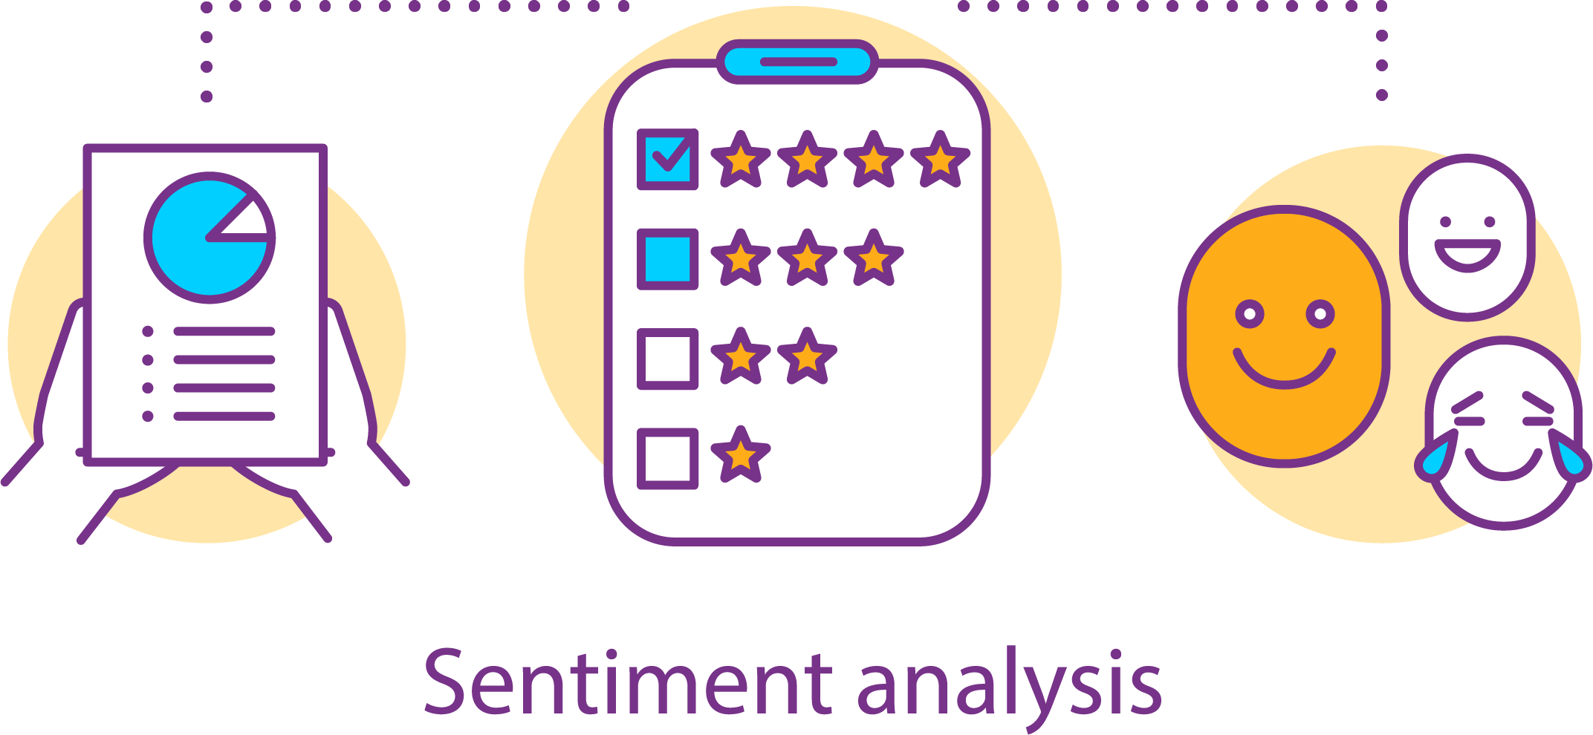

***Step 13: Merging the positive and negative reviews***

We are merging the positive and negative reviews to create a word cloud of positive and negative reviews.

***Step 14: Plotting the positive and negative world cloud***

**Positive Word cloud**

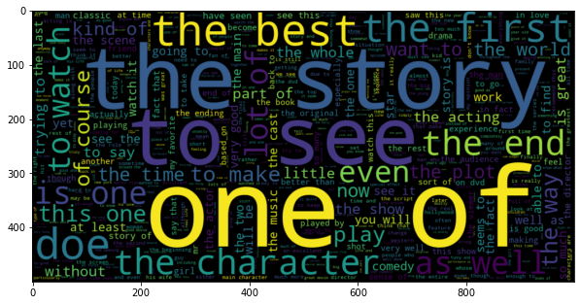

**Negative Word Cloud**

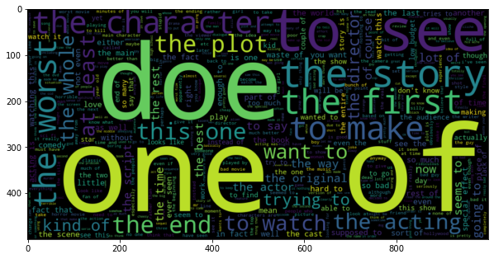

***Step 15: Priniting the final Result***

**Accuracy by the three Classifier**

Classifier Accuracy Confusion Matrix Time for Training(s) Time for prediction(s)

---------------------------------------------------------------------------------------------------------------------------------

SGD Classifier : 0.85016 [[10455 2045] 3.70609 0.0119658

[ 1701 10799]]

Ridge Classifier : 0.84204 [[10471 2029] 0.812829 0.0119691

[ 1920 10580]]

**CONCLUSION**

Hence, we found **SGD classifier as more accurate compare to RidgeClassifier**, but **time for training is more in case of SGD Classifier.** Hence sentiment analyzer with two classifiers is completed with word-cloud.

