I decided to implement an RPG game using Python while inheriting the procedural programming paradigm. My high-level pseudocode for the game is as follows:

1. Implement character initialisation function to create character. ADD LEVEL
2. Implement creature initialisation function to create creature. 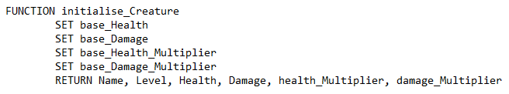
3. Implement attack function to reduce the target’s health after being attacked by the attacker. 
4. Implement level up procedure so after every battle the character and creature level up. A screenshot of a computer program

   Description automatically generated
5. Implement potion procedure to allow the character to gain health during battle. A black text with black letters

   Description automatically generated
6. Implement main game loop and ensurre the player conntinues playing until defeated or they choose to quit. 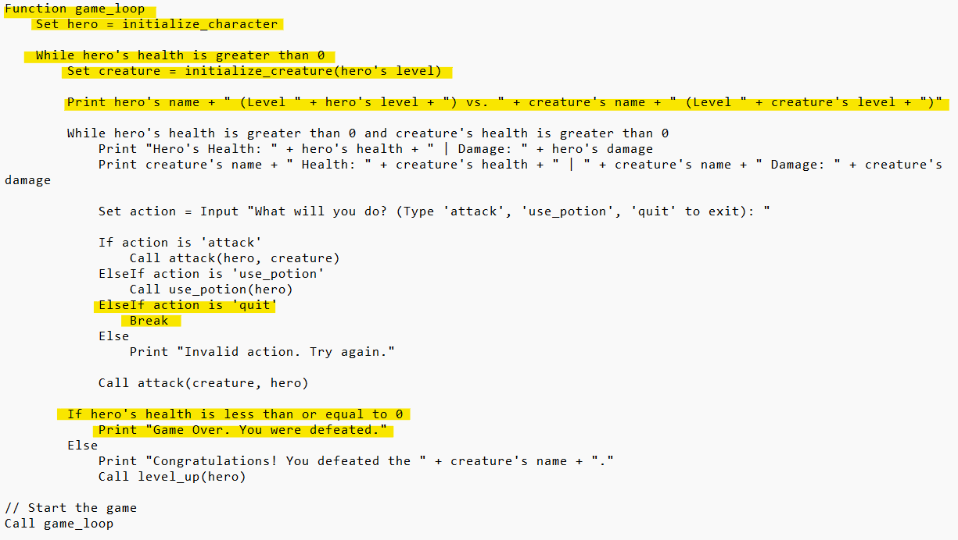
7. Implement a loop within this loop that focuses on each individual battle until the outcome is determined. Implement user input to decide how the player decides to play the game based on the actions attack use_potion and quit. Depending on what action the player chooses the corresponding procedure/function is called. A screenshot of a computer

   Description automatically generated
8. While coding the level up function I realised there is no point having two level up functions if both the character and creature level up together so I only added hero level up function and the creatures’ level will match the heroes. 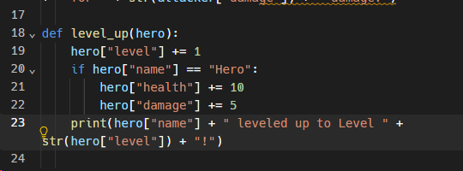
9. During development of the game loop I had encountered an infinite loop due to messing up the while loop. This was because I messed up the greater than and less than sign for the loop meaning the condition “creature[“health”] < 0” will always be false as it is checking if the creature’s health is less than zero. It is supposed to check if the creature’s health is greater than zero, I have attached an image of the amended code and underlined what part went wrong. A screenshot of a computer screen

   Description automatically generated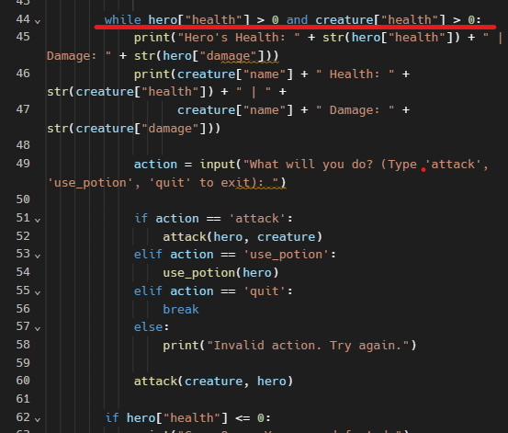
10. Upon testing I had noticed the quit button did not work as it did not break out the outer loop and instead carried on fighting the creature. I fixed this by using a flag to control the game loop. A screen shot of a computer program

    Description automatically generatedA screenshot of a computer program

    Description automatically generatedA screen shot of a computer code

    Description automatically generatedA screen shot of a computer program

    Description automatically generated
11. After incorporating Dragon Ball Z characters, I was faced with this error. This was because I forgot to add validation to take in the fact the user may input incorrect data. I fixed this by automatically defaulting to a hero instead of the game breaking due to this error. A screen shot of a computer

    Description automatically generated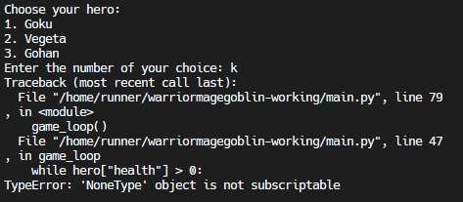A screen shot of a computer program

    Description automatically generatedA screen shot of a computer

    Description automatically generated

Upon testing the game during development, I realised the game does not follow closely enough to my task proposal and lacks originality, so I decided to add features to make the game harder and improve the overall smoothness and immersive of the game. I did this by:

* Modifying the initialize character and level up function to incorporate a multiplier for the hero’s health and damage instead of using hard coded numbers. A black screen with text and numbers

  Description automatically generatedA screen shot of a computer program

  Description automatically generated
* Adjust the health and damage multiplier for the initialize creature to make the creature more formidable as the heros level increases. A computer screen with text and numbers

  Description automatically generated
* Add the ability to use potions that will increase the heros health to improve the longevity of the game. A black screen with white text

  Description automatically generated A screenshot of a computer screen

  Description automatically generated
* However, I realised that this could be abused by the player so I added a limit to the amount of potions that can be used. A black background with text

  Description automatically generatedA computer screen with text

  Description automatically generatedA screenshot of a computer screen

  Description automatically generated
* After struggling to think of character names and creature names I decided to add names inspired by the Dragon Ball Z universe. I gave the player the opportunity to choose between these three heroes and they all had different stats. Also, different creatures would spawn randomly to add to the immersive Ness of this simple text-based game. 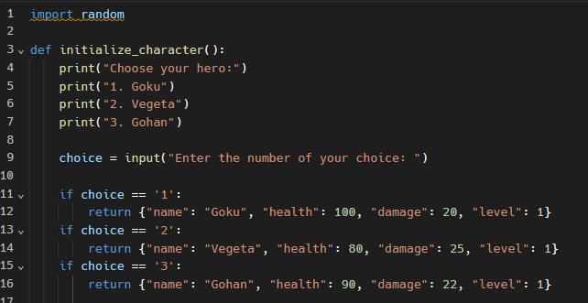A screen shot of a computer program

  Description automatically generated
* To match with dragon ball z theme, I changed the use potion to use senzu bean to better fit the mechanics of the game and keep the terminology consistent relevant. I added a bag for the user to keep track of the amount of senzu beans they must add strategies to the game and the player can see when they will run out. A screen shot of a computer code

  Description automatically generated A computer screen with text and numbers

  Description automatically generated A screen shot of a computer code

  Description automatically generated A screenshot of a computer program

  Description automatically generated
* I added the ability to turn super saiyan when character reaches level 5 when this happens the heros health and dmage will double. A screen shot of a computer code

  Description automatically generated A computer screen shot of text

  Description automatically generated A screenshot of a computer program

  Description automatically generated
* I also created a function that added the ability to use dragon balls that double the heros damage similarly to the use senzu bean function. A screenshot of a computer screen

  Description automatically generated A computer screen with text and images

  Description automatically generated A screen shot of a computer program

  Description automatically generated A screenshot of a computer screen

  Description automatically generated
* In order to make the game specific to me I added a secret code that the user can input which will give their hero 999 health and damage. The code is my studentID. A blue background with yellow text

  Description automatically generatedA screen shot of a computer

  Description automatically generatedA computer screen shot of a computer program

  Description automatically generated

I have created a new flowchart that better represents my RPG game as it has gone through many major changes during development:

