S26-04

Low-Cost Smart Sensor Spoofer on Unmanned Air System

Detailed Design Document

11/7/2025

Izzy Burley
Kush Parmar
Carl Holmberg
Drew Schineller
Sachel Jetly
Will Field

Table of Contents
1. Introduction (All projects) 3
2. System Architecture (All projects) 4
2.1 Overall System Architecture of Subsystems 4
2.2 System Interactions 6
3. Physical/Mechanical Design (Hardware / Hybrid projects) 6
3.1 Ground Station Physical Design 6
3.2 Neural Network Processing Unit Physical Design 7
4. Electrical/Electronic Design (Hardware / Hybrid projects) 7
4.1. Wiring Diagram 8
4.2. Component Selections 8
5. Software / Firmware Design (Software / Hybrid projects) 9
5.1 Overview 9
5.2 Architecture 9
5.3 Algorithms & Control Flow 10
5.3.1 System Flow Overview 11
5.3.2 Core Algorithms 11
5.3.3 Timing & Control Flow 15
5.4 Communication Protocols & APIs 16
5.4.1 Unreal Engine 5 Interfacing 16
5.4.2 Simulink Communication Protocol 16
5.4.3 Simulink to Sensor Array (Data Injection) 17
5.5 Summary 18
6. Module-Level Design (All projects) 19
6.1 Overview 19
6.2 Unreal Engine 5 Environment 19
6.3 Simulink Bridge 21
6.4 UAV Hardware Abstraction Layer 23
6.5 Edge Device Neural Network 25
7. Data Handling & Interfaces (All projects, emphasis varies) 27
7.1 Internal Interfaces and Data Storage: 27
7.2 External Interfaces: 28
8. Security & Safety Considerations (All projects) 28
9. Error Handling & Recovery (All projects) 29
9.1 System-Wide Fault Management Framework 29
9.2 Ground Station (Unreal Engine 5 Subsystem) 30
9.3 Simulink Bridge (Communication and Data Flow Link) 30
9.4 UAV & Neural Network Subsystem 31
9.4.1 Hardware Abstraction Layer (HAL) 31
9.4.2 Edge Neural Network Module 33
9.4.3 Control and Safety Behavior 33
10. Verification & Validation Plan (All projects) 34
10.1 Overview 34
10.1 Spoofing Module – Verification and Validation 34
10.2 Neural Network Module – Verification and Validation 35
10.3 UAV Control System Module – Verification and Validation 36
10.4 Ground Control Station– Verification and Validation 36
10.5 Power and Failsafe Verification and Validation 37
10.6 Integration Verification and Validation 37
11. Bill of Materials (Hardware / Hybrid) OR Dependency List (Software) 38
11.1 Hardware 38
11.2 Software 38
12. Appendices (All projects) 39
12.1 Glossary 39
12.2 References 40

1. Introduction (All projects)
The UAV Sensor Spoofer System is a dual platform setup designed to simulate, detect, and analyze sensor spoofing in unmanned aerial vehicles (UAVs). The primary objective of this project is to develop a reliable framework that supports both spoofing signal generation and real-time spoof detection using neural network processing with hardware integrated in the UAV.
This system will support research efforts for the U.S. Navy (NAWCAD Pax River) by providing validated data on spoofing techniques and defense mechanisms. The project emphasizes affordability and modularity, allowing small UAVs to serve as both emitters (spoofers) and receivers (detectors) in various controlled environments.
The project scope includes:
- Developing a ground-based spoofing module to simulate LiDAR, radar, GPS, or camera spoofing with a point cloud in a simulated, Unreal Engine, virtual environment.
- Integrating a neural network processing unit on the UAV for real-time spoof detection and classification.
- Designing a control and navigation subsystem in Simulink to maintain stable flight and compensate for spoofed data inputs.
- Creating a ground control station (GCS) interface for operator monitoring, data logging, and configuration of spoofing profiles.
This document references the Requirements Specification (RS-01), ensuring that all testing and validation align with previously established functional and performance requirements.
A ground station transmits a mix of real and spoofed signals toward a UAV equipped with multi-sensor arrays using hardware while varying within a point cloud. The UAV’s neural network processes incoming data, detects anomalies, and flags potential spoofing attempts while maintaining flight stability. The results are logged, analyzed, and visualized through MATLAB post-processing to assess detection of accuracy and spoofing effectiveness.

2. System Architecture (All projects)
The overall system is composed of 3 major subsystems: the Ground Station, Simulink Bridge, and the UAV & Neural Network module. Together, these subsystems enable sensor spoofing, data transmission, and spoof detection analysis. The system is designed to allow both simulated and physical validation of spoofing effects.

2.1 Overall System Architecture of Subsystems
2.1.1 Ground Station – Spoofing and Control Source
This subsystem is implemented virtually using Unreal Engine 5. The objective is to generate realistic LiDAR point cloud data and other sensor streams. This serves as the spoofing module, capable of transmitting either real or spoofed sensor data. The Ground Station manages system control, logging, and user interface functions for adjusting parameters and monitoring transmissions.
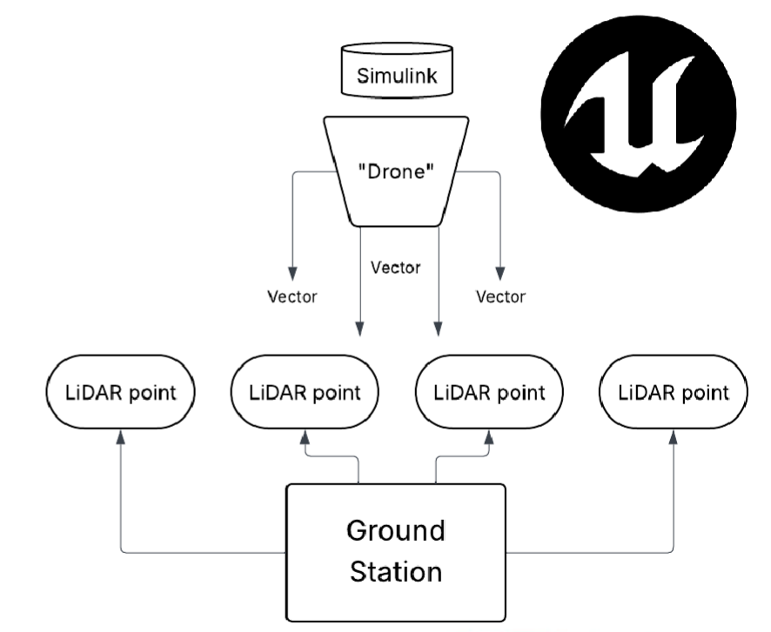

2.1.2 Simulink Bridge - Communication and Data Flow Link
This subsystem acts as the middleware interface between the Ground Station and the physical UAV. The Simulink bridge handles data synchronization, scaling, and timing between the Unreal Engine outputs and the UAV’s systems that are on board. The bridge ensures data is injected in real time into the UAV’s sensors and maintains some sort of control loop to ensure redundancy and evaluation of spoofed vs. Real data. MATLAB’s Simulink facilitates both simulation testing and hardware integration.
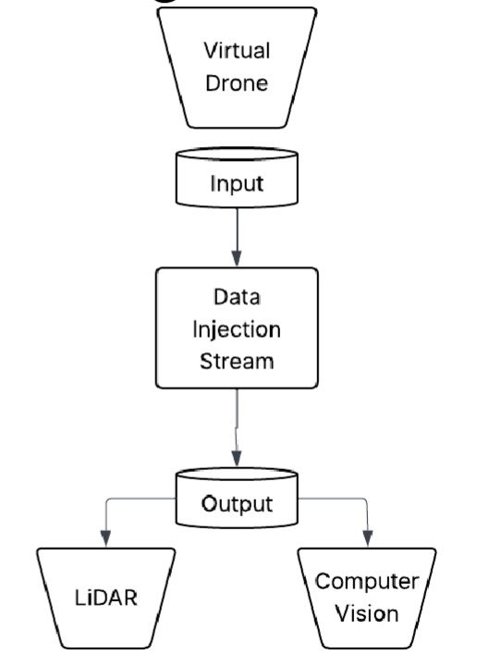

2.1.3 UAV & Neural Network – Detection and Classification Subsystem
The UAV carries onboard sensors (LiDAR, camera, GPS) and receives real and spoofed data from the Simulink Bridge. A Neural Network module, running on an embedded edge processor (NVIDIA Jetson), performs real-time classification of incoming data to determine the authenticity of the data (real or spoofed). The onboard control system maintains flight stability and data logging while compensating for anomalies detected by the neural network. This subsystem demonstrates adaptive learning, allowing the neural networking to retrain only newly acquired spoofing packets.
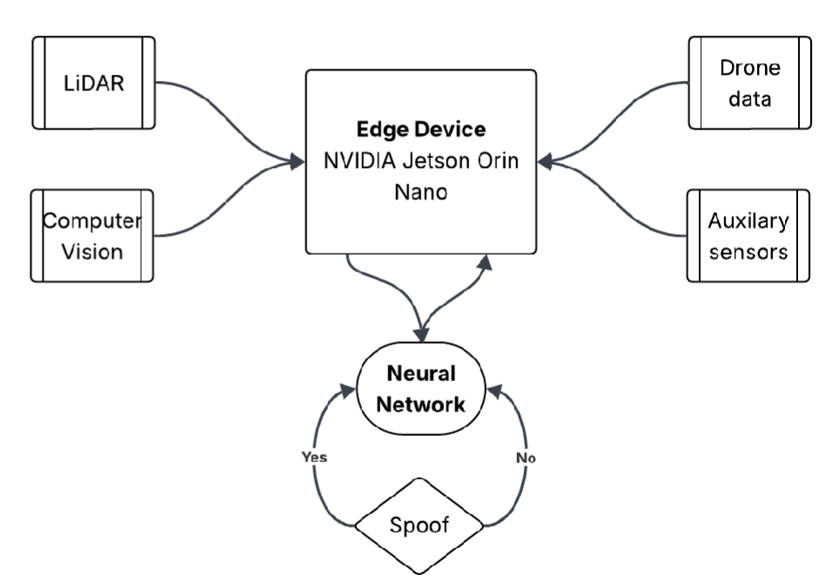

2.2 System Interactions
- Data Flow
Ground station -> Simulink Bridge -> UAV sensor array -> Neural Network analysis -> classified results via Ground Station logging
- Power
The UAV is powered by its onboard battery system, which supports all flight and computation subsystems, including the neural network hardware. The Ground Station and Simulink Bridge are powered by ground-based systems.
- Controls
Commands for flight control and spoofing configuration come from the Ground Station. The UAV’s control system autonomously adjusts its response based on the neural network’s classification outputs (e.g., if spoofing is detected, the UAV can trigger a failsafe mode or recalibration).

3. Physical/Mechanical Design (Hardware / Hybrid projects)

3.1 Ground Station Physical Design
The constraints of the ground station are minimal. Portability is not necessarily a concern since the ground station is stationary, only relaying the necessary signals to the UAV, and in the case of HiL testing, directly connected to the neural network processing unit. Since the primary function of the ground station is simulating the drone itself within Unreal Engine and bridging via Simulink, the entire software stack can be run through one computer. Therefore, our primary environmental considerations regard the proper operation of the computer: temperature and humidity. Shock and vibration are not considered since the intended operation of the ground station is not portable and set up in stable environments. To design against humidity (and other general water damage to devices in the ground station) we propose a weather-resistant enclosure containing the computer for the running Simulink bridge (if deployed in a real-world environment), otherwise only the sensor array for HiL testing as the ground station can be any arbitrary computer capable of running Unreal Engine and Simulink.

3.2 Neural Network Processing Unit Physical Design
The neural network processing unit is designed as a standalone device containing the NVIDIA Jetson Orin Nano board, a Raspberry Pi Pico, a battery, and the sensor array. Unlike the ground station, all environmental constraints are relevant, including vibrations, humidity, and temperature. In addition, its weight is a crucial design consideration which influences the potential applicable UAVs by their respective payload capacities. Likewise, since specific LiDAR and GPS modules have not been chosen, the specific weight, outside exposure, and power considerations cannot be fully determined currently.
The neural network processing unit internals should be completely insulated from the outside elements with the only exposed features being its specific power and data interfaces, and sensors necessary for its function (LiDAR sensors, GPS module if it cannot operate within the box itself). This is because both the Jetson and the Pi are not shipped already “hardened” to outside environments and are development boards with bare PCBs. As a result, we choose to keep all of the internal electronics completely separated from the outside elements in an enclosure, rather than mounting directly to a UAV. This further has the advantage of portability and allows the system to be an isolated and agnostic payload for any potential UAV.

4. Electrical/Electronic Design (Hardware / Hybrid projects)

4.1. Wiring Diagram
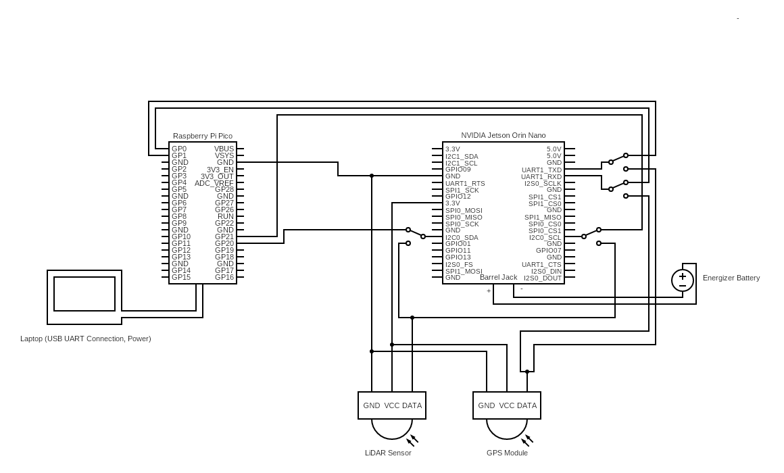
Above is the main wiring diagram of our full system. As shown, our design utilizes a laptop connected to a Raspberry Pi Pico as an interface to send our spoofed LiDAR and GPS signals over I2C and UART respectfully. These signals are then injected directly into the NVIDIA Jetson Orin Nano, processing the signals using edge AI models and storing relevant data. The system also has “switches” to toggle between the constructive data and the real-world data gathered by our GPS Module and LiDAR sensor. The Jetson Orin Nano requires a portable energy source, so we chose a 10,000mAh Energizer rechargeable power bank to power the module.

4.2. Component Selections
When selecting our main electronic components for this project, we followed our specification and ensured that every device we use will be Commercial Off-The-Shelf (COTS) and relatively low-cost. Due to these restrictions, we first decided on the NVIDIA Jetson Orin Nano, an edge computing device with 67 TOPS of AI performance that only costs $250 for the development board. The board also comes with an onboard GPU, CPU, and RAM that can efficiently power our machine learning models in as close to real time as possible given our budgetary constraints.
The Raspberry Pi Pico was chosen as it has the capability to transmit data over UART, SPI, and I2C buses built into its GPIO pins. Utilizing this microcontroller, we can obtain live data streams of spoofed signals from the connected laptop and closely emulate the LiDAR and GPS sensor’s I2C address and dataflow, not requiring any extra interfacing by the Jetson board to recognize the spoofed signals and accurately imitating what a physical spoof would look like.
The LiDAR sensor and GPS module have not been selected yet, as once the LiDAR sensor is selected we will be able to properly budget for the GPS module, and vice versa. These devices, however, both have standardized message formats and knowing these we can begin to develop our constructive/simulated signals to be only slightly tweaked once the physical devices are sourced.

5. Software / Firmware Design (Software / Hybrid projects)

5.1 Overview
The software system connects and operates 3 distinct subsystems. These are broken down into an Unreal Engine 5 virtual environment, Simulink-based middleware, and an edge device neural network.
The UE5 (Unreal Engine 5) environment serves as a controllable digital twin of the physical world; generating synthetic data such as LiDAR point clouds, GPS data, images, and other similar telemetry. This virtual environment provides a repeatable and configurable space for simulating flight conditions, obstacles, and the target of this project; spoofing events without requiring physical hardware or real world placement that can cause project setbacks.
Simulink provides a means of communication and control bridge between the simulation and the physical systems. It manages real time data transfer, timing, and protocol translation to the appropriate sensor(s). This layer ensures that the simulated data and control commands maintain appropriate timings and consistent data formatting for transmission to the hardware platform.
Finally the edge device neural network subsystem runs the inference models that analyze incoming data for pattern recognition, spoof detection, or other mission critical tasks. It receives processed data from the bridge executes neural inferencing locally on the edge device, and stores results on the device.
Together, these components form a closed loop architecture that enables real time feedback between simulation, computation, and control. The modular design allows each subsystem to operate independently for unit testing while also supporting full integration for system wide validation.

5.2 Architecture
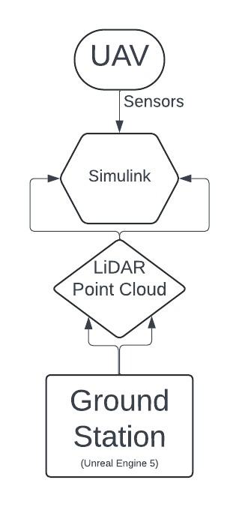
Figure 5.1
The system architecture is illustrated in Figure 5.1. It summarizes the data flow and interaction between the three main subsystems described in the previous section. The Ground station generates simulated LiDAR point cloud data within the UE 5 environment. This data is transmitted through the Simulink interface, which handles timing, conversion, and communication between the simulated environment and the UAV subsystem. The UAV, whether simulated or physical, receives sensor inputs and provides feedback data that can be visualized or analyzed at the Ground Station. This diagram provides a high-level view of the closed-loop data path used throughout the system and serves as a reference for the detailed module descriptions that follow.

5.3 Algorithms & Control Flow

5.3.1 System Flow Overview
At runtime, the Unreal Engine 5 (UE5) environment initializes the virtual world and configures a software LiDAR generator. UE5 produces time-tagged point-cloud frames by ray-sampling the scene and, when enabled, injecting spoofed returns using the same ray process. Each frame includes a header and a payload of ordered points. Frames are emitted at a fixed rate and handed off to the Simulink interface.
The Simulink bridge receives each frame, validates integrity (size/CRC), normalizes it to a standard schema, and aligns timestamps to the simulation clock. It maintains a small buffer to absorb jitter, assigns/propagates frame IDs, and forwards frames to the UAV edge device over the configured transport. Simulink also returns telemetry (latency, drops, health) to the ground station for monitoring.
On the UAV edge device, the pipeline preprocesses the incoming frame (normalize), runs the neural-network inference, and applies decision logic (smoothing + hysteresis) to produce a stable spoof/no-spoof flag with a confidence score. Results and module health are sent back to Simulink for visualization and optional control feedback. The loop repeats at the target rate (e.g., 20–30 Hz) with end-to-end latency kept within the budget; if deadlines are missed, the system enters a degraded mode (reduced point density or fallback model) while continuing real-time operation.

5.3.2 Core Algorithms
The systems core functionality is driven by two primary algorithms operating in sequence:
A. LiDAR Point Cloud Generation in UE5
The LiDAR point cloud is generated entirely within the Unreal Engine 5 environment, without the use of any physical LiDAR hardware. UE5 functions as a virtual sensing environment capable of producing both “real” and “spoofed” LiDAR data through ray-based scene sampling.
The process begins with the creation of a virtual environment containing 3D models, materials, and lighting conditions representative of a real-world scene. Within this environment, a virtual LiDAR generator defines scanning parameters such as the number of beams, angular resolution, rotation rate, and field of view. Instead of emulating a hardware sensor, UE5 uses its raycasting and physics engine to compute depth and intensity values for each point in the scene based on surface interactions, reflectivity, and geometry.
For each frame, UE5 calculates the position and orientation of the virtual sensor, casts rays throughout the environment, and compiles the resulting hit data into a structured point cloud. Both authentic scene reflections and engineered spoof elements (such as injected false walls, reflective clusters, or ghost points) are generated using the same underlying ray-based process. This allows the system to simulate complex sensing conditions including deceptive or adversarial inputs entirely in software.
The resulting point cloud is then exported from UE5 as a time-tagged data frame, ready for serialization and transmission to the Simulink interface for downstream neural network analysis.
Algorithm: UE5_ScanFrame_WithSpoof
Inputs:
S // UE5 scene
L // LiDAR config {channels C, FOV, dtheta_h, R_spin, r_min, r_max}
Pose(t) // virtual sensor pose over time
Spoof // {enabled, type, params, density, seed}
k // frame_id
Outputs:
F_k // points {(x,y,z,t_ns,ring,range, tag)}
H_k // {frame_id, n_points, t_frame_start, flags}
Procedure:
1) t0 = now(); F_k = {}; rng = Seed(Spoof.seed, k)

2) // SCAN: beams over channels x azimuth
for c in 0..L.C-1:
for theta_h in sweep(-L.FOV/2, +L.FOV/2, L.dtheta_h):
t_beam = t0 + time_offset(theta_h, c, L.R_spin)
T_ws = interpolate(Pose, t_beam)

// beam direction in sensor frame -> world frame
dir_s = direction_from(theta_h, vertical_angle(c))
dir_w = rotate(T_ws, dir_s)
org_w = translation(T_ws)

// raycast into scene
hit = UE5_Raycast(S, org_w, dir_w, L.r_max)
if not hit: continue

r = clamp(hit.range, L.r_min, L.r_max)
p_w = org_w + r * dir_w
p_s = inverse(T_ws) * p_w

append(F_k, {x=p_s.x, y=p_s.y, z=p_s.z,
t_ns=to_ns(t_beam), ring=c, range=r, tag="real"})

3) // SPOOF: generate additional points inside UE5
if Spoof.enabled:
O = UE5_GenerateSpoof(Spoof.type, Spoof.params, density=Spoof.density, rng)
// assign timestamps consistent with scan
for q in O:
t_q = t0 + map_to_scan_time(q, L, Pose) // e.g., by azimuth
append(F_k, {x=q.x, y=q.y, z=q.z,
t_ns=to_ns(t_q), ring=q.ring, range=q.range, tag="spoof"})

4) // ORDER + HEADER
F_k = sort(F_k, by t_ns)
H_k = {frame_id=k, n_points=len(F_k), t_frame_start=to_ns(t0),
flags = (Spoof.enabled ? FLAGS_SPOOFED : 0)}

5) return F_k, H_k

B. Neural Network Inference & Decision Logic
The edge device ingests each time-tagged LiDAR frame from Simulink and performs real-time inference to assess whether the scene contains spoofed returns. The pipeline converts raw points into a compact, model-friendly representation (e.g., voxel grid or point features), executes a quantized neural network optimized for the target hardware (e.g., TensorRT/ONNX on Jetson), and applies decision logic (smoothing and hysteresis) to produce a stable binary flag and confidence score.
Preprocessing includes voxelization/downsampling to bound compute, normalization to the model’s training ranges, and optional feature augmentation (ring index, range, local curvature). The inference engine returns a spoof likelihood score in [0,1]. To avoid chatter from frame-to-frame noise, the score is filtered with an exponential smoother and threshold with hysteresis (TH_high / TH_low). Results are published back to Simulink along with model metadata (model_id, revision, latency) and health metrics. On runtime faults the system falls back to a lightweight baseline (rule score or tiny model) and marks the decision as degraded while maintaining real-time operation.
Algorithm: EdgeNN_Infer_Decide
Inputs:
F_k // LiDAR frame: {(x,y,z,t_ns,ring,range,tag?)} from Simulink
Model // {engine, model_id, input_spec, quantization}
Params // {voxel_size, max_points, norm_stats, alpha, TH_high, TH_low}
Budget // {t_pre_ms, t_inf_ms, t_post_ms, t_total_ms}
k // frame_id
Outputs:
D_k // decision {flag in {0,1}, score in [0,1], degraded in {0,1}}
M_k // telemetry {latency_ms, model_id, rev, n_points_in, n_voxels}

Procedure:
1) t_start = now()

2) // PREPROCESS: bound size and match training distribution
P = clamp_points(F_k, max_points=Params.max_points)
V = voxelize(P, voxel=Params.voxel_size) // grid or sparse tensor
X = normalize(V, stats=Params.norm_stats) // mean/var or min/max
if deadline_exceeded(t_start, Budget.t_pre_ms): goto DEGRADE

3) // INFERENCE: run quantized engine on edge accelerator
y = Model.engine.infer(X) // y in [0,1]
if timeout_or_error(): goto DEGRADE

4) // POSTPROCESS: smooth + hysteresis for stability
score = exp_smooth(prev_score, y, alpha=Params.alpha)
if score > Params.TH_high: flag = 1
else if score < Params.TH_low: flag = 0
else: flag = prev_flag
if deadline_exceeded(t_start, Budget.t_post_ms): goto DEGRADE

5) // OUTPUT + METRICS
latency = ms_since(t_start)
D_k = {flag=flag, score=score, degraded=0}
M_k = {latency_ms=latency, model_id=Model.model_id,
n_points_in=len(P), n_voxels=size(V)}
publish(D_k, M_k)
prev_score = score; prev_flag = flag
return D_k, M_k

DEGRADE:
// Fallback path to preserve real-time behavior
score_fallback = heuristic_score(P or V) // cheap rule-based
// apply same hysteresis to fallback score
score = exp_smooth(prev_score, score_fallback, alpha=Params.alpha)
if score > Params.TH_high: flag = 1
else if score < Params.TH_low: flag = 0
else: flag = prev_flag
D_k = {flag=flag, score=score, degraded=1}
M_k = {latency_ms=ms_since(t_start), model_id=Model.model_id,
n_points_in=len(P), n_voxels=size(V)}
publish(D_k, M_k); prev_score = score; prev_flag = flag
return D_k, M_k

5.3.3 Timing & Control Flow
Runtime model. The system operates in fixed cycles at a target frame rate (e.g., 20–30 Hz). Each cycle spans one LiDAR frame from UE5, transport via Simulink, preprocessing, neural inference on the edge device, and feedback. Components run asynchronously with bounded queues; timestamps and frame IDs maintain ordering across modules.
A. Timings & Loop Rates
The system operates in fixed cycles at a target frame rate (e.g., 20–30 Hz). Each cycle spans one LiDAR frame from UE5, transport via Simulink, preprocessing, neural inference on the edge device, and feedback. Components run asynchronously with bounded queues; timestamps and frame IDs maintain ordering across modules.
Stage | Rate (Hz) | Deadline (ms) | p95 Latency | Notes
UE 5 LiDAR Gen | 20-30 | 33-50 | <= 80% | Raycast + header pack
Simulink | 20-30 | 10 | <= 6% | CRC, schema, ID, forwarding
Edge Preprocess | 20-30 | 8 | <= 5% | Downsample & normalize
Edge NN Inference | 20-30 | 10 | <= 8% | Quantized engine
Postproc + Publish | 20-30 | 5 | <= 3% | Smoothen metrics

B. Control Flow per Data Frame
Timestamps monotonic t_ns generated in UE5 at frame start; propagated unchanged. Frame IDs: increment in UE5; used to join results with source frames. Clock discipline simulink is the reference clock for scheduling; edge device accepts UE5 timestamps but measures local latency for metrics.
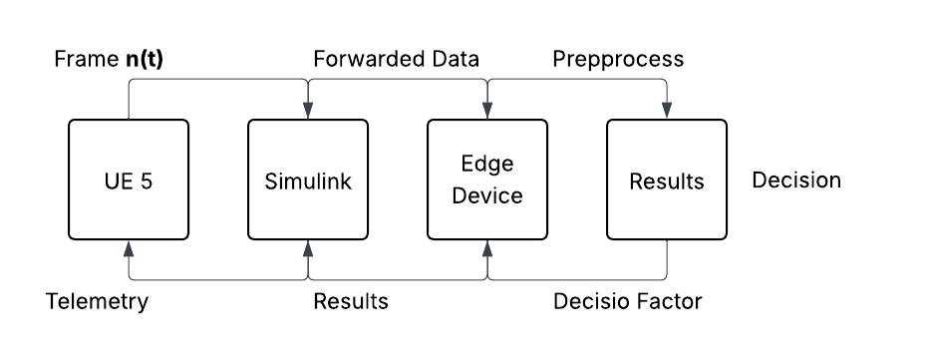

5.4 Communication Protocols & APIs
This section describes the interfaces and communication standards used throughout the system, detailing how data and commands are exchanged between the Unreal Engine 5 environment, the Simulink middleware, the UAV edge device, and the onboard sensors. All protocols are designed for deterministic, low-latency transfer with well-defined message structures and error handling.

5.4.1 Unreal Engine 5 Interfacing
The UE5 module acts as the data producer for simulated LiDAR frames. Communication between UE5 and the Simulink environment is implemented through a lightweight TCP socket API, exposing structured messages that encapsulate point-cloud frames and telemetry.
Key aspects:
- Transport Layer: TCP/IP over local or virtual network interface (loopback for local simulations).
- Message Format: JSON-encoded headers followed by binary point-cloud payloads (XYZI or XYZIR).
- Synchronization: Each frame includes frame_id, timestamp, and a CRC-32 checksum for integrity verification.
- API Functions (UE5 Plugin):
  - InitSocket(port) – Initialize communication channel
  - SendFrame(header, payload) – Transmit serialized LiDAR frame
  - ReceiveAck() – Wait for confirmation from Simulink
  - CloseSocket() – Graceful teardown
- Performance: 10–30 Hz sustained transmission, typical latency < 5 ms per frame.
This protocol enables UE5 to function as a real-time virtual sensor, streaming LiDAR data directly into Simulink for synchronization and downstream analysis.

5.4.2 Simulink Communication Protocol
Simulink serves as the middleware and timing controller between the virtual sensing layer (UE5) and the embedded edge hardware.
Protocol Layering:
- Input Interface: TCP Client socket connected to UE5.
- Internal Messaging: Simulink buses carrying LiDARFrame structures (timestamp, pose, point array, metadata).
- Output Interface: UDP or serial (RS-232/TTL) link to the UAV edge device depending on configuration.
- Error Handling: CRC verification, packet counters, and acknowledgment scheme to detect drops or duplicates.
struct LiDARHeader
{
uint32 frame_id;
uint64 timestamp_ns;
uint16 n_points;
uint8 flags;
uint32 crc32;
}
Followed by an array of packed (x, y, z, intensity) points.
Simulink also exposes a MATLAB-based API (sendFrame(), readResult(), checkCRC()) to allow debugging and visualization without recompilation of the model.

5.4.3 Simulink to Sensor Array (Data Injection)
Simulink must communicate with sensor array to actually move the data frames from the virtual environment to the sensor array. This creates the closest scenario to real life that is possible for the proposed setup
A. Transports & Roles
- Upstream input (to Simulink): UE5 frames over TCP (from §5.4.2).
- Downstream output (to Sensor Array): Simulink transmits sensor-accurate streams using one of the injection modes below.
B. Injection Modes
- Protocol-level emulation (wire-compatible, no pins)
  - Simulink sends packets that match the real sensor protocol (e.g., LiDAR-over-UDP with frame/seq/count/CRC; IMU via MAVLink/CAN).
  - Edge device uses unchanged, real drivers.
  - Pros: realistic timing/packetization; simple to deploy.
- Electrical Hardware-in-the-Loop (pin-level)
  - Simulink → USB/Ethernet → Sensor Emulation MCU which behaves as the sensor electrically:
    - SPI slave replies to master bursts; I²C slave serves registers; UART streams NMEA/MAVLink; CAN node publishes frames; GPIO/IRQ asserts DRDY/frame-start.
  - Pros: exercises ISR, DMA, bus timing; closest to real hardware.
C. Message Schema
All sensor types use a common envelope; payload varies by sensor.
struct SampleMsg
{
uint32 frame_id;
uint64 t_ns; // UE5/Simulink time
uint8 sensor_type; // 0=LiDAR,1=IMU,2=GPS,...
uint8 qos; // 0=best-effort,1=must-deliver
uint16 payload_len;
uint32 crc32;
uint8 payload[payload_len]; // e.g., XYZI blocks, IMU samples, NMEA
}

D. Timing & synchronization
- Cadence: LiDAR 20–30 Hz; IMU 100–400 Hz; GPS 1–10 Hz (configurable).
- Clock source: Simulink reference clock; Sensor Array/MCU syncs on first “time-sync” message, applies drift correction.
- Jitter targets: inject jitter < 2 ms per frame; inter-packet gaps match the real device.
- Back-pressure: fixed-depth SPSC queues (depth=2). On overflow, drop oldest and log.

5.5 Summary
The software framework integrates simulation, communication, and inference into a unified closed-loop system that mirrors real-world sensing behavior.
At its core, Unreal Engine 5 generates LiDAR point clouds, both authentic and spoofed, entirely within a virtual environment. These data frames are transmitted to Simulink, which serves as the virtual sensor hub that synchronizes timestamps, manages communication pipelines, and injects virtual sensor data into the Sensor Array for hardware-in-the-loop operation.
Through standardized communication protocols and APIs, the system supports deterministic timing, consistent message formatting, and modular expansion to additional sensor types or data sources. Simulink bridges the virtual and physical domains by relaying simulated frames through either protocol-level or electrical-level injection to the Edge Device, where real-time neural network inference is performed to identify spoofed or anomalous inputs.
Overall, the software design provides a modular, time-synchronized, and fault-tolerant platform that tightly integrates simulation, control, and sensing to create the closest possible approximation to a real-world sensing and spoof detection environment.

6. Module-Level Design (All projects)

6.1 Overview
The software system is divided into four primary modules: Unreal Engine 5 Environment, Simulink Bridge, UAV Hardware Abstraction Layer (HAL), and the Edge Device Neural Network.
Each module performs a specific role within the closed-loop architecture and collectively enables realistic sensing, communication, and inference between the virtual and physical components of the system.
The Unreal Engine 5 Environment generates the simulated LiDAR data, including both authentic and spoofed point-cloud frames. These frames are transmitted to the Simulink Bridge, which acts as the central interface between the virtual environment and the hardware-in-the-loop platform. Simulink manages frame scheduling, synchronization, and data injection into the Sensor Array, ensuring accurate temporal alignment and consistent message formatting.
The UAV Hardware Abstraction Layer translates the injected data streams into sensor-accurate outputs using standard communication protocols such as SPI, I²C, UART, and CAN. This layer emulates the electrical and protocol-level behavior of real sensors so that the downstream hardware perceives the simulated data as genuine sensor input.
Finally, the Edge Device Neural Network module performs real-time inference on the incoming LiDAR frames to detect spoofed signals and classify environmental conditions. It also generates control or feedback data that can be fed back into Simulink for visualization and evaluation.
Together, these modules create a modular and scalable architecture in which each component operates independently but cooperates through standardized APIs and timing controls. Section 6 provides a detailed breakdown of each module, outlining its purpose, inputs, outputs, dependencies, and operational constraints.

6.2 Unreal Engine 5 Environment
The Unreal Engine 5 (UE5) environment serves the virtual sensing domain and the sandbox for the entire system. It replicates 3D realistic environments, lighting conditions, and materials to create similar to real life 3D structures
Inputs
- Scene assets and environment configuration files (meshes, textures, materials, lighting).
- Virtual LiDAR parameters (number of channels, FOV, resolution, rotation rate, range limits).
- Spoof configuration parameters (type, density, spatial region, random seed).
- Camera and UAV pose trajectory data for time-synchronized frame generation.
- Timing and synchronization signals from Simulink for frame scheduling.
Outputs
- Structured LiDAR point-cloud frames containing:
  - Cartesian coordinates (x, y, z)
  - Intensity and timestamp (t_ns)
  - Ring index and range
  - Spoof tag flag
- Frame headers (frame_id, timestamp, point count, flags, CRC).
- System telemetry (frame rate, latency, fault flags).
- Optional debug visualizations rendered within the UE5 viewport.
Internal Logic
UE5 operates as a multi-threaded simulation that casts virtual LiDAR beams throughout the environment using its built-in raycasting engine.
Each scan cycle consists of the following steps:
- Initialize LiDAR and spoof parameters.
- Compute the sensor pose based on UAV trajectory.
- Raycast beams into the environment to determine intersection points.
- Calculate return intensity based on material reflectivity and incidence angle.
- Inject spoof points if spoof mode is enabled.
- Compile the results into a time-tagged point-cloud frame.
- Serialize and transmit the frame to Simulink over a TCP socket.
The simulation loop runs at a fixed rate of 20–30 Hz, synchronized to the Simulink scheduler to ensure deterministic frame timing.
Dependencies
- Unreal Engine 5 (C++ and Blueprint scripting environment).
- UE5 Ray Tracing and Physics subsystems.
- Custom UE5 plugin for LiDAR frame serialization and TCP data streaming.
- Configuration data from Simulink (sensor parameters and spoof settings).
Constraints
- Frame rate limited by GPU and CPU rendering performance (nominally 20–30 Hz).
- Maximum supported LiDAR point count: ~1.2 million points per frame.
- Must maintain <10 ms latency for frame serialization and transmission.
- Requires stable synchronization with Simulink’s timing loop to avoid dropped frames.
- Scene complexity and lighting resolution directly affect raycasting performance.
Summary
The Unreal Engine 5 Environment functions as the data source for the entire system, generating realistic and controlled LiDAR point clouds under configurable conditions. Its ability to simulate spoofing scenarios and maintain synchronization with real-time data flow makes it the cornerstone of the virtual sensing architecture.

6.3 Simulink Bridge
The Simulink Bridge serves as the central communication and synchronization hub between the Unreal Engine 5 environment and the hardware-in-the-loop (HIL) system. It receives serialized LiDAR frames from UE5, validates and reformats the data, and then injects it into the Sensor Array for downstream processing by the Edge Device Neural Network. The Simulink Bridge is responsible for maintaining deterministic timing, queue management, and fault detection, ensuring that virtual sensor data is delivered in real time to the edge hardware.
Inputs
- Serialized LiDAR point-cloud frames and headers from UE5 (TCP input).
- Synchronization and configuration commands (sensor rate, spoof enable, timing offsets).
- Timing signals from Simulink scheduler (simulation step tick).
- Feedback and control messages from the Edge Device (telemetry, status, inference results).
Outputs
- Reformatted LiDAR frames compatible with Sensor Array protocol or emulation MCU interface.
- Acknowledgment packets to UE5 for each successfully received frame.
- Time-aligned data streams over UDP or serial link to the Sensor Array.
- System telemetry (latency, dropped frames, queue depth, fault flags).
- Control updates to the Edge Device or virtual environment as needed.
Internal Logic
The Simulink Bridge operates within the Simulink environment as a real-time model with discrete sample timing. Its main tasks occur in a deterministic loop synchronized to the system’s target frame rate (20–30 Hz).
- Frame Reception: Accepts incoming TCP packets from UE5 and reassembles the frame header and payload.
- Validation: Checks for correct CRC, frame ID continuity, and expected payload length.
- Reformatting: Converts incoming data to standardized internal structures (e.g., LiDARFrame bus object).
- Scheduling: Queues validated frames in a circular buffer to ensure constant latency.
- Data Injection: Sends formatted sensor data to the Sensor Array using the appropriate transport (UDP, SPI, or USB-to-MCU).
- Feedback Handling: Receives telemetry and results from the Edge Device and logs them in Simulink scopes or dashboards.
- Fault Handling: Detects communication loss, timeouts, or corrupted frames, triggering retry or degraded operation modes.
Dependencies
- MATLAB/Simulink Real-Time environment.
- Simulink Coder for deployment and timing synchronization.
- MATLAB TCP/UDP Toolbox for communication with UE5 and Sensor Array.
- Custom Simulink blocks for CRC validation, timing control, and data type conversion.
- Real-time clock or hardware timer for synchronization with UE5 timestamps.
Constraints
- Must process and forward each LiDAR frame within a 50 ms time window (20 Hz minimum frame rate).
- Maximum end-to-end latency budget: 80 ms (UE5 → Edge Device).
- Network throughput requirement: up to 10 MB/s depending on point density.
- Limited queue depth (typically 2–3 frames) to prevent buffer-induced lag.
- Requires reliable synchronization with both UE5 and the Edge Device to maintain frame order.
Summary
The Simulink Bridge is the middleware layer that connects the virtual and physical domains of the system. It guarantees timing integrity, ensures consistent data formatting, and supports real-time injection of LiDAR data into the Sensor Array. Its modular architecture allows flexible configuration for either software-in-the-loop (SIL) or hardware-in-the-loop (HIL) testing, making it a key component in verifying both simulation accuracy and neural inference performance.

6.4 UAV Hardware Abstraction Layer
The UAV Hardware Abstraction Layer (HAL) provides a standardized interface between the simulated data sent from Simulink and the physical edge hardware that receives it. This layer ensures that injected virtual sensor data is interpreted by the edge device exactly as if it were coming from real onboard sensors. It manages all bus-level communication protocols (SPI, I²C, UART, CAN, GPIO) and abstracts hardware details so that higher-level software, including the neural network module, can operate independently of specific hardware implementations.
Inputs
- Formatted LiDAR frames and sensor data packets from Simulink Bridge (via UDP, USB, or serial).
- Configuration commands (sensor mode, rate, spoof enable/disable, calibration constants).
- Timing triggers or synchronization pulses from Simulink scheduler.
- Control or acknowledgment signals from the edge device (read requests, interrupts).
Outputs
- Bus-level signals over SPI, I²C, UART, or CAN emulating real sensor behavior.
- Data-ready or interrupt pulses on GPIO pins to indicate frame availability.
- Status and health telemetry back to Simulink (bus error, timeout, sync drift).
- Optional analog or PWM outputs for auxiliary simulated sensors.

Internal Logic
The HAL runs on either a microcontroller or FPGA-based interface board connected between Simulink and the edge device. Its main operations occur in a loop synchronized with the frame timing from Simulink.
- Frame Reception: Receive decoded sensor frames from Simulink through serial or Ethernet interface.
- Parsing & Buffering: Parse headers, validate checksums, and queue sensor data into internal registers.
- Bus Emulation:
  - SPI: Act as an SPI slave, responding to edge device requests with pre-buffered sensor data.
  - I²C: Operate as an I²C slave device exposing register-based sensor readings.
  - UART: Stream continuous data packets (e.g., NMEA or MAVLink) at the configured baud rate.
  - CAN: Transmit CAN frames with proper arbitration IDs and timing intervals.
- Timing & Interrupt Control: Generate GPIO or IRQ pulses (e.g., “data ready”) to match the real sensor’s timing pattern.
- Error Handling: Detect communication faults or timing violations, report status codes to Simulink, and retry transactions if necessary.
- Synchronization: Adjust timing offset based on drift feedback from Simulink to maintain sub-millisecond alignment.
Dependencies
- Embedded microcontroller (e.g., STM32, Teensy, or Arduino) or FPGA board for electrical signal generation.
- Firmware implementing SPI, I²C, UART, and CAN protocol stacks.
- Communication link to Simulink (serial, USB, or Ethernet).
- Timing reference signal or synchronization clock from Simulink.
- Power interface and logic-level compatibility with edge device I/O.
Constraints
- Signal update rate limited by bus speed (SPI up to 5 MHz, I²C up to 400 kHz, UART up to 1 Mbps).
- Synchronization drift must remain below 1 ms across 60 seconds of runtime.
- Queue depth of 1–2 frames to prevent stale data or overrun conditions.
- Electrical isolation required when interfacing with live hardware to prevent back-drive damage.
- Latency between frame reception and bus output must remain <5 ms for real-time operation.

Summary
The UAV Hardware Abstraction Layer functions as the bridge between virtual data and real hardware, converting high-level simulation data into accurate sensor bus signals. By emulating real sensors at the protocol or electrical level, it allows the edge device to operate as though connected to actual UAV instrumentation. This modular design supports flexible testing, safe hardware validation, and seamless integration between simulation and embedded control systems.

6.5 Edge Device Neural Network
The Edge Device Neural Network (NN) module performs real-time inference on the LiDAR frames received from the UAV Hardware Abstraction Layer. Its primary purpose is to identify spoofed LiDAR points, classify environmental conditions, and provide decision feedback to the control system.
Operating on an embedded computing platform such as an NVIDIA Jetson or similar ARM-based SoC, the module is optimized for low-latency processing and continuous operation. It enables onboard intelligence by analyzing incoming data locally, without requiring cloud or offboard computation.
Inputs
- Preprocessed LiDAR frames from the Hardware Abstraction Layer (SPI, UART, or UDP input).
- Configuration parameters for the neural model (model ID, precision, threshold values, and smoothing factors).
- Timing and synchronization data from Simulink for frame alignment.
- Optional auxiliary sensor data (IMU, GPS, or camera feed) for multi-modal analysis.
Outputs
- Inference results per frame:
  - Spoof detection flag (0 = real, 1 = spoofed)
  - Confidence score (0.0–1.0)
  - Detected spoof cluster coordinates (optional)
- System telemetry including inference latency, resource utilization, and fault flags.
- Feedback and control messages sent to Simulink for visualization and response handling.
- Optional activation heatmaps or confidence maps for debugging and model validation.
Internal Logic
The neural network module follows a multi-stage pipeline designed to operate deterministically at the system frame rate (20–30 Hz):
- Frame Reception: Acquire LiDAR frames through the HAL using DMA or buffered communication.
- Preprocessing:
  - Downsample and voxelize point cloud data to fixed resolution.
  - Normalize coordinates and intensity values to match model input specifications.
  - Convert to tensor format ([batch, channels, height, width] or [N, features]).
- Inference Execution:
  - Run quantized model using TensorRT, ONNX Runtime, or PyTorch runtime optimized for embedded GPU.
  - Measure inference time per frame and compare against the real-time deadline.
- Postprocessing:
  - Apply smoothing (exponential moving average) to confidence scores.
  - Apply hysteresis logic to stabilize spoof detection state between frames.
  - Generate flag and metadata for Simulink.
Dependencies
- Edge computing platform (e.g., NVIDIA Jetson Nano/Xavier or equivalent ARM-based board).
- TensorRT or ONNX Runtime for accelerated inference.
- CUDA/cuDNN libraries for GPU computation.
- Simulink communication interface library (UDP or serial).
- Model configuration and calibration files provided during initialization.
Constraints
- Maximum end-to-end inference latency: <10 ms per frame to maintain 20–30 Hz operation.
- Model size limited to onboard memory (typically ≤100 MB for quantized networks).
- Power consumption capped at 15 W for embedded operation.
- Real-time loop must maintain consistent timing alignment with Simulink frame scheduler.
- Model updates are restricted to validated, version-controlled builds for safety and consistency.

Summary
The Edge Device Neural Network module provides the decision-making capability for the UAV system by running real-time inference on LiDAR data received from the simulated or emulated sensors. Its design ensures low-latency execution, stability under degraded conditions, and continuous synchronization with the overall system timing loop. This module completes the end-to-end data path by transforming simulated sensor input into actionable intelligence, enabling reliable spoof detection and closed-loop verification within the test architecture.

7. Data Handling & Interfaces (All projects, emphasis varies)

7.1 Internal Interfaces and Data Storage:
Our project collects and stores data from various sources, primarily from our sensors and machine learning models. To store this data efficiently, we will be utilizing the NVME SSD slot onboard the Jetson for fast and reliable storage. Data will be gathered in one single XML/JSON formatted file with the structure below, allowing for easy parsing and analysis.
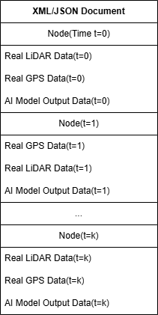
This document will then be stored on startup with a name corresponding to the date-time at startup, utilized as a unique identifier. Each node within the document will contain LiDAR, GPS and AI Model data tagged with the time (in milliseconds) since startup time of the Jetson board. This allows us to obtain a precise time and date and provides a unique identifier to differentiate various test runs from each other.
Gathering data from our sensors will be done via the sensor’s specified interfaces, such as I2C, SPI, and/or UART. Referencing to our wiring diagram above, we will be using I2C for LiDAR data collection and UART for GPS data collection, although these protocols may be subject to change once specific sensor models are decided. Our Jetson board (and Pico) can handle all three communication protocols, allowing for this flexibility.
Additionally, spoofed LiDAR data from UE5 will be processed by Simulink (see Section 6) and then sent internally from a laptop to the Raspberry Pi Pico over UART (Physical USB Interface). The Spoofed GPS data will be stored locally in ASCII format on the laptop specified above, which will then be read into a binary data stream and sent to the Pico in a similar manner.

7.2 External Interfaces:
Externally, our Raspberry Pi Pico interfaces with the UAV Platform via emulating the LiDAR and GPS sensors. For the LiDAR Sensor, the Pico emulates the exact I2C address and data message format to ensure the Jetson board receives the data seamlessly as if the real sensor was being utilized. The GPS module is mimicked similarly, as UART only requires the data message format and baud rate to be consistent.
By limiting our total external interfaces and utilizing UART and I2C, we can easily control the spoofed dataflow to our UAV system, allowing for data to be gathered without the risk of any spoofing signals reaching unintended targets. This is desired as spoofed signals in the GPS bandwidth are heavily regulated, preventing any open-air testing.

8. Security & Safety Considerations (All projects)
The primary safety concern for this project is public safety rather than electrical safety and data integrity due to the nature of the work in LiDAR and GNSS signal generation with UAVs. The potential consequences of this system extend beyond testing near public infrastructure and thus must be addressed and must meet FAA compliance standards. Uncontrolled signal experiments could degrade navigation for ground vehicles, commercial air vehicles, autonomous systems, and interfere with location, navigation, and timing-dependent services that could undermine public safety and confidence. For these reasons, protecting the public and critical infrastructure is a primary concern while developing and testing our spoof detection and threat-vector creation systems.
Primarily, testing will be restricted to simulations. If the system is working well in simulation with enough time left in the semester to justify physical creation, an anechoic chamber or some sort of faraday cage will be used. Live public space signal injection is explicitly prohibited and will not be executed in any situation regardless of authority or use case. Lab safety practices includes ensuring proper RF containment, pretest checklists for equipment, continuous monitoring, and comprehensive logging for all system outputs.
Personnel will ensure to follow institutional safety procedures and maintain documented emergency procedures for tests that could affect the public safety of both nearby and far areas. At all times both a drone kill switch and system kill switch will be used, and the conducted tests will be scheduled to automatically end and turn off after a set period.
From an engineering standards perspective, the design emphasizes fail safe behavior and constrained operating procedures. The design emphasizes fail-safe behavior and constrained operational standards. Even in testing chambers, we will employ hardware limits on signal strength, output power, and hardware interlocks which prevent unintended broadcasts from bleeding through the chamber in an event of a leak. We will map specific standards and guidelines (IEEE standards and similar) into the development and verification plan to ensure traceability of our project from requirements to verification and testing.
Throughout the simulation process, data logging will be used to ensure the system is running as expected in all edge cases prior to implementation of the physical system. Standard encryption will be used for all communications as the project likely has resulting military applications. The system itself is meant to be resilient to certain cyber-attacks by using a neural network to identify and remove spoofed signals from the data frames. There are no electrical systems that would pose electrical safety concerns in our design. The power source we have chosen to use has built in failsafe mechanisms like current limitations.

9. Error Handling & Recovery (All projects)
Each subsystem includes measures to detect, isolate, and recover from transient, persistent, and critical faults while maintaining real-time operation and preserving data integrity. The system design prioritizes graceful degradation over complete failure, ensuring continuity of data flow and control under fault conditions. All modules use a standardized approach consisting of fault detection, classification, containment, and recovery.

9.1 System-Wide Fault Management Framework
Detection:
- Heartbeat packets between the Simulink Bridge and Edge Device operate at 20–30 Hz; missed beats trigger a communication fault.
- CRC-32 validation, frame-ID tracking, and telemetry checks identify dropped or corrupted frames.
- Latency, queue depth, and frame-loss metrics are monitored continuously to pre-empt timing faults.
Classification:
Faults are categorized into:
- Transient recoverable faults – temporary network jitter, dropped packets, or short-term overload.
- Persistent recoverable faults – repeated CRC errors, synchronization drift, or minor hardware malfunctions.
- Critical faults – power loss, thermal overload, or neural-network failure.
Containment and Recovery:
When a fault is detected, the affected subsystem enters a contained degraded mode, attempts to internal correction, performs integrity checks, and resumes normal operation once stable conditions are verified.

9.2 Ground Station (Unreal Engine 5 Subsystem)
Fault Conditions:
- Missed or delayed frame generation due to GPU load.
- Socket timeout or acknowledgment loss in TCP communication.
Detection:
- Timestamp drift of ±5 ms or greater relative to Simulink reference clock.
- Three consecutive missed acknowledgments from Simulink Bridge.
Recovery Actions:
- Reinitialize the TCP connection and resend the most recent valid frame.
- Reduce LiDAR frame rate (e.g., 30 → 20 Hz) to maintain stable performance.
- Temporarily suspend spoof injection and revert to real-data-only streaming until synchronization is restored.
Containment:
All spoofing activity halts during recovery to prevent propagation of invalid data into the rest of the system.

9.3 Simulink Bridge (Communication and Data Flow Link)
Fault Conditions:
- Corrupted or out-of-sequence frames.
- Queue overflow due to delayed processing or bandwidth mismatch.
- Lost synchronization between Unreal Engine 5 and the Edge Device.
Detection:
- CRC failure or frame-ID discontinuity.
- Queue-depth thresholds exceeded or timing offsets beyond allowable tolerance.
Recovery Actions:
- Request retransmission of the previous valid frame if operating under TCP mode.
- Discard intermediate frames to realign sequence counters and re-establish deterministic timing.
- Enter degraded timing mode by lowering throughput or point-cloud density until stability returns.
- Restart Simulink execution automatically via watchdog if no frame is processed within twice the expected frame period.
Containment:
On communication loss, Simulink freezes the last valid output frame and flags the data as “stale” to maintain synchronization integrity with the UAV subsystem.

9.4 UAV & Neural Network Subsystem
This subsystem encompasses the UAV Hardware Abstraction Layer (HAL), the Edge Neural Network Module, and the onboard control logic. It is responsible for interpreting sensor data, detecting spoofing events, and maintaining safe operation during anomalies.

9.4.1 Hardware Abstraction Layer (HAL)
Fault Conditions:
- Bus-level timeout or buffer underrun on I²C, SPI, or UART.
- Electrical noise, short disconnection, or synchronization drift.
Detection:
- NACK counters, parity errors, and timing drift exceeding 1 ms per minute.
Recovery Actions:
- Automatically reset or reinitialize the affected communication bus.
- Output the last valid frame with a “stale” flag to prevent data discontinuity.
- Disable persistently faulted interfaces and notify Simulink via telemetry.
Containment:
HAL isolates the faulted bus from other active interfaces to prevent cascading failures.

9.4.2 Edge Neural Network Module
Fault Conditions:
- Inference latency exceeding deadline.
- Tensor shape or model validation error.
- Overheating or power throttling on the Jetson Orin Nano.
Detection:
- Watchdog monitoring of inference completion per frame.
- Telemetry of temperature, GPU utilization, and inference latency.
Recovery Actions:
- Invoke fallback inference mode using heuristic or simplified model logic to maintain real-time operation.
- Reload the last verified neural model revision if corruption is detected.
- Throttle model complexity (reduce voxel density or inference rate) when thermal limits are reached.
Containment:
During degraded operation, inference confidence values are flagged as low-reliability, and spoof decisions are withheld from the control loop until recovery is complete.

9.4.3 Control and Safety Behavior
Safe-State Triggers:
- Neural network crash or high uncertainty (> 0.8 confidence variance).
- Power or thermal alarm on the Jetson processor.
- Communication loss between Simulink and the Edge Device exceeding 200 ms.
- Bus-level communication fault persisting for > 1 s.
Safe-State Behavior:
- Suspend spoofing and revert to real-sensor-only operation.
- Maintain UAV stability using the last valid control command for up to 3 seconds.
- Broadcast FAULT_SAFE_MODE status to all subsystems and the Ground Control Station.
- Store a full diagnostic snapshot for post-test analysis.
Recovery Sequence:
- Isolate and reset the faulted component.
- Perform self-tests (CRC, latency, temperature, synchronization).
- Operate in reduced-rate mode until stable operation is confirmed for three consecutive frames.
- Resume normal timing and data flow.

10. Verification & Validation Plan (All projects)

10.1 Overview
This section outlines the planned simulations analysis and subsystem level tests for this system. This project can be divided into 6 logical modules that can be tested individually before integration testing the entire system together. The modules are 1) Spoofing Module, 2) Neural Network Module, 3) Control System, 4) Ground Control Station, 5) Power Module, 6) Failsafe Module. Each planned testing scheme will be mapped back to the system level requirements.

10.1 Spoofing Module – Verification and Validation
The spoofing module will be tested using the Unreal Engine 5 environment and using MATLAB tools to validate spoof fidelity, controllability, selective spoofing, and configuration requirements.
Test Plans and Requirements Mapping:
1) Generate baseline vs. spoofed LiDAR point clouds in Unreal Engine and compare them using MATLAB
This test verifies that the spoofed geometry matches the intended spoofing profile designed and the spoofing geometry is maintained over the entire time
Requirements: REQ-SP-001, PERF-SP-001
2) Spoof two sensors and confirm that the injected data appears in both feeds with correct timing and alignment
This test ensures that the spoofer can manipulate more than one sensor stream at a time and maintain calibration
Requirements: REQ-SP-002
3) Dynamic spoof parameter change triggered from operator
Evaluate how quickly and smoothly the spoof output changes to the new environment without being unstable
Requirements: REQ-SP-003, PERF-SP-003
4) Wireless profile update and spoof command test
This should validate that the spoofing profile correctly uploats and can produce observable spoof changes on the UAV within the expected timing parameters
Requirements: REQ-SP-005, REQ-SP-006
5) 10-minute Spoof Stability
Spoof geometry should be relatively stable with no corruption or gradual issues
Requirements: PERF-SP-002
6) Logging Test
Check that every spoof is able to record real sensor data, spoofed output, and the spoofing parameters. The logs must be complete and readable.
Requirements: REQ-SP-007

10.2 Neural Network Module – Verification and Validation
Testing Plans and Requirements Mapping:
- Offline dataset accuracy on real v spoofed datasets
This test will validate the NN ability to correctly distinguish between spoofed point clouds despite variations in noise, environments’, or spoofing intensity. The outcome should be that we can make a confusion matrix and be able to calculate the recall.
Requirements: REQ-NN-001, PERF-NN-002.
- Incremental retraining test using new spoofing parameters
Measure full update cycle and ensure the NN incorporates new patterns into its classifier without degrading prior performance.
Requirements: REQ-NN-002, PERF-NN-003.
- Multiple model support so both LIDAR and camera based NN algorithms can be loaded onto the Jetson, and the models can interact without losing data and timing accuracy
Requirements: REQ-NN-003
- Jetson should operate under acceptable power constraints and latency profiling
Validate that the time that the Jetson takes to operate falls under “real time” operation and that the Jetson power draw remains within an acceptable amount during operation
REQ-NN_-004, PERF-NN-001
- Evaluation of NN with occluded or partially corrupted point clouds
The NN should be robust enough to either reject or raise flags about the unclear point clouds and avoid misclassification.
Requirements: REQ-NN-005, REQ-NN-006

10.3 UAV Control System Module – Verification and Validation
1) Verify that the flight simulation can maintain the altitude, heading and tracking
Control the stability of the UAV before introducing spoofed data
Requirements: REQ-CN-001
2) Inject gradually distorted LIDAR/GPS data through the Simulink Bridge to simulate spoof-induced drift
Validate the controller's ability to compensate for the injected data without oscillation and keep the path deviation <10 %
Requirements: REQ-CN-002
3) Flight validation with spoofed sensor input
Verify that the control outputs of the UAV are stable or a failsafe is triggered.
Requirements: REQ-CN-001, REQ-CN-002, REQ-CN-003
4) Synchronized log evaluation to make sure that the NN clasifications, the spoofed dataframes, and the control actions are all timing aligned
Requirements: REQ-CN-004

10.4 Ground Control Station– Verification and Validation
1) Communication link range test
Progressively increase the distance to 3 miles and confirm the communication link by checking the link quality, packet delivery ratio, and latency
2) Spoof parameter configuration test
Confirm that the UI commands propogate to the spoofer and produced the desired changes
Requirements: REQ-SP-005
3) Validate that new spoofing profiles transfer successfully and take place without reboot
Requirements: REQ-SP-006
4) Selective Spoof Confirmation
Activate only LIDAR or only GPS spoof and verify the correct routing and signal separation
Requirements: REQ-SP-004
5) Real-time visualization test
Display incoming LiDAR and camera feeds with spoof detection overlays; ensure frame rate remains smooth and time synchronized.
Requirements: Must Have Display, REQ-CN-004.

10.5 Power and Failsafe Verification and Validation
1) Full system power test
Validate that the Jetson and the electronics maintain stable power draw and temperature under spoofing and the NN load
Requirements: REQ-NN-004
2)Endurance Test
Run the whole system for extended periods to ensure there is no premature battery depletion or temperature issues
Requirements: Minimum flight time
3)Fault Injection Tests
Introduce worst case scenario (corrupted packets, high uncertainty NN outputs, sensor blackouts) to verify failsafe transitions
Requirements: REQ-CN-003

10.6 Integration Verification and Validation
1) End-to-end system execution
Inject spoofed geometry in Unreal Engine -> feed through Simulink -> classify via NN -> control via autopilot -> visualize on GCS.
Validate detection, compensation, visualization, and logging all functions together with proper timing.
Requirements:
- All Spoofing: REQ-SP-001 - REQ-SP-007
- All Neural Network: REQ-NN-001 - REQ-NN-006
- All Control/Nav: REQ-CN-001 - REQ-CN-004
- All Performance
- All Must-Have flight & range capabilities
Additional Integration Passing Qualifications:
- Spoof injection reproduces intended geometry with high fidelity
- NN consistently flags spoofed frames within real-time deadlines
- Controller maintains safe flight or activates failsafe correctly
- GCS shows correct visual overlays with synchronized timestamps
- All subsystems produce complete logs with no frame loss

11. Bill of Materials (Hardware / Hybrid) OR Dependency List (Software)

11.1 Hardware
Item | Source | Unit Cost | Quantity | Total Unit Cost
LiDAR Sensor Array | VIAVI | $0.00 | 1 | $0.00
AI Edge Computer | NVIDIA Jetson Orin Nano Super Developer Kit | $249.00 | 1 | $249.00
UAV (Drone) | TBD (AOE Department Loan?) | $0.00 | 1 | $0.00
Power Supply | Energizer | MAX 10,000 mAh 15W USB-C 3 Port Bank | $15.59 | 1 | $15.59
Microcontroller | Raspberry Pi Pico Microcontroller w/ RP2040 Chip | $7.00 | 1 | $7.00
GPS Module | GPS Module GY‑NEO6MV2 (u‑blox NEO‑6M) + patch antenna Ali Express | $1.66 | 1 | $1.66
 |  |  | Total | $273.25

11.2 Software
Software | Subcomponents/Dependencies | Cost
Unreal Engine 5 | C++ and Blueprint Scripting Environment  Ray Tracing and Physics Subsystems  Plugin for LiDAR Frame Serialization  Plugin for TCP Data Streaming | $0.00
Simulink | MATLAB  Simulink Coder  MATLAB TCP/UDP Toolbox | $0.00

12. Appendices (All projects)

12.1 Glossary
UAV: This refers to an Unmanned Aerial Vehicle that carries sensors, the neural network module, and the flight control system.
UE5: This refers to Unreal Engine 5 which generates the virtual environment and produces both real and spoofed LiDAR frames.
GCS: This refers to the Ground Control Station used for operator monitoring, telemetry display, spoof profile configuration, and data logging.
LiDAR: This refers to Light Detection and Ranging technology that produces point clouds representing three-dimensional structures.
GPS: This refers to the Global Positioning System that provides geolocation data used by the UAV navigation subsystem.
NN: This refers to the Neural Network running on the edge device that classifies incoming sensor data as real or spoofed.
I2C: This refers to a digital communication bus used to transmit data between microcontrollers and low speed sensors.
SPI: This refers to a synchronous serial communication interface used for high speed sensor data transfer.
UART: This refers to Universal Asynchronous Receiver Transmitter communication used for streaming serial data such as GPS messages.
COTS: This refers to Commercial Off the Shelf hardware that is low cost and readily available for integration.
TCP: This refers to the Transmission Control Protocol used for reliable ordered communication between UE5 and Simulink.
UDP: This refers to the User Datagram Protocol used for low latency data transmission to the UAV sensor for processing hardware.
JSON: This refers to JavaScript Object Notation which is used in the report to encode LiDAR frame headers sent from UE5.
CRC32: This refers to a thirty two bit cyclic redundancy check value used to detect data corruption in transmitted frames.
HAL: This refers to the Hardware Abstraction Layer that provides standardized access to UAV sensors and interfaces.
IMU: This refers to an Inertial Measurement Unit that measures acceleration and rotational rates for UAV flight stabilization.
CAN: This refers to the Controller Area Network bus mentioned in the sensor injection section for structured flight data communication.
MAVLink: This refers to a lightweight messaging protocol used for UAV telemetry and command exchange.
NMEA: This refers to the standardized message format used by many GPS modules to represent location and timing data.
Electrical Hardware-in-the-Loop: This is a testing method where simulated sensor data is transmitted at the electrical interfaces of a real sensor bus such as I2C, SPI, or UART to replicate real hardware behavior
Ground Control Station (GCS) : Operator interface for visualizing sensor streams, monitoring telemetry, configuring spoof profiles, and logging system data.

12.2 References
Datasheets & Hardware Documentation
- NVIDIA Jetson Orin Nano Developer Kit – Technical Reference Manual, Power/Thermal Guidelines
- Raspberry Pico RP2040 Microcontroller Datasheet
- LiDAR Sensor Technical Manual
- GNSS/GPS Module Protocol Specifications
Standards & Specifications
- ASTM F3442 – Standard Terminology for Unmanned Aircraft Systems
- ASTM F3266 – Remote ID and UAV Operational Data Specifications
- SAE AS6518 – Recommended Practices for UAV Integrity and Safety
- IEEE 1939 – LiDAR Data Exchange Standard
- NIST Interoperability Framework for Autonomous Systems
Technical Papers:
1] T. Cao, Y. Zhang, Z. Lin, and J. Choi, “Adversarial sensor attack on LiDAR-based perception in autonomous driving,” 2021 IEEE/CVF Conference on Computer Vision and Pattern Recognition Workshops (CVPRW), pp. 2435–2444, Jun. 2021.
[2] Y. Sun, X. Wang, Z. Lin, and K. Saenko, “Adversarial attacks on 3D point cloud classification,” IEEE International Conference on Computer Vision (ICCV), pp. 1596–1604, Oct. 2019.
[3] C. Tu, T. Tramer, and X. Zhang, “Physically realizable adversarial examples for LiDAR object detection,” 2020 IEEE Security and Privacy Workshops (SPW), pp. 62–68, May 2020.
[4] C. R. Qi, H. Su, K. Mo, and L. J. Guibas, “PointNet: Deep learning on point sets for 3D classification and segmentation,” 2017 IEEE Conference on Computer Vision and Pattern Recognition (CVPR), pp. 652–660, Jul. 2017.
[5] C. R. Qi, L. Yi, H. Su, and L. J. Guibas, “PointNet++: Deep hierarchical feature learning on point sets in a metric space,” Advances in Neural Information Processing Systems, pp. 5099–5108, 2017.
[6] D. Zhou, W. Chen, and X. Wang, “Robust Point Cloud Classification under Adversarial Attacks,” 2020 IEEE/CVF Conference on Computer Vision and Pattern Recognition (CVPR), pp. 8880–8889, Jun. 2020.
[7] F. Schwarz, J. Köhler, M. Enzweiler, and U. Franke, “UnrealLiDAR: A synthetic LiDAR dataset for virtual testing of autonomous driving,” 2021 IEEE Intelligent Vehicles Symposium (IV), pp. 167–174, Jul. 2021.
[8] H. Shafique, M. Adeel, and Y. Ayaz, “A survey of GPS spoofing attacks and defenses for unmanned aerial vehicles,” IEEE Access, vol. 8, pp. 145214–145226, 2020.

