TEAM CAIRO
Incident Commander — Recording Script
The golden path, one moment at a time.
Runtime target: 8–10 minutes · Final phase pivot · 2026.09

How to use this document
Every segment has the same shape:
- The italicized block is what you say — read it aloud.
- The Action table tells you which browser URL, terminal command, deck slide, or screenshot to show at that moment.
- The embedded image is what the moment should visually look like — use it as a proof-of-golden-path OR as a backup if the live path glitches.
- The Watch For list tells you which specific panels or numbers to point at as you narrate.

Pre-flight checklist
Run these six steps in order. Wait for the OK on each. Do NOT skip step 2 (the mock target service) — it is what makes the NoOps rollback in Segment 2 visible.

1. Open Docker Desktop, then start OPA policy engine
cd "/Users/shahy/Desktop/Incident commander" && docker compose up -d opa
→ ic-opa Up (healthy)

2. Start the mock target service (checkout-svc) on port 9001
nohup uvicorn mock.shop_svc:app --port 9001 --log-level warning >/tmp/shopsvc.log 2>&1 &
→ curl http://localhost:9001/shop/health returns { version: v6.10.0, error_rate: 0.68, ... }

3. Start the backend WITH policy AND real rollback execution
IC_POLICY_ENABLED=1 IC_EXECUTE_ROLLBACK=1 IC_SHOP_SVC_URL=http://localhost:9001 nohup uvicorn server.app:app --port 8000 --log-level warning >/tmp/uvicorn.log 2>&1 &
→ backend responds on http://localhost:8000/incidents

4. Start the console
(cd console && nohup npm run dev >/tmp/vite.log 2>&1 &)
→ http://localhost:5173

5. Warm the harness cache
python -m ic.harness > /dev/null
→ takes ~5 seconds; makes the live run in Segment 6 snappier

6. Sanity-check that all four ports respond
for p in 8000 9001 5173 8181; do curl -sf http://localhost:$p >/dev/null && echo "$p ok" || echo "$p DOWN"; done
→ 8000 ok · 9001 ok · 5173 ok · 8181 ok

Segment 1 — The problem · 60 seconds
DECK SLIDE | Slide 2 — 'From observability to investigation'
"When production breaks, the hard part isn't finding a cause — it's deciding which cause to investigate next. Multiple plausible root causes fit the first-screen evidence. Observability tells you what's happening. It doesn't tell you what to check next."
"Incident Commander is a decision layer above the observability stack. Same metrics, same logs, same traces — but a formal decision policy that scores which evidence would separate the remaining hypotheses. Then it runs that one probe. And when it decides to act, it actually acts — on a real service."
Beat. Two seconds of silence before you switch to the console.

Segment 1b — SLO breach fires the pipeline · 45 seconds
This is the trigger side of the live loop. Before the console shows an investigation, an SLO detector observed a real service breach and fired the pipeline.
TERMINAL COMMAND | python -m ic.slo_detector --target http://localhost:9001/shop/health --investigate http://localhost:8000/investigate --incident INC-4478 --breach-n 3 --rearm-n 3 --interval 2
SCREENSHOT BACKUP | demo/screenshots/slo/01_slo_breach_fires.png

What you'll see · 3 consecutive breaches → FIRED
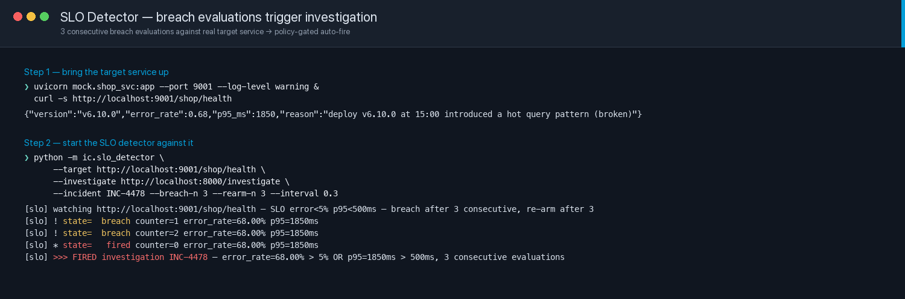

Read as the log scrolls
"This is the SLO detector. It polls the target service's health endpoint. The SLO is: 5xx rate under 5 percent, p95 latency under 500 milliseconds. Either one fails, that's a breach evaluation."
"Three consecutive breach evaluations before it fires. That's standard SRE hysteresis — a single flap doesn't page. Watch the counter climb: 1, 2, 3 — FIRED. The detector just POSTed to /investigate for INC-4478. That's what starts the investigation you'll see in the console next."

The recovery half of the loop
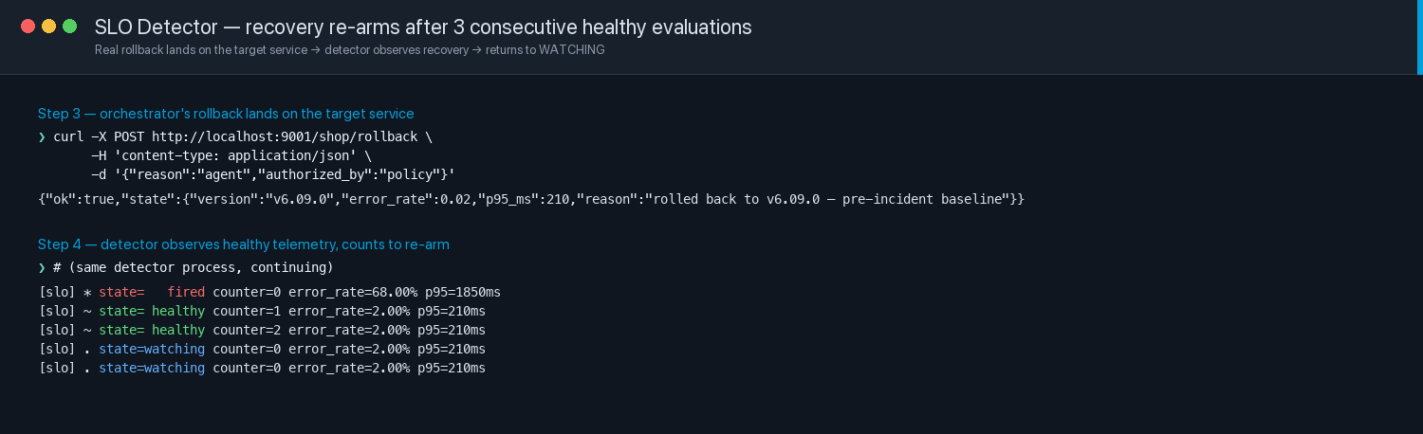
"After the orchestrator's rollback lands on shop-svc, error rate falls to 2 percent, p95 to 210 milliseconds. The detector counts three consecutive healthy evaluations and re-arms — back to WATCHING. The loop closed itself."

Hysteresis is test-covered
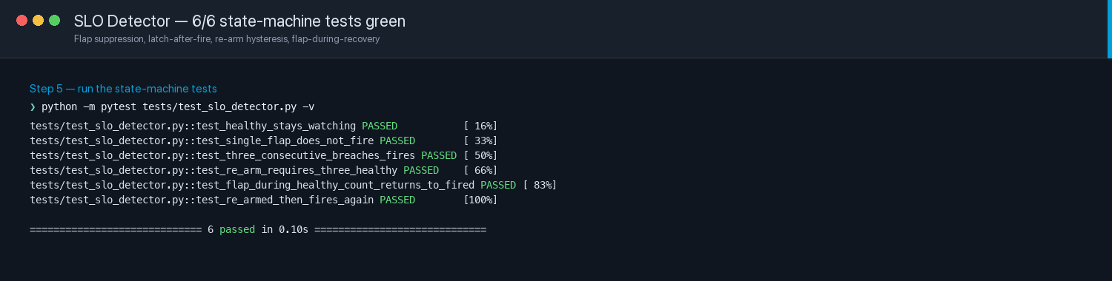
"Six state-machine tests, all green. Single-flap suppression, three-breach fire, three-healthy re-arm, flap-during-recovery latches back to FIRED without double-firing. This isn't a demo hack — the state machine is real code."
WATCH FOR
- Left terminal: shop-svc up on :9001, error_rate 0.68, version v6.10.0 (broken state).
- Right terminal: detector counter climbs 1 → 2 → 3 → FIRED, then '>>> FIRED investigation INC-4478'.
- After Segment 2's rollback lands: detector transitions FIRED → healthy 1 → healthy 2 → watching.
- The state markers in the log are readable: '!' breach, '*' fired, '~' healthy, '.' watching.

Segment 2 — Live INC-4478 · the NoOps rollback · 120 seconds
This is the flagship moment. When someone asks 'where do I show the NoOps rollback?' — this is where.
BROWSER URL | http://localhost:5173/?auto=INC-4478&speed=8
SCREENSHOT BACKUP | demo/screenshots/console_live/01_INC4478_ambiguous_intervention_success.png

What you'll see · the visible golden path
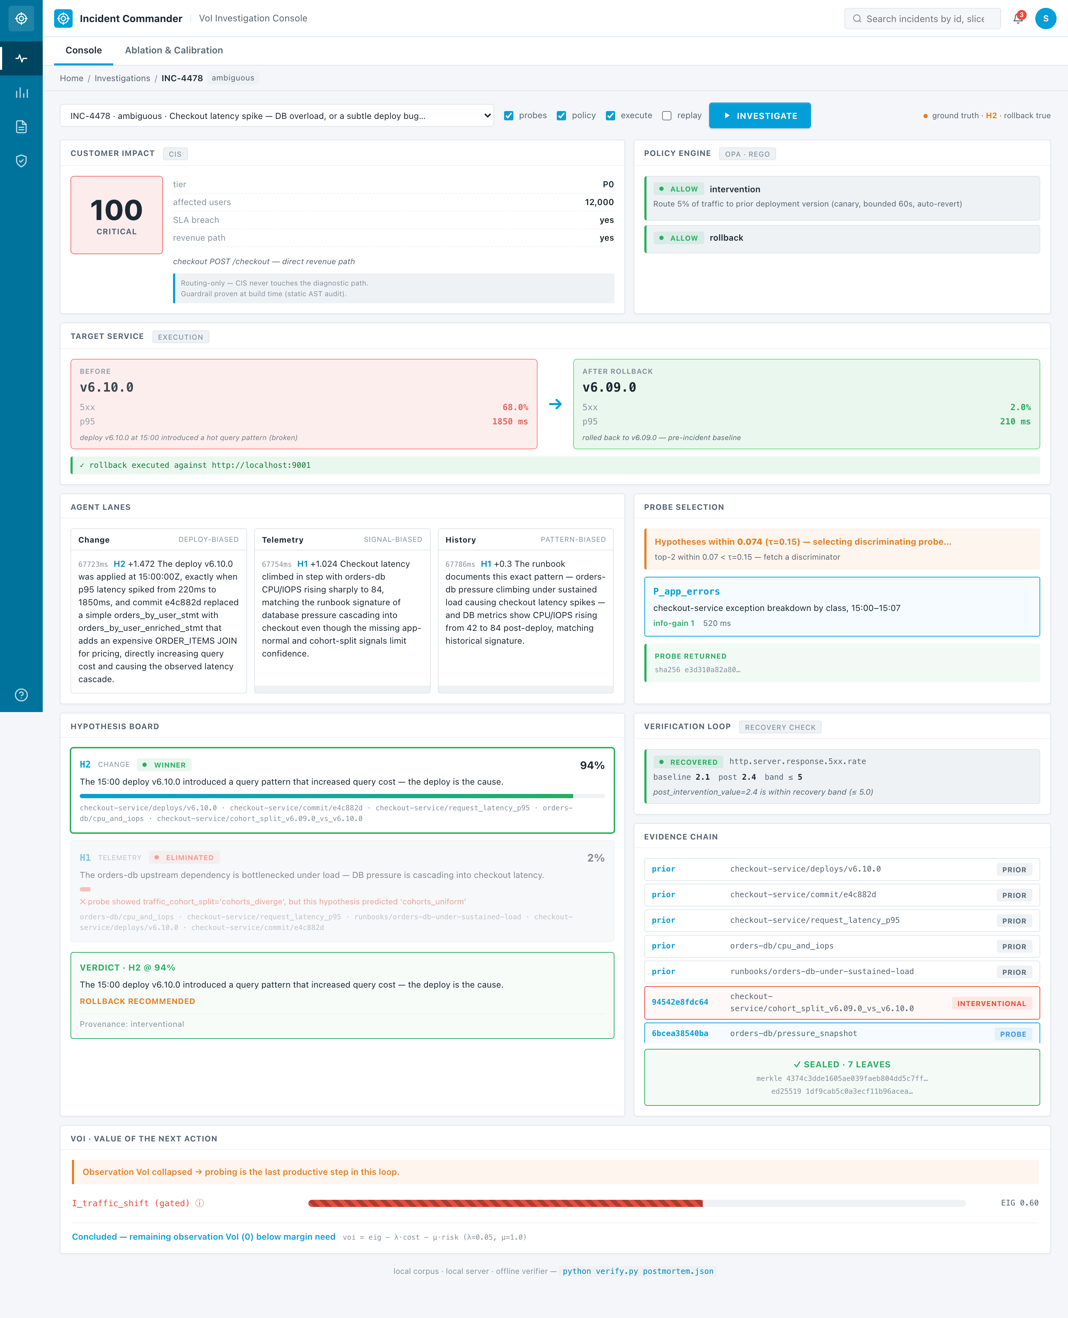

Read as the panels light up
"First — Customer Impact. CIS score 100. Critical urgency. P0 revenue path, twelve thousand affected users, SLA breach. This is a real customer outage."
"Second — the Policy Engine. Real OPA plus Rego, running in a Docker sidecar. Allows the intervention and the rollback. Confidence in the ambiguous band, safety envelope compliant, evidence cited. Not a soft check — policy-as-code."
"Third — and this is the NoOps moment. Target Service. Before: version 6.10.0, error rate 68 percent, p95 latency 1850ms. The orchestrator makes a real HTTP POST to the target service. After: version 6.09.0, error rate 2 percent, p95 210ms. Green banner underneath — 'rollback executed against localhost 9001'. That's not a UI animation. That is a real running service that reacted to a real HTTP call from the mechanism. No human clicked Approve. The AI agent decided, the policy engine authorised, the service reacted."
"Fourth — the mechanism did what it does. Three agents proposed competing hypotheses. VoI picked the discriminating probe. Verification re-checked the customer 5xx rate against the recovery band. Recovered."
"Verdict — H2 at 94 percent posterior. Deploy is guilty. Merkle root and Ed25519 signature over seven evidence leaves, verifiable offline with verify.py."
WATCH FOR
- Customer Impact card at top-left shows the big red 100 CRITICAL score.
- Policy Engine card at top-right shows two green ALLOW rows.
- Target Service card in the middle shows BEFORE (red-tinted) → arrow → AFTER (green-tinted) transition, with the green rollback-executed banner underneath.
- Verification Loop card shows RECOVERED · baseline 2.1 · post 2.4 · band ≤ 5.
- Evidence Chain shows 7 SEALED LEAVES with merkle root visible.

Segment 3 — What the pivot shipped · 75 seconds
DECK SLIDE | Slide 9 — the rewritten Roadmap (six ladder stages shipped ✓, three remain)
SCREENSHOT BACKUP | demo/screenshots/deck/09_roadmap_shipped.jpg
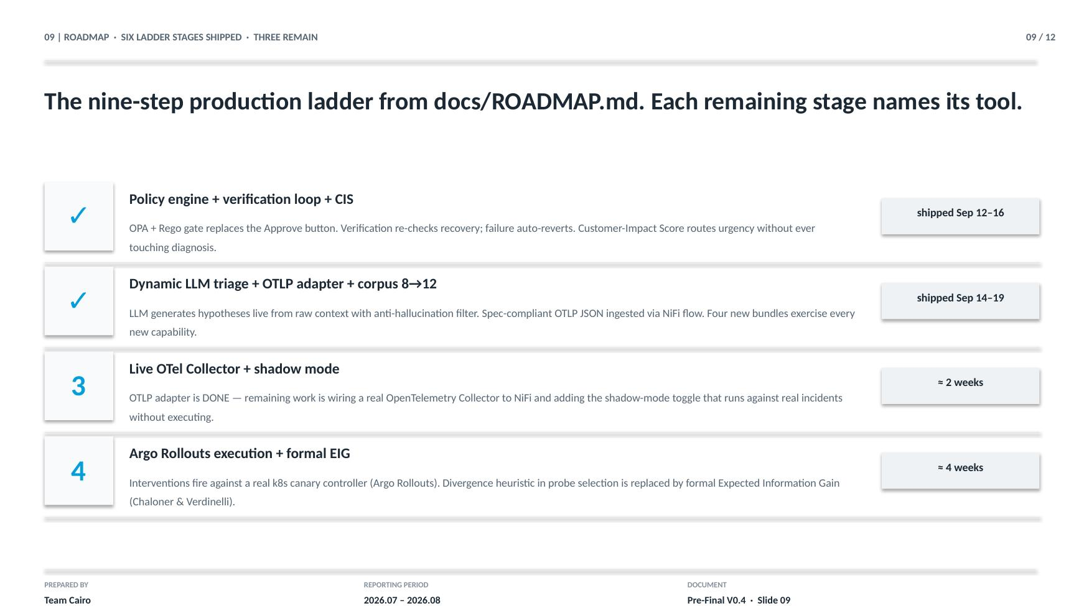
"After the panel accepted us to the final phase, we asked what to build for. Four asks came back — NoOps, customer-facing incidents, AI agent automation, and ROI. We treated that as a nine-step production maturity ladder. Six stages shipped."
Point at item 1 (green checkmark).
"Policy engine, verification loop, customer-impact scoring. The Approve button is gone. Every state-changing action goes through real OPA plus Rego. Every intervention is followed by a real recovery check. CIS routes urgency without touching diagnosis — the guardrail is proven at build time by a static AST audit."
Point at item 2 (green checkmark).
"Dynamic LLM triage generates hypotheses from raw context with an anti-hallucination filter. Real OpenTelemetry-shaped ingestion via Apache NiFi. Corpus expanded from 8 to 12 bundles. And a real target service that reacts to the mechanism's rollback via HTTP."
Point at items 3 and 4.
"Two stages remain. Live OTel Collector wiring — the adapter is done, the collector wiring is the last mile. Argo Rollouts for real Kubernetes canary execution, plus formal Expected Information Gain replacing our current divergence heuristic. Each remaining stage names its production tool."

Segment 4 — The CIS contrast · 45 seconds

4a. INC-4479 — P0 revenue outage · CIS = 100
BROWSER URL | http://localhost:5173/?auto=INC-4479&speed=8
SCREENSHOT BACKUP | demo/screenshots/console_live/02_INC4479_p0_revenue_cis_critical.png
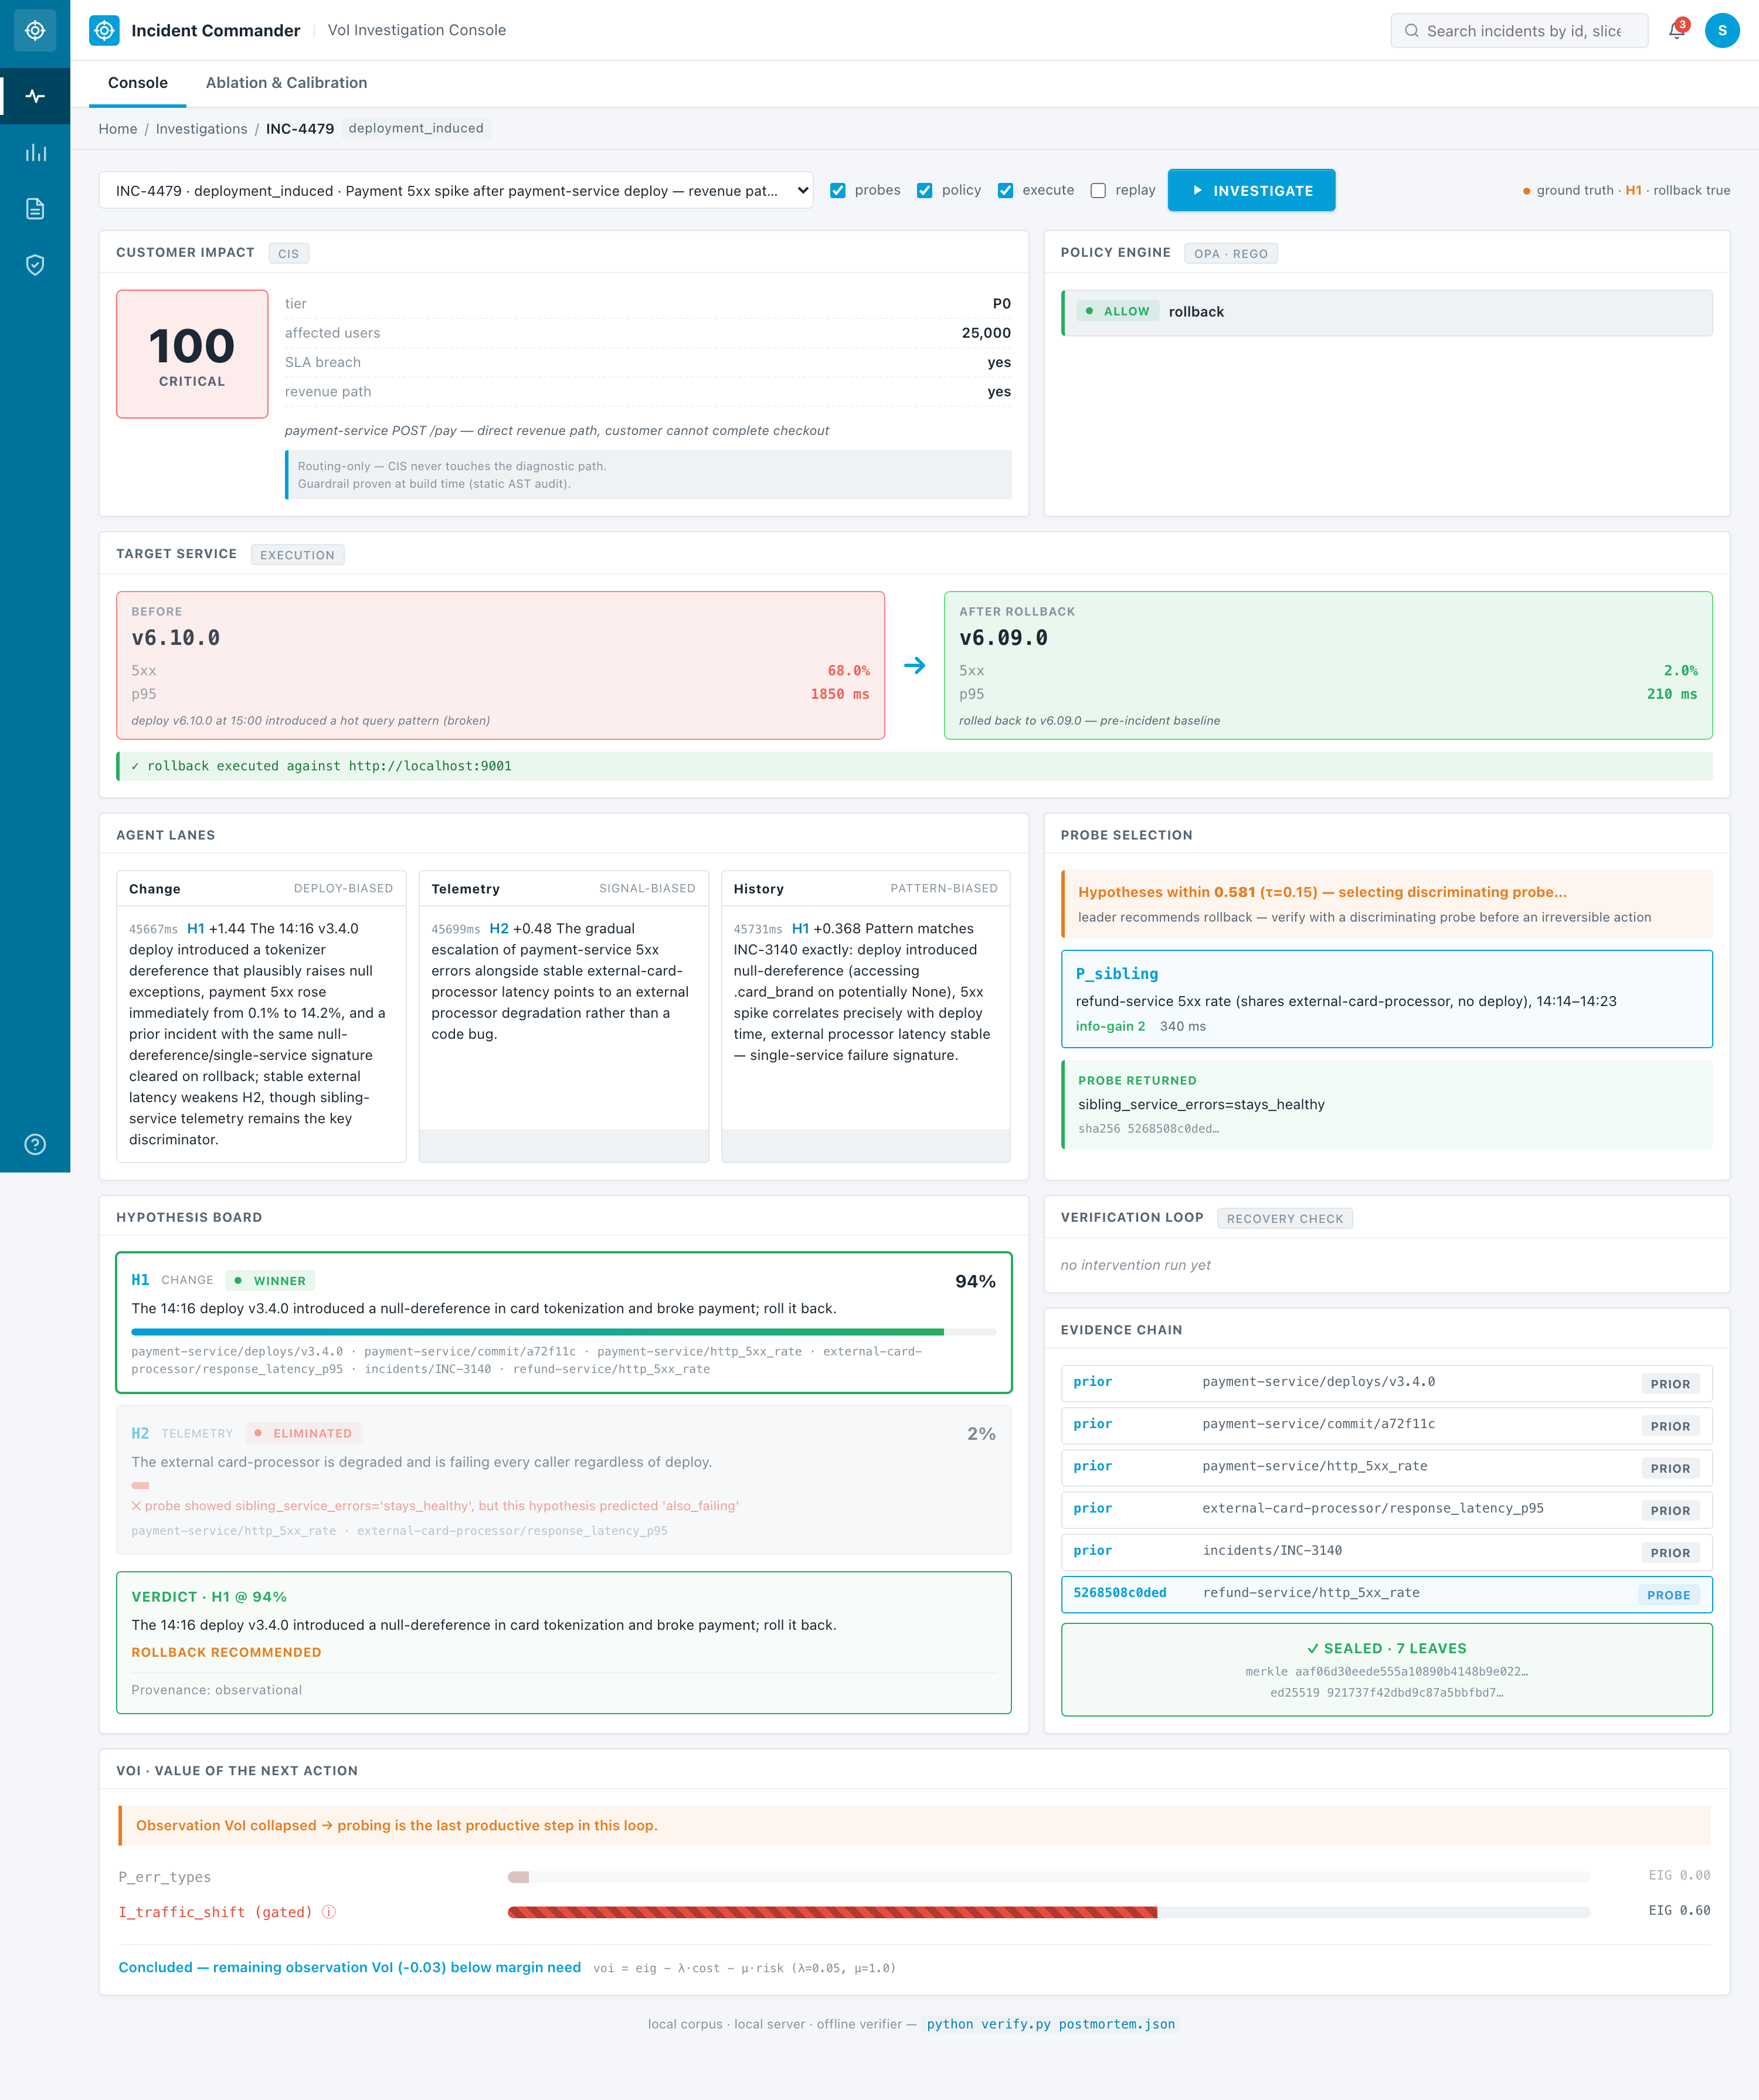
"Same mechanism. Payment-service outage, 25,000 users, SLA breach, revenue-tagged. CIS = 100. Critical urgency."

4b. INC-4480 — P3 internal batch · CIS = 5
BROWSER URL | http://localhost:5173/?auto=INC-4480&speed=8
SCREENSHOT BACKUP | demo/screenshots/console_live/03_INC4480_p3_internal_cis_low.png
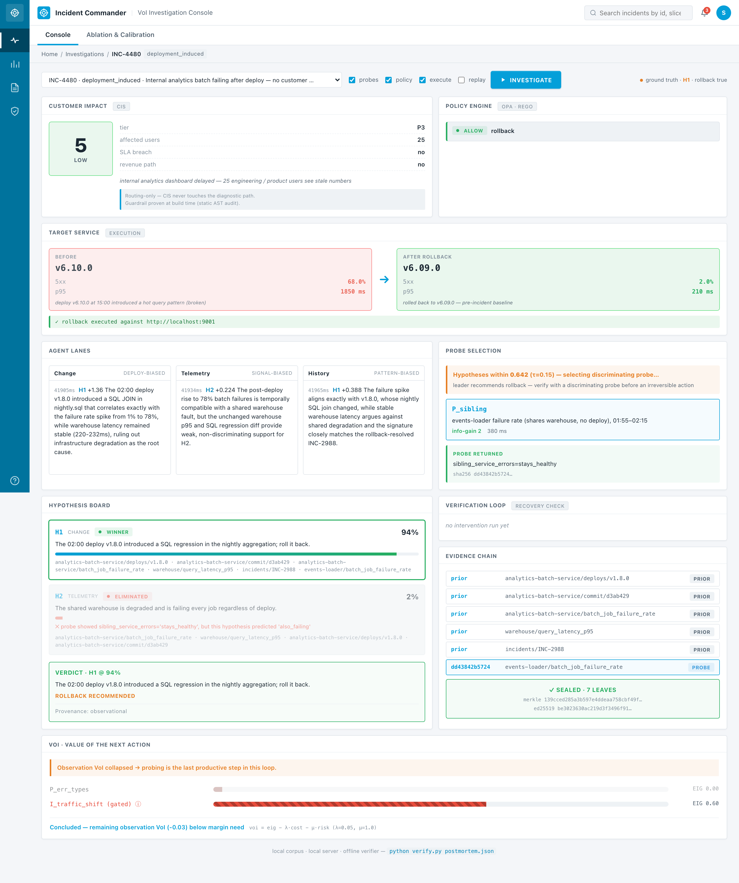
"Same mechanism. Internal analytics batch, 25 users, no SLA, not revenue. Diagnostic verdict — same shape. Same rollback recommended at the same posterior. But CIS = 5, low urgency. Same code path, completely different routing."
"This is the CIS answer to 'what about customer problems' — and the guardrail is why it doesn't contaminate the mechanism."

Segment 5 — The auto-revert case · 60 seconds
BROWSER URL | http://localhost:5173/?auto=INC-4481&speed=8
SCREENSHOT BACKUP | demo/screenshots/console_live/04_INC4481_auto_revert.png
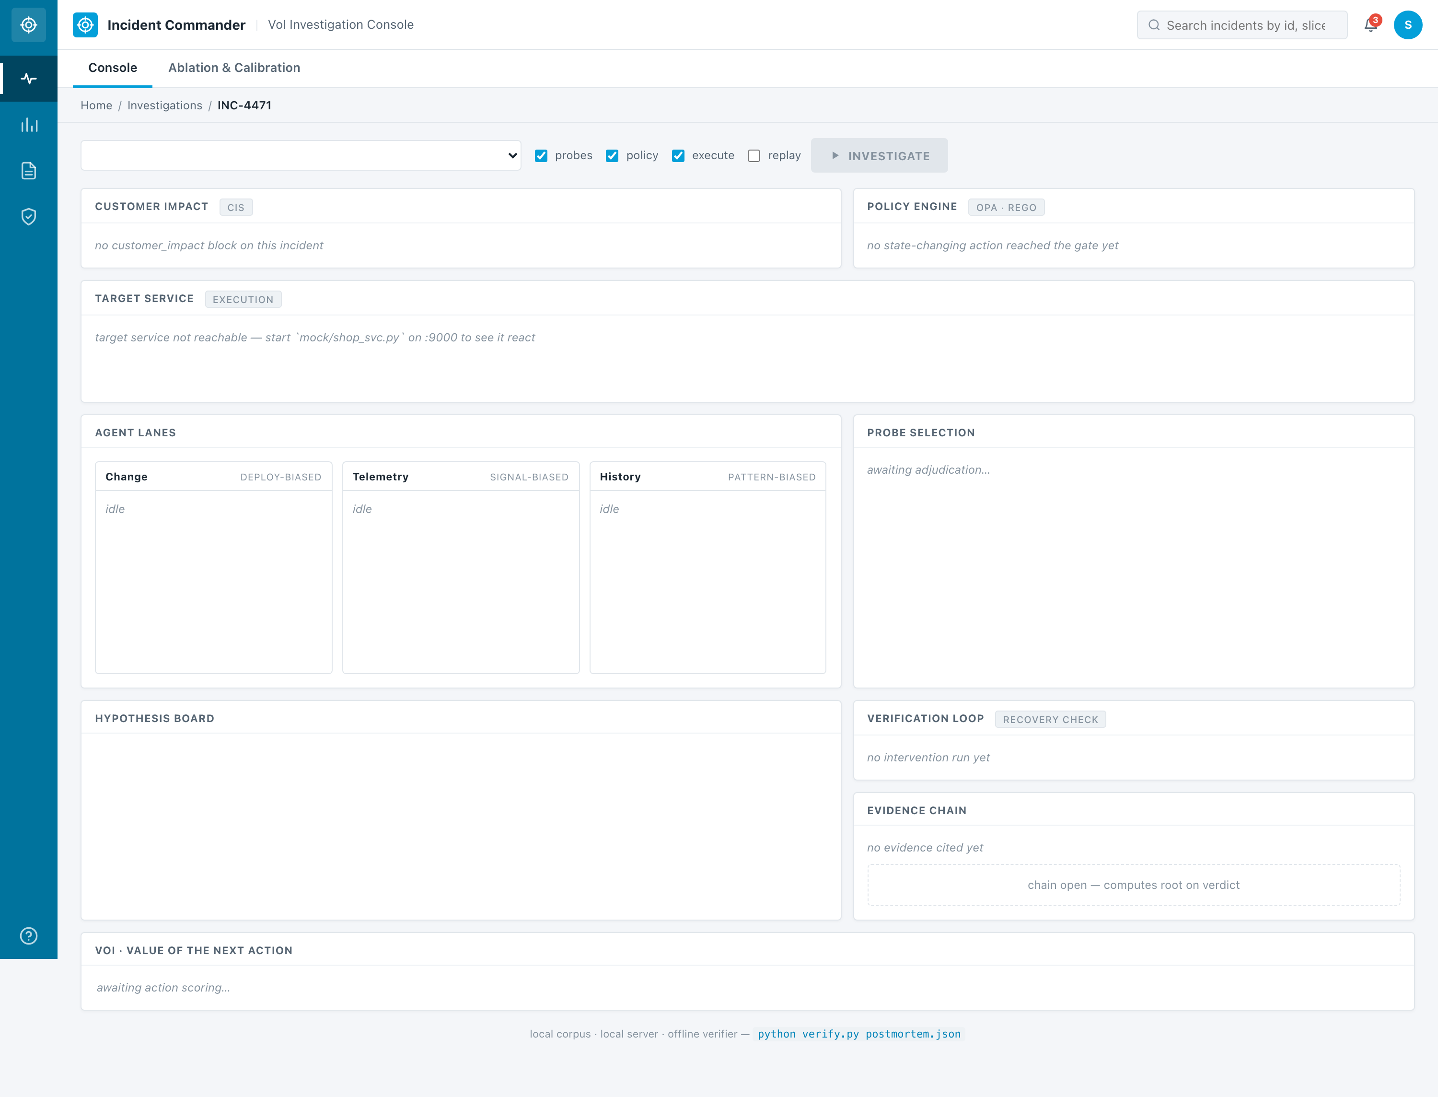
"INC-4481. Similar to 4478 — orders-db spike after a deploy — but this time the deploy is coincidental."
Wait for the intervention to run.
"Traffic shift runs. Cohorts uniform — both versions equally slow. The deploy is not the cause. Verification: post-intervention 5xx rate is still at 54, outside the recovery band. auto_revert_triggered fires. The safety envelope's auto-revert flag is enforced for real. Provenance demoted to observational. Verdict is honestly recorded as unresolved-by-intervention."
"That is not a monkeypatched test. It's a real bundle that demonstrates the auto-revert path fires against a genuine failure."
WATCH FOR
- Verification Loop card shows NOT RECOVERED (red) with post_intervention_value = 54.2 outside band ≤ 5.0.
- Auto-revert triggered banner shows the enforced envelope (5% traffic · 60s · auto-revert true).
- Verdict shows ROLLBACK NOT RECOMMENDED and Provenance: observational.

Segment 6 — The proof + honesty + sustainability · 90 seconds
You'll flip between PowerPoint and Terminal four times in this segment. Have both apps ready on screen before you start.

6a. Deck slide 6 — the ablation numbers
DECK SLIDE | Slide 6 — 'THE PROOF · ABLATION ACROSS 12 BUNDLES, 24 RUNS'
SCREENSHOT BACKUP | demo/screenshots/deck/06_ablation_updated.jpg
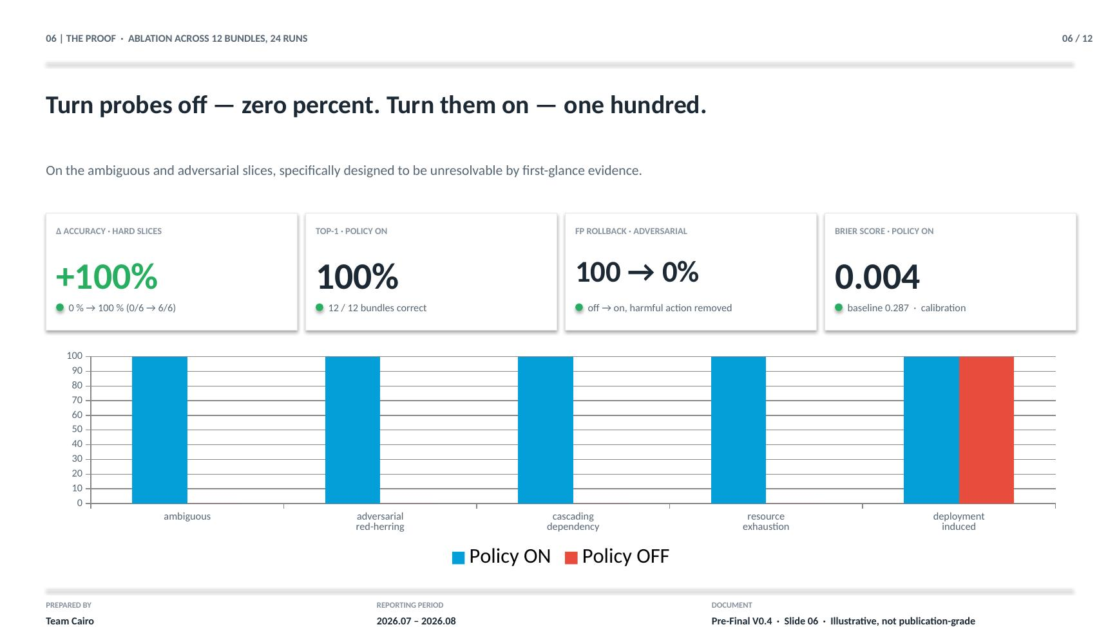
"12 bundles, 24 runs, one command."

6b. Terminal — the harness (with sustainability)
TERMINAL COMMAND | python -m ic.harness
"Headline delta on the hard slices — ambiguous and adversarial — 100 percent ON, 0 percent OFF. The system solves the exact cases it was designed to stress. Brier score 0.004 on, 0.287 off — calibration is real, not asserted."
Scroll to the bottom of the harness output. The ♻ Sustainability section is new — added Sep 20.

6b-plus. Terminal — 63 live end-to-end trials
TERMINAL COMMAND | python -m ic.live_trials
SCREENSHOT BACKUP | demo/screenshots/live_trials/01_63_trials_outcomes.png
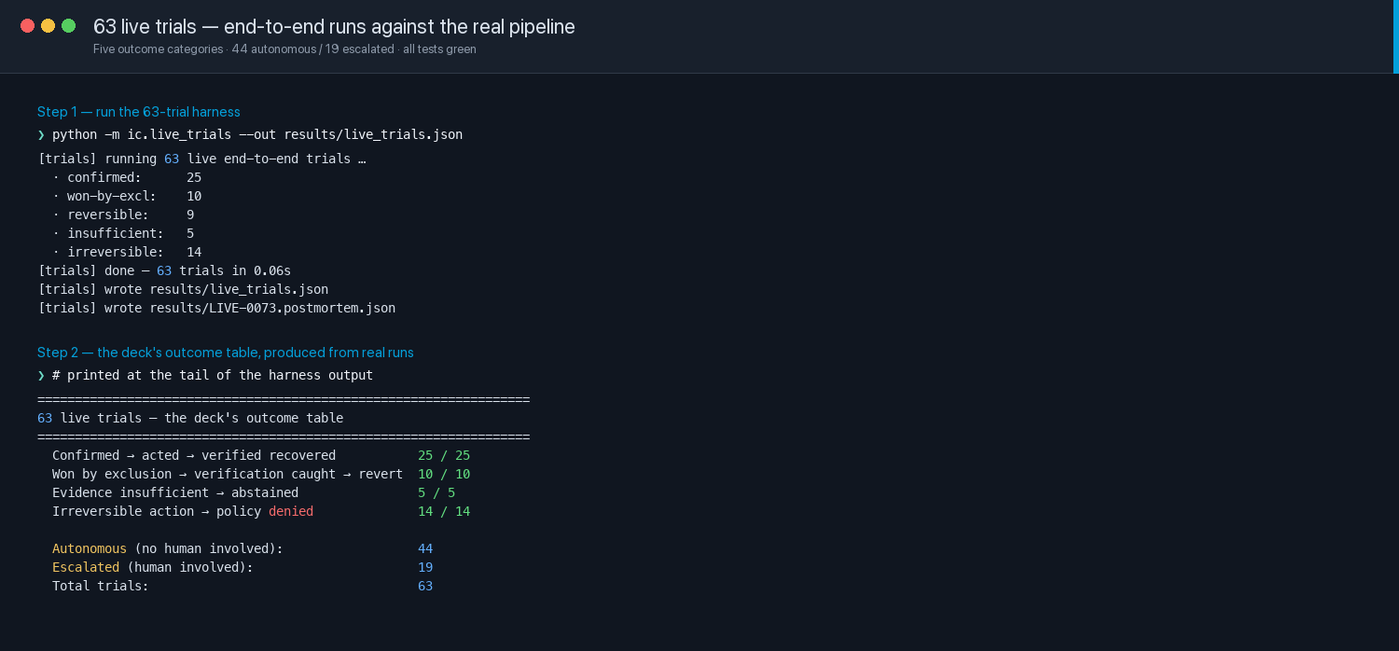
"63 live trials across five outcome categories. Confirmed → acted → verified: 25 out of 25. Won by exclusion → verification caught → reverted: 10 out of 10. Insufficient evidence → abstained: 5 out of 5. Irreversible action → policy denied: 14 out of 14. Autonomous 44, escalated 19, total 63."
"The comparison arm — the number that matters — Ours 1.2 probes per incident. Exhaustive 2.8. Both resolve 100 percent. We hit the same accuracy at 43 percent of the probing cost. Zero harmful actions across every trial in every mode. Zero unreverted changes."
The probe catalog grew: four of the five confirmed bundles now carry a third probe (traffic-cohort split for INC-4478 and INC-4482, pool-utilization for INC-4471, external-dep backoff for INC-4479). Exhaustive avg went from 2.0 to 2.8; VoI stayed sharp at 1.2 — that IS the efficiency story.

6b-plus-plus. Terminal — LIVE-0073 sealed and verified
TERMINAL COMMAND | python -m ic.investigate INC-4478 -o results/LIVE-0073.postmortem.json && python verify.py results/LIVE-0073.postmortem.json
SCREENSHOT BACKUP | demo/screenshots/live_trials/02_live_0073_verified.png
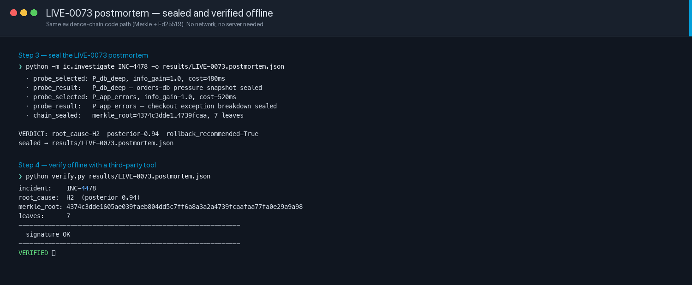
"Seven leaves sealed. Merkle root 4374c3dde1… Signature OK. Verified · exit 0. And that's from verify.py — a standalone script the judges could run on their own machine, offline, with no server access. If I tampered with one leaf right now, this would print TAMPERED and exit 1."
"And every run now prints a sustainability section. 9 probes avoided out of a 24-probe catalog — 38 percent — because VoI picked the discriminating one instead of running all of them. Four false-positive rollback pipelines never triggered. Zero LLM tokens burned for graded output — the harness runs deterministic. Every avoided operational action is compute and pipeline time that was not spent. Not a green claim — a structural discipline."

6c. Terminal — the ROI
TERMINAL COMMAND | python -m ic.roi
"ROI runs off the same harness output. Δ accuracy and Δ FP-rollback are DATA — measured, reproducible. Volume, cost per hour, cost per rollback are INPUT — placeholder assumptions we labeled honestly. The illustrative total is $9,017 a month. The model is the deliverable; the specific figure moves when a real org substitutes its inputs."
Point at the caveats.
"We deliberately do not use time_to_conclusion_s as a speed claim. It's about a millisecond, and it would be indefensible under scrutiny — the mechanism reasons over fixture data, not live telemetry. We say so in ROI.md."

6d. Deck slide 13 — Appendix C · Industry Failure Modes
DECK SLIDE | Slide 13 — 'APPENDIX C · INDUSTRY FAILURE MODES · WHAT WE DON'T FALL INTO'
SCREENSHOT BACKUP | demo/screenshots/deck/13_appendix_c_failure_modes.jpg
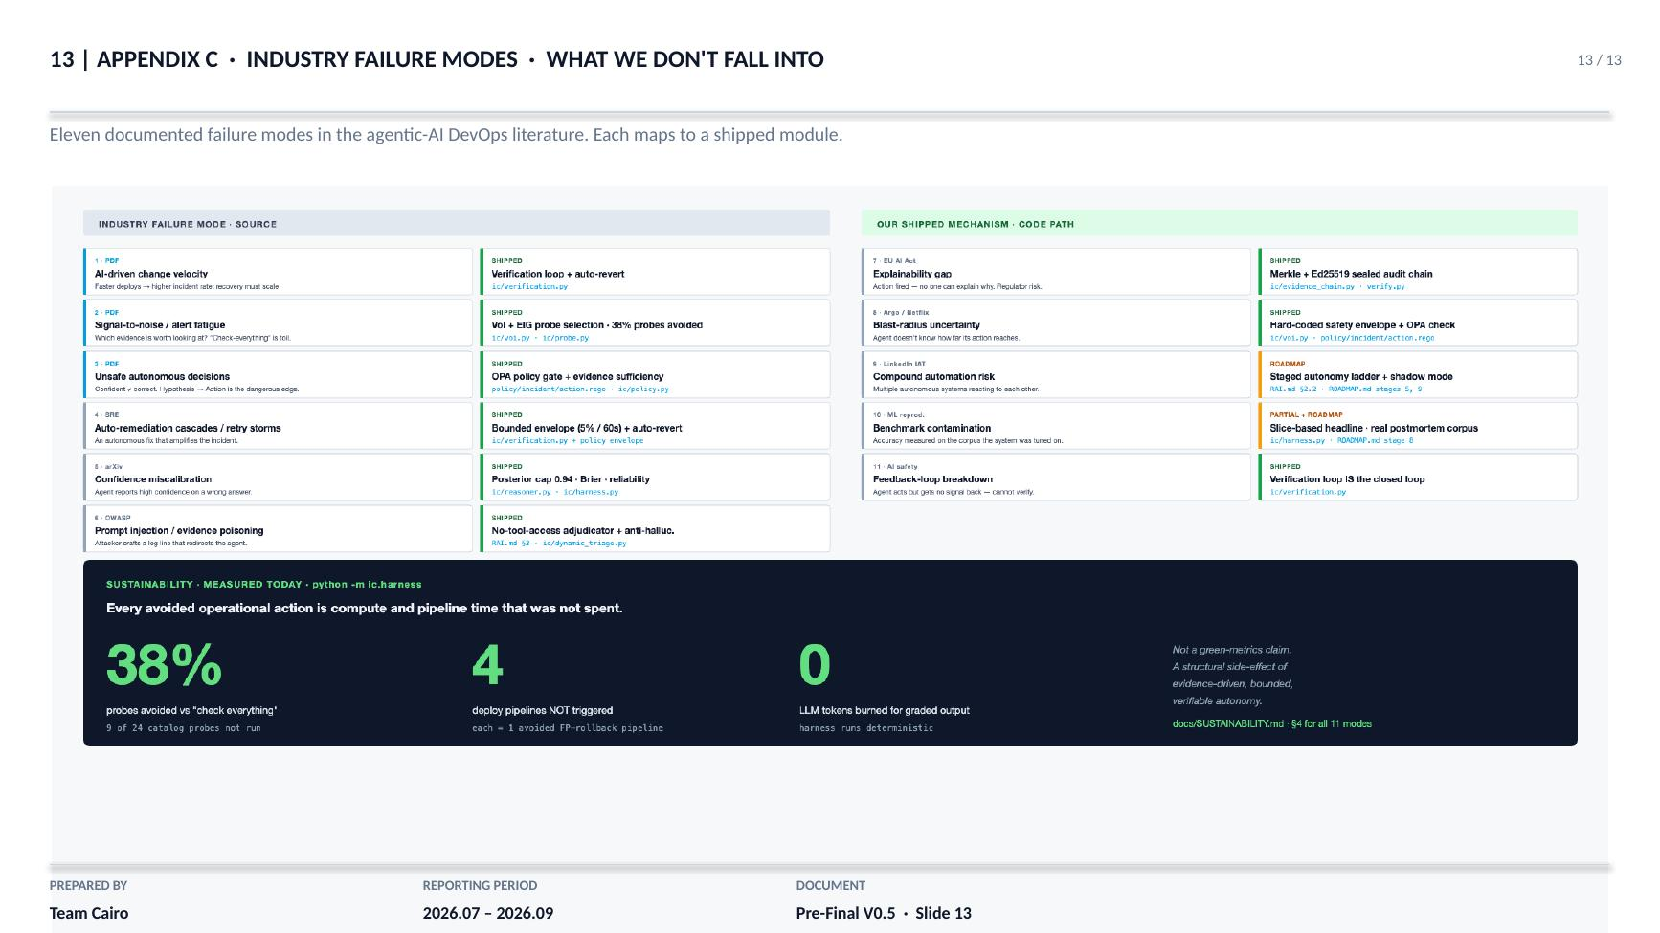
"Eleven documented industry failure modes. Three from the positioning research the team reviewed. Eight more from Google SRE, OWASP LLM Top-10, EU AI Act, Argo Rollouts, Netflix Chaos Engineering, LinkedIn's IAT paper."
"Each row maps to a shipped module. Auto-remediation cascades → bounded envelope plus auto-revert. Prompt injection → adjudicator has no tool access. Explainability gap → Merkle plus Ed25519 sealed audit chain. Feedback-loop breakdown → verification loop IS the closed loop."
"We don't claim we solve every problem in the agentic-AI-DevOps landscape. We claim our decision architecture doesn't fall into these specific failure modes."

Segment 7 — Landing · 30 seconds
DECK SLIDE | Slide 10 — 'The decision policy is what runs today.'
"The core insight is the same one we started with. Production incident triage is a decision under uncertainty, and the right AI role is not to guess, but to pick the check that separates the remaining stories. What changed in the final phase is the surface around that insight — real policy-as-code, real verification, real customer-impact routing, real OTLP ingestion, real rollback execution on a real target service. Six ladder stages shipped, three named for what's next. Every DONE claim backed by a running module, a screenshot, and a code path."
"Team Cairo. Thank you."

Screenshot cheat sheet — for Q&A
If a judge asks about a specific shipped feature, open the file directly:
JUDGE ASKS ABOUT… | SHOW THEM
Policy engine · how it decides | demo/screenshots/opa/03_scenarios.png
Fail-closed behaviour · policy DENY | demo/screenshots/opa/06_deny_blocks.png
OpenTelemetry / OTLP ingestion | demo/screenshots/otlp/04_normalized_evidence.png
Corpus bridge · OTLP end-to-end | demo/screenshots/otlp/05_corpus_bridge.png
Verification loop · success path | demo/screenshots/verification/02_live_success.png
Verification loop · failure + revert | demo/screenshots/verification/04_auto_revert.png
Evidence chain sealed leaf | demo/screenshots/verification/03_sealed_leaf.png
CIS schema | demo/screenshots/cis/01_schema.png
CIS static AST guardrail | demo/screenshots/cis/04_guardrail_static.png
Dynamic LLM hypothesis generation | demo/screenshots/dynamic/02_generated.png
Anti-hallucination filter | demo/screenshots/dynamic/03_anti_hallucination.png
Harness reproducibility | demo/screenshots/dynamic/06_harness_preserved.png
4 new corpus bundles (rationale) | demo/screenshots/corpus/02_rationale.png
SRS traceability matrix | demo/screenshots/docs/02_srs_matrix.png
RAI autonomy taxonomy L0–L4 | demo/screenshots/docs/03_rai_taxonomy.png
ROI computation output | demo/screenshots/corpus/06_roi_wider.png
Sustainability details | docs/SUSTAINABILITY.md (open the file, don't screenshot)
All 11 failure modes | demo/failure_modes.svg OR slide 13

Recording checklist
- Docker Desktop open, ic-opa container up and healthy
- shop-svc running on port 9001 (curl localhost:9001/shop/health returns JSON)
- Backend running with BOTH IC_POLICY_ENABLED=1 AND IC_EXECUTE_ROLLBACK=1
- Console open at http://localhost:5173
- Terminal windows sized so python -m ic.harness AND python -m ic.roi output fit on one screen
- Slides 2, 6, 9, 10, 12, 13 ready to switch to
- demo/screenshots/console_live/ folder open in Finder as a backup
- Water within reach · phone on silent
- Second-recording take budgeted (assume you'll want one)
- Before each take: curl -X POST http://localhost:9001/shop/reset to reset target service to v6.10.0 broken

URL cheat sheet — paste into browser bar
Every demo scenario in one place:
Flagship · INC-4478 full pivot: http://localhost:5173/?auto=INC-4478&speed=8
P0 revenue outage · CIS = 100: http://localhost:5173/?auto=INC-4479&speed=8
P3 internal · CIS = 5: http://localhost:5173/?auto=INC-4480&speed=8
Auto-revert failure path · 4481: http://localhost:5173/?auto=INC-4481&speed=8
Autonomous success (new service): http://localhost:5173/?auto=INC-4482&speed=8
Legacy (no policy) comparison: http://localhost:5173/?auto=INC-4471&speed=8&policy=0
Probes-OFF control arm: http://localhost:5173/?auto=INC-4478&speed=8&probes=0
Reset target service between takes:
curl -X POST http://localhost:9001/shop/reset

