**HOW TO SET UP PUTTY FOR AWS SERVER**

**Step 1: In Host Name (or IP address) put in:** ubuntu@ec2-54-149-247-114.us-west-2.compute.amazonaws.com

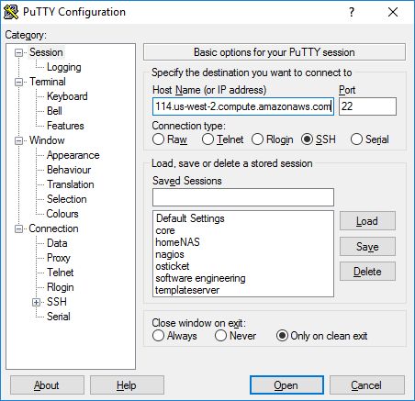

**Step 2:**

On the lefthand side click SSH -> Auth -> Attached the .ppk I sent

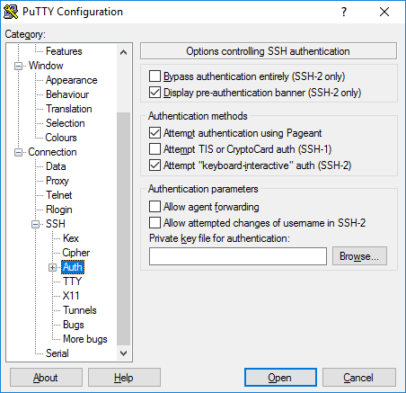

**Step 3: Go back to Session on the left, under “Saved Sessions” name it whatever you want and press “Save”.**

After that all you should have to do to connect to the server is double click it.

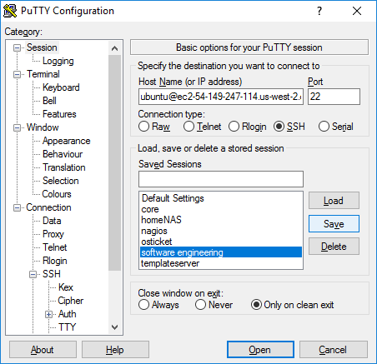

Once you’re in, just try running 2 quick commands to verify everything is working as intended.

1: sudo su – Will show you as root account (be careful with this command)

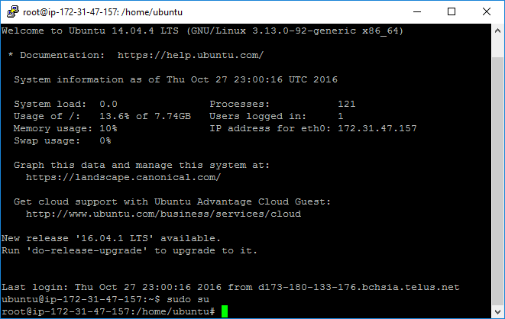

2: ifconfig – should show this same IP (pending its static) 172.31.47.157

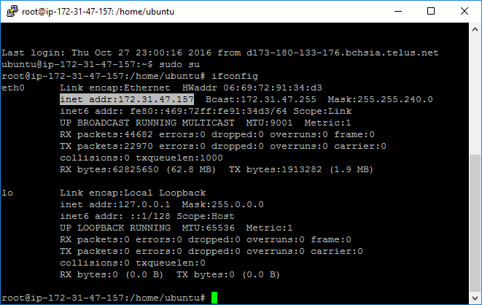

For people needing to FTP you’re going to need to keep that key as well.