**Chapter 2 Assignments**

1120211099 周豪捷

1. According to Nyquist formula, the maximum data rate is:

bandwidth * 2 = 4 KHz * 2 = 8 Kbps

If the channel is noisy, with the ratio of S/N is 30 dB, which means

$$\frac{S}{N}= {10}^{30/10}=1000$$

According to Shannon formula, the maximum data rate is:

Bandwidth * log2(1 + S/N)= 4 KHz * log(1 + 1000)

= 39.87 Kbps

**2.**

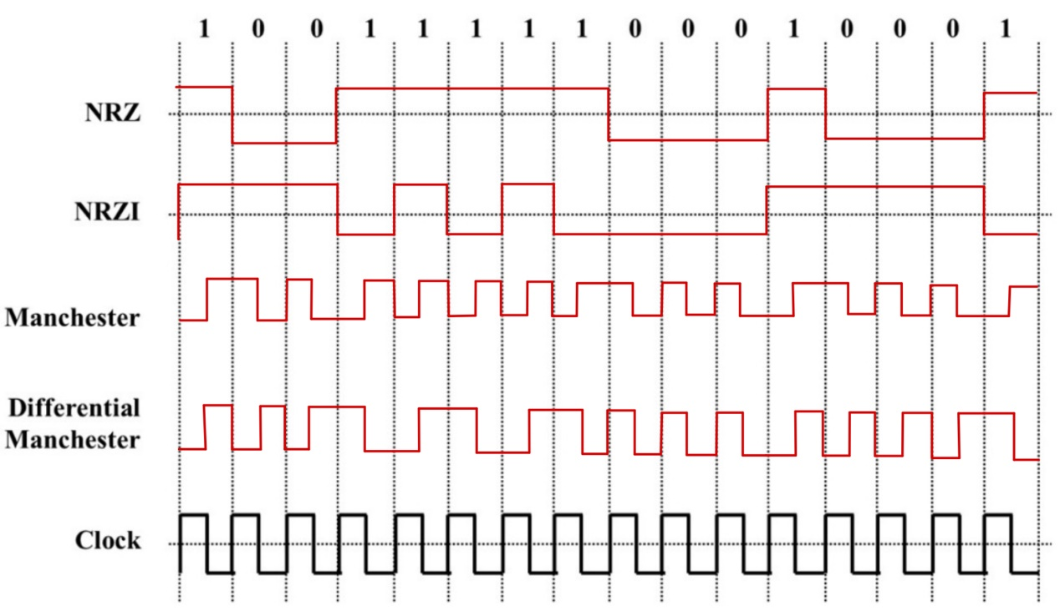

**3.**

**(1)** Lower data rate: Manchester encoding takes more time to transmit the same amount of data than other encoding schemes.

**(2)** Higher bandwidth requirement: In Manchester encoding, each bit requires two voltage transitions for each interval.

**(3)** Clock synchronization:  Manchester encoding requires the receiver to synchronize its clock with the transmitter’s clock.

**(4)** Bandwidth inefficient: Only 50% of bandwidth in Manchester encoding is efficient.

**4.**

X * A = (1 – 1 + 3 + 1 – 1 + 3 + 1 + 1) / 8 = 1

X * B = (1 - 1 + 3 – 1 – 1 – 3 + 1 - 1) / 8 = -1

X * C = (1 + 1 + 3 + 1 – 1 – 3 – 1 - 1) / 8 = 0

X * D = (1 + 1 + 3 – 1 + 1 + 3 + 1 - 1) / 8 = 1

With the calculation results above, it’s clearly that:

A, B, D transmitted bits, C transmitted nothing.

A sent bit 1.

B sent bit 0.

D sent bit 1.