**Chapter 5 Assignments**

1120211099 周豪捷

**1.**

（1）Routing

Routing is the process of determining the optimal path for data packets to travel from the source to the destination across a network. It involves analyzing network topology, traffic conditions, and other factors to decide the most efficient route.

Routing occurs at the network layer (Layer 3) of the OSI model.

（2）Forwarding

Forwarding is the actual transmission of data packets from one network device to another based on the routing decisions made. It involves examining the destination address of incoming packets and sending them out the appropriate interface toward their next hop.

Forwarding occurs at the data link layer (Layer 2) and network layer (Layer 3) of the OSI model, depending on the device and its capabilities.

（3）Switching

Switching is a specific type of forwarding that occurs within local area networks (LANs). It involves the process of receiving, analyzing, and forwarding data packets within a LAN based on the destination MAC (Media Access Control) address.

Switching occurs at the data link layer (Layer 2) of the OSI model.

**2.**

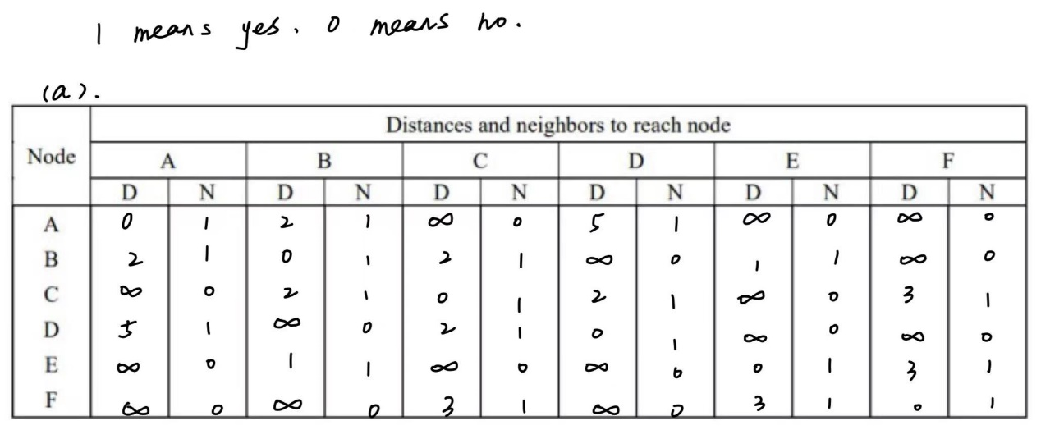

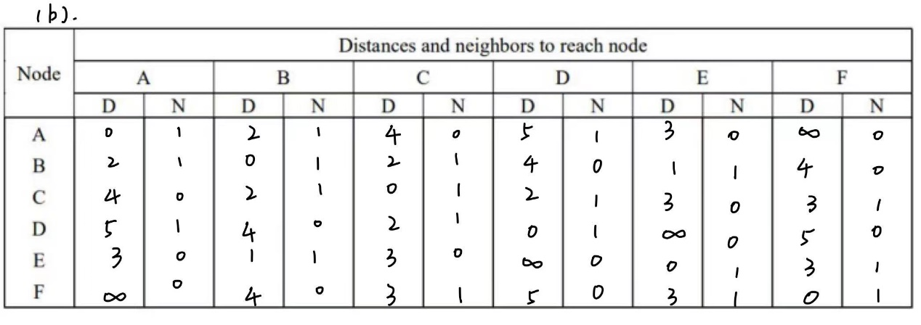

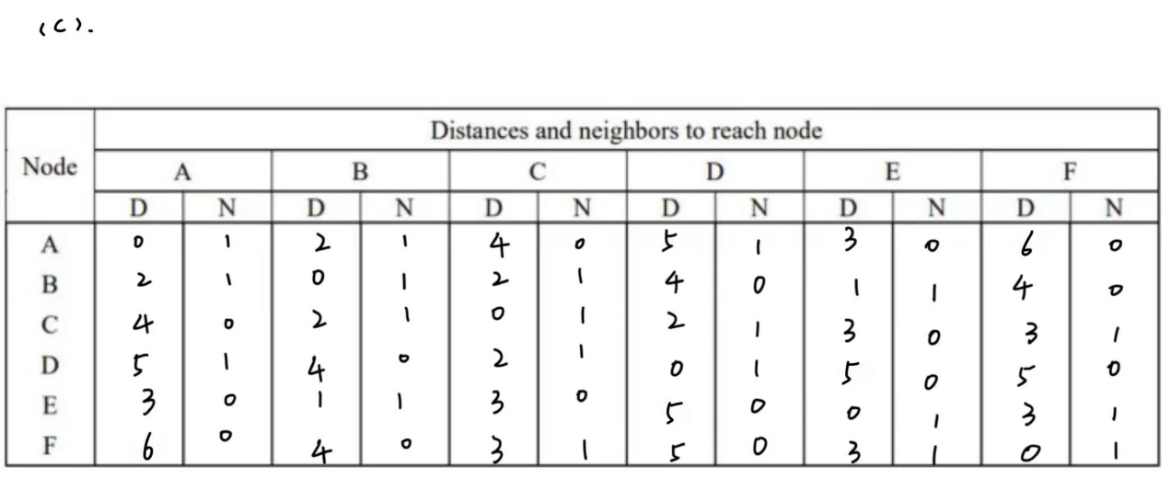

**3.**