**Chapter 4 Assignments**

1120211099 周豪捷

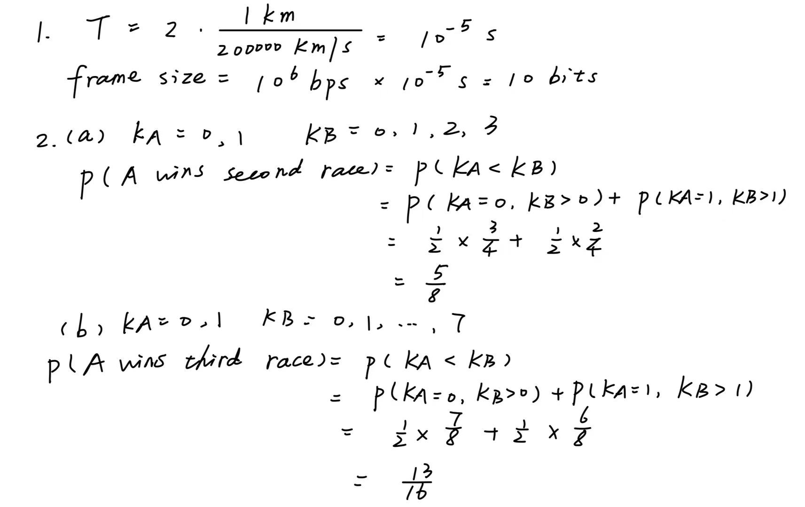

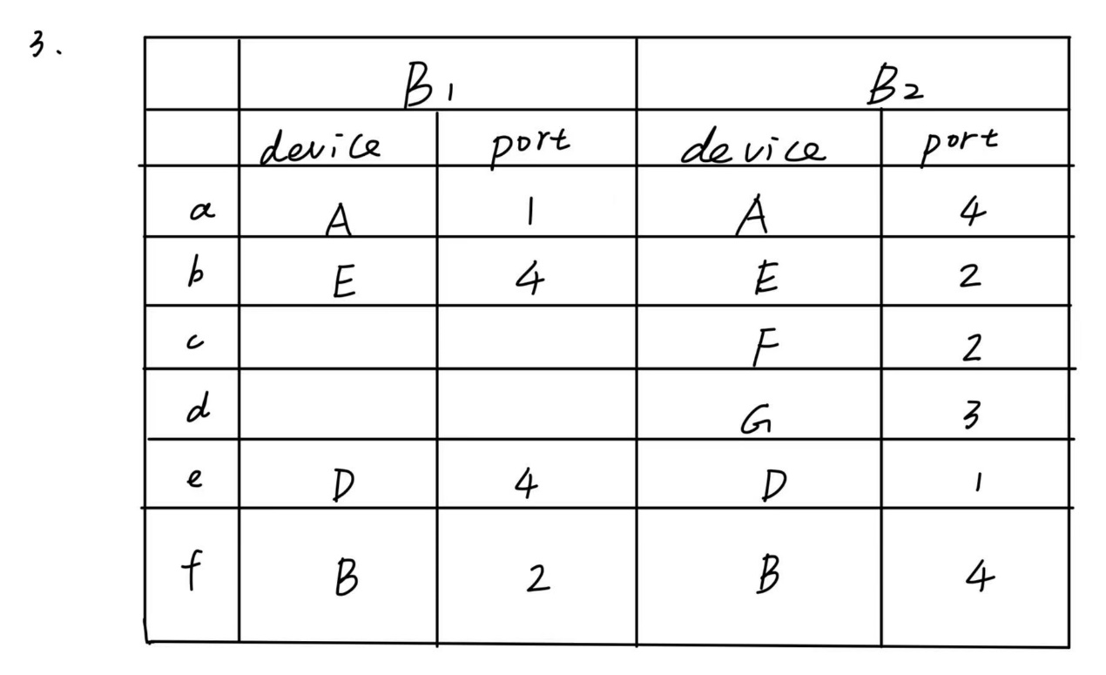

**4.**

Reasons for collision detection more complex in wireless networks than wired networks:

(1) Station must be able to send and receive data at the same time.

(2) Collision may not be detected because of the hidden terminal problem.

(3) Distance between stations in wireless LANs can be great. Signal fading could prevent a station at one end from hearing a collision at other end.

Methods to detect hidden terminals in 802.11 networks:

1. RSSI: Analyze the received signal strength indicator of frames received by the AP. A significant difference in RSSI between frames from different devices could indicate the presence of hidden terminals.
2. CSMA/CA: CSMA/CA mechanism relies on sensing the wireless medium to detect ongoing transmissions before initiating a new transmission. By observing the behavior of CSMA/CA, hidden terminals can be inferred. For example, if a device consistently waits for long periods before transmitting, it might be due to hidden terminals.