- Name of Use Case
Name of the Use Case | IoT platform for Smart Market
Version No. | v0.1
Date | ---
Team Members (with student ids) | ---
- Scope and Objectives of Function
Scope and Objectives of Use Case
Scope | The proposed IoT platform aims to digitalize and automate the shopping experience inside a supermarket through smart shopping carts, real-time inventory management, and Telegram bots for both customers and store staff.
Objective(s) | The expected results include the automation of product addition and removal within the shopping cart, as well as enabling store staff to finalize customer purchases and efficiently manage inventory updates.
Domain(s) | Smart Market, Inventory Management, Smart Logistics.
Stakeholder(s) | Supermarket customers, Store staff, Warehouse managers, Store management and administration
Short description | The platform integrates smart shopping carts equipped with internal scanners and load cells to detect products and validate weight. Customers interact through a dedicated Telegram bot that updates the cart content in real time and generates a final QR code for checkout. The supermarket product database is constantly updated, and the system automatically issues alerts for low-stock items. A staff-side Telegram bot enables employees to finalize purchases and receive restocking notifications.  Summarizing, the main features it offers are:  - Smart cart with barcode/RFID reader and weight sensors;  - Customer Telegram bot for shopping list and cart management and Staff Telegram bot for checkout and restocking operations;  - Automatic low-stock alerting and Real-time product database updates;  - REST and MQTT communication.

- Diagram of Use Case
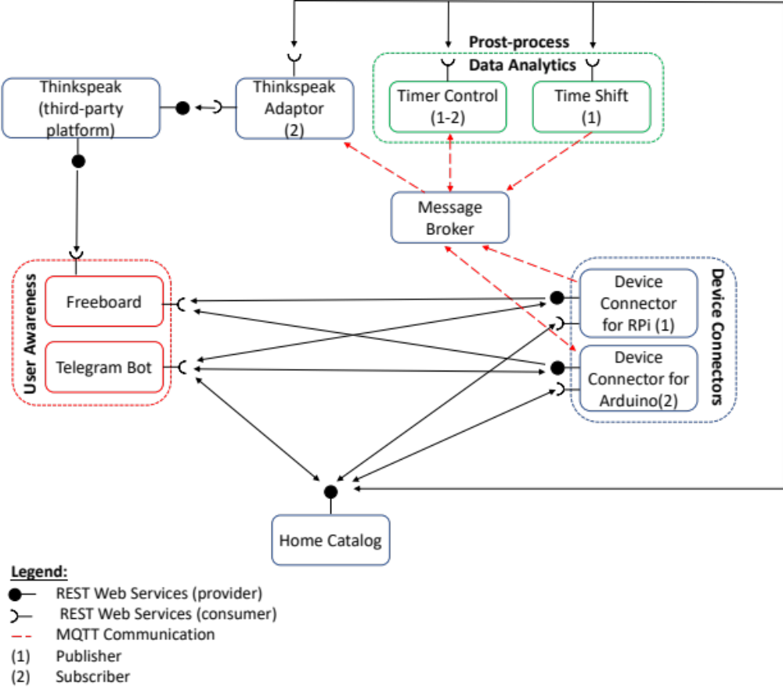
- Complete description of the system
The platform follows a microservices architecture and relies on two communication paradigms:
- MQTT for asynchronous event-based communication (product insertion, weight alarms, low-stock alerts).
- REST Web Services for synchronous communication (cart queries, database updates, bot interactions).
Detailed Actor Descriptions
1. MQTT Message Broker
Handles events such as:
- Product insertion
- Weight updates
- Alarms
- Inventory notifications
- Synchronization between cart and customer bot
2. Market Catalog
Provides:
- REST endpoints for all microservices
- MQTT topics
- Stock thresholds
- Cart configurations and weight logic
All actors query the Catalog during startup.
3. Smart Cart Connector
- Barcode/RFID product scanning
- Integrated load cell weight measurement
- MQTT publication of events (product added, weight mismatch)
- REST APIs for cart status and content
- Alarm generation for mismatched or unscanned items
4. Weight Checking Service
- Subscribes to weight data from carts
- Validates expected vs. real weight
- Publishes MQTT alarms in case of discrepancies
5. Customer Telegram Bot
- Links the customer to a specific cart via QR code
- Updates product list in real time
- Shows quantities, prices, and total cost
- Generates the final checkout QR code
6. Staff Telegram Bot
- Scans the customer's final QR code
- Finalizes the purchase
- Updates product inventory
- Receives MQTT low-stock alerts
7. Inventory Management Service
- Monitors stock quantities
- Updates the product database after each purchase
- Publishes low-stock alerts (<5 units)
8. Product Database
Contains:
- Product ID
- Name
- Price
- Weight
- Stock
9. Alert System
Generates and distributes:
- Weight mismatch alarms
- Low-stock notifications to staff Telegram bot
- Desired Hardware components (only among those we can provide)

Device Name | Quantity | Needed for…

5. Desired Hardware Components
Device Name | Quantity | Needed For...
Raspberry Pi | (x) | Smart cart logic, barcode scanners, weight sensors
Arduino / Microcontroller | (x) | Weight sensing system / embedded control
Load cells + HX711 | (x) | Measuring cart weight variations
Barcode / RFID reader | (x) | Product identification
Battery pack | (x) | Smart cart power supply
Router / Access Point | (x) | MQTT/REST communication
Smartphone/Tablet | (x) | Staff bot interaction

