**Welcome**

**Tools used:**  
Discord

**Steps:**

1. Open the CyberSentinels discord.
2. Go to announcement channel and you will find the flag.

**Flag:** root@localhost{W3lc0m3_T0_r00t@l0c4lh3l1!}

**The Great Login Heist**

**Tools Used:**

Wireshark

**Steps:**

1. Open Wireshark and load “secret_pass.pcapng”.

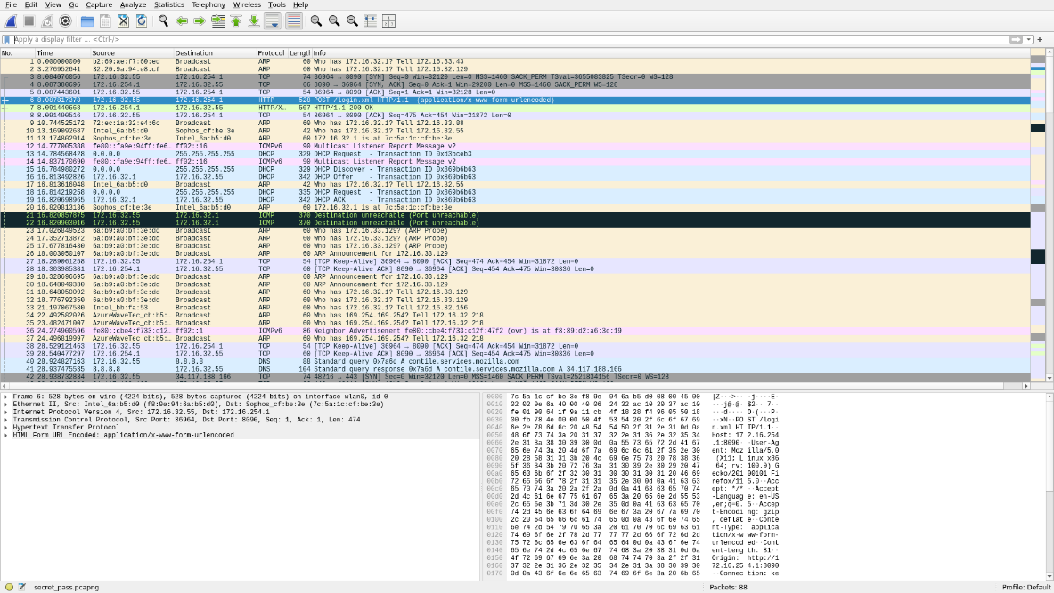

1. Now filter it by typing “http.request” in the box.
2. Now you will see 2 packets being shown. The length of the packet changes.

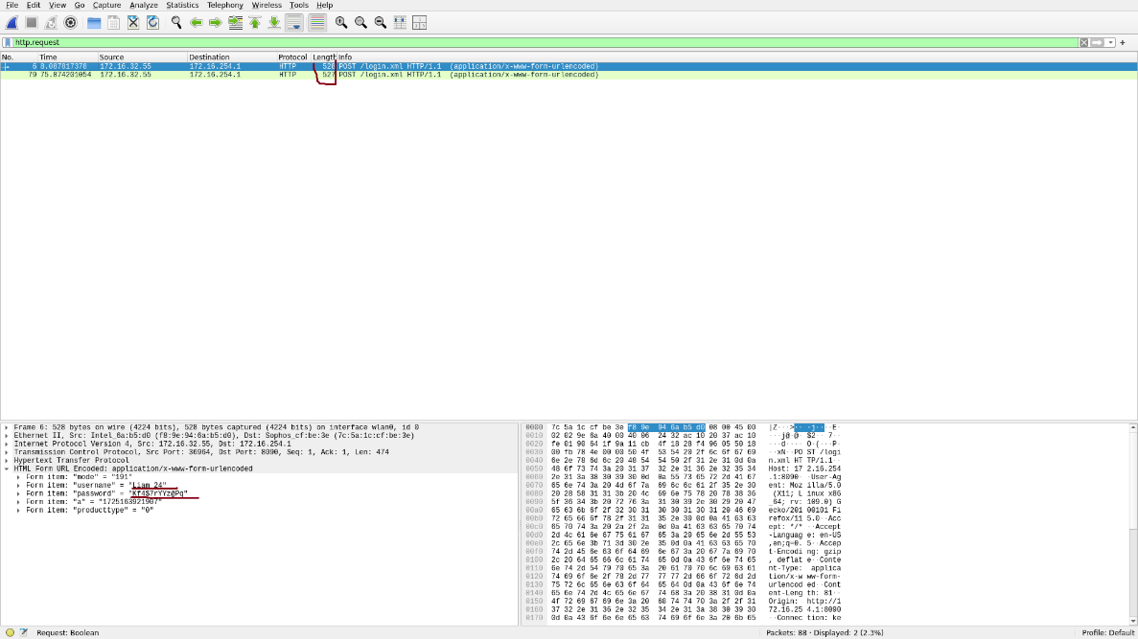

1. When u click the flag u can see both the username and the password as shown above.

Flag: root@localhost{Liam_24_Kf4$7rYYz@Pq}

**Play with QR**

**Tools Used:**

ls command

**Steps:**

1. Navigate to the QR codes folder and open the terminal. Type in the cmd “ls -la”, this gives the information about the files. When you look closely, you notice that the sizes of all files are 535 bytes except one which is 528 bytes.

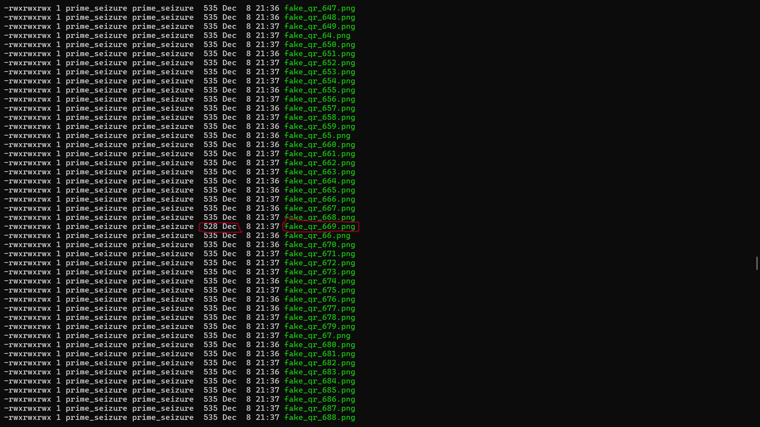

1. Now open the file “fake_qr_669.png” and scan it.

**Flag** : root@localhost{7h3_q6_!s_fun}