**Reverse**

**Tools Used:**

Binary Ninja

**Steps:**

1. Open the file in binary ninja and decompile the secret function.

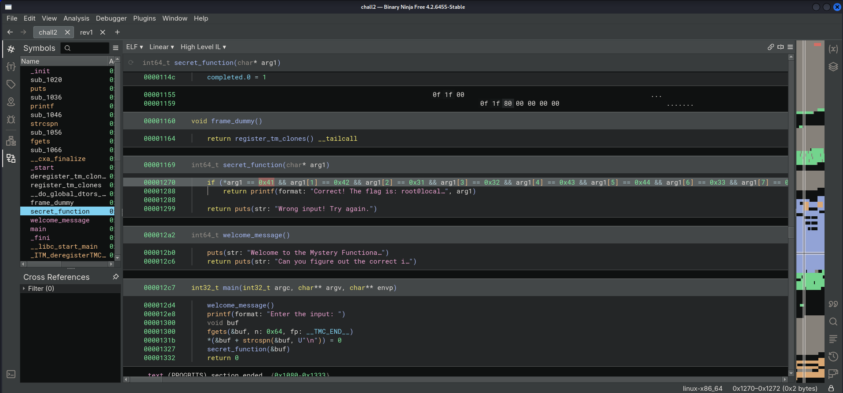

1. Decode the hex codes in the function.

**Flag:** root@localhost{AB12CD34EF56H7}

**Enigma Unveiled**

**Tools Used:**

Binary Ninja

**Steps:**

1. Open the file in binary ninja.

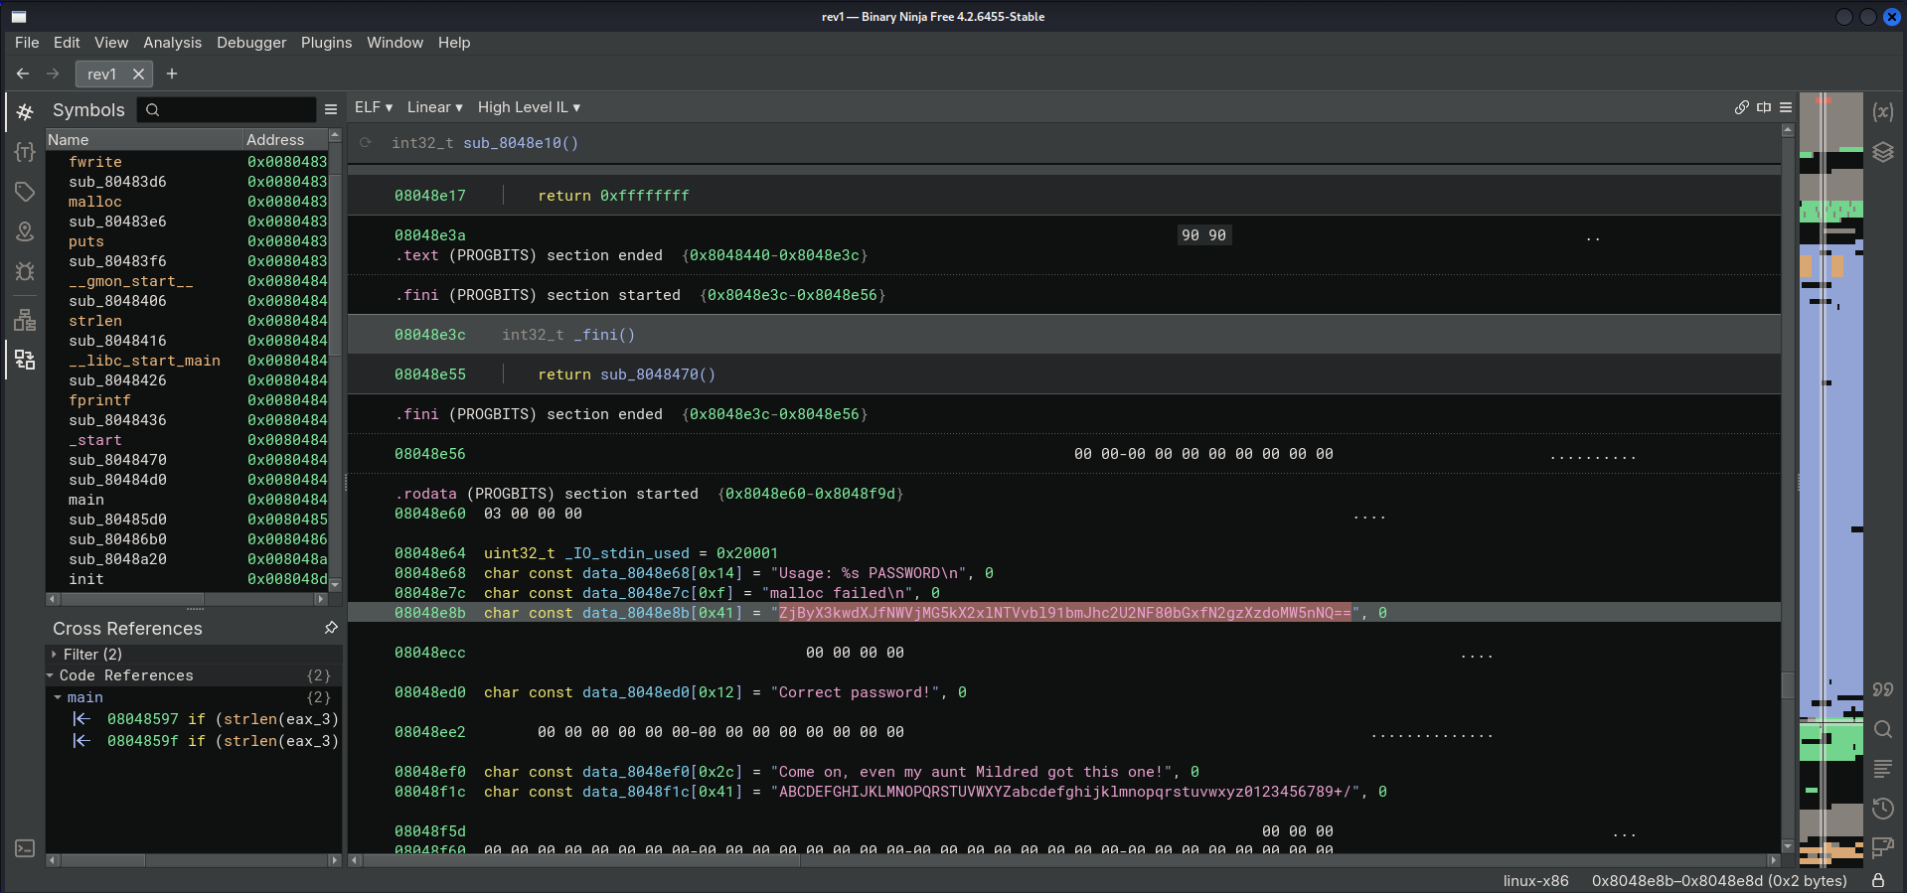

1. Decode the string from base64.

**Flag:** root@localhost{f0r_y0ur_5ec0nd_le55on_unbase64_4ll_7h3_7h1ng5}