**Easy_Web_Challenge**

**Tools Used:**

Burpsuite

**Steps:**

1. Open burpsuite and go to the “target” tab. Then open the browser and add the given link.
2. Go back to burpsuite and click on, script.js and you will find both the username and password.

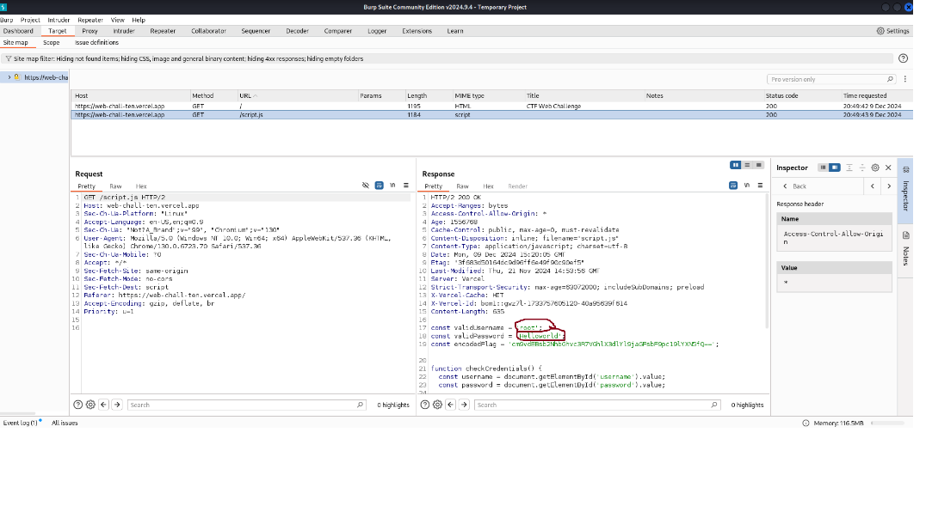

**Flag:** root@localhost{The_web_chall_is_easy}

**Mini Vulnerable Compiler**

**Steps:**

1. Write this code in the compiler

import os

print(os.system('cat flag.txt')) and compile it.

**Flag:** r00t@locahost{mini_compiler_pwn}

**iDoor: The Secret Portal**

**Tools Used:**

Crackstation

Sha256 encrypt

**Steps:**

1. Open the given link and copy the hashed value.

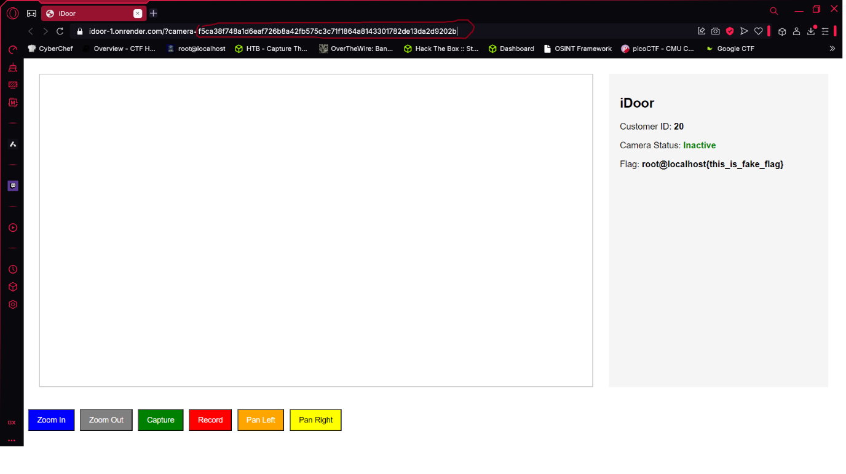

1. Now paste the value in crackstation and check its type.

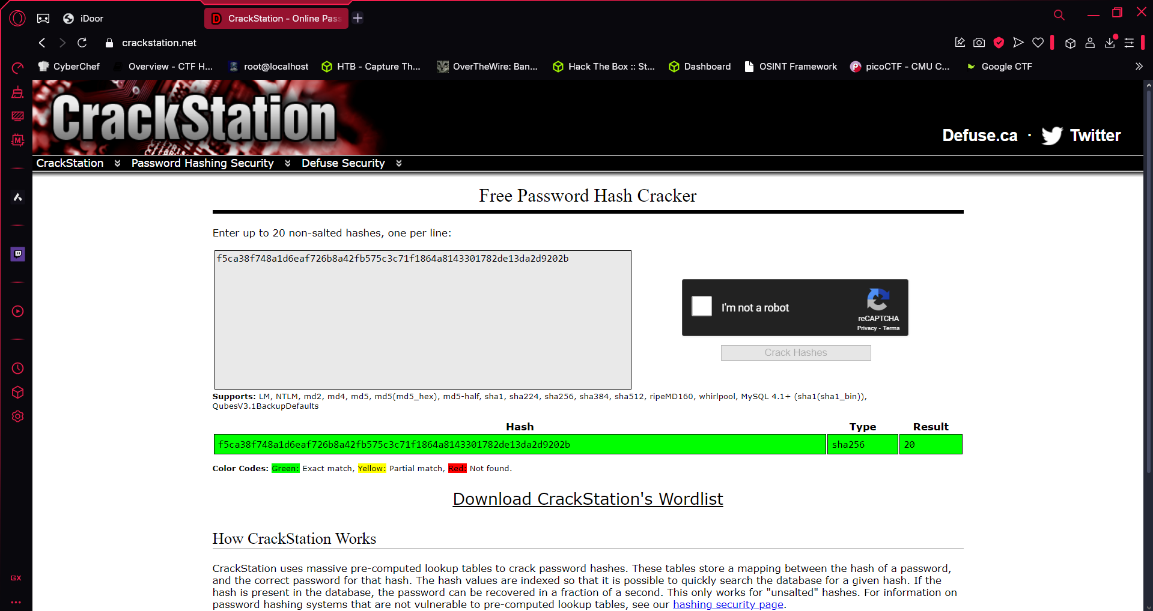

1. Now use “echo -n 0 | sha256sum” to hash it for the value of root user “0”.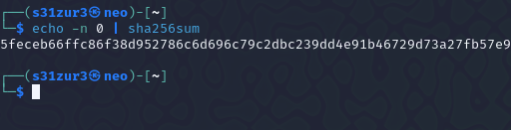

**Flag:** root@localhost{770a058a80a9bca0a87c3e2ebe1ee9b2}

**XSS Vulnerability**

**Tools Used:**

Selfmade xss script

**Steps:**

1. Type this script into the text box “<img src=x onerror=alert('test')>”

**Flag:** root@localhost{Byp4ss_Sanitiz3r_123}