Personal Profile Assessment - 1

**Personal Information**

Include your name - Grant Nicholas

student number - s3954897

student email address - [s3954897@student.rmit.edu.au](mailto:s3954897@student.rmit.edu.au)

Picture

**nationality and culture Australian** – English heritage

**Education and Qualifications**

Year 12 – 1988 - St Brendan's College – Yeppoon Queensland

Trade Certificate - Radio Fitter Mechanic (Electronic Systems)

Completed 2 years of Bachelor of Electronic Engineering at USQ - Deferred

Diploma - Business Management

Diploma - Project Management

Cert IV - Training and Assessment

Languages spoken - English

**Personal fact/hobby**

My love of fishing prompted a friend and I to begin our own startup company and releasing a Mobile Application called “iDfish” that has been live on the Apple’s App Store and Google Play for the last 6 years.

**Interest in IT**

* **What is your interest in IT (Information Technology)? When did your interest in IT start?**
  + I have an interest in advanced technological systems. For example, I am interested in and follow the progress of topics like the James Webb Space Telescope, Space x, Starlink satellite system, self-driving cars, the International Thermonuclear Experimental Reactor (ITER), just to name a few. My interest in IT began in 1980 at the age of 9 when my parents bought a “Soundic Pong Console. This was my first introduction to IT, and close to the beginning of the consumer IT evolution. In 1981 I upgraded from the 6-game monochrome gaming console to a personal computer. The Commodore VIC-20 was where I had my first introduction to BASIC programming language. From this point forward I have always gravitated to technologies and computers. My first job outside of school was with the Roya; Australian Navy as an electronics weapon systems technician specialising Radar/Sonar and digital control systems.
* **Why did you choose to come to RMIT (Royal Melbourne Institute of Technology)?** 
  + My decision to come to RMIT through OUA (Open Universities Australia) was born out of necessity because of my startup company. At this time, we have outsourced the programming to a local third-party provider and have found that it is exceedingly difficult to get what we want. On many occasions we have not been satisfied with the outcome. We have attempted to find alternative suppliers several times, but the size and complexity of the application has been insurmountable for anyone that reviews the project.
* **What do you expect to learn during your studies?**
  + I want to be abreast of current standards, terminology and processing standards so I can perform changes and upgrades to the iDfish Application in house. Larger upgrade requirements I will project manage the team so we can achieve our desired outcomes with tighter control over the timelines and progress. I will also be able to participate in these changes and upgrades as a member of my own team.

## Ideal Job

* + <https://www.seek.com.au/job/55894531?type=standard#sol=49941caede9c247bcde45f7485e56a169eb74f8d>

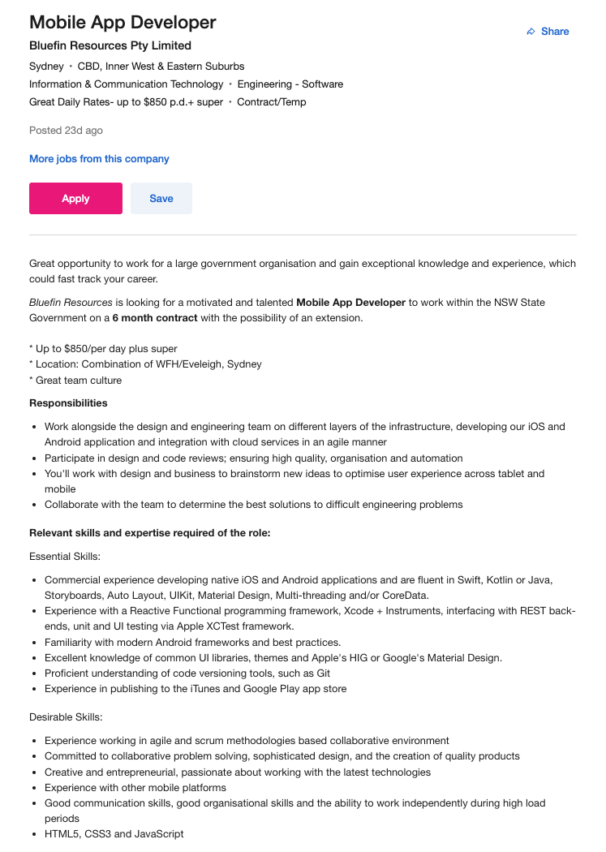

* **A description (in your own words) of the position, and particularly what makes this position appealing to you.** 
  + This is a team orientated app development role with a focus on fast paced staged results on a range of current programming frameworks. It also includes current database and cloud server access techniques that I would benefit from being proficient such as multi-threading.
* **A description (in your own words) of the skills, qualifications and experience required for the position.** 
  + To be successful in this role I will need to have the following personal skills:
    - Solution orientated.
    - Lateral thinker.
    - Clear communicator.
    - Can work in a team environment.
    - Can function under pressure.
  + To be successful in this role I will need to have a thorough knowledge and understanding of all the following:
    - Current programming languages for both android and iOS platforms.
    - Current interface design standards including being familiar with all the current UIKits and how they can best be implemented.
    - Back-end data access and processing from mobile platforms.
    - Current programming fundamental with understanding of storyboarding wireframing and version control.
    - Publishing knowledge to bring finished outcome to market.
* **A description (in your own words) of the skills, qualifications and experience you currently have.** 
  + I have the necessary personal skills and have worked in many environments requiring the personal skills necessary for this role.
  + I have had introductory exposure to most of the necessary knowledge for this role, but I have numerous holes with some of the languages and processes required that would prohibit my complete technical understanding of the overall requirements. I do not have the formal qualifications in any of the requested essential skills listed.
* **A plan describing how you will obtain the skills, qualifications and experience required for the position, building on those you have now. This need not be detailed, (and will probably change significantly over time anyway) but try to be as specific as you can.**
  + Step 1. Complete a Bachelor of Information Technology with an effuses on Mobile programming, database application, and mobile application design.
  + Step 2. Self-educate skills and create real world examples of the requested skills.
  + Step 3. Design/build and implement smaller projects using the skills required for the role. (This practical implementation of the necessary skills helps cement understanding and demonstrates to a potential employer the required skills).

Personal Profile

Project Idea

* **Overview (100 words) - This should be a summary of what the project will be.**

Using a mobile device such as a phone to scan a serial number of a bike, e-bike, e-scooter and/or mobility scooter to then record and store this item specific information against an individual's personal account in a cloud-based server. This will help to deter would be theft and subsequent sale of stolen items. This registration data can be accessed by a user looking to register a new item or check if an item that is being purchased second hand has been flagged as stolen. The system would also allow one user to transfer item registration to another as proof of transaction of a legitimate sale.

* Motivation (100) words) - This should be a description of why the project will be interesting or useful. This may include statistics or other evidence, such as: "There  
   service. are 1.5 billion cat owners in Australia, and so there is a huge market for an automated cat feeder. Using Raspberry Pi technology is a cheap and easily assembled solution to this problem."
* Description (500 words) - Detailed description of the features of the product or service
* Tools and Technologies (100) words) - Describe the software, hardware and/or other equipment needed. Include
* any relevant open-source tools as appropriate.
* Skills Required (100 words) - List the skills required for your project, including software that needs to be written, and special hardware (if any). How feasible will it be to find the skills, software and hardware required?
* Outcome (100 words) - If the project is successful, what will be the outcome? How will the original problem be solved? What impact will this development have?

Project - bike/e-bike register/mobility scooters/e-scooters

My bike/scooter Register App/Database

Create an account

Use OCR to scan and record Serial number model number of device against your account

Upload a photo/proof of purchase

Record unique details/modifications updates etc.

Use compiled data for insurance purposes and claims (Produce a list of items or details of a single item)

“Is stolen” flag

If sold shift to buyers' alternative buyers' account

If buying scan serial number to quickly check if flagged as stolen or to confirm sellers ID match's item

Stolen items that have been scanned get reported to the person that listed them as stolen.

Receive alert if your stolen item has been found

Commercial viability advertising banner ads

Functions scalable depending on subscription level

Global potential

Room for growth into a marketplace for secondhand items. Simply flag an item for sale.

Presentation

Reference