Analysis of **FCIH Students Grades** dataset

The FCIH Students Grades dataset contains students grades for year 2017/2018 (2nd semester).

***Subjects grades distribution***

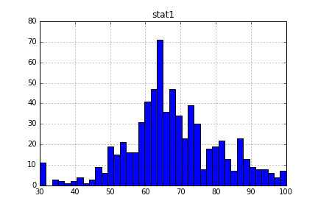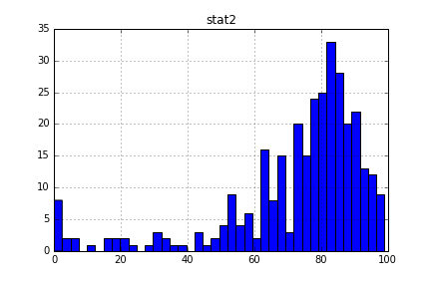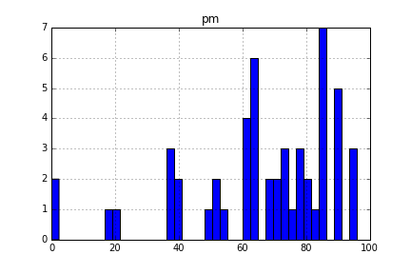

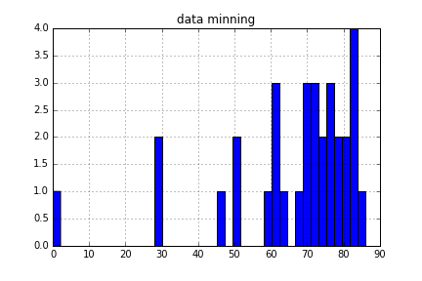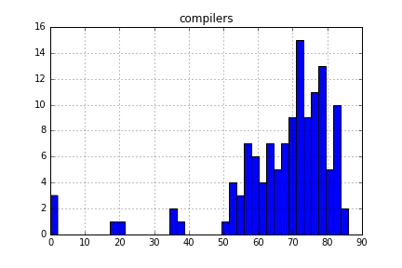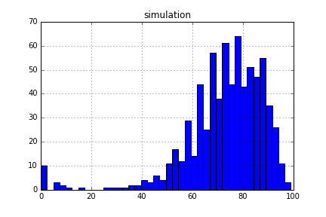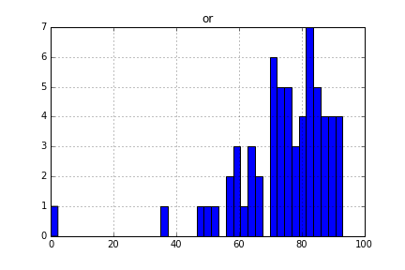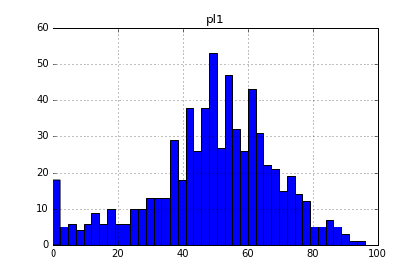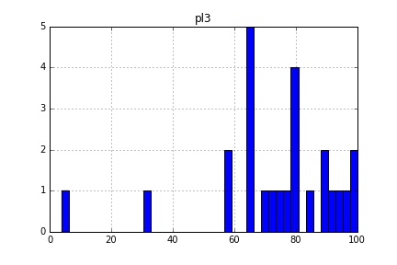

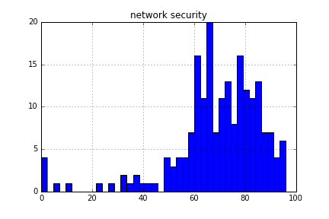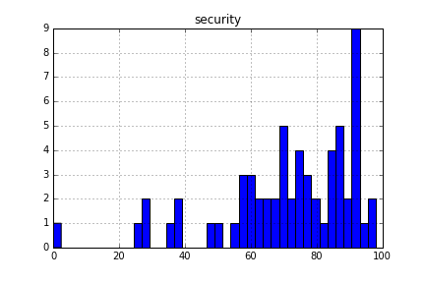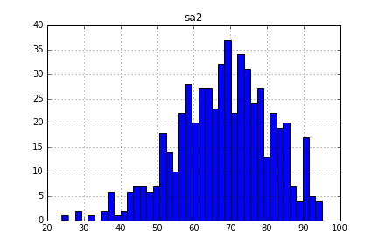

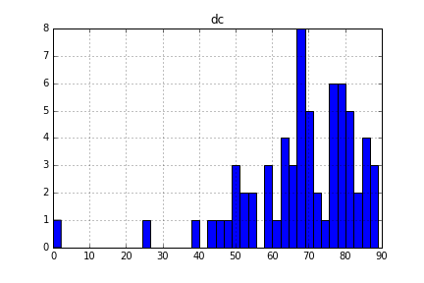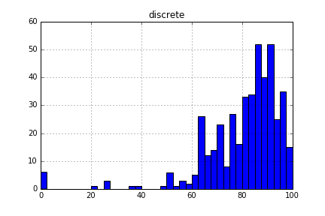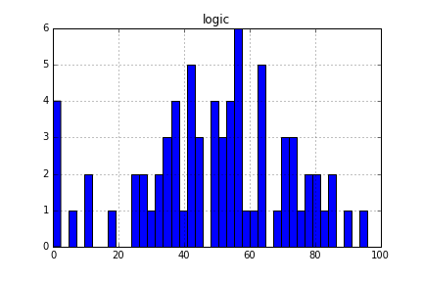

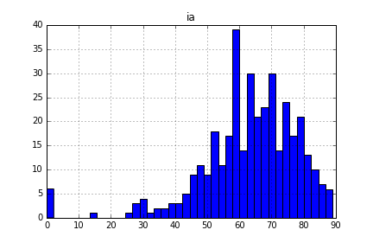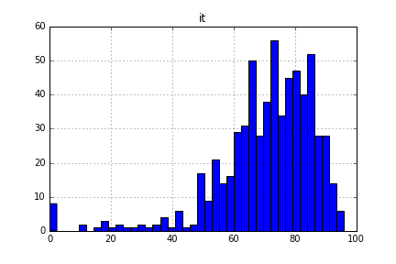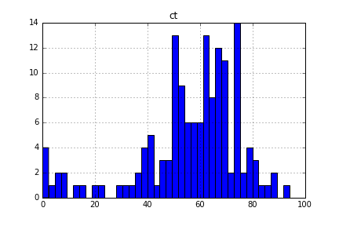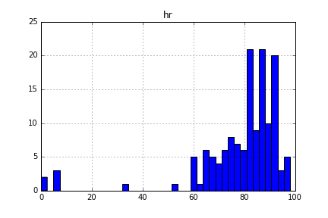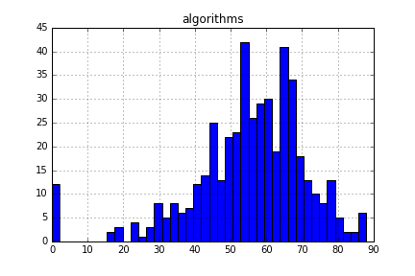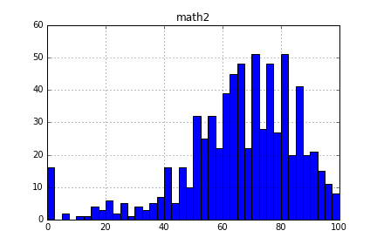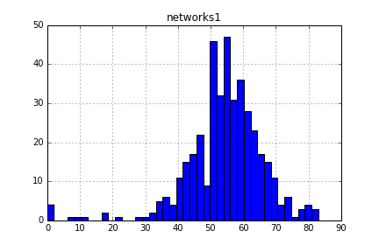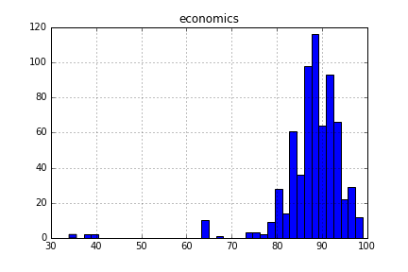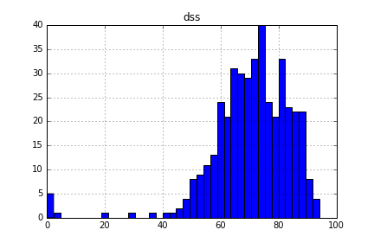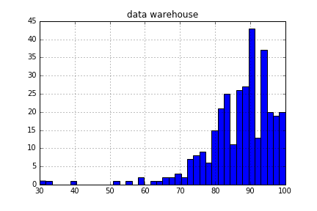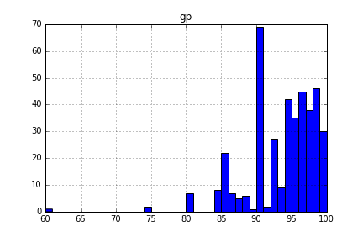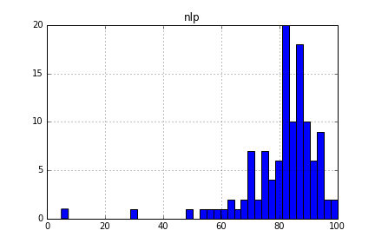

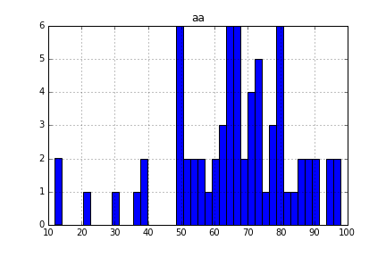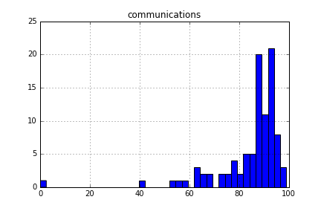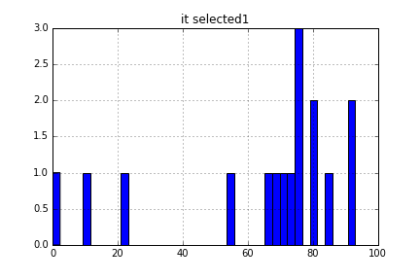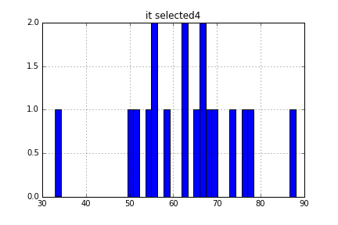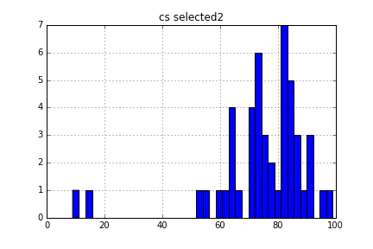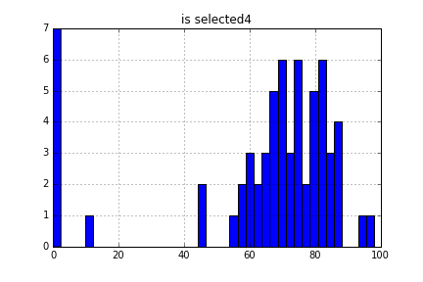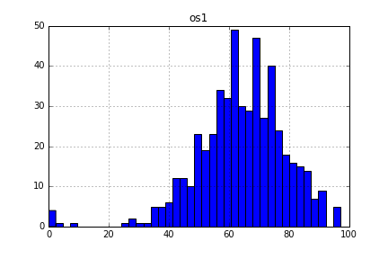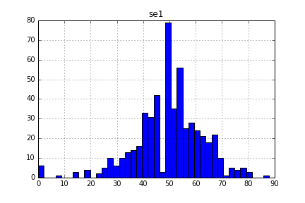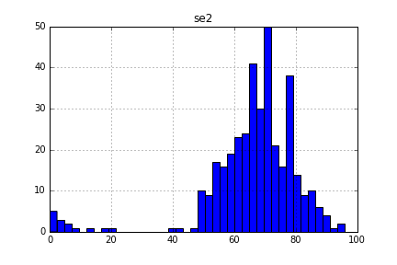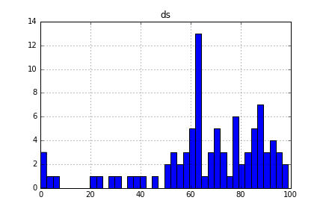

**How much can we predict student total GPA based on a subject grade**

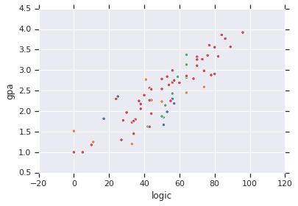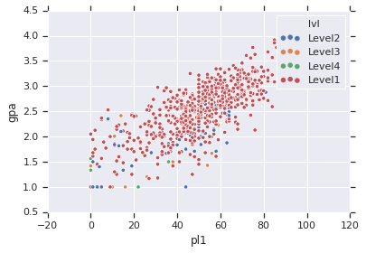

**Using line plot with hue to indicate the student level we can see the**

**relation between a given subject grade with the over all student GPA**

**more clearly that a scatter bot:**

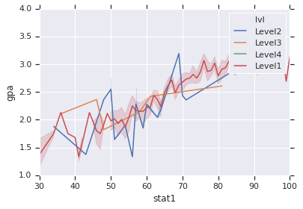

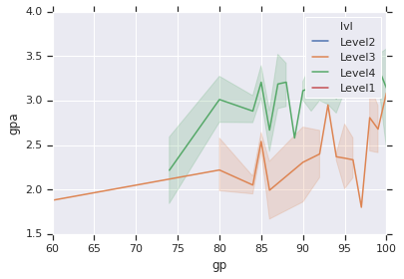

**It is clear that only level 3 & 4 students only are enrolled to Graduation Project and to have a better GPA if they are in Level4.**

**This can be reasoned by that they enroll to subjects in their order and don’t have to re-take some of their courses to succeed. (This is not a general rule)**

**BUT it can be advised that to register the GP only when you are in your final year (according to this data)**

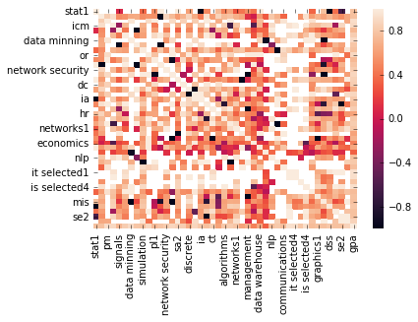

**CAN’T RELY OF THOSE DUE TO DATA INCOMPLETENESS**

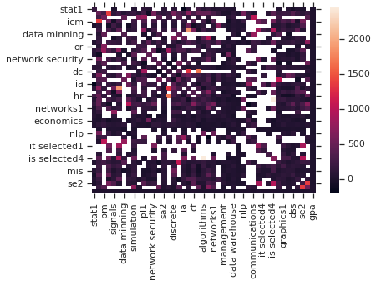

Using box plot outliers shines and need more care & investigation and

may contain students who needs help (ex. Psychological support)

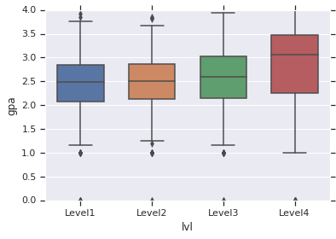

Looking at the GPA distribution, we can claim that the mean GPA of a level increases each level to reach the maximum in the last one.

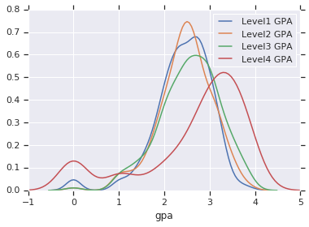

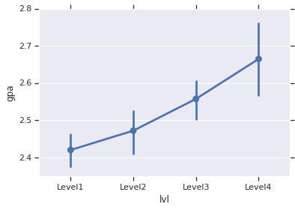

It is very useful to look at the student density in each subject in order to make enhancements next year

The most dense course is: Fundamentals of Management

Faculty may adjust the course hall to fit this size

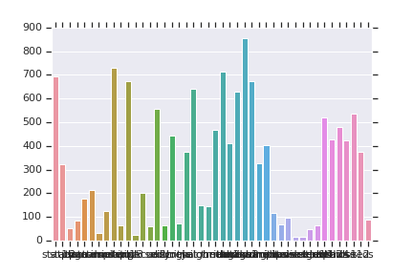

If this graph is combined with halls size. Every subject can be assigned to the most fitted hall enabled by faculty resources

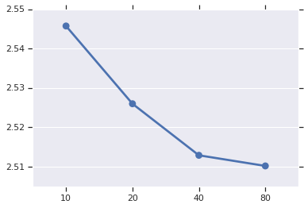

**GPA Sample Mean: GPA Mean: 2.520307543766786**

**samples_10 2.615830**

**samples_20 2.529846**

**samples_40 2.527007**

**samples_80 2.519526**

**GPA Sample Variance: GPA Variance: 0.6281055005144071**

**samples_10 0.063369**

**samples_20 0.024262**

**samples_40 0.011794**

**samples_80 0.009599**

Are CS Selected students have GPA greater than the Others GPA ?

**This can be tested, but the answer is not guaranteed to be right because this grades are for a single term. So, in order to minimize the error selecting a Level3 students GPA is a good idea**

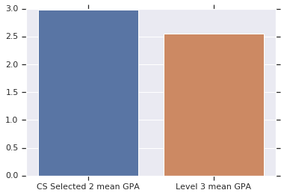

**Indeed They ARE**