OPERATIONS DECISION MEMO / NOVEMBER 2026

Review Policy for Sensor Outages
  - For telemetry operations and reliability leads | James Jean
Advance the confidence rule to shadow evaluation. Keep it out of live decisions until missed-event risk and review capacity are measured.
When one of two synchronized channels goes missing, an automated event label may still be useful. The question is when to trust it and when to send the window to a person. I compared those choices on the same 1,800 later synthetic windows from 30 held-out device instances.

What the two options trade
Sustained dropout | Issue every label | Use frozen confidence rule
Automated labels | 1,800 / 1,800 | 1,438 / 1,800 (79.9%)
Wrong automated labels | 431 / 1,800 (23.9%) | 274 / 1,438 (19.1%)
Windows sent to review | 0 | 362 / 1,800 (20.1%)

Of the 362 deferred items, 157 would have received a wrong label and 205 a correct one. That does not say how many a reviewer would get right. Of the 274 wrong labels the rule still issued, 260 were missed events.
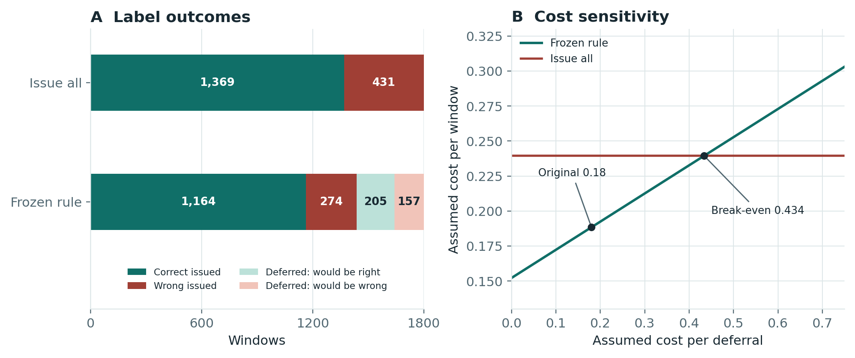
Figure 1. Same 1,800 windows in both options. Deferred labels are counterfactual model outputs. Costs are assumptions, not dollars or measured reviewer outcomes.

VALIDATION PLAN

What to Test Before Rollout

Budget the review queue
Per 1,000 windows, the fixed rule would defer about 122 clean, 130 brief-dropout, or 201 sustained-dropout windows if the corresponding benchmark condition repeated. Use the actual mix, arrival volume and review duration for staffing. Stress-test bursts and long outages separately.
The simplified cost model values a wrong automated label at one unit. At the benchmark weight of 0.18 units per deferral, the rule costs 0.188 units per window versus 0.239 for issue-all. The rule breaks even at 0.434 units per deferral. Reviewer errors, delays and unequal error costs can change that comparison.

How to run the shadow test
Keep existing alerts active. Log scores, masks, outage types, decisions and queue timestamps. On later time blocks and held-out devices, compare the frozen rule with issue-all and an explicit outage escalation rule. Adjudicate a stratified sample of issued and deferred items, including high-confidence no-event labels.

Agree on decision gates before collecting results
Gate | Advance only when | If the gate fails
Missed events | The upper uncertainty bound is below the pre-agreed missed-event limit. | Escalate outages and investigate confident misses.
Review capacity | Workload and queue age stay within agreed limits during outage bursts. | Keep shadow mode and revise queue or fallback policy.
Evidence coverage | Common loss types, unseen devices, and later periods have enough adjudicated examples. | Collect more labels; keep live behavior unchanged.

If the team changes a cutoff, use new validation data and a fresh holdout. The synthetic benchmark gives a comparison and an audit trail; it does not establish field accuracy, staffing levels or savings.

