25 black screens/558:
['11011102321007', '11011101211021', '51011101841008', '11011101051002', '51011102171007', '11011102541003', '11011101151005', '51011101371001', '51011101831005', '11011101211004', '51011101401006', '51011105351003', '11011101391019', '11011101761003', '11011101601001', '11011104341005', '51011103071005', '11011101071011', '11011101221007', '51011101841010', '11011104211007', '51011101711002', '51011102341012', '51011101371012', '11011101021006']

To evaluate the TMTV-NET, data from 558 patients with lymphoma with PET/CT scans along with their manual segmentations across multiple imaging centers with 3 different scanner manufacturers (Phillips, GE, Siemens) were used.

Modification of the implementation :
To maximise the efficiency of the TMTV-NET, we have made some modifications on the input and the output levels.
Input :
-phillips : Old phillips PET dicom files have a tag containing directly the suv factor, there was no need to calculate it.
-rescale slope : In the conversion from Dicom BQML series to a single Nifti SUV file, multiplying by the rescale slope gave wrong SUV values. This step was removed from the conversion process thus only multiplying by the suv factor to get the correct values.
-Dicom to nifti conversion with SimpleITK : We have observed on a few PET scans that the module SimpleITK fails to give the correct raw values for some files. We chose to use the convert_generic module from the dicom2nifti python library to convert from a dicom series to a nifti file, then multiply the raw obtained values by the suv factor.

Output :
-thresholding at suv = 4 : GT and prediction masks can often be enhanced simply by thresholding them at SUV = 4.

Evaluation :
We will procede with two approches, a global approche and a lesionwise approche. The global approche uses metrics applied on each of the whole Ground Truth (GT) and prediction masks. The lesionwise approche isolates each lesion and counts how many lesions were effectively detected for each patient.

Global metric evaluation :

Masks were considered as a whole set. As sometimes the GT mask may be composed of multiple layers, we need to flatten it into a single layer. Then we filtered the masks (GT and prediciton) to only take voxels with a SUV > 4 (see fig.1 for example of GT). The following metrics were then applied :

-Dice Score Coefficient (DSC)
-Hausdorff’s distance at 95th percentile (mm)
-Normalised Surface Distance (NSD) at 5mm tolerance
-TMTV Recall
-TMTV precision

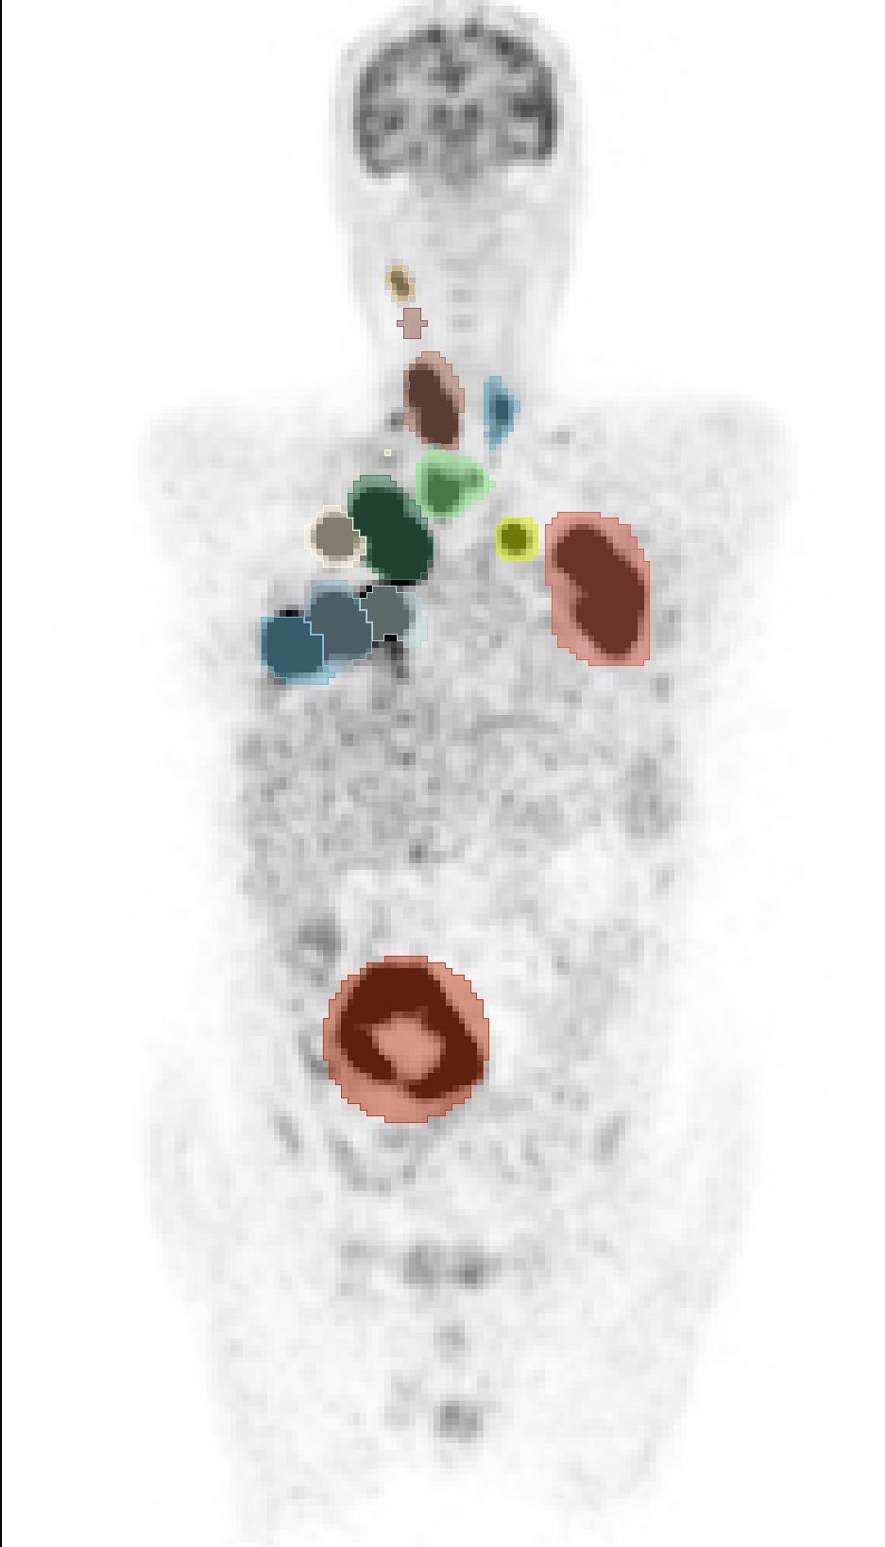
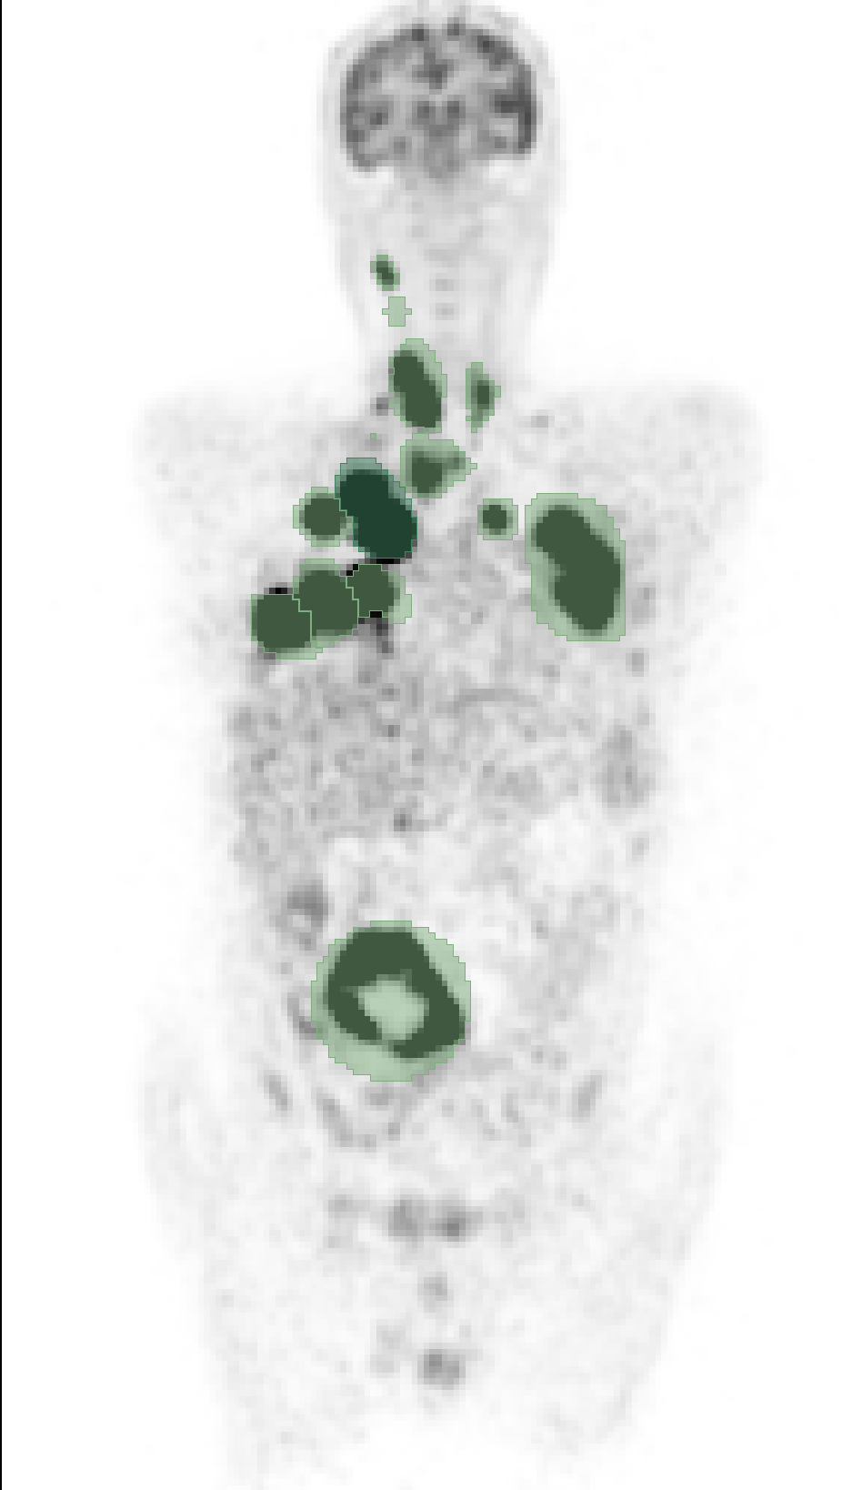
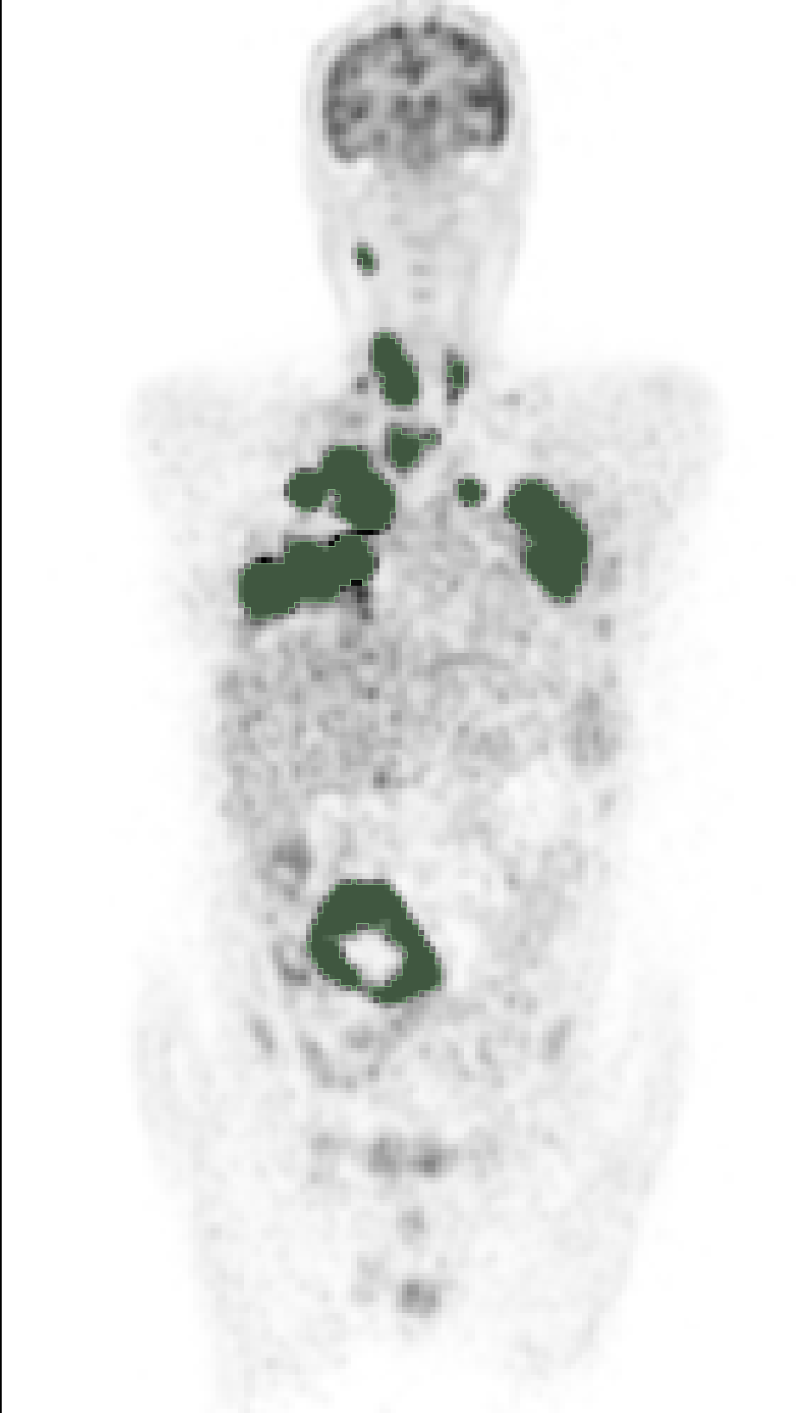

Lesionwise metric evaluation :

GT and pred masks were subdivided into disjoint lesions and metrics were applied to each GT/predicted lesion with its corresponding predicted/GT lesion(s). First, the mask were flattened into a single layer, then the cc3d python library was used to isolate disjoint lesions into their own masks. Finally, the SUV > 4 threshold was applied. This exact order (isolation => threshold) was chosen in order to count the originally connected lesions before thresholding as one lesion even if it was separated by the thresholding step (fig.2 for example of GT).
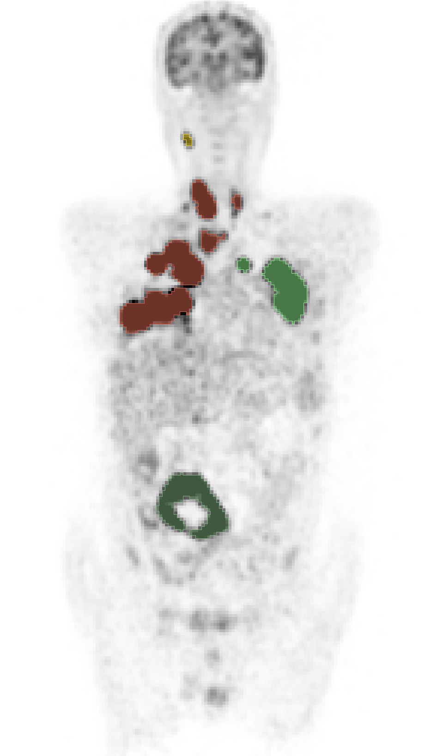
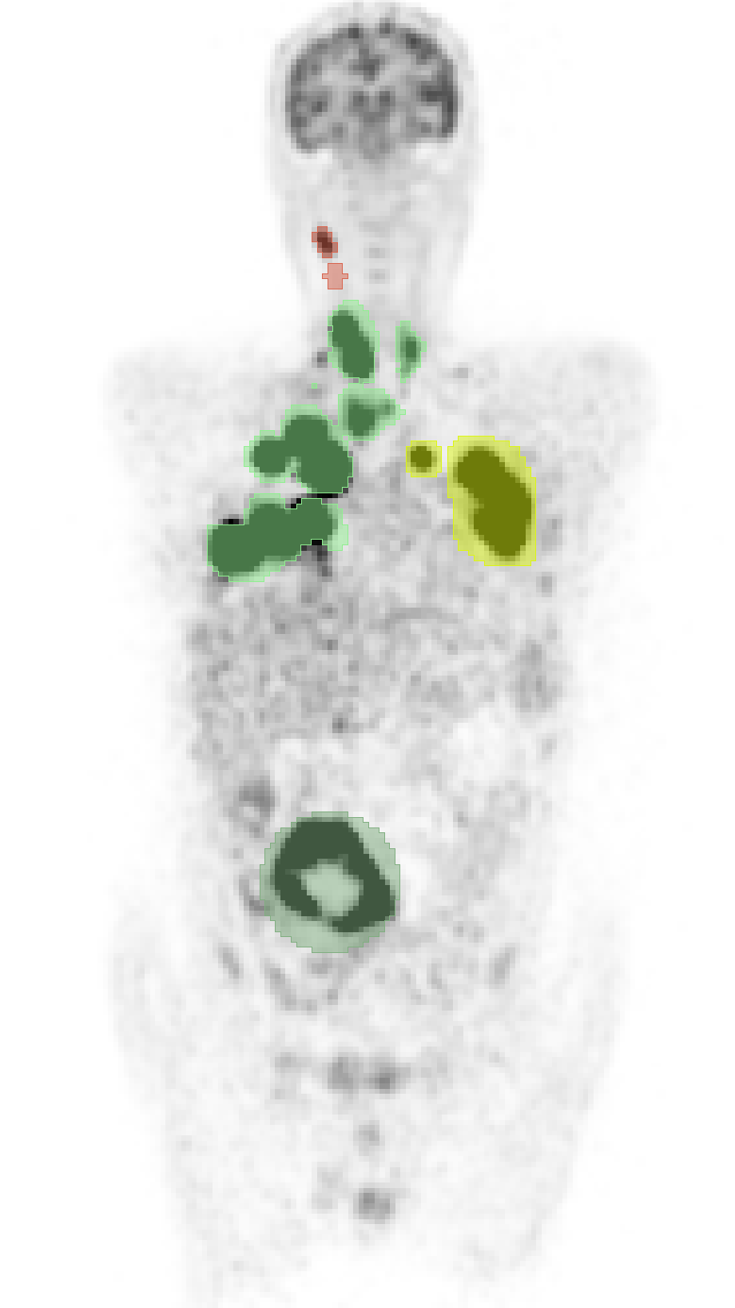

If a lesion in the prediction mask overlaps with a lesion in the GT mask, the two are associated and we had to decide wether the predicted lesion was a TP or a FP and if the GT lesion is a TP or a FN using a certain metric (DSC and NSD were used)
- A prediction is a FP : if the « overlap » with all GT lesions it overlaps with is considered « not enough » to count it as a TP prediction. We applied a metric on the prediction and the union of the GT lesions it overlaps with and compared the score with an arbitrary value. If it’s lower than the fixed value, it is considered a FP. If it is higher it is considered a TP prediction.
- A GT lesion is a FN : if the « overlap » with all predicted lesions it overlaps with is considered « not enough » to count it as a TP lesion. We applied a metric on the prediction and the union of the GT lesions it overlaps with and compared the score with an arbitrary value. If it’s lower than the fixed value, it is considered a FN. If it is higher it is considered a TP GT lesion.
The threshold DSC or NSD score has been fixed to 50 %.

Results over all the 558 patients:

Global metrics (25 null masks were not counted as was the case for the TMTV-NET paper):
dice = 80,51% ± 26,37
hausdorff= 120 mm ± 122
nsd=82,5% ± 22,94
tmtv recall = 75,7 % ± 30,19
tmtv precision = 95,91% ± 12,71
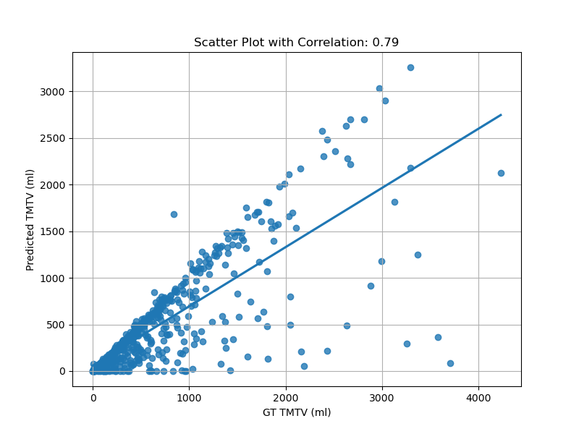

Lesionwise metrics using NSD>0,5 across all the database (null masks were not counted):
lesionwise recall = 76,07% ± 25,77
lesionwise precision = 61% ± 29,12

This says that the TMTV-NET does a fairly good job of detecting all of the lesions but it often segments nonexistant lesions. Now let’s take a look at the predictions in terms of how well a patient’s lesions were detected :

Using NSD >0,5:

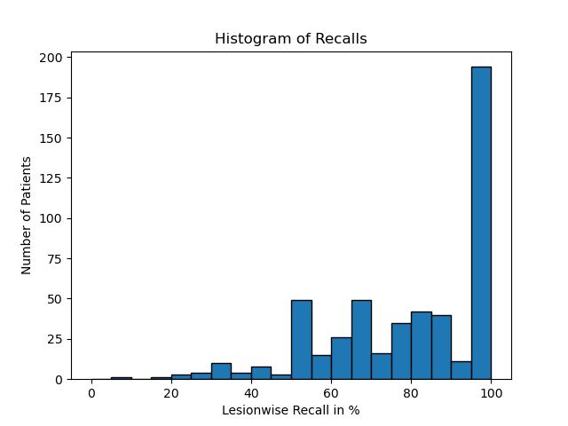
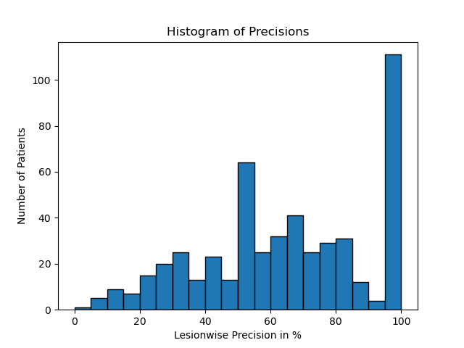

Lesionwise metrics using DSC>0,5 across all the database (null masks were not counted):
lesionwise recall = 77,95% ± 21,59
lesionwise precision = 63,43% ± 25,84
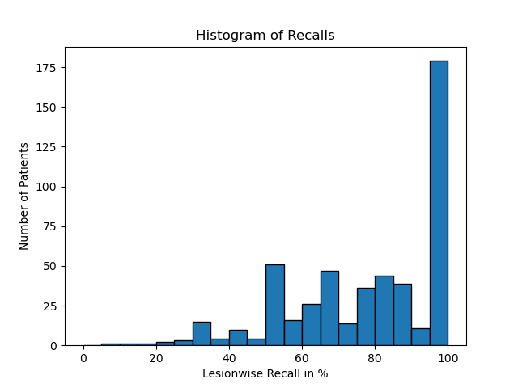
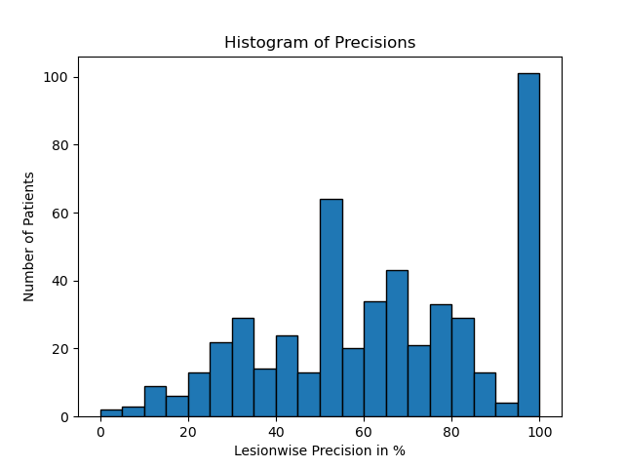

DSC and NSD overall show the same pattern and values.

Comparing with the TMTV-NET paper :
Since the TMTV-Net Paper only provides the TMTV correlation, the TMTV recall (refered to as the detection rate in the paper) the mean of the global dice score, we can only compare our evaluation on these metrics.

 | TMTV Correlation | Mean Dice Score | TMTV Recall | AE (mL) | ARE
TMTV-Net Paper | 0,89 | 66% ± 12 | 68% ± 19 | 157,32 ± 378,12 | 0,43 ± 0,54
Our study | 0,79 | 80,51% ± 26,37 | 75,7 % ± 30,19 | 198,4 ± 416,6 | 0,3 ± 0,47

It should be noted that the TMTV correlation (AE and ARE as well) is not a good indicator of the efficiency of the model, since TMTV-Net predicted TMTV and GT TMTV values can be close while also having a terrible dice score, this happens when a similar predicted volume covers the wrong areas. A drop in the correlation is therefore not an indicator of the inefficiency of the model, but can rather be justified by the thresholding of the predictions since they are more often oversegmented than the ground truth.
TMTV-Net thus shows better performance on our dataset with the modifications applied to the implementation of the model, showing a higher Mean Dice Score and TMTV Recall.

51011101871009_4thresholded_SEG.nii.gz')[1]
array([[ 0.00000000e+00, -4.07283020e+00, 0.00000000e+00,
5.96307007e+02],
[ 4.07283020e+00, 0.00000000e+00, 0.00000000e+00,
-4.07191986e+02],
[ 0.00000000e+00, 0.00000000e+00, 2.02699995e+00,
-1.34014001e+03],
[ 0.00000000e+00, 0.00000000e+00, 0.00000000e+00,
1.00000000e+00]])

DOCUMENTATION :
Le dossier ‘Stage TMTV-NET’ contient 3 sous dossiers important : Inference – data – scripts .
-Inference : c’est le dossier qui contient le modèle + les poids à l’aide desquels on build l’image docker utilisée pour faire tourner des inférences.
-Scripts : ce dossier contient des scripts python pour le traitement des résultats sortis par l’inférence, tout ce qui est seuillage, calcul des métriques globales et lésionnelles… les fichiers qui nous interessent sont script.py et stats.py. Script.py contient les fonctions qui vont permettre de prendre en entrée la sortie brut du TMTV-Net et sortir pour chaque patient un fichier texte avec toutes les métriques globales et lesionnelles. Stats.py permet d’effectuer des opérations sur la globalité des fichiers texte pour calculer des moyennes ou des incertitudes, mais aussi pour obtenir des csv pour une certaine metrique.
-Data : contient la base de donnée dicom, les gt, les predictions, ainsi que l’analyse des prédictions.

558 =241(bonnes prediction)+317(mauvaises predictions)

317 = 158+159 (moitié moitié)

241= 120+121 (moitié moitié)

25 nuls dans la base de test

NOTE POUR LA STATION : De temps en temps le pilote de la carte graphique se désinstalle tout seul pour une raison ou pour une autre (ça m’est arrivé 3 fois) il suffit de le réinstaller, il faut pour cela exécuter le fichier ‘NVIDIA-Linux-x86_64-550.78.run’ dans le dossier telechargments via le terminal avec la commande sudo.

Probleme docker gpu
Installer le driver
sudo apt-get install -y nvidia-container-toolkit
sudo docker pull nvidia/cuda:12.4.1-base-ubuntu22.04
sudo docker run --rm --gpus all nvidia/cuda:12.4.1-base-ubuntu22.04 nvidia-smi
Erreur: "Failed to initialize NVML: Unknown Error" faire ceci:
sudo nano /etc/nvidia-container-runtime/config.toml, then changed no-cgroups = false, save
Restart docker daemon: sudo systemctl restart docker, then you can test by running sudo docker run --rm --runtime=nvidia --gpus all ubuntu nvidia-smi
Source:
https://stackoverflow.com/questions/72932940/failed-to-initialize-nvml-unknown-error-in-docker-after-few-hours

Mot de passe : yahya2424

Inference :
Pour lancer l’inference, se placer dans le dossier data et lancer la commande suivante en remplaçant ‘tmtv-net-inference-no-sitk’ par le nom de l’image :
for file in ./dicom/*; do sudo docker run -it --gpus all -v "$file":/input -v '/home/yahya/Documents/Stage TMTV-NET/data/pred_masks':/output tmtv-net-inference-no-sitk; done
Lesionwise :
Dans les fichiers metriques.txt il y a deux approches lesionwise, la deuxième est plus convenable que la première, c’est celle qui sera utilisée.
Dans l’état actuel du code, les metriques lesionwise sont calculée à l’aide du dice score. On peut changer cela en NSD, il faut pour cela changer certaines choses dans le fichier script.py. J’ai fait ces changements dans le fichier script_nsd.py

SCRIPT.PY
Pour que les fonctions ci-dessous marchent, il faut absolument que la strucure des dossiers soit la meme que l’actuelle avec les meme noms (data)→(pred_masks,gt_masks,dicom,analyse)pred_masks,gt_masks,dicom,analyse
Deux fonctions importantes : AssessSegmentation(gt_nii_path,tmtv_seg_path,patient_dicom,tolerance_mm,suv_threshold=4,percentile_hausdorff=95) :
Fait l’analyse d’une seule prédiction.
En sortie : 4 fichiers :
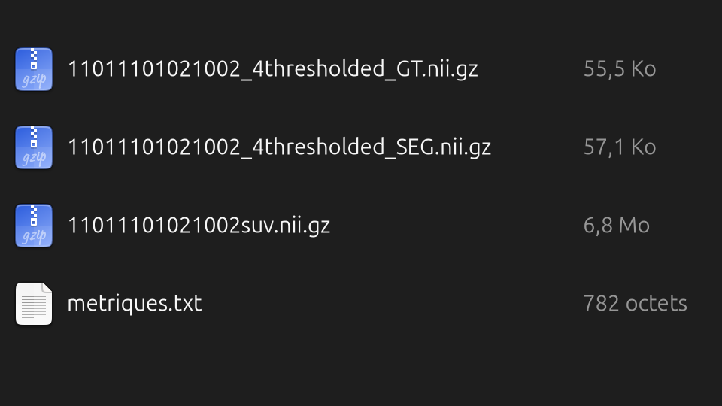

-gt_nii_path : c’est le chemin du fichier nifti GT.
-tmtv_seg_path : c’est le chemin du fichier de prediction nii.gz
-patient_dicom : dossier contenant les série dicom PET et CT
-tolerance_mm : c’est la tolérance utilisée pour le NSD/BJI en milimetres (on prend 5mm). C’est Tau dans l’image ci dessous
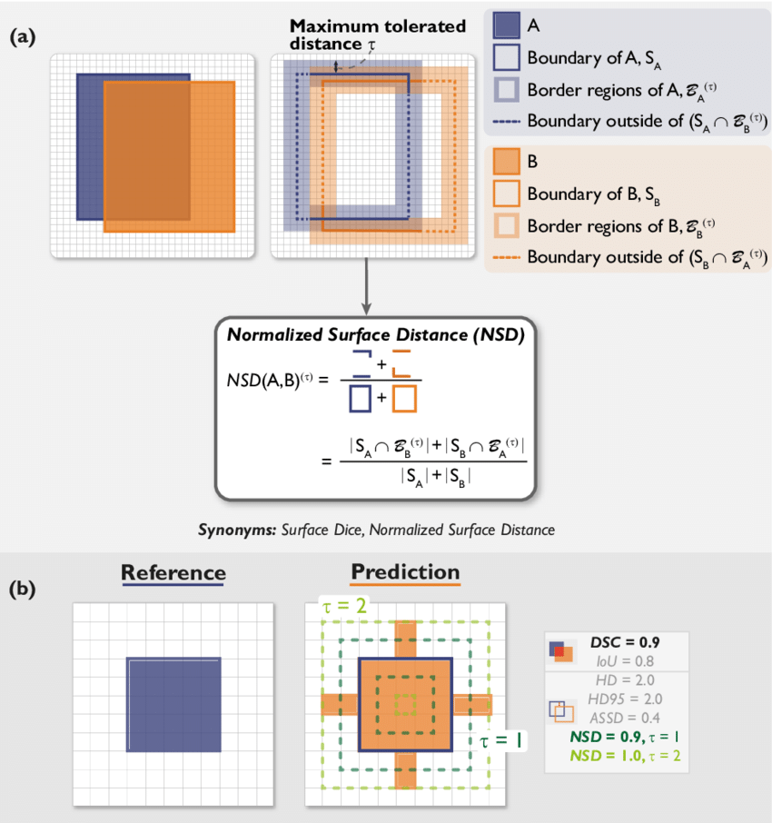

-suv_threshold : seuil de filtrage des masques GT/pred
-percentile_hausdorff : la distance d’hausdorff prend la distance maximale, pour ignorer une éventuelle anomalie, on prend la distance dans le 95ème centile. https://structseg2019.grand-challenge.org/Evaluation/

assessAll(data_base_folder,tolerance_mm,percentile_hausdorff=95,suv_threshold=4,patients_list=0):
Evalue toutes les prédictions dans le dossier analyse.
data_base_folder : le chemin du dossier contenant (pred_masks,gt_masks,dicom,analyse)
patients_list : c’est le fichier texte ‘Patients_survival(1).txt’ où il y a tous les patients qu’il faut analyser. Le fichier est dans le dossier ‘Stage TMTV-NET’

Tous les CSV sont dans le dossier data. Pour les créer, il faut utiliser les fonctions dans stats.py

