End-to-End Venue Graph Architecture
  - Automated Crowd Analytics and Structural Reasoning

1. General Workflow Overview
The End-to-End Venue Graph Architecture is an advanced AI surveillance pipeline designed to move beyond simple crowd counting. Instead of just treating a camera feed as a grid of pixels, it understands the physical architecture of the environment (the 'Venue Graph') and tracks how crowds flow through those physical spaces.
The pipeline operates in three distinct stages:
- Automated Venue Extraction: A pre-trained Vision Transformer automatically scans the camera feed, ignores crowds/clutter, and mathematically maps out the walkable corridors to generate a structural floorplan.
- Crowd Density Estimation (DDPFNet): Simultaneously, a Swin Transformer backbone analyzes the raw image to predict pixel-by-pixel crowd density heatmaps.
- Graph Risk Reasoning: The raw pixel data is projected onto the extracted physical layout. A Graph Neural Network (GNN) then analyzes the topological connections between rooms to predict the final Crowd Count and categorical Risk Level (Safe, Watch, Critical) for each distinct architectural zone.

2. Automated Venue Graph Generation
The cornerstone of the system is the Automated Venue Graph Extractor. In traditional crowd analytics, a human operator must manually draw polygons over a camera feed to tell the system where the 'rooms' and 'doors' are. This is unscalable for smart cities with thousands of cameras.
Our system automates this entirely using a pre-trained Vision Transformer Foundation Model (SegFormer), which was pre-trained on millions of structured environments. When connected to a camera, the model performs Semantic Scene Parsing to discover the layout of the venue.

Algorithmic Methodology
1. Semantic Grouping: The AI separates structural features (walls, ceilings, trees) from walkable surfaces (floors, paths, roads). Crucially, it groups 'person' pixels together with 'floor' pixels to ensure that dense crowds do not fragment the structural mapping.
2. Morphological Cleaning: The segmented mask undergoes aggressive morphological transformations (closing/opening) to bridge any gaps.
3. Convex Hull Polygonization: Contour detection maps the bounds of the walkable space, and a Convex Hull algorithm computes clean, structural architectural boundaries (ignoring the jagged edges caused by occlusions).
4. Graph Instantiation: The resulting polygons are mathematically instantiated into a structured JSON configuration (the Venue Graph) containing distinct Semantic Zones and their Adjacency connections.

Showcase: Structured Indoor Environment (The Mall Dataset)
To demonstrate the system's structural reasoning, it was deployed on the Ke Chen Mall Dataset—a famous computer vision dataset containing thousands of frames of surveillance footage from an indoor shopping mall corridor.
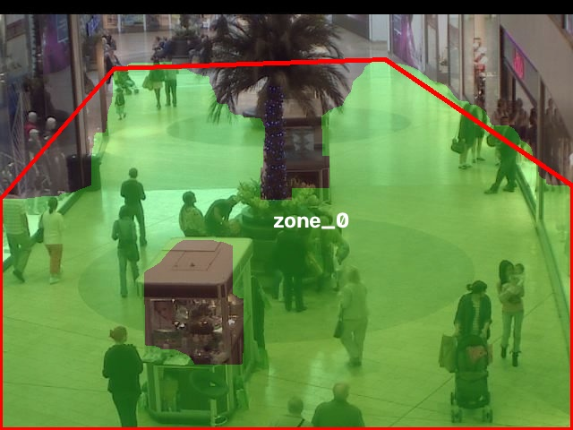
Figure 1: AI dynamically extracting the walkable mall corridor while ignoring storefront walls and ceilings.
As seen in Figure 1, the AI perfectly maps the structural boundary of the corridor. Because the Mall Dataset is a continuous video sequence from a fixed CCTV camera, it allows us to test the temporal stability of the extractor.

Temporal Stability and Crowd Occlusion
A major challenge in automatic extraction is occlusion. When a massive group of shoppers walks through the corridor, they block the floor. A naive model would redraw the room shape to avoid the people. Our geometric Convex Hull approach solves this. As tested across frames 1 through 2000 of the Mall Dataset, the AI correctly identifies that the underlying architecture hasn't moved, drawing the exact same stable structural polygon over the corridor regardless of crowd density.
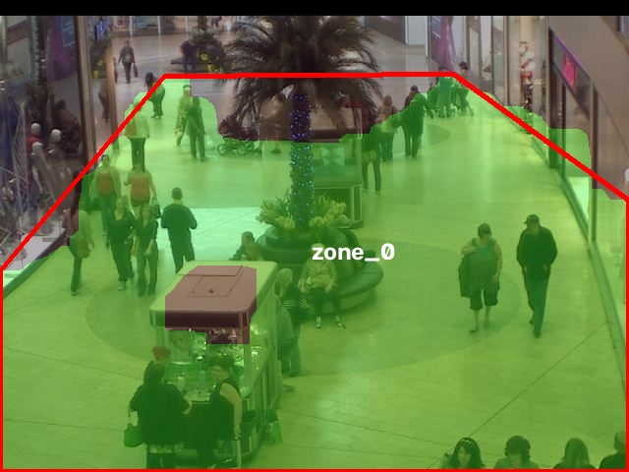
Figure 2: The model maintaining stable architectural boundaries despite heavy crowd occlusion in Frame 1000.

Showcase: Unstructured Environments (ShanghaiTech)
The model is also robust enough to handle unstructured, open-air environments like those found in the ShanghaiTech dataset. In open plazas with thousands of people, the system seamlessly adapts to draw massive, unified bounds around the entire walkable street.
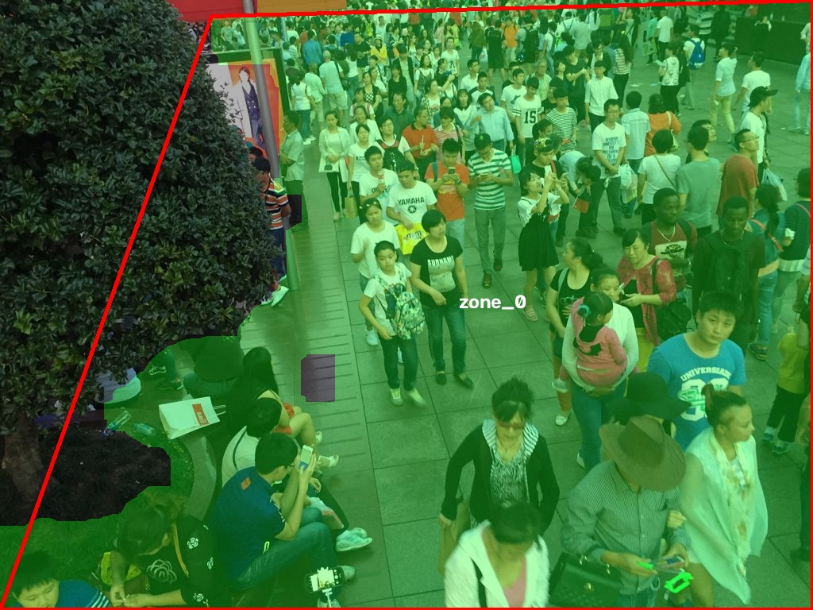
Figure 3: Unstructured venue extraction mapping a massive open-air plaza.

