**Chapter 1**

1. Which of the following are operators, and which are values?

Note: Long Answers are only for your reference, prepare your answers for 7 marks.

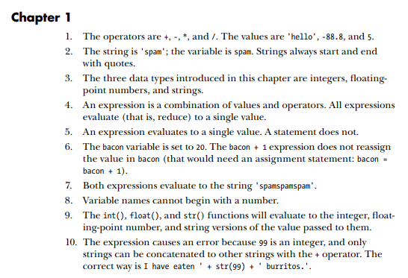

**Chapter 2**

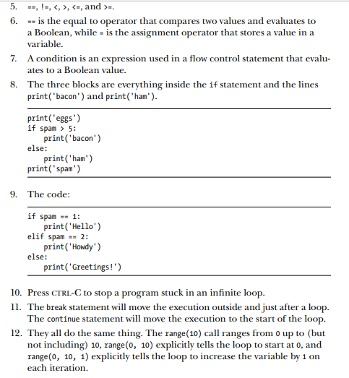

**Chapter 3**

**Chapter 4**

**Chapter 5**

**Chapter 6**



