Unit- 1

Basics of functional English

**1.1 introduction:**

English is a west germanic language originated from Anglo Frisians who brought to Britain in the mid of 5th – 7th century ad. (now north west germany). The old English was developed by them and later in 15th century it got modified into the early modern english. The famous poet/dramatist shakespeare used this english for his most of the poetries and writings. During 17th century again it got modified and then named as modern english and started getting exported to various parts of world because of british colonization. Now english is a dominant language in britain, ireland, usa, canada, australia, and new zealand so on. Even gradually it took over the place of common language in europe by replacing french and latin during 20th century. Due to influence and efforts of those english-speaking christian missionaries resulted in english becoming a second language in almost all the countries in the globe.

English language public instruction began in india in the 1830s during the [rule of the east india company (](https://en.wikipedia.org/wiki/Company_rule_in_India#Education)india was then, and is today, one of the most linguistically diverse regions of the world). In 1835, english [replaced persian a](https://en.wikipedia.org/wiki/English_Education_Act_1835)s the official language of the company. [Lord macaulay p](https://en.wikipedia.org/wiki/Thomas_Babington_Macaulay%2C_1st_Baron_Macaulay)layed a major role in introducing english and western concepts to education in india. He supported the replacement of persian by english as the official language, the use of english as the medium of instruction in all schools, and the training of english-speaking indians as teachers. Throughout the 1840s and 1850s, primary-, middle-, and high-schools were opened in many districts of [british india,](https://en.wikipedia.org/wiki/Presidencies_and_provinces_of_British_India) with most high schools offering english language instruction in some subjects. In 1857, just before the end of company rule, universities modelled on the [university of london](https://en.wikipedia.org/wiki/University_of_London) and using english as the medium of instruction were established in [bombay,](https://en.wikipedia.org/wiki/Mumbai) [calcutta](https://en.wikipedia.org/wiki/Kolkata) and [madras.](https://en.wikipedia.org/wiki/Chennai) During subsequent [crown rule](https://en.wikipedia.org/wiki/The_Crown) in india, or the [british raj,](https://en.wikipedia.org/wiki/British_Raj) lasting from 1858 to 1947, english language penetration increased throughout india. This was driven in part by the gradually increasing hiring of indians in the [civil services. A](https://en.wikipedia.org/wiki/Civil_services)t the time of india's independence in 1947, english was the only functional [lingua franca i](https://en.wikipedia.org/wiki/Lingua_franca)n the country.

After [indian independence i](https://en.wikipedia.org/wiki/Partition_of_India)n 1947, [hindi w](https://en.wikipedia.org/wiki/Hindi)as declared the first official language, and attempts were made to declare hindi the sole national language of india. Due to [protests from tamil nadu](https://en.wikipedia.org/wiki/Anti-Hindi_agitations_of_Tamil_Nadu) and other non-hindi-speaking states, it was decided to temporarily retain english for official purposes until at least 1965. By the end of this period, however, opposition from non-hindi states was still too strong to have hindi declared the sole language. With this in mind, the english language amendment bill declared english to be an associate language "until such time as all non-hindi states had agreed to its being dropped." this has not yet occurred, and it is still widely used. For instance, it is the only reliable means of day-to-day communication between the central government and the non-hindi states.

The view of the [english language](https://en.wikipedia.org/wiki/English_language) among many indians has gone from associating it with colonialism to associating it with economic progress, and english continues to be an official language of india.

While there is an assumption that english is readily available in india, available studies show that its usage is actually restricted to the elite, because of inadequate education to large parts of the indian population. The use of outdated teaching methods and the poor grasp of english exhibited by the authors of many guidebooks, disadvantage students who rely on such books.

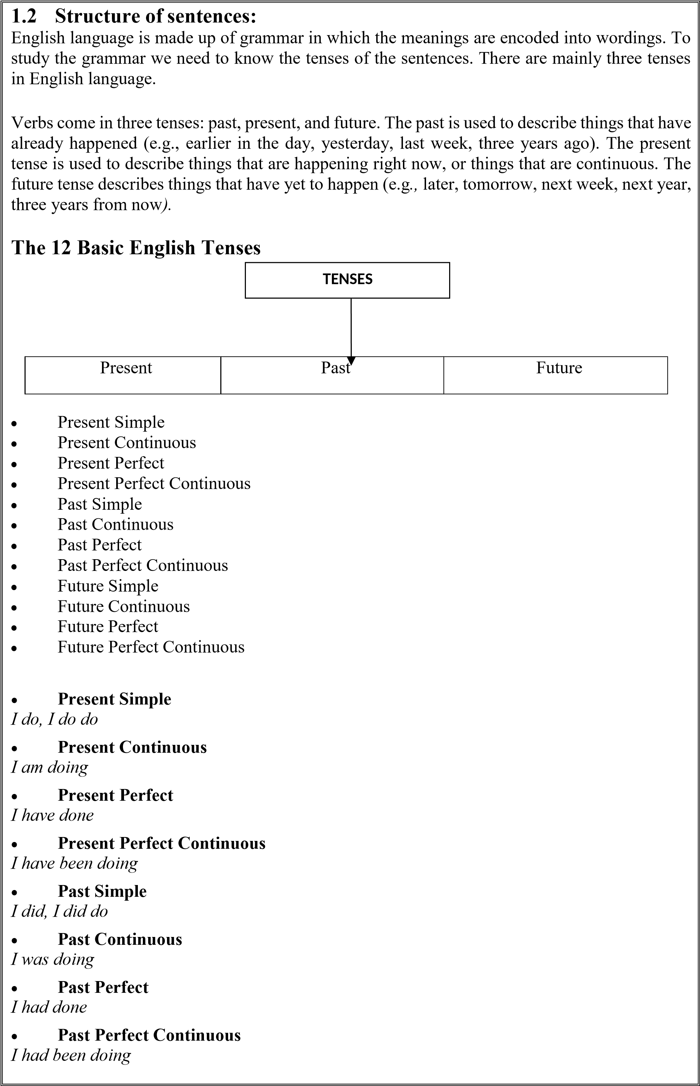

• [**future simple** ](https://www.englishclub.com/grammar/verb-tenses_future.htm)

*I will do*

• [**future continuous** ](https://www.englishclub.com/grammar/verb-tenses_future-continuous.htm)

*I will be doing*

• [**future perfect** ](https://www.englishclub.com/grammar/verb-tenses_future-perfect.htm)

*I will have done*

• [**future perfect continuous** ](https://www.englishclub.com/grammar/verb-tenses_future-perfect-continuous.htm)

*I will have been doing*

*The following table illustrates the proper use of verb tenses :*

|  |  |  |
| --- | --- | --- |
| **Simple present** | **Simple past** | **Simple future** |
| I *read* nearly every day. | Last night, i *read* an entire novel. | I *will read* as much as i can this year. |
| **Present continuous**  I *am reading* shakespeare at the moment. | **Past continuous**  I *was reading* edgar allan poe last night  . | **Future continuous**  I *will be reading* nathaniel hawthorne soon. |
| **Present perfect** | **Past perfect** | **Future perfect** |
| I *have read* so many books i can’t keep count. | I *had read* at least 100 books by the time i was twelve. | I *will have read* at least 500 books by the end of the year. |
| **Present perfect continuous** | **Past perfect continuous** | **Future perfect continuous** |
| I *have been reading* since i was four years old. | I *had been reading* for at least a year before my sister learned to read. | I *will have been reading* for at least two hours before dinner tonight. |

The job of [grammar i](https://www.thoughtco.com/what-is-grammar-1690909)s to organize [words i](https://www.thoughtco.com/word-english-language-1692612)nto [sentences, a](https://www.thoughtco.com/sentence-grammar-1692087)nd there are many ways to do that. (or we could say*,* words can be organized into sentences in many different ways*.*) For this reason, describing *how* to put a sentence together isn't as easy as explaining how to bake a cake or assemble a model plane. There are no easy recipes, no step-by-step instructions. But that doesn't mean that crafting an effective sentence depends on magic or good luck.

**There are 5 basic sentence structures.** They can be mentioned as below:

1. **Subject+ verb** eg: the boy plays
2. **Subject + verb+ object** e.g: Balu kicks the ball
3. **Subject+ verb+ adjective** eg: diya is pretty
4. **Subject + verb+ adverb** eg: manu laughs loudly
5. **Subject+ verb+ noun** eg: john is a driver

**1.3 parts of speech**

We can categorize English words into **9 basic types** called "parts of speech" or "word classes". It's quite important to recognize parts of speech. This helps you to analyse sentences and understand them. It also helps you to construct good sentences.

This is a summary of the 9 parts of speech. You can find more detail if you click on each part of speech.

|  |  |  |  |
| --- | --- | --- | --- |
| **Part of speech** | **Function or "job"** | **Example words** | **Example sentences** |
| [**Verb**](https://www.englishclub.com/grammar/verbs.htm) | Action or state | (to) be, have, do, like, work, sing, can, must | English club **is** a web site. I **like** English club. |
| [**Noun**](https://www.englishclub.com/grammar/nouns.htm) | Thing or person | Pen, dog, work, music, town, London, teacher, john | This is my **dog**. He lives in my **house**. We live in **London**. |
| [**Adjective**](https://www.englishclub.com/grammar/adjectives.htm) | Describes a noun | Good, big, red, well,  Interesting | My dogs are **big**. I like **big** dogs. |
| **Part of speech** | **Function or "job"** | **Example words** | **Example sentences** |
| [**Determiner**](https://www.englishclub.com/grammar/determiners.htm) | Limits or "determines" a noun | A/an, the, 2, some, many | I have **two** dogs and **some** rabbits. |
| [**Adverb**](https://www.englishclub.com/grammar/adverbs.htm) | Describes a verb, adjective or adverb | Quickly, silently, well,  Badly, very, really | My dog eats **quickly**. When he is **very** hungry, he eats **really** quickly. |
| [**Pronoun**](https://www.englishclub.com/grammar/pronouns.htm) | Replaces a noun | I, you, he, she, some | Tara is Indian. **She** is beautiful. |
| [**Preposition**](https://www.englishclub.com/grammar/prepositions.htm) | Links a noun to another word | To, at, after, on, but | We went **to** school **on** Monday. |
| [**Conjunction**](https://www.englishclub.com/grammar/conjunctions.htm) | Joins clauses or sentences or words | And, but, when | I like dogs **and** I like cats. I like cats **and** dogs. I like dogs **but** I don't like cats. |
| [**Interjection**](https://www.englishclub.com/grammar/interjections.htm) | Short exclamation, sometimes  Inserted into a sentence | Oh!, ouch!, hi!, well | **Ouch**! That hurts! **Hi**! How are you? **Well**, i don't know. |

The parts of speech explain how a word is used in a sentence. It is a category to which a word is assigned in accordance with its syntactic functions. In English the main parts of speech are noun, pronoun, adjective, determiner, verb, adverb, preposition, conjunction, and interjection. It is also called as [word class.](https://www.bing.com/search?q=define%2Bword%2Bclass)

**Noun:**

A noun is the name of a person, place, thing or idea.

**Kinds of noun:**

1. **Proper noun:** a proper noun is the name of some particular person or place.

Ex- Ram, Shyam, Delhi.

1. **Common noun:**

A common noun is a name given in common to every person or thing of the same kind or class.

Ex- boy, girl, teacher etc.

**3. Collective noun:**

A collective noun is the name of a group of persons or things.

Ex- army, committee, crowd etc.

1. **Abstract noun:** a noun denoting an idea, quality, or state rather than a concrete object.

Ex- strength, innocence, fear, judgment. Etc.

1. **Material noun:**

Material noun is the name given to the material, substance or things made up of the alloy. Ex- cotton, gold, silver etc.

**Noun: gender**

**1. Masculine gender:**

A noun that denotes male animal is said to be of the masculine gender.

Ex- man, boy, tiger, sun etc.

**2. Feminine gender:**

A noun that denotes a female animal is said to be of the feminine gender.

Ex- woman, girl, nature, lioness etc.

**3. Common gender:**

A noun that denotes either a male or a female is said to be of the common gender.

Ex- parent, child, student, cousin etc.

**4. Neuter gender:**

A noun that denotes a thing without life, neither male nor female, is said to be of the neuter gender.

Ex- book, pen, room etc.

**Noun:**

**1.singular noun:**

A noun that denotes one person or thing, is said to be in the singular number.

Ex- pen, cow, boy etc.

**2. Plural noun:**

A noun that denotes more than one person or thing, is said to be in the plural number.

Ex- pens, boys, cows etc

**Noun: countable / uncountable**

Countable nouns are the names of objects, people etc that we can count.

Ex- book, apple, doctor, horse etc.

Uncountable nouns are the names of things which we can’t count. They mainly denote substance and abstract things. Ex- milk, oil, sugar, gold, honesty etc.

**Noun: cases**

The case of a noun tells us about the position of that noun or pronoun in a sentence. In English, there are five cases.

**Nominative case:** a noun is said to be in the nominative case if it is the subject of a verb.

Ex- ram is an intelligent boy. **Objective case:**

Nouns or pronouns are said to be in objective case if they are the direct object of verbs or the objects of the preposition. **Dative case:**

A noun is said to be in dative case if it is the indirect object of the verb.

Rohan brought me a flower. (‘me’ is in dative case)

**Possessive case:** a noun is said to be in the possessive case if it denotes possession or ownership.

Ex- this is your pencil. (‘your’ is in possessive case) **vocative case:**

A noun or pronoun is said to be in vocative case if it is used to call ( or to get attention of a person or persons)

Ex- Mr. Mallya, people are waiting for you in the hall. (Mr. Mallya is in vocative case)

**Pronoun:**

A pronoun is used in the place of a noun to avoid repetition. Hence it is the word which replaces the noun.

What is a pronoun?

Pronouns make up a small subcategory of nouns. The distinguishing characteristic of pronouns is that they can be substituted for other nouns. For instance, if you’re telling a story about your sister sarah, the story will begin to sound repetitive if you keep repeating “sarah” over and over again.

Example, sarah has always loved fashion. Sarah announced that sarah wants to go to fashion school.

You could try to mix it up by sometimes referring to sarah as “my sister,” but then it sounds like you’re referring to two different people.

Example : sarah has always loved fashion. My sister announced that sarah wants to go to fashion school.

Instead, you can use the pronouns *she* and *her* to refer to sarah.

Sarah has always loved fashion. She announced that she wants to go to fashion school.

**Adjective:**

It describes, modifies or gives more information about a noun/ pronoun. **Verb:** it shows an action or state of being. It shows what someone or something is doing. **Adverb:** it modifies/ describes a verb, an adjective or another adverb.

What are adjectives?

**Adjectives** are words that describe the qualities or states of being of nouns: *enormous, doglike, silly, yellow, fun, fast*. They can also describe the quantity of nouns: *many, few, millions, eleven*.

Adjectives modify nouns

Most students learn that adjectives are words that modify (describe) nouns. Adjectives do not modify verbs or adverbs or other adjectives.

Examples:

Margot wore a **beautiful** hat to the pie-eating contest.

**Furry** dogs may overheat in the summertime.

My cake should have **sixteen** candles.

The **scariest** villain of all time is darth vade

In the sentences above, the adjectives are easy to spot because they come immediately before the nouns they modify.

But adjectives can do more than just modify nouns. They can also act as a complement to linking verbs or the verb *to be*. A linking verb is a verb like *to feel, to seem,* or *to taste* that describes a state of being or a sensory experience.

**Examples:**

That cow sure is **happy**.

It smells **gross** in the locker room.

Driving is **faster** than walking.

The technical term for an adjective used this way is *predicate adjective*.

**Uses of adjectives**

Adjectives tell the reader how much—or how many—of something you’re talking about, which thing you want passed to you, or which kind of something you want.

**Example:**

Please use **three white flowers** in the arrangement.

*Three* and *white* are modifying flowers.

Often, when adjectives are used together, you should separate them with a comma or conjunction. See “coordinate adjectives” below for more detail. **Examples:**

I’m looking for a **small, good-tempered dog** to keep as a pet. My new dog is **small and good-tempered**.

**Preposition:**

It shows the relationship of a noun/pronoun to another word. They can indicate time, place or relationship.

**A preposition is a word used to link** [**nouns,**](http://www.gingersoftware.com/content/grammar-rules/nouns/) [**pronouns,**](http://www.gingersoftware.com/content/grammar-rules/pronouns-2/) **or phrases to other words within a sentence.** They act to connect the people, objects, time and locations of a sentence**.** Prepositions are usually short words, and they are normally placed directly in front of nouns. In some cases, you’ll find prepositions in front of [gerund verbs.](http://www.gingersoftware.com/content/grammar-rules/verbs/gerunds-and-infinitives/)

A nice way to think about prepositions is as the words that help glue a sentence together. They do this by expressing position and movement, possession, time and how an action is completed. Indeed, several of the most frequently used words in all of english, such as *of, to, for, with, on* and at, are prepositions. Explaining prepositions can seem complicated, but they are a common part of language and most of us use them naturally without even thinking about it.

In fact, it’s interesting to note that prepositions are regarded as a ‘closed class’ of words in the english language. This means, unlike verbs and nouns, no new words are added to this group over time. In a way, it reflects their role as the functional workhorse of the sentence. They are unassuming and subtle, yet vitally important to the meaning of language.

* The first rule is that to make sentences clear, specific prepositions are needed. For example, the preposition *in* means one thing and the preposition *on* cannot substitute for it in all cases. Some prepositions are interchangeable but not always. The correct preposition means one particular thing and using a different proposition will give the sentence a very different meaning. *I want to see you* ***in*** *the house now, bill!* Means something very different from *i want to see you* ***on*** *the house now, bill!* ***In*** *the house* means bill should go through the door, walk inside, and stand in the hall or living room. ***On*** *the house* means bill would need to get a ladder and climb to the roof where he would be *on top of* the house.
* The second rule for using prepositions is that prepositions are generally followed by nouns or pronouns. There was a time in the past when teachers held strictly to this rule, but it made for some clunky sentences. *I am seeking someone i can depend on* ends with the preposition *on*, so people who insisted that sentences shouldn’t end with a preposition would be forced to use convoluted and unnatural phrasing. To avoid ending that sentence above with a preposition, you’d have to say, *someone i can depend on is whom i am seeking.*
* There are more than 100 prepositions in the english language. In addition, there are endless possibilities for creating [prepositional phrases**,**](http://www.gingersoftware.com/content/grammar-rules/preposition/prepositional-phrases/)phrases that begin with a preposition and end with a noun or pronoun. In the following sections, you will find examples of prepositions, types of prepositions, a comprehensive list of prepositions, and some helpful preposition exercises. As you read the examples and study the list, remember that prepositions usually convey concepts such as comparison, direction, place, purpose, source possession, and time.

Examples of prepositions

In the following sentences, examples of prepositions have been italicized. As you read, consider how using different prepositions or even different types of prepositions in place of the examples might change the relationship between the rest of the words in the sentence.

* I prefer to read *in* the library.
* He climbed *up* the ladder to get *onto* the roof.
* Please sign your name *on* the dotted line *after* you read the contract.
* Go *down* the stairs and *through* the door.
* He swam *across* the pool.
* Take your brother *with* you.

**Types of prepositions**

There are three types of prepositions, including time prepositions, place prepositions, and direction prepositions.

[**Time prepositions** a](http://www.gingersoftware.com/content/grammar-rules/preposition/preposition-time/)re those such as *before, after, during,* and *until;*

[**Place prepositions** a](http://www.gingersoftware.com/content/grammar-rules/preposition/preposition-place/)re those indicating position, such as *around, between,* and *against;* and **direction prepositions** are those indicative of direction, such as *across, up,* and *down.* Each type of preposition is important. **Prepositions of time**

Basic examples of time prepositions include: *at, on, in, before* and *after*. They are used to help indicate when something happened, happens or will happen. It can get a little confusing though, as many different prepositions can be used.

Prepositions of time examples in the following sentences are in bold for easy identification. For example:

* I was born **on** july 4th, 1982.
* I was born **in** 1982.
* I was born **at** exactly 2am.
* I was born two minutes **before** my twin brother.
* I was born **after** the great war ended.

The above makes it seem quite difficult, with five different prepositions used to indicate when something happened. However, there is a set of guidelines that can help decide which preposition to use:

For years, months, seasons, centuries and times of day, use the preposition ***in***:

* I first met john **in** 1987. It’s always cold **in** january
* Easter falls **in** spring each year.
* The second world war occurred **in** the 20th century.

We eat breakfast **in** the morning.

For days, dates and specific holiday days, use the preposition ***on***.

1. We go to school **on** mondays, but not **on** sunday.
2. Christmas is **on** december 25th.
3. Buy me a present **on** my birthday.

For times, indicators of exception and festivals, use the preposition ***at***:

* Families often argue **at** christmas time.
* I work faster **at** night.
* Her shift finished **at** 7pm.

***Before*** and ***after*** should be much easier to understand than the other examples of prepositions of time. Both are used to explain when something happened, happens or will happen, but specifically in relation to another thing.

* **Before** i discovered this bar, i used to go straight home **after** work.
* We will not leave **before** 3pm.
* David comes **before** bryan in the line, but **after** louise.

Other prepositions of time could include: *during, about, around, until and throughout.*

* The concert will be staged **throughout** the month of may.
* I learned how to ski **during** the holidays.
* He usually arrives **around** 3pm.
* It was **about** six in the morning when we made it to bed.
* The store is open **until** midnight.

**Prepositions of place**

To confuse matters a bit, the most common prepositions to indicate time – **on, at, in** – are also the most common prepositions to indicate position. However, the rules are a little clearer as place prepositions are a more rigid concept than time prepositions.

Prepositions of place examples in the following sentences are in bold for easy identification.

* The cat is **on** the table.
* The dogs are **in** the kennel.
* We can meet **at** the crossroads.

The guidelines can be broken down as follows:

**On** is used when referring to something with a surface:

* The sculpture hangs **on** the wall.
* The images are **on** the page.
* The specials are **on** the menu, which is **on** the table.

**In** is used when referring to something that is inside or within confined boundaries. This could be anything, even a country:

1. Jim is **in** france, visiting his aunt **in** the hospital.
2. The whiskey is **in** the jar **in** the fridge.
3. The girls play **in** the garden.

**At** is used when referring to something at a specific point:

1. The boys are **at** the entrance **at** the movie theatre.
2. He stood **at** the bus stop **at** the corner of water and high streets.
3. We will meet **at** the airport.

Lots of other prepositions of place, such as *under, over, inside, outside, above* and *below* are used in english. There is, however, a lot less confusion as they refer to rigid positions rather than abstract ones.

* The cat is **under** the table.
* Put the sandwich **over** there.
* The key is locked **inside** the car.
* They stepped **outside** the house.
* Major is ranked **above** corporal.
* He is waving at you from **below** the stairs.

**Prepositions of movement**

Prepositions of movement are quite easy to understand as they are less abstract than prepositions of place and time. Essentially, they describe how something or someone moves from one place to another. The most commonly used preposition of movement is ***to***, which usually serves to highlight that there is movement towards a specific destination.

Prepositions of movement examples in the following sentences are in bold for easy identification.

* He has gone on vacation **to** france.
* She went **to** the bowling alley every friday last summer.
* I will go **to** bed when i am tired.
* They will go **to** the zoo if they finish their errands.

Other more specific prepositions of movement include: *through, across, off, down* and *into*. These prepositions can sometimes get mixed up with others. While they are similar, they have individual meanings that add context to the movement. ***Across*** refers to moving from one side to another.

* Mike travelled **across** america on his motorcycle.
* Rebecca and judi are swimming **across** the lake.

***Through*** refers to moving directly inside something and out the other end.

* The bullet ben shot went **through** the window.
* The train passes **through** the tunnel.

***Into*** refers to entering or looking inside something.

* James went **into** the room**.**
* They stare **into** the darkness.

***Up, over, down, past*** and ***around*** indicate directions of movement:

1. Jack went **up** the hill.
2. Jill came tumbling **down** after.
3. We will travel **over** rough terrain on our way to grandma’s house.
4. The horse runs **around** the track all morning.
5. A car zoomed **past** a truck on the highway.

**Conjunction:**

It joins the two words, ideas, phrases or clauses together in a sentence and shows how they are connected.

A conjunction is a part of speech that is used to connect words, phrases, clauses, or sentences. Conjunctions are considered to be invariable grammar particle, and they may or may not stand between items they conjoin. **Types of conjunctions**

There are several different types of conjunctions that do various jobs within sentence structures. These include:

* [***Subordinating conjunctions*** –](http://www.gingersoftware.com/content/grammar-rules/conjunctions/subordinating-conjunctions/) also known as subordinators, these conjunctions join dependent clauses to independent clauses.
* [***Coordinating* conjunction** –](http://www.gingersoftware.com/content/grammar-rules/conjunctions/coordinating-conjunctions/) also known as coordinators, these conjunctions coordinate or join two or more sentences, main clauses, words, or other parts of speech which are of the same syntactic importance.
* [***Correlative conjunction*** –](http://www.gingersoftware.com/content/grammar-rules/conjunctions/correlative-conjunctions/) these conjunctions correlate, working in pairs to join phrases or words that carry equal importance within a sentence.
* [**Conjunctive adverbs** –](http://www.gingersoftware.com/content/grammar-rules/conjunctions/conjunctive-adverbs/) while some instructors do not teach conjunctive adverbs alongside conjunctions, these important parts of speech are worth a mention here. These [**adverbs** a](http://www.gingersoftware.com/content/grammar-rules/adverb/)lways connect one clause to another, and are used to show sequence, contrast, cause and effect, and other relationships.

When people first learn to write, they usually begin with short, basic sentences like these: “*my name is ted. I am a boy. I like dogs.”* One of the most important jobs conjunctions do is to connect these short sentences so they sound more like this: “*i am a boy named ted, and i like dogs.”*

**Conjunction rules**

There are a few important rules for using conjunctions. Remember them and you will find that your writing flows better:

* Conjunctions are for connecting thoughts, actions, and ideas as well as [**nouns**,](http://www.gingersoftware.com/content/grammar-rules/nouns/) clauses, and other parts of speech. For example: *mary went to the supermarket* ***and*** *bought oranges*. Conjunctions are useful for making lists. For example: *we made pancakes, eggs,* ***and*** *coffee for breakfast.*
* When using conjunctions, make sure that all the parts of your sentences agree. For example: “*i work busily* ***yet*** *am careful”* does not agree. “*i work busily* ***yet*** *carefully”* shows agreement.

**Conjunctions list**

There are only a few common conjunctions, yet these words perform many functions: they present explanations, ideas, exceptions, consequences, and contrasts. Here is a list of conjunctions commonly used in american english:

* And
* As
* Because
* But
* For
* Just as
* Or
* Neither
* Nor
* Not only
* So
* Whether
* Yet

**Examples of conjunctions**

In the following examples, the conjunctions are in bold for easy recognition:

* I tried to hit the nail ***but*** hit my thumb instead.
* I have two goldfish ***and*** a cat.
* I’d like a bike ***for*** commuting to work.
* You can have peach ice cream ***or*** a brownie sundae.
* Neither the black dress ***nor***th gray one looks right on me.
* My dad always worked hard ***so*** we could afford the things we wanted.
* I try very hard in school ***yet*** i am not receiving good grades.

**Interjection:**

It is a word/phrase that expresses a strong feeling or emotion. It is a short exclamation.

An interjection is one of the eight major parts of speech, along [with](http://grammar.yourdictionary.com/parts-of-speech/verbs/)

[Verbs,](http://grammar.yourdictionary.com/parts-of-speech/verbs/) [nouns,](http://grammar.yourdictionary.com/parts-of-speech/nouns/) [pronouns,](http://www.yourdictionary.com/library/grammar/parts-of-speech/pronouns.html) [adjectives,](http://www.yourdictionary.com/library/grammar/parts-of-speech/adjectives.html) [adverbs,](http://www.yourdictionary.com/library/grammar/parts-of-speech/adverbs.html) [prepositions a](http://grammar.yourdictionary.com/parts-of-speech/prepositions/)nd [conjunctions.](http://grammar.yourdictionary.com/parts-of-speech/conjunctions/) Some grammarians believe interjections are the least important part of speech. That might be because interjections aren't generally required in order for the meaning of a sentence to be clear.

Interjections, like "wow" and "ouch," are solely designed to convey emotion in an abrupt and exclamatory way. They express meaning or feeling in a word or two. They do not relate grammatically to the other parts of the sentence, nor do they help the reader understand the relationship between words and phrases in the sentence.

Instead, interjections simply convey the way the author (or speaker) is feeling. Interjections are rarely used in academic or formal writing; they're more common in fiction or artistic writing. They're usually, but not always, offset by an exclamation point (which is also used to show emotion).

**Use of interjections**

You'll find interjections at the beginning of sentences, in the middle of sentences, at the end of sentences, and sometimes as standalone sentences on their own. **Beginning of sentences**

Interjections are commonly used at the beginning of the sentence. They're also associated with a [punctuation mark d](https://grammar.yourdictionary.com/punctuation/what/fourteen-punctuation-marks.html)esigned to convey emotion: the exclamation point.

For example:

* "oh no, i can't believe that it is snowing here again!"
* "wow, this is such a pleasant surprise!"

In these sentences, the interjection ("oh no" and "wow") appear at the beginning of the sentence. In addition, the emotion is strong and the sentence itself ends with an exclamation point to illustrate that.

**Determiner/ articles:**

It may be definite or indefinite which helps to define noun. A [determiner i](http://education.yourdictionary.com/for-teachers/teaching-articles-and-determiners.html)s a word that introduces a noun. It always comes before a noun, not after, and it also comes before any other adjectives used to describe the noun.

Determiners are required before a singular noun but are optional when it comes to introducing plural nouns. For example, consider the placement and usage of the common determiner *the* in the sentences below:

* *The* bunny went home.
* I ate *the* chocolate cookie for dessert.
* Metal cans are recyclable.
* *The* metal cans are recyclable.

In every example, the determiner is placed before the noun or noun phrase, regardless of whether the noun in the subject or predicate. In the first example, it comes directly before the noun, but in the second example, it comes before the adjective ("chocolate") that describes the noun ("cookie").

Note also that in the third example there is no determiner, as determiners are optional for plural nouns and noun phrases. When you want to discuss the noun in general (i.e., all metal cans), you don't need a determiner for plural nouns. However, the fourth example shows that you may add a determiner to refer to specific nouns (i.e., the metal cans right here).

There are four different types of determiners in english: articles, [demonstratives,](http://www.yourdictionary.com/demonstrative) [quantifiers,](http://www.yourdictionary.com/quantifier) and possessives. **Articles**

[Articles a](http://grammar.yourdictionary.com/grammar-rules-and-tips/definite-and-indefinite-articles.html)re among the most common of the determiners. There are three singular articles: *a, an*, and *the.* Articles specify (or determine) which noun the speaker is referring to. *A* and *an* are **indefinite articles** and are used when you are talking about a general version of the noun. For example:

* *A* dog is *a* good pet.
* *An* ostrich would beat *a* chicken in *a* race.

In these examples, the sentence is talking about dogs or ostriches in general, meaning any dog. When your meaning is general, use an indefinite article. Note that *a* is used before words that begin with consonants while *an* is used before words beginning with vowels.

On the other hand, *the* is a **definite article**, meaning the speaker is referring to a specific noun. For example:

* We went to *the* best restaurant in town.
* *The* dog is barking too loudly.

Here the speaker is referring to a particular dog and a particular restaurant. It's not a general category, but only one animal or place that's important. When your meaning is specific, use a definite article.

* 1. **Linkers**

Linking words help us to connect ideas and sentences when we speak or write english. We can use linking words to give examples, add information, summarize, sequence information, give a reason or result, or to contrast ideas.

Example: it was raining. I stayed at home.

We can see that the first idea ‘it was raining’ is the reason for the second idea ‘i stayed at home’. We can use linkers such as **so** or **therefore** to make the relation between two ideas clear. Hence, they show the relationship of reason and result or cause and effect. Linkers are also prepositions.

* 1. **Idioms and phrases**

**Idioms:**

An idiom is a phrase or an expression that has a figurative, or sometimes literal, meaning. Categorized as formulaic language, an idiom's figurative meaning is different from the literal meaning. There are thousands of idioms, occurring frequently in all languages. Hence it can be defined as an expression that takes on a figurative meaning when certain words are combined, which is different from the literal definition of the individual words. It’s an expression whose meaning is not predictable from the usual meaning is not predictable from the usual meanings of its constituent elements.

E.g.: “shoot yourself in the foot” means to do something that hurts yourself. “kick the bucket” means to die

“piece of cake” means it’s easy

**Phrases and clauses:**

Phrases are the small group of words standing together as a conceptual unit, typically forming a component of a clause. In everyday speech, we use phrases it may be any group of words which carries a special idiomatic meaning or a synonymous with expression. There are two types of clauses called as independent clause and a subordinate/dependent clause.

E.g.: the bewildered tourist was lost. The senile old man was confused.

**Uses of phrases in standardizing communication:**

Most important quality of a good leader is ability to communicate effectively. When it is communicated effectively the personal relationship will improve and thus it leads to efficiency at work place and also an employee. The uses are:

* To diffuse tense conversation: it helps in finding the relation between what is reported in sentence and time of it happening. 
* To facilitate clear understanding: when we add more phrases there is a chance of understanding more. 
* To add trust and respect to relationship: when more of phrases are used, the trust and respect of the employees towards the organization. 

**1.6 accent and pronunciation:**

The term *accent* has various meanings, but in [speaking,](https://www.thoughtco.com/speech-linguistics-1692121) an accent is an identifiable style of [pronunciation,](https://www.thoughtco.com/pronunciation-english-1691686) often varying regionally or even socioeconomically. Accent is the stress or emphasis on a particular part of something usually a word. It would be the loudest part of a word. A distinctive way of pronouncing a language, especially one associated with a particular country, area, or social class. Accents are not just regional but sometimes contain information about a person's ethnicity, such as in the case of non-native english speakers; education; or economic status. An **accent** is a particular way of pronouncing a language. 'Warsh' for wash in cajun louisiana, 'new yawk' for new york among native new yorkers, 'aboot' for about in canada. E.g.: knee= /ni: / knife= / naif/

Pronunciation is the act or a way of saying a word. Accent is the mark used to show the stress on the syllabus or to pronounce with emphasis. E.g.: direction, finale.

**Phonetics alphabet**

Sometimes it is important that the information we transmit it absolutely correctly received. For this reason, sometime we my spell as word and to do this we use the phonetic alphabet.

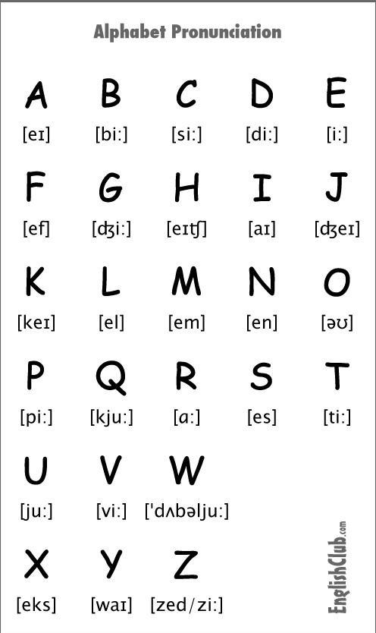

**Letters: -**

|  |  |  |
| --- | --- | --- |
| **Letter** | **Code word** | **Pronunciation** |
| A | Alphas | Al fah |
| B | Bravo | Brah voh |
| C | Charlie | Char lee |
| D | Delta | Dell tah |
| E | Echo | Eck oh |
| F | Foxtrot | Foks trot |
| G | Golf | Golf |
| H | Hotel | Ho tell |
| I | India | In dee ah |
| J | Juliet | Jew lee ett |
| K | Kilo | Key loh |
| L | Lima | Lee mah |
| M | Mike | Mike |
| N | November | No vem ber |
| O | Oscar | Oss cah |
| P | Papa | Pah pah |
| Q | Quebec | Keh beck |
| R | Romeo | Row me oh |
| S | Sierra | See air rah |
| T | Tango | Tang go |
| U | Uniform | You nee form |
| V | Victor | Vik tah |
| W | Whiskey | Wiss key |
| X | X-ray | Ecks ray |
| Y | Yankee | Yang key |
| Z | Zulu | Zoo loo |

**Digits: -**

|  |  |  |
| --- | --- | --- |
| **Digit** | **Code word** | **Pronunciation** |
| 0 | Zero | Ze ro |
| 1 | One | Wun |
| 2 | Two | Too |
| 3 | Three | Tree |
| 4 | Four | Fow er |
| 5 | Five | Fife |
| 6 | Six | Six |
| 7 | Seven | Sev en |
| 8 | Eight | Ait |
| 9 | Nine | Nin er |

**1.7 comprehensive and reading skills**

Motivating students to read widely is integral to comprehension instruction. Motivation plays an important part both in helping students learn to read and in promoting higher levels of literacy. Wide reading experiences enhance students' abilities to comprehend an increasingly wider array of text types and texts of increasing difficulty.

It is no surprise that students who are good readers read a great deal-both in school and on their own. They read a variety of texts for a variety of purposes-to learn, to keep informed, to satisfy curiosity, and to entertain themselves.

The reading experiences, attitudes, and perspectives of students determine the ways in which they perceive the purpose of reading and value its benefits. Instructional practices to promote students' motivation to read widely include:

* Providing daily opportunities for students to read both self-selected and teacher-and peer- recommended texts; and
* Providing frequent opportunities for both student- and teacher-led discussions of what students are reading.
* Organizing cooperative learning groups in which students can discuss what they read, help each other choose the strategies that are most appropriate for a specific text; 
* Encouraging students to read so as to learn about a concept or topic that is meaningful to them;
* Involving students actively in reading-related activities;
* Encouragement for students to read independently; and
* Opportunities for students to choose from texts that reflect different genres and reading levels.

Reading comprehension can be challenging for [lots of reasons.](https://www.understood.org/en/learning-attention-issues/child-learning-disabilities/reading-issues/understanding-your-childs-trouble-with-reading) Whatever the cause, knowing the skills involved, and which ones your child struggles with, can help you get the right support.

Here are six essential skills needed for reading comprehension, and tips on what can help kids improve this skill.

**1. Decoding**

[Decoding i](https://www.understood.org/en/learning-attention-issues/child-learning-disabilities/reading-issues/decoding-what-it-is-and-how-it-works)s a vital step in the reading process. Kids use this skill to sound out words they’ve heard before but haven’t seen written out. The ability to do that is the foundation for other reading skills.

Decoding relies on an early language skill called [phonemic awareness.](https://www.understood.org/en/learning-attention-issues/child-learning-disabilities/reading-issues/phonological-awareness-phonemic-awareness-and-phonics-what-you-need-to-know) (This skill is part of an even broader skill called *phonological awareness*.) Phonemic awareness lets kids hear individual sounds in words (known as *phonemes*). It also allows them to “play” with sounds at the word and syllable level.

Decoding also relies on connecting individual sounds to letters. For instance, to read the word *sun*, kids must know that the letter *s* makes the /s/ sound. Grasping the connection between a letter (or group of letters) and the sounds they typically make is an important step toward “sounding out” words.

**What can help:** Most kids pick up the broad skill of [phonological awareness n](https://www.understood.org/en/learning-attention-issues/child-learning-disabilities/reading-issues/phonological-awareness-what-it-is-and-how-it-works)aturally, by being exposed to books, songs, and [rhymes.](https://www.understood.org/en/school-learning/learning-at-home/encouraging-reading-writing/8-childrens-books-featuring-rhyme-and-alliteration) But some kids don’t. In fact, one of the early signs of reading difficulties is trouble with rhyming, counting syllables, or identifying the first sound in a word.

The best way to help kids with these skills is through specific instruction and practice. Kids have to be taught how to identify and work with sounds. You can also [build phonological awareness](https://www.understood.org/en/school-learning/learning-at-home/encouraging-reading-writing/9-ways-to-build-phonological-awareness-in-pre-k-and-kindergarten) at home through activities like word games and reading to your child.

**2. Fluency**

To read fluently, kids need to instantly recognize words, includin[g ones they can’t sound out.](https://www.understood.org/en/learning-attention-issues/child-learning-disabilities/reading-issues/the-difference-between-decodable-and-non-decodable-words) Fluency speeds up the rate at which they can read and understand text. It’s also important when kids encounter irregular words, like *of* and *the*, which can’t be sounded out.

Sounding out or decoding every word can take a lot of effort. *Word recognition* is the ability to recognize whole words instantly by sight, without sounding them out.

When kids can read quickly and without making too many errors, they are “fluent” readers.

Fluent readers read smoothly at a good pace. They group words together to help with meaning, and they use the proper tone in their voice when reading aloud. [Reading fluency i](https://www.understood.org/en/learning-attention-issues/child-learning-disabilities/reading-issues/why-isnt-my-child-reading-fast-enough)s essential for good reading comprehension.

**What can help:** Word recognition can be a big obstacle for struggling readers. Average readers need to see a word four to 14 times before it becomes a “[sight word”](https://www.understood.org/en/learning-attention-issues/child-learning-disabilities/reading-issues/at-a-glance-star-words-by-grade) they automatically recognize. Kids with dyslexia, for instance, may need to see it up to 40 times.

Lots of kids struggle with reading fluency. As with other reading skills, kids need lots of specific instruction and practice to improve word recognition.

The main way to [help build this skill i](https://www.understood.org/en/school-learning/partnering-with-childs-school/instructional-strategies/7-ways-to-improve-reading-fluency)s through practice reading books. It’s important to [pick out books that are at the right level o](https://www.understood.org/en/school-learning/learning-at-home/encouraging-reading-writing/4-steps-to-choosing-books-at-your-childs-reading-level)f difficulty for kids.

**3. Vocabulary**

To understand what you’re reading, you need to understand most of the words in the text. Having a strong vocabulary is a key component of reading comprehension. Students can learn vocabulary through instruction. But they typically learn the meaning of words through everyday experience and also by reading.

**What can help:** The more words kids are exposed to, the richer their vocabulary becomes. You can help [build your child’s vocabulary b](https://www.understood.org/en/school-learning/partnering-with-childs-school/instructional-strategies/7-ways-to-improve-vocabulary)y having frequent conversations on a variety of topics. Try to include new words and ideas. Telling jokes and playing word games is a fun way to build this skill.

Reading together every day also helps improve vocabulary. When reading aloud, stop at new words and define them. But also encourage your child to read alone. Even without hearing a definition of a new word, your child can use context to help figure it out.

Teachers can help, too. They can carefully choose interesting words to teach and then give explicit instruction (instruction that is specialized and direct). They can engage students in conversation. And they can make learning vocabulary fun by playing word games in class.

For more ideas, watch as an expert explains [how to help struggling readers build their vocabulary.](https://www.understood.org/en/school-learning/learning-at-home/encouraging-reading-writing/video-helping-struggling-readers-build-their-vocabulary)

1. **Sentence Construction and Cohesion**

Understanding how sentences are built might seem like a [writing skill.](https://www.understood.org/en/learning-attention-issues/child-learning-disabilities/writing-issues/6-skills-kids-need-for-written-expression) So might connecting ideas within and between sentences, which is called *cohesion*. But these skills are important for reading comprehension as well.

Knowing how ideas link up at the sentence level helps kids get meaning from passages and entire texts. It also leads to something called *coherence*, or the ability to connect ideas to other ideas in an overall piece of writing.

**What can help:** Explicit instruction can teach kids the basics of sentence construction. For example, teachers can work with students on connecting two or more thoughts, through both writing and reading.

1. **Reasoning and Background Knowledge**

Most readers relate what they’ve read to what they know. So it’s important for kids to have background or prior knowledge about the world when they read. They also need to be able to “read between the lines” and pull out meaning even when it’s not literally spelled out.

Take this example: A child is reading a story about a poor family in the 1930s. Having knowledge about the Great Depression can provide insight into what’s happening in the story. The child can use that background knowledge to make inferences and draw conclusions.

**What can help:** Your child can build knowledge through reading, conversations, movies and TV shows, and art. Life experience and hands-on activities also [build knowledge.](https://www.understood.org/en/community-events/blogs/teacher-tips/2017/06/06/teacher-tip-the-most-fun-way-to-build-reading-skills-for-back-to-school) Expose your child to as much as possible, and talk about what you’ve learned from experiences you’ve had together and separately. Help your child make connections between new knowledge and existing knowledge. And ask open-ended questions that require thinking and explanations.

You can also read a teacher tip on [using animated videos to help your child make inferences.](https://www.understood.org/en/community-events/blogs/teacher-tips/2017/04/12/teacher-tip-use-animated-videos-to-help-your-child-learn-to-make-inferences)

**6. Working Memory and Attention**

These two skills are both part of a group of abilities known as [executive function.](https://www.understood.org/en/learning-attention-issues/child-learning-disabilities/executive-functioning-issues/3-areas-of-executive-function) They’re [different but closely related.](https://www.understood.org/en/learning-attention-issues/child-learning-disabilities/distractibility-inattention/attention-how-its-different-from-working-memory)

When kids read, attention allows them to take in information from the text. [Working memory](https://www.understood.org/en/learning-attention-issues/child-learning-disabilities/executive-functioning-issues/working-memory-what-it-is-and-how-it-works) allows them to hold on to that information and use it to gain meaning and build knowledge from what they’re reading.

The ability to [self-monitor w](https://www.understood.org/en/learning-attention-issues/child-learning-disabilities/executive-functioning-issues/4-ways-kids-use-self-monitoring-to-learn)hile reading is also tied to that. Kids need to be able to recognize when they don’t understand something. Then they need to stop, go back, and re-read to clear up any confusion they may have.

**What can help:** There are many ways you can help improve your child’s working memory. Skill builders don’t have to feel like work, either. There are a number of games and everyday activities that ca[n build working memory w](https://www.understood.org/en/school-learning/learning-at-home/homework-study-skills/8-working-memory-boosters)ithout kids even knowing it.

To help increase your child’s attention, look for reading material that’s interesting or motivating. For example, some kids may like [graphic novels.](https://www.understood.org/en/school-learning/learning-at-home/encouraging-reading-writing/how-graphic-novels-can-help-kids-with-reading-issues) Encourage your child to stop and re-read when something isn’t clear. And demonstrate how you “think aloud” when you read to make sure what you’re reading makes sense.

**1.8 Explicit and Implicit Comprehension:**

**1.8.1. Explicit Comprehension:**

The word explicit means clear and fully expressed. If something is explicit, there is no question as to what it means and no hidden s and thus no any misunderstandings.

“Something is Explicit when it is clearly stated and spelled out and there is no any room for confusions in the writing of the contract or passages.”

If the first sentence of the story is, “It was a dark stormy night…” This is an explicit fact. Here there is no chance of debate and reader cannot be confused and think that story is set on sunny morning. They include basically who, what, when and where the story is happening or happened.

It is also called as the direct way of narrating story. E. G.: Government raises tax rates this year.

**1.8.2. Implicit Comprehension:**

If something is implicit, it is not expressly stated. Reader understands it any way according to his thinking ability using other clues given in the text.

“Implicit is something when it is not directly stated but it is either suggested in the wordings or necessary to explain the purpose”

Usually, implicit exercises are used in the texts of adult reading because they provide wider opportunity for the reader for the imagination.

“The trees are saying widely outside Anne’s window as she prepared for bed, and the gutters were overflowing...”

Here the reader can assume/think that it is night even though it is not stated clearly. They involve the motivations of the characters in the text/ story.

E.g.: Government changes of the polices and tax structures.

**Direct questions (8 MARKS)**

1. Briefly explain the historical background of English language.
2. Write a note on Tense forms in English language.
3. What are the types of tenses? Explain.
4. How many Parts of speech are there? Briefly explain it with examples.
5. What are Idioms? Where it is been used? 6. Write a note on Clauses and phrases.
6. What are the two types of Comprehensions used in English writings? Explain.
7. Briefly explain the sentence structure in English.
8. Explain the importance of English language as a communication tool.
9. Briefly explain how the English language dominated other languages in the globe.
10. What do you mean by Linkers? Explain it with examples.
11. Write a passage on the topic “A night in devil’s room”.

***************

UNIT IV

ADVANCED WRITTEN COMMUNICATIONS AND

DESIGNING AND DELIVERING ORAL PRESENTATIONS

**4.1 Written Communication:**

Written communication involves any type of interaction that makes use of the written word. Communication is a key to any endeavour involving more than one person. Communicating through writing is essential in the modern world and is becoming ever more so as we participate in what is now commonly called the information age. In fact, written communication is the most common form of business communication. It is essential for small business owners and managers to develop effective written communication skills and to encourage the same in all employees. The information age has altered the ways in which we communicate and placed an increasing emphasis on written versus oral communications.

The ever-increasing use of computers and computer networks to organize and transmit information means the need for competent writing skills is rising. Dr. Craig Hogan, a former university professor who now heads an online school for business writing, receives hundreds of inquiries each month from managers and executives requesting help with improving their own and their employees' writing skills. Dr. Hogan explains, in an article entitled "What Corporate America Can't Build: A Sentence," that millions of people previously not required to do a lot of writing on the job are now expected to write frequently and rapidly. According to Dr. Hogan, many of them are not up to the task. "E-mail is a party to which English teachers have not been invited. It has companies tearing their hair out." Survey results from The National Commission on Writing study back up this assessment. They found that a third of employees in the nation's "blue chip" companies write poorly and are in need of remedial writing instruction.

The need to develop good writing skills is only highlighted by the fact that in the information age, it is not uncommon to have business relationships with customers and suppliers that are established and maintained exclusively through the use of written communications. In this environment, "the words we write are very real representations of our companies and ourselves. We must be sure that our e-mail messages are sending the right messages about us," explained Janis Fisher Chan, author of *E-Mail: A Write It Well Guide-How to Write and Manage E-Mail in the Workplace*, in an article appearing in *Broker Magazine*. The key to communication, of course, is to convey meaning in as accurate and concise a manner as possible. People do not read business memoranda for the pleasure of reading. They do so in order to receive instructions or information upon which to base decisions or take action. Therefore, highly literary prose is not desirable in business writing. Overly formal prose may also be counterproductive by seeming stand-offish or simply wordy. A style of writing that is too informal can also convey an unintended message, namely that the subject matter is not serious or not taken seriously by the sender. A straightforward, courteous tone is usually the best choice but one that may not come naturally without practice.

**THE COMMUNICATION PROCESS**

The basic process of communication begins when a fact or idea is observed by one person. That person (the sender) may decide to translate the observation into a message, and then transmit the message through some communication medium to another person (the receiver). The receiver then must interpret the message and provide feedback to the sender indicating that the message has been understood and appropriate action taken.

As Herta A. Murphy and Herbert W. Hildebrandt observed in *Effective Business Communications*, good communication should be complete, concise, clear, concrete, correct, considerate, and courteous. More specifically, this means that communication should: answer basic questions like who, what, when, where; be relevant and not overly wordy; focus on the receiver and his or her interests; use specific facts and figures and active verbs; use a conversational tone for readability; include examples and visual aids when needed; be tactful and good-natured; and be accurate and non-discriminatory. Unclear, inaccurate, or inconsiderate business communication can waste valuable time, alienate employees or customers, and destroy goodwill toward management or the overall business.

There are some advantages of written communication. They are discussed below:

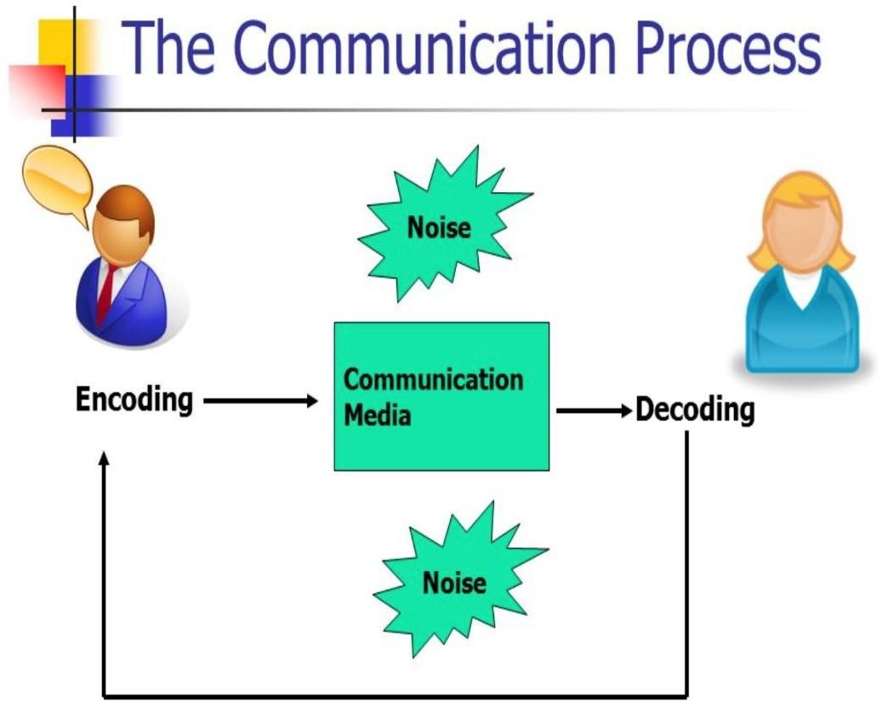

**4.2. ADVANTAGES OF WRITTEN COMMUNICATION:**

* **Easy to preserve:** The documents of [**written communication**](https://thebusinesscommunication.com/what-is-written-communication/) are easy to preserve. Oral and non-verbal communication cannot be preserved. If it is needed, important information can be collected from the preserved documents.
* **Easy presentation of complex matter:** Written communication is the best way to represent any complex matter easily and attractively.
* **Permanent record:** The documents of written communication act as a permanent record. When it is needed, important information can be easily collected from the preserved documents.
* **Prevention of wastage of time and money:** Written communication prevents the waste of money and time. Without meeting with each other the communicator and communicate can exchange their views.
* **Accurate presentation:** Through the documents of the written communication top executive can present the information more accurately and clearly. As it is a legal document everybody takes much care does draft it.
* **Use as a reference:** If it is needed, written communication can be used as future reference.

power and authority to the subordinate. It is quite impossible to delegate power without a written document.

* **Longevity:** Written document can be preserved for a long time easily. That is why; all the important issues of an organization should be back and white.
* **Effective communication:** Written communication helps to make communication effective. It is more dependable and effective than those of other forms of communication.
* **Maintaining image:** Written communication helps to maintain the images of both the person and the organization. It also protects the images of the company or organization.
* **Proper information:** It is a proper and complete communication system. There is no opportunity to include any unnecessary information in a written document.
* **Less distortion possibility:** In this communication system information is recorded permanently. So, there is less possibility of distortion and alteration of the information.
* **No opportunity to misinterpret:** there is any opportunity to misinterpret the information or messages of written communication.
* **Controlling tool:** Written communication can help to control the organizational activity. The written document may be used as a tool for controlling.
* **Easy to verify:** The information and messages that are preserved can be verified easily. If there arises any misunderstanding any party can easily verify the information.
* **Others:** Clear understanding, Legal document, Acceptability, Reduction of risk, Creating confidence, Easy circulation, Wide access or coverage etc.

**4.3. DIS ADVANTAGES O F WRITTEN COMMUNICAT ION**

The limitations and disadvantages of written communication are given below:

* **Expensive:** Written communication is comparatively expensive. For this communication paper, pen, ink, typewriter, computer and a large number of employees are needed.
* **Time consuming:** Written communication takes time to communicate with others. It is a time consuming media. It costs the valuable time of both the writer and the reader.
* **Red-Taoism:** Red-Taoism is one of the most disadvantages of written communication. It means to take time for approval of a project.
* **Useless for illiterate person:** It messages receiver is illiterate, written communication is quite impossible. This is major disadvantage written communication.
* **Difficult to maintain secrecy:** It is an unexpected medium to keep business secrecy. Secrecy is not always possible to maintain through written communication. Because here needs to discuss everything in black and white.
* **Lack of flexibility:** Since writing documents cannot be changed easily at any time. Lack of flexibility is one of the most important limitations of written communication.
* **Delay in response:** It takes much time to get a response from the message receiver; prompt response is not possible in case of written communication that is possible in oral communication.
* **Delay in decision making:** Written communication takes much time to communicate with all the parties concerned. So the decision maker cannot take decisions quickly.
* **Cost in record keeping:** It is very difficult and expensive to keep all the records in written communication.
* **Complex words:** Sometimes the writer uses complex words in writing a message. It becomes difficult to meaning out to the reader. So the objectives of the communication may lose.
* **Lack of direct relation:** If there is no direct relation between the writer and the reader, writer communication cannot help to establish a direct relation between them.

**Other:** Prompt feedback is impossible, Slowness, Bureaucratic attitude, Understanding problem between boos and subordinates, lack in quick clarification and correction, formality problem, lack of personal intimacy, etc.

**How to Make the Writing Communication effective?**

Effective writing allows the reader to thoroughly understand everything you are saying. This is not always easy to do. Here are a few tips that will help you:

1. **Know your goal and state it clearly**. Do you want the reader to do something for you or are you merely passing along information? Do you want a response from the reader or do you want him to take action? Your purpose needs to be stated in the communication. Avoid information that is not relevant. Clarity is key.
2. **Tone** can help your writing be more effective. Certain forms of communication, like [memorandums a](http://grammar.yourdictionary.com/grammar-rules-and-tips/tips-for-writing-memorandums.html)nd [proposals n](http://grammar.yourdictionary.com/writing/how-to-write-a-proposal.html)eed a formal tone. Writing to someone you know well would need a more informal tone. The kind of tone depends on the audience and purpose of the writing.
3. **Explain in clear terms** what you want the reader to do. They cannot oblige if they do not understand. Also, they may not even want to try to help if the communication is vague and sloppily written. It is good to include why it is beneficial to them to do what you ask or to help you.
4. **Language needs to be simple**. Do not overuse clichés, jargon, and expressions or try to impress with big words. Keep sentences and paragraphs short and concise.
5. Less is more when it comes to **length**. Leave out words that do not contribute to the main focus of the communication. This can make the reader work harder to know why you wrote.
6. **Using an** [**active voice** w](http://grammar.yourdictionary.com/style-and-usage/active-voice-adds-impact-to-your-writing.html)ill strengthen your writing. Sentences that are written in the active voice will flow better and are easier to understand. Long, complicated sentences will slow the reader down, even more so if they are written in the passive voice. An active example is "I caught the ball." and a passive example is "The ball was caught by me." Active voice will engage the reader and keep his attention.
7. **Good** [**grammar a**](http://grammar.yourdictionary.com/grammar-rules-and-tips/)**nd** [**punctuation** a](http://grammar.yourdictionary.com/punctuation/)re very important. It is a good idea to have someone else proofread your writing before you send it. If you cannot do that, then try reading it out loud.

**Common Grammatical Mistakes**

Effective writing does not contain errors. Here are some common grammatical errors that people make:

* + Affect and effect - "Affect" means "to influence" and it is a verb, like "It affected his work." "Effect" is a noun and means "result" like in "side effects."
  + Then and than - "Then" is an adverb which refers to a time, like "We ate and then saw a movie". "Than" is used in a comparison and is a conjunction, like "My car is bigger than yours."
  + Your and you're - "Your" is possessive, like "Is that your boat?" "You're" is a contraction for "you are" like "You're so funny."
  + Its and it's - "Its" is possessive, like "Its shape is oval." "It's" is a contraction for "it is" like "It's time to go."
  + Company's and companies - "Company's" is possessive, like "The company's logo is colorful." "Companies" is plural, like "He owns three companies."

There, their, and they're - "There" is an adverb meaning in or at that place, like "There it is!" "Their" is the possessive form of the pronoun "they", like "Their hair was soaked."

"They're" is a contraction for "they are" like "They're going to get in trouble."

**4.4. FUNDAMENTALS OF BUSINESS WRITING:**

If you want to communicate more clearly, it’s time to master the art of good business writing. To polish your writing and make it a useful tool in any business setting, remember to follow the 10 Cs of good business writing:

1. **Complete.**

It’s all too easy to forget that your reader doesn’t have the same information as you. A complete message should include all pertinent information – the when, where, why, who and how. You should also include a clear explanation of any action you want your reader to take.

1. **Concise.**

Check your writing carefully for redundant words, such as “postpone until later” (you can’t postpone until before, so “postpone” is sufficient). Cut out stock phrases such as “I am writing to inform you.” A concise message shows the reader that you value theirtime.

1. **Clear.**

Your writing should be clear enough to leave no room for doubt or ambiguity as to what you are trying to say and what action is required. Keep jargon to a minimum and lay out the facts in a logical order.

1. **Conversational.**

There’s no need to write as if you were writing a legal letter. Write as if you were talking face to face in a friendly but professional tone. Steer clear of slang, but keep your tone warm and remember you are talking to a human being.

1. **Correct.** You only get one chance to make a first impression. That adage is important when it comes to business writing – if your writing is incorrect, your first impression will be sullied. Pay particular attention to: Details such as name and title, correctness in spelling and grammar, correct information and a reader-friendly format.
2. **Coherent.**

Your reader needs to understand your message immediately. As you set down your thoughts and ideas, do so in a logical manner and help your reader to follow along by linking your ideas together sensibly.

1. **Credible.**

Good business writing relies on facts, not opinions. Once lost credibility is hard to repair, so always check your facts and sources. When referencing facts, pay attention to how the data was collected and whether the results were unbiased. Make sure your information is up to date.

1. **Concrete.**

Concrete writing means writing that steers clear of vague words and phrases in favor of specifics. For example, “some,” “many,” “a few,” “as soon as possible.” These should be replaced with concrete numbers, dates, and timescales.

1. **Courteous.**

Always put your reader first. Courteous writing includes striving for a positive tone by avoiding commanding phrases such as “you must” and negative phrases such as “you failed.” There is no need to strive for false positivity, but taking care over word choice shows consideration for your reader.

1. **Considerate.**

Considerate writing means your document is easy to read and scan. You can do this by splitting information into paragraphs with one idea per paragraph, by using bullets and lists for ease of scanning, by using stylistic choices such as bold and italic to emphasize your point, and by using internal headings to guide your reader through the document.

**Key points for Effective Writing Communication**

1. Know your goal and state it clearly. ...
2. Tone can help your writing be more effective. ...
3. Explain in clear terms what you want the reader to do. ...
4. Language needs to be simple. ...
5. Less is more when it comes to length. ...
6. Using an active voice will strengthen your writing. ...
7. Good grammar and punctuation are very important.

**4.5. Five Elements of Effective Writing**

1. **CENTRAL IDEA:**

This element of good writing involves focusing on a clear, manageable idea, argument, or thesis around which to organize your material. It includes selecting subordinate ideas that support and reinforce your central idea. Checkpoints: G Purpose or central idea is sufficiently limited for meaningful discussion. G Central idea is clearly stated, normally in the opening. G All subordinate ideas relate clearly to the central idea.

1. **ORGANIZATION**:

This element of writing has to do with coherent arrangement of material. It involves keeping the reader oriented to the central and subordinate ideas. Good organization is logical and sequential. It guides the reader between divisions of the material. Checkpoints: G Introduction orients the reader to the central idea and the line of reasoning. G Material is arranged in a logical and coherent sequence; subordinate ideas are effectively identified. G Transitions are clear and helpful. G Conclusion or closing summarizes the argument, emphasizes the central idea, and leaves the reader with a sense of completion.

1. **SUPPORTING MATERIAL:**

Explanations, examples, statistics, and quotations make the ideas and information presented meaningful and memorable for the reader. In exposition, the role of supporting material is to clarify; in argument, to persuade. Checkpoints: G Examples are relevant, specific, detailed, sufficient, and persuasive. G Quotations support the argument. Wilber’s/Elements

1. **EXPRESSION, WORD CHOICE, AND POINT OF VIEW** Language is clear, specific, accurate, and appropriate to the audience, purpose, and material. Variety in sentence structure and length creates emphasis. Checkpoints: G Word choice is clear, specific, accurate, unassuming, and free of clichés and misused jargon. G Sentences are free of wordiness and ambiguity.
2. **SPELLING, GRAMMAR, AND PUNCTUATION** This element of good writing counts only when it’s wrong. Fair or not, your reader will notice your spelling, grammar, or punctuation only when you make a mistake. Checkpoints: G Spelling, including technical terms and proper names, is correct. G Correct words are used to convey the intended meaning. G Generally accepted rules of grammar and syntax are followed, including possessive forms, parallel construction, etc. G Punctuation, particularly comma placement, reflects standard usage. G Copy is free of mechanical errors and mistakes in proofreading.

**4.6. ABC- 3 Models of effective Communication**

**Accuracy! Brevity! Clarity! Three Keywords for Effective Communication** the ABC of an effective writing model stands for,

1. Accuracy
2. Brevity 3. Clarity

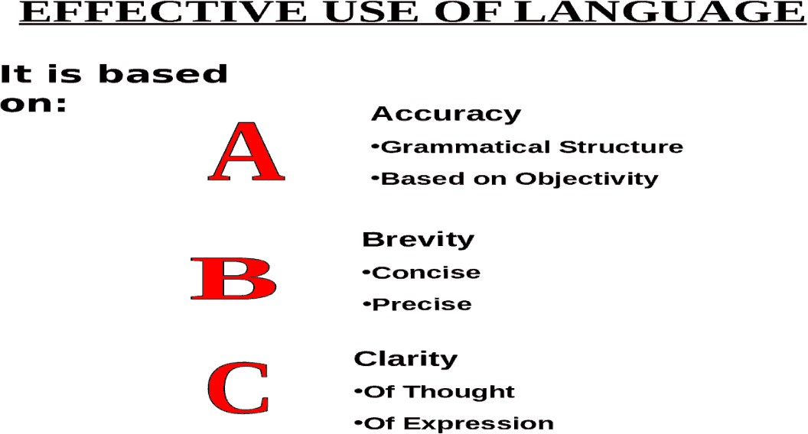

1. **ACCURACY:**

Generally, accuracy means that freedom form error, or closeness to Truth or fact, resulting from exercise due to diligence. Accuracy depends on how the data is collected, and is usually judged by comparing several measurements from the same or different sources.

In the business writing, Accuracy refers to how correct learner’s use of the language system is, including their use of grammar, pronunciation and vocabulary. Accuracy is often compared to fluency when we talk about a learner’s level of speaking or writing. Language manipulation activities can help develop accuracy. Totally Accuracy means grammatical correctness.

1. **BREVITY**:

Brevity means economy in word usage, pruning away useless words. We should avoid repetition and redundancy. Brevity in writing is writing in a style that is brief, while at the same time covers all necessary points. It is one of the more difficult things to do well in writing, but often produces some of the best work and influences on writing of a great business plan. Brevity comes from brevis, which means "brief" in Latin. You can use brevity for things that are literally short, like the brevity of an elevator meeting, or the quality of fleetingness, like the brevity of youth. Brevity is also a style of speaking or writing with economy. Some might call this ability to say less and offer more: brevity with clarity. Say what you mean and only what you mean, keeping the reader in mind, and avoiding unnecessarily complicated words.

1. **CLARITY:**

Clarity in writing means the ability to state our thoughts without any ambiguity. It is unnecessary to use a polysyllabic word where a monosyllabic one will do. Needless use of long words or abstract words result in obscurity. There can be two types of clarity. Grammatical and Conceptual. One of the aids to clarity is adequate punctuation. By conceptual clarity, we mean that whatever concepts we are trying to describe should be such that the reader should be able to easily empathize with what we write.

**MEETING AGENDA- MINUTES**

An Agenda, also called a docket or a schedule, is a list of activities in the order they are to be taken up, from the beginning till the adjournment. An agenda helps in preparing for a meeting by providing a list of items and a clear set of topics, objectives, and time frames that are needed to be discussed upon.

**What Is an Agenda?**

An agenda is a list of activities to be done in an ordered sequence. In meetings, [business agenda r](https://www.examples.com/business/business-agenda.html)efers to the activities and topics that need to be discussed or performed at a particular time or the things to achieve during a meeting. The agenda is also used to determine the goal of a meeting.

**What Is the Purpose of an Agenda?**

The main purpose of an agenda is to give the participants a clear understanding of the meeting or subject at hand and logically guide the participants with the whole process. It also makes the participant be familiarized with the topics to be discussed.

**What Should Be Included on an Agenda?**

Almost all business follows a similar format of an agenda to run their meeting effectively and ensure that it stays on time. To make your meeting as effective as them, include these things in your agenda or download [our printable agenda h](https://www.examples.com/business/printable-agenda.html)ere to make everything easy for you.

* **The title of the agenda.** The titles are important in any [agenda example a](https://www.examples.com/business/agenda-template.html)s it can be used as identification.
* **The objective of the meeting.** The objective of the meeting should also be included in the meeting to remind the participants about what the meeting is all about and what it hopes to achieve.
* **The topics and or activities.** The agenda should list all the topics or activities to be addressed in a meeting.
* **The time allocation.** Every topic and/or activities must have a time allocation so that it will be followed accordingly.
* **Call to action.** The agenda should have a call to action that signifies the start and end of the meeting.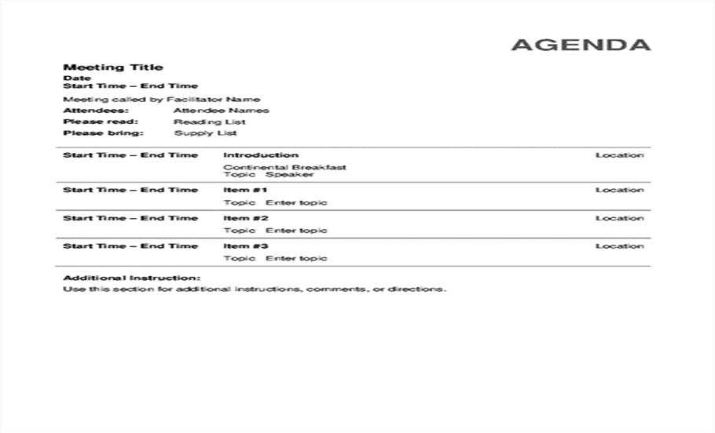

**Tips for Writing an Agenda**

* **Create the agenda three or more days or even weeks before the actual meeting.** It gives you more time in preparing the agenda and gives enough time to cover all the important information.\
* **Set up a standard meeting agenda.** The [meeting agenda](https://www.examples.com/business/meeting-agenda.html) includes progress updates, upcoming milestones, and a list of people who will not be around in the next few weeks.
* **Consult the team.** Get input from the team about what needs to be addressed and discussed.
* **Write all the important information.** The topics, activities, updates and time must all be present in the [free agenda.](https://www.examples.com/business/free-agenda-example.html)
* **Follow a standard and well-structured agenda.** The agenda must be understood by everyone who will read it.
* **Distribute it before the actual meeting.** So that the participants are informed and notified beforehand. **Dos and Don’ts of an Agenda**

**Dos**

* Plan and prepare the agenda ahead of time.
* Give your agenda a title.
* Include all the necessary information in your agenda.
* Follow a standard agenda format.
* Make your agenda clear and well-written.

**Don’ts**

* Distribute it during the actual meeting.
* Not preparing adequately.
* Providing irrelevant, unnecessary, and insignificant information.
* Using unfamiliar terminologies and jargon that are not familiar with the company. Providing unorganized and disordered agenda

**8 MARKS Direct Questions:**

1. What do you mean by written communication? Mention the importance of it in a business.
2. Explain the Advantages and Disadvantages of Written Communication in a Business.
3. Mention the 10 Fundamentals of Business writing. Explain.
4. Give a brief note on ABC-3 Models required in an effective written communication.
5. What is an Agenda? Explain with Dos and Don’ts of an Agenda.
6. What are minutes of Meeting? What are the five elements to be included in it? Explain.
7. Give a brief note on Online sharing in written communication.
8. Define Memorandum. What are the parts of memorandum? Explain.
9. Explain the importance of effective presentation skills.
10. What do you mean by a Professional presentation? How to make it effective?
11. Explain the tools for an effective written communication.
12. Give a brief note on:
13. Online sharing of documents
14. Notice for meeting

**\*\*\*\*\*\*\*\*\*\*\*\*\*\*\*\*\***