**44-599: Introduction to Data Visualization**

**Worksheet for drawing Funnel Chart using Tableau**

1. This embedded worksheet has a dataset.
2. Dataset: Contains data of Board of supervisors website, which is government website of San Francisco.
3. Open *Tableau* and connect the Excel data provided below.



1. Drag and drop the unique page views measure in rows.
2. Now, drag and drop the page title dimension in the colors menu provided in the marks window pane.
3. Now, sort the interview stages to descending order so that it satisfies the definition of funnel chart i.e. visualizing the progressive reduction of data as it passes from one phase to another.
4. Then drag and drop the page views measure in the size menu in order to show the reduction of page views in each page.
5. Select the view size to entire view. It should look similar to the image below:

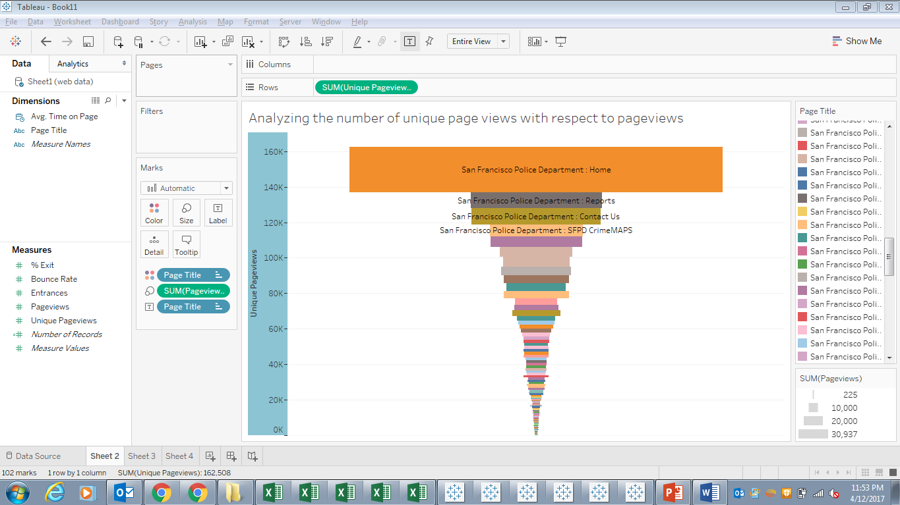

1. In order to achieve the second goal i.e. to analyze the average amount of time spent on a particular page, drag and drop the avg. time in sec measure in rows.
2. Now drag and drop the page title dimension in the colors menu provided in the marks window pane.
3. Then drag and drop the avg. time in sec measure in the size menu in order to show the reduction of time in each page.
4. Select the view size to entire view. It should look similar to the image below:

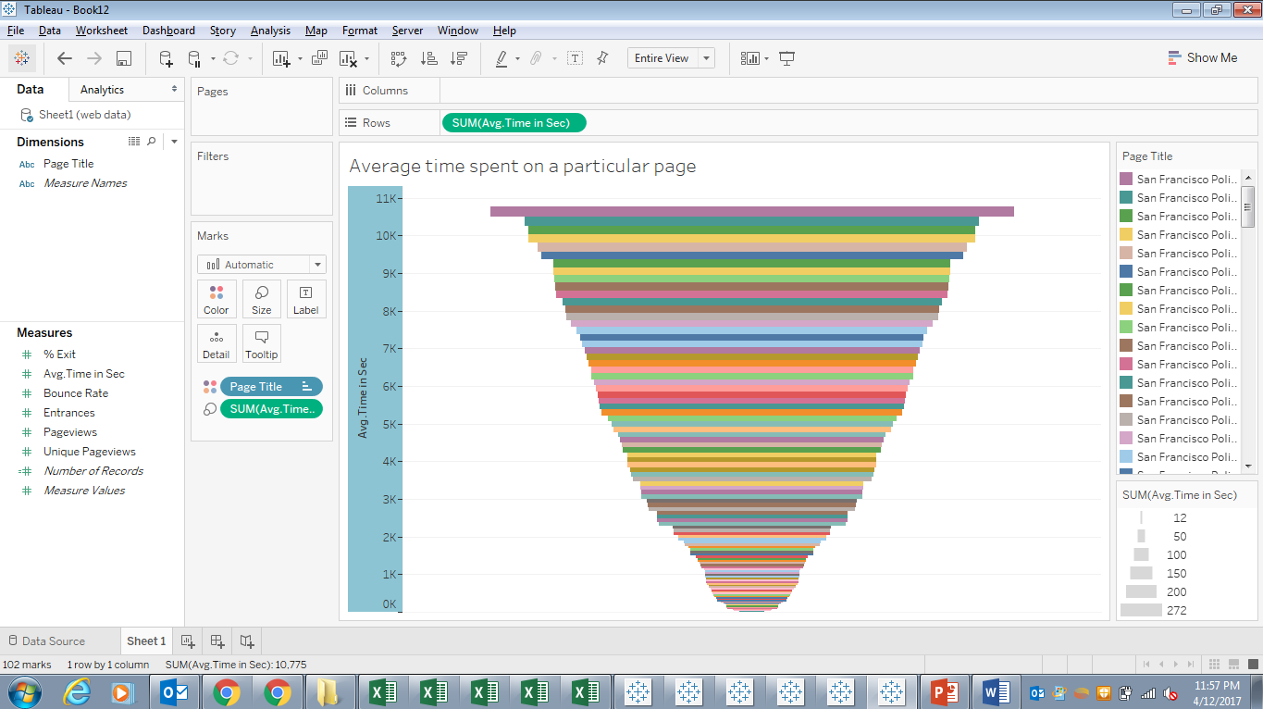

Data source:

Dataset:

<https://catalog.data.gov/dataset/web-analytics-for-sfgov-sites-2016-q1>

Github Link:

<https://github.com/S528127/FunnelChart>

Tool Link:

<https://www.tableau.com/academic/students>