**44-599: Introduction to Data Visualization**

**Worksheet for drawing Spiral Chart using IBM Watson Tool**

**Objective:** To generate a spiral chart using IBM Watson.

1. In this worksheet a single data set is taken.
2. **Data set** – (Marketing customer value analysis) contains data of customers and their claim details of their policies.
3. Click on the excel sheet and download it.



**Steps to generate:**

1. To use the Watson IBM tool, register online by signing in through the Gmail account.
2. Open the tool and by clicking on the new data, browse or drag and drop the data set into the tool.

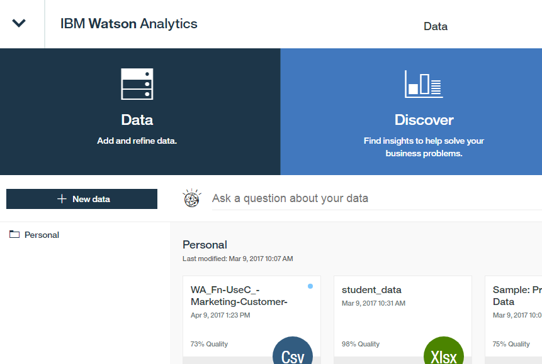

6. Now, click on the file and open it and choose the required visualization.

As we are creating a spiral chart, click on the spiral chart under the predictive analysis.

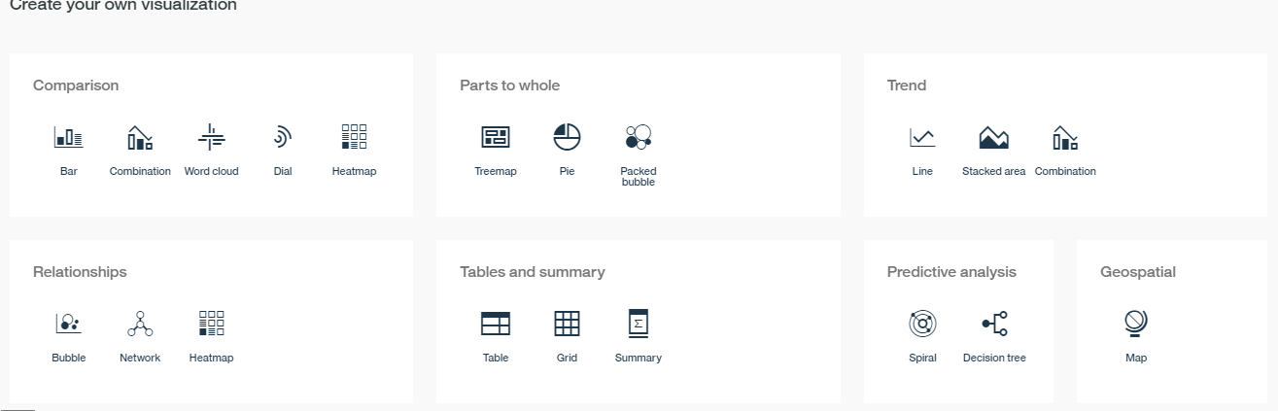

7. By clicking on the target add the required data class to it to generate a predictive outcome.

8. The first required outcome is what drives the income?

By adding income to the target, the spiral chart is generated.

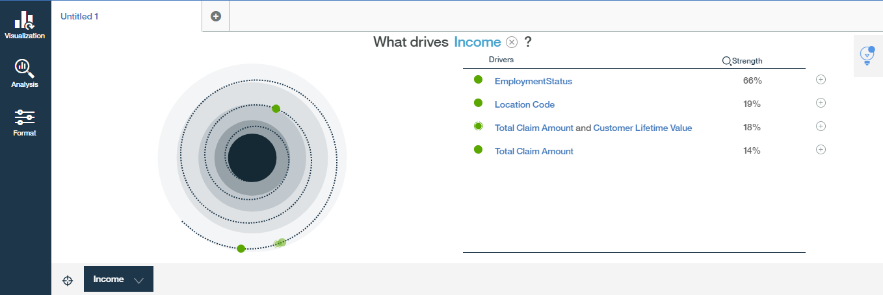

9. The second required outcome is what drives customer lifetime value?

By adding customer lifetime value to the target, the spiral chart is generated.

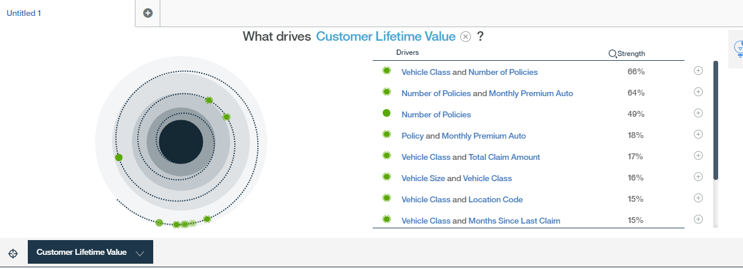

10. **Data source link**

* <https://www.ibm.com/communities/analytics/watson-analytics-blog/marketing-customer-value-analysis/>

11. **Git hub link**