**Installing jdk8 and NetBeans 8.2**

This document is a reference that shows you the steps to install **jdk8** and **NetBeans 8.2,** follow the steps carefully.

**1. jdk 8 Installation:**

Go through the link to install jdk8 (Java Development Kit Version 8) before installing the **NetBeans**

<http://www.oracle.com/technetwork/java/javase/downloads/jdk8-downloads-2133151.html>

Check the **Accept License Agreement** and select the appropriate configuration (see the below one for example).

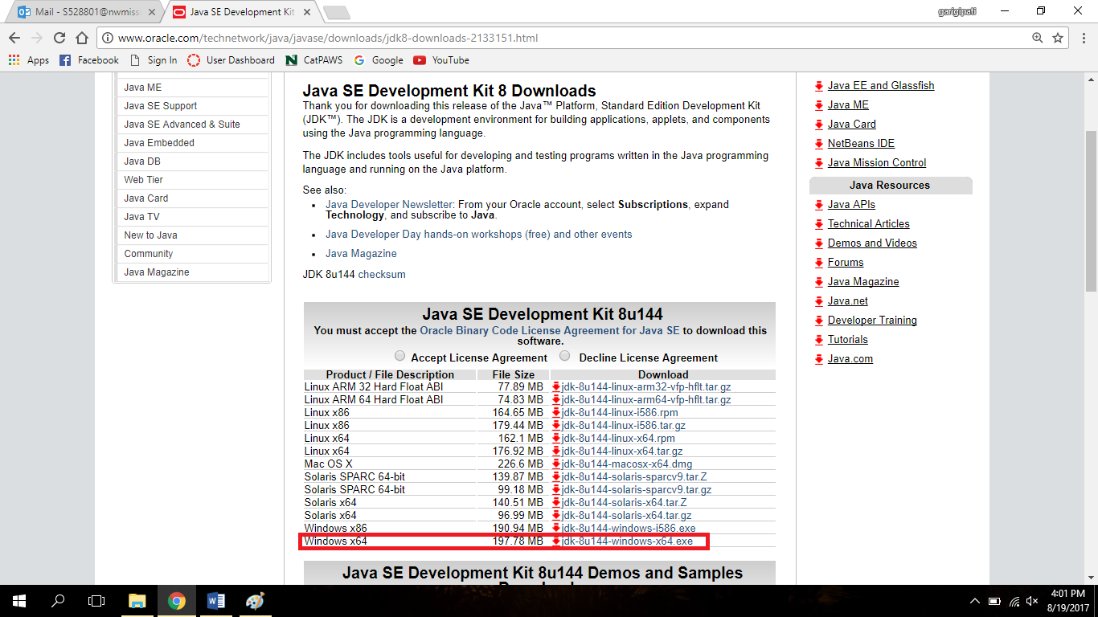

Click on **Next** button that will appear on the window as below

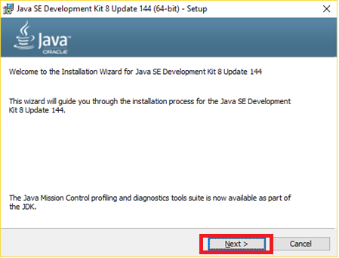

Select **Development Tools** and click on **Next** Button

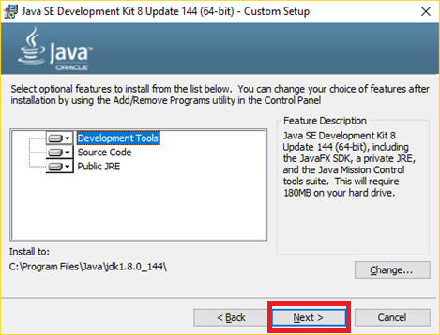

You will get a window as below after you click on **Next** button

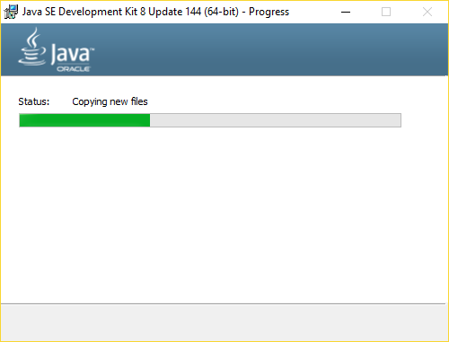

After the files are successfully spoied, click on **Next** button to install jdk**8**

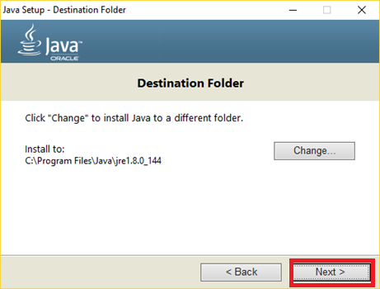

You will see a window like this showing the installation

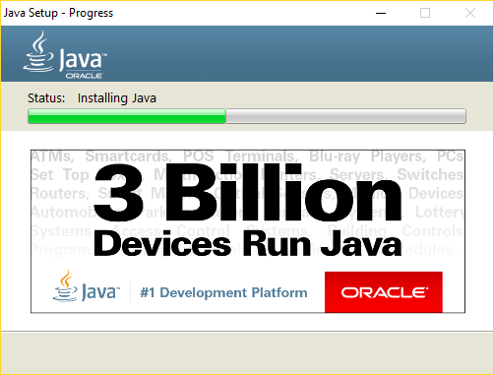

Check the files in your local disk to make sure that **jdk** **8** has installed successfully

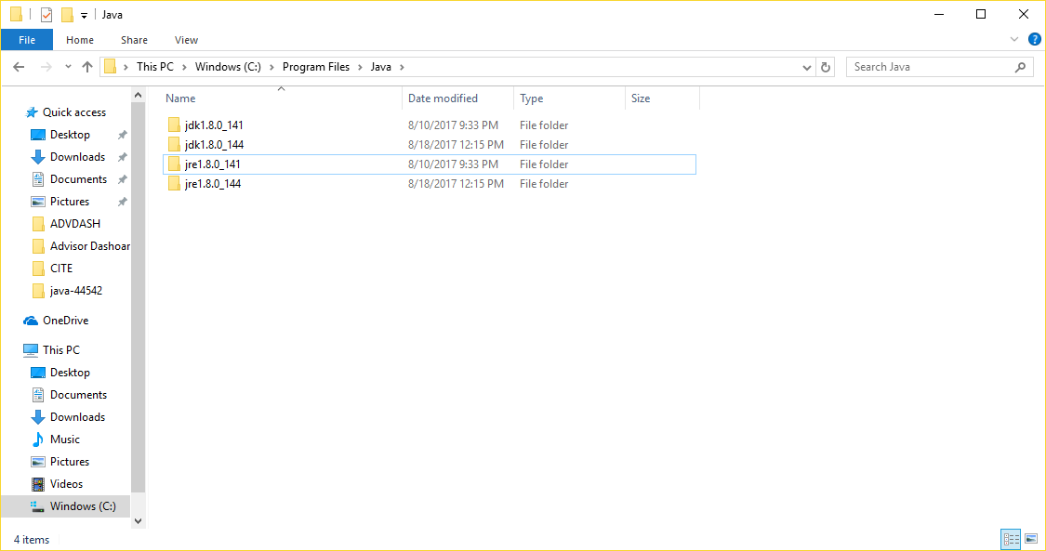

**2.Installing NetBeans 8.2 Version:**

Go through the link to download **NetBeans** latest version and select the appropriate one

(For reference, see the following window)

<https://netbeans.org/downloads/>

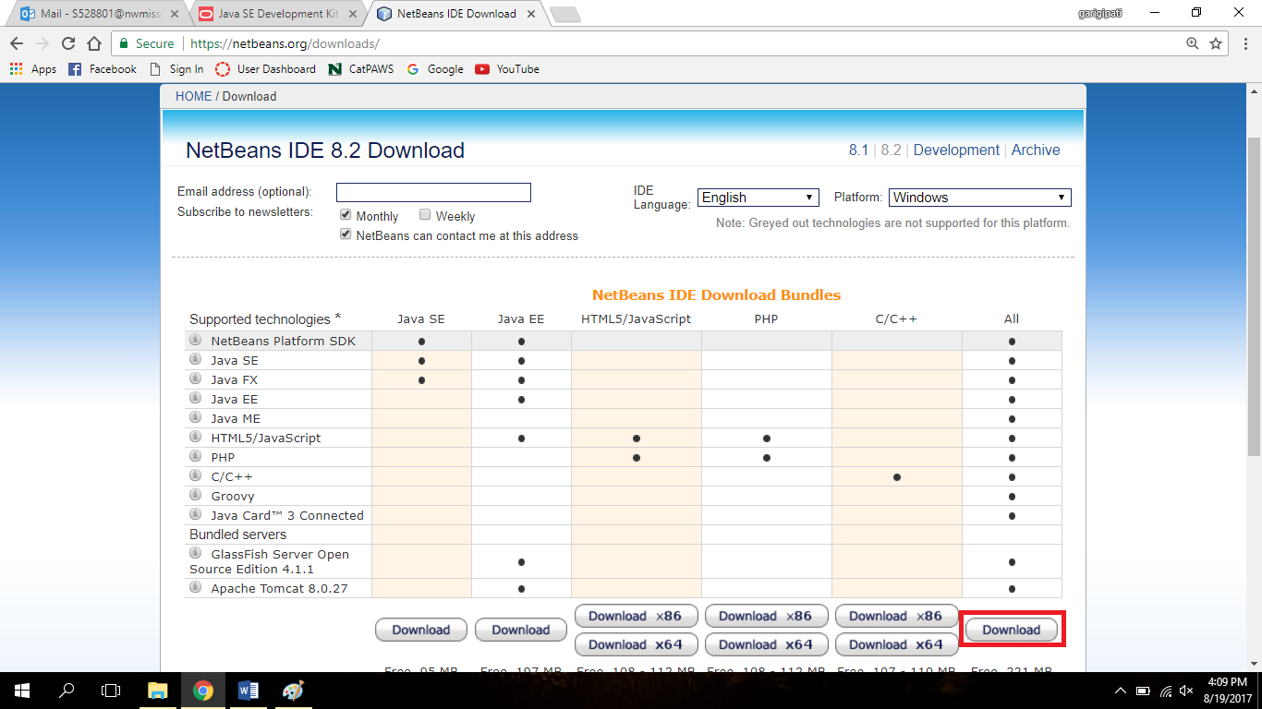

Click on **Next** button that will appear in the window as shown below

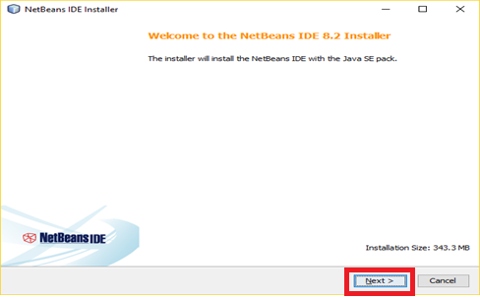

Check for the paths and you can change the location by clicking on the **Browse** button and then click **Next** button

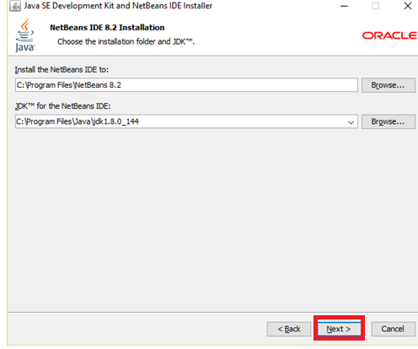

Click on **Install** button to get the **NetBeans** installed into your system

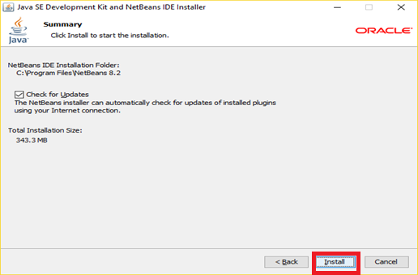

You will see a window a showing the installation, do not click on **cancel**

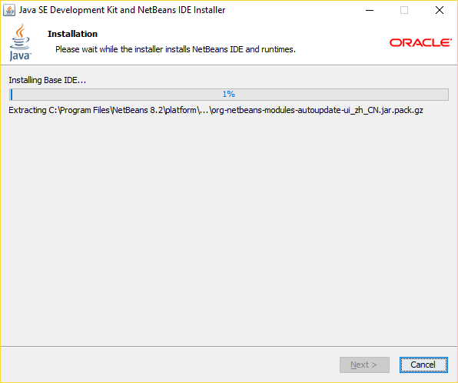

Click on **Finish** to complete the installation.

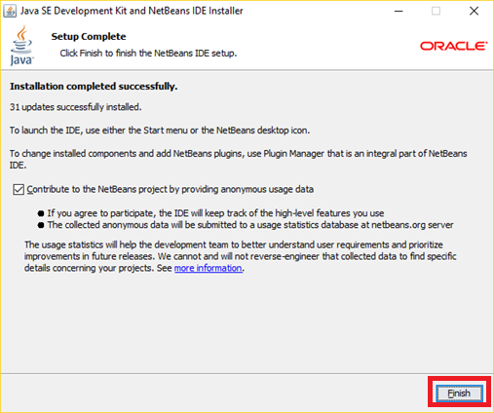

You have successfully installed **NetBeans.**

Check for **NetBeans** folder under Program Files

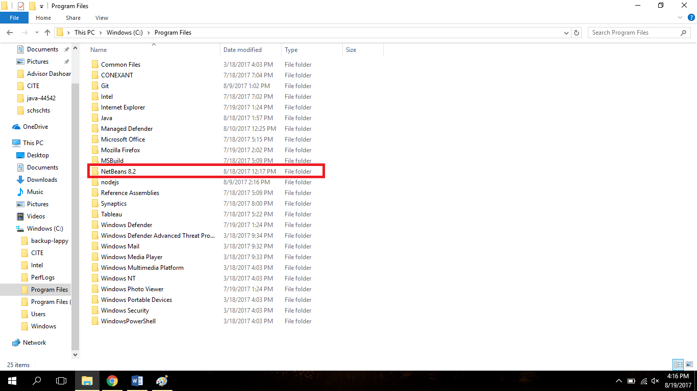

After installation, double click on **NetBeans** you will see this kind of window there you can create your projects.

