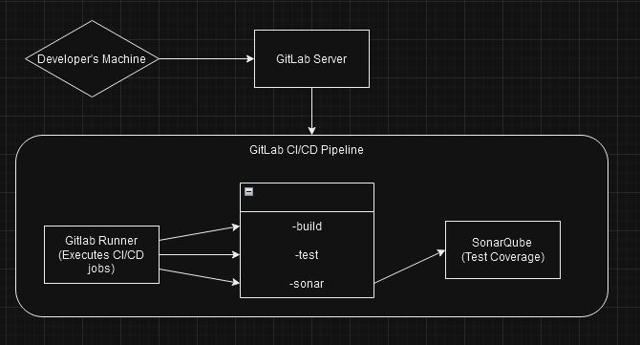

1. **Developer's Machine**:

* The development environment where code is created and pushed to the GitLab repository.

1. **GitLab Server**: The centralized repository where the code is hosted. It includes:
   * GitLab CI/CD Configuration: Defines the pipeline stages and jobs.
   * GitLab Runner: Executes CI/CD jobs defined in the pipeline.
2. **GitLab Runner**:

* Acts as an executor for CI/CD jobs. It interacts with the GitLab server to retrieve job information and executes those jobs in defined environments.
* Gitlab runner is running from developer’s machine.

1. **Pipeline Execution Flow**:
   * Build Stage: Compilation of code, packaging, and creating artifacts.
   * Test Stage: Running automated tests to ensure code quality and functionality.
   * Sonarqube Integration: Analysis of code quality, test coverage, and potential issues.
2. **Sonarqube Instance**:

* An independent server hosting Sonarqube, which receives code analysis requests from the pipeline. It provides detailed reports on code quality, code smells, test coverage, and more.