- Navigate to SA Staff - Documents - All Documents (sharepoint.com) in a browser
- In the lower left corner, select “Return to classic SharePoint”
- Select “Library” from the three tabs towards the top of the screen
- Select “Sync”
- 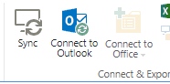
- This should open a dialog box that will think for a moment before adding an additional option in your file explorer that looks like this:
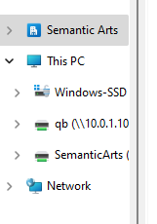

You should now be able to open, edit, add/delete files from the shared library without using a web browser. Keep in mind your changes are immediately synced to everyone, so for instance a deleted file is gone for all. These files are also visible to anyone on the team, so if there is any additional security required speak with JT for proper storage.

