Triple Stores vs. Neo4j Graph Database
By Michael Uschold, Semantic Arts
uschold@semanticarts.com

On March 5, 2015 I attended Graph Days in Seattle to learn about the Neo4j graph database product. The following are my views along, and do not reflect the position of Semantic Arts.
I attended because I wanted to know how Neo4j compared to triple stores, and under what if any circumstances would I recommend it to someone as their preferred solution. If you have interest in this area and a similar event comes to your area, I would certainly recommend that you attend. The food was good, the views were good (to the Olympic mountains), the speakers were good, and I got most of my questions answered.
Here are my main findings:
- Value Proposition: all of the benefits of graph databases that were mentioned are also benefits of triple stores. The latter have additional benefits. They compared Neo4j to both SQL and NoSQL
- Data Models: there is a very large overlap (maybe 95%) between the graph data model of Neo4j and RDF, which underpins triple store offerings. There are significant differences in how they are used.
- Query Languages: What you can do is mostly the same, but there is a lot of difference in the how. There are some very nice features in the Neo4j syntax that I would like to see in a future version of SPARQL.
- Global Identifiers: there are no global identifiers that are analogous to URIs in a triple store.
- Metadata/Schema: There appears to be no direct support for creating a metadata of any kind, it seems. They sing the praises of shema-less, as does the NoSQL community. In doing so they (unwittingly?) regard the benefits of not being forced to have a schema all the time as justification for making it impossible to have a schema at any time.
- Inference & Integrity constraints: There appears to be no support for inference nor for integrity constraints. There are ways to do it, but it would be all manual. This is partly a consequence of schemaless-ness.
- User Interface: Overall very good. There are some very nice features that I would like to see in the triple store product I have been using.
- Loading Data: The standard way to load data is directly from suitably formatted .csv files using a query that indicate what are the node, attributes and values.
- DB Integration & Enterprise Architecture: Findings 4 & 5 suggest that Neo4j is not a good choice for being able to link many different data sets together based on a common schema. It could be a good choice for point solutions where there is no need for data integrity support or integrating multiple databases. They seem to have a substantial number of clients using the tool, some very large, like Walmart.

Value Propositions: The comparisons were mostly with relational but also to NoSQL. The key benefits are flexibility, and the ability to represent and manage data relationships. Development time benefits are flexibility and ease of evolution and maintenance. Runtime benefits include better query performance. Eliminating the need for writing complex joins was highlighted. A key theme is the ability to represent and leverage data relationships. NoSQL is terrible at this, RDBs do ok up to a point, graph DBs are really good at it. They gave a number of interesting use cases where large companies are using Neo4j, including Walmart.

Data Models: It was evident from the query language and how they spoke about graphs that there was a strong overlap between RDF and “property graphs”, the underlying data model for Neo4j. Some conversations suggested that RDF is a superset of property graphs, insofar as anything in a property graph can be losslessly translated to RDF, and that the reverse is not the case. Some heads were nodding when I said it seems about 95% overlap. I did not find out what those differences are, nor did anyone know if there was a whitepaper of any sort that carefully explained the difference.
Despite being so close, there are some significant differences in how the graphs are used; this is reflected in the query language. First, relationships can have properties on them. Say you record who likes a product and an arc is added to the DB [JaneDoe LIKES iPhone6]. You can put a score property on the LIKES relationship to indicate they degree (e.g. on a 1-5 scale). You can achieve the same effect in RDF, but it is done differently, and is more awkward. Another important difference is how the data properties are handled. In RDF (or OWL, anyway) links to literals are added to the graph just like links to other nodes. In Neo4j, links to literals are stored right on the node, not in the graph. This is done for performance reasons.

Query Language: It is very similar to SPARQL, in terms of what you can do, which follows from the fact that the underlying data models are so similar. However from just a few hours of working with it, I liked it more than SPARQL. It seemed easier to learn, friendlier, more flexible and more powerful. Things that I cannot imagine how to do in SPARQL, seem straight forward in Neo4j’s query language. [No doubt some of these things are possible in SPARQL, but I don’t know about them] Otherwise, I would like to see some of these things added to some future version of SPARQL. One difference that is not better or worse, is that there are no question marks used in Neo4j to indicate a variable. Below are a few things that I liked. Rather than use the actual Neo4j syntax, I will write it as if SPARQL had adopted the basic idea (e.g. I will use question marks for variables). So think of this as a pseudo-syntax for exposition purposes.
- You don’t have to say rdf:type to link an individual to its node type, you just use colon. E.g. "?p:Person" instead of "?p rdf:type Person"
- Datatype properties are not represented as triples with a literal as the object, instead a dot notation is used. Instead of ?person hasFirstName “Melissa” you say ?person.name = ‘Melissa’
- You can have the triples go in either order, indicated by an arrow. "?s - ?p -> ?o" is equivalent to "?o <- ?p - ?s." This means you can sometimes avoid repeating a node in a chain. Instead of saying "?s ?p1 ?o1." followed by "?o1 ?p2 ?o2", you can just say something like ?s - ?p1 -> ?o1 <- ?p2 ?o2. You might use this to say something like John:Person FRIENDS_WITH ?x:Person owns ?x.Tesla.
- You can use vertical bar for ‘or’ for a predicate. If in SPARQL, it would look something like this: "?s ?p1|?p2 ?o.", a shorter form of "?s ?p1 ?o OR ?s ?p2 ?o."
- You can have a variable bind to a whole chain of triples (i.e. subgraph), which is very powerful. These are called PATHS.
- You can specify a minimum and maximum number of links to traverse. This can be practically impossible to do for complex SQL queries. It would be useful for exploring social networks. You can also specify that one particular individual appears somewhere in the PATH. See figure below:
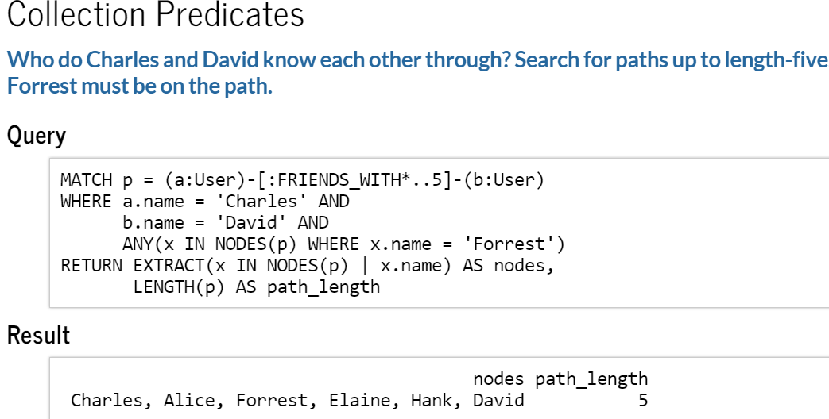

Global Identifiers: One of the great innovations for RDF is having URIs as global identifiers. This makes is possible (unlike in an RDB) to effortlessly snap together data from independent data bases. This feature is not present in Neo4j. They have internal identifiers, of course, but nothing like the idea of a URI.

Metadata/Schema, Inference and Integrity Constraints: They speak of “node types” which correspond to classes, e.g.. However, other than give it a label (e.g. Employee, Place, Restaurant) there is nothing you can say about what it means. Similarly, you can create properties and give them labels (e.g. CHECKED_INTO) but there is no way to indicate that if a wine glass checked into a laptop, you have a problem. In OWL or RDFS, you could give the property a domain to indicate that only Persons could check into something. There is no way to do this in Neo4j. In fact, there seems to be zero facility to say anything at all about what the data means or how it should be used. I brought this up to different people and they seemed unaware of the possibility that anyone might ever what to do that, and recounted how the developers just love not having to create and be locked into a schema. The fact is that both of the following things can be true:
- there are advantages of not being forced to create a schema if you don’t want to.
- there are advantages to having a schema and some people actual want the benefits.

RDF-based triple store have many of the same advantage as Neo4j by not forcing you to create a schema. But it also gives you a way to have one if you want.

Inference & Integrity Constraints: It more or less follows from the fact that there is no way to create metadata, that there is no way to use an ontology to define meaning for the data nor to leverage an ontology to do inference, either to make implicit information explicit or to maintain consistency. Most triple stores offer some support for inference. You get a menu of what kinds of inferences you want, and you pick those that matter most – trading off the benefits with the performance hit. These inferences will enforce some integrity. You would be left to create your own queries to see if there is bad data of a different sort that you can anticipate exactly how it might look. For Neo4j, you would have to do all of that yourself.

In response to my drawing attention to these differences between Neo4j and RDF-based triple stores, one person responded that Neo4j is not intended to work on the web, suggesting that semantic web technologies are not necessarily the most appropriate ones. It is easy to see why this sort of response would arise. The term “Semantic Web” disguises the fact that the advantages of global identifiers, ontology schema and inference work perfectly well off the web. That they work on the web too is a bonus. Ironically, the majority of the features and benefits of the semantic web stack of technologies are fairly independent of the web.

User Interface: There were some very nice features in the UI. I note two. First, you can see the recent queries and answers right there when you are entering your next query. Just scroll down. That is very handy, compared to having to go to a special window to see recent queries, then go back and forth. Second, there is a nice graphic layout integrated into the UI, it is not a separate thing you have to do in a separate window. Below is an example of a PATH that is returned as an answer to a query:

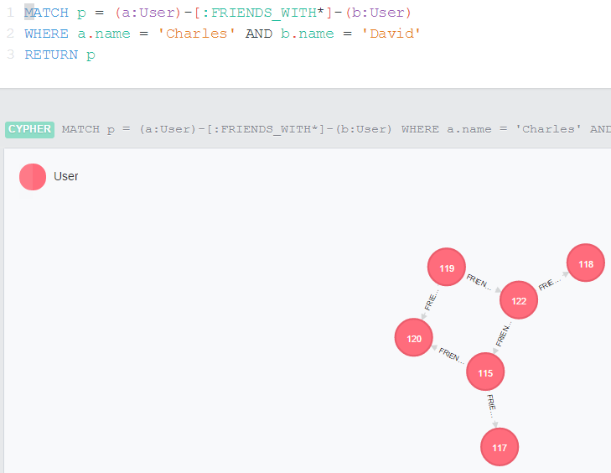

Loading Data: The standard way to load data is to prepare suitably formatted .csv files and write a query that specifies how to input the information in the graph. I don’t know how much of an advantage this is, but it is different. You load a series of .csv files that contain different data. Because there are no global identifiers, you have to take care to makes sure things snap together.
Here is an example of how to load data indicating what gates are in what terminals:

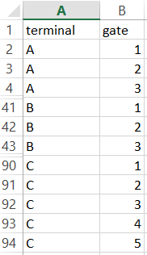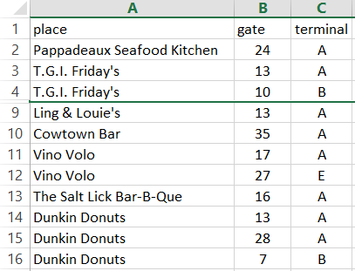

/* This loads the data from the file gates_terminals.csv */
LOAD CSV WITH HEADERS FROM “…\gates_terminals.csv” AS line
MERGE (t:Terminal {name: line.terminal })
MERGE (:Gate {number: TOINT(line.gate )})-[:IN_TERMINAL]->(t);

/* This loads the data from the file places.csv */
LOAD CSV WITH HEADERS FROM “…\places.csv” AS line
MATCH (t:Terminal {name: line.terminal })
MATCH (gate:Gate {number: TOINT(line.gate) })-[:IN_TERMINAL]->(t)
MERGE (place:Place {name: line.place })
MERGE (place)-[:AT_GATE]->(gate);

DB Integration & Enterprise Architecture: While Neo4j addresses some important problems, it ignores others. The fact that there is no support for ontology, inferencing nor global identifiers, it would seem that Neo4j is not a good choice for being able to link many different data sets together based on a common schema. It also means your enterprise will be locked into an application centric mode with data and application silos.

It could be a good choice for point solutions where there is no need for data integrity support or integrating multiple databases. They seem to have a substantial number of clients using the tool, some very large, like Walmart.

