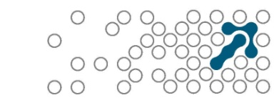
Semantic Arts, Inc.
11 Old Town Square, Suite 200, Fort Collins, CO 80524
www.semanticarts.com
office: 970-490-2224
January 14, 2015
Dr. Mark Musen

Dear Mark,
This is a letter to clarify some of the value we get from Protégé in our commercial work. First, I wholeheartedly support all that Dave McComb said in a separate letter. The following adds to that.
While there are a number of tools commercially available that may be used for developing, loading and viewing OWL ontologies, only one is even roughly comparable in terms of functionality: TopBraid Composer. While this tool has a variety of features lacking in Protégé, the reverse is also true. Several years ago, TopBraid Composer moved away from directly supporting OWL and started focusing more on linked data and RDF. For example, TopBraid Composer explicitly prohibits loading a .owl file, forcing the use of an .rdf extension. More importantly, there is no support for the mainstream OWL 2.0 inference engines, Hermit, Fact++ or TrOWL. This is a significant problem, especially during the ontology development process.
In fact, there is an argument that one probably should no longer refer to TopBraid Composer an OWL tool. It has support for loading and editing OWL ontologies just because they are expressed in the linked data format, RDF. Thus, Protégé continues to play a very important role in our work and the work with our commercial clients..

Sincerely,

Michael Uschold, PhD
Senior Ontology Consultant, Semantic Arts, Inc.

