CV Analyzer
To access the app directly use this link: https://sa-naqvi.github.io/Algo_CV_Analyzer/
1. Introduction & Problem Definition
This project aims to automate and optimize the CV screening process using classical string matching algorithms to search for job-relevant keywords in candidate resumes. The system not only identifies keyword occurrences but also benchmarks and compares three fundamental pattern matching algorithms: Brute Force, Rabin-Karp, and Knuth-Morris-Pratt (KMP), in terms of speed, accuracy, and efficiency. By doing so, it provides both a functional tool for CV analysis and an analytical framework for algorithm evaluation.
2. System Design
2.1 Architecture Overview
The CV Analyzer is a full-stack web application consisting of:
- Frontend: React + Tailwind CSS for a responsive and interactive user interface.
- Backend: Flask (Python) providing APIs for text processing, algorithm computation, and performance measurement.
- Storage: Local dataset containing text extracted from CV files (PDF/DOCX) preprocessed into a pickle file for efficiency.
Flowchart of CV Analyzer System
- User Input
  - User selects a job description or enters custom keywords.
  - Chooses an algorithm (Brute Force / Rabin-Karp / KMP).
- Backend Processing
  - Backend loads all CVs from the preprocessed dataset.
  - Each CV is searched for the given keywords using the chosen algorithm.
- Computation & Analysis
  - The backend records:
    - Execution time (ms)
    - Character comparisons and Hash collisions (for Rabin-Karp)
    - Number of matches
  - Results are aggregated and categorized by CV size (small, medium, large).
- Frontend Visualization
  - Results are displayed as tables and interactive bar charts.
  - Users can compare algorithms or view detailed keyword match data
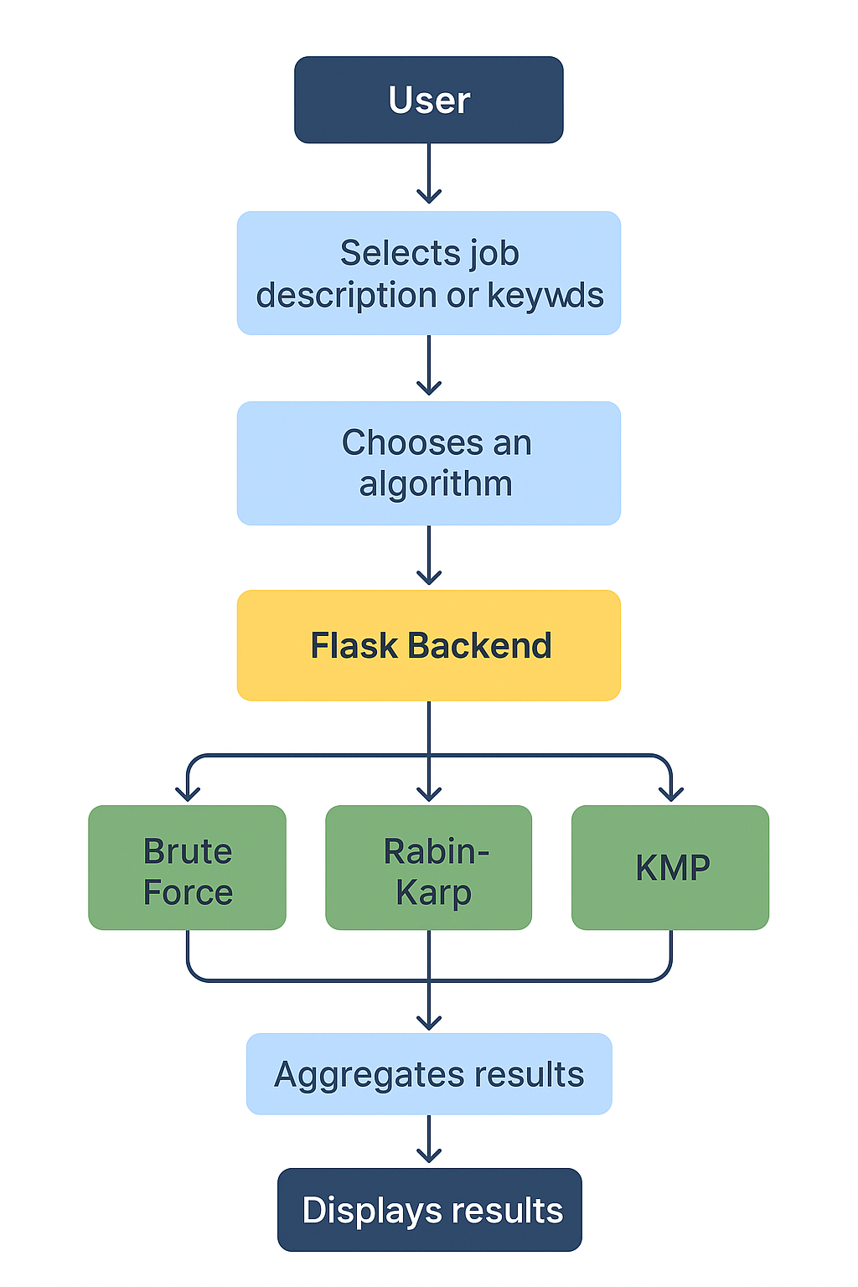
3. Algorithm Explanation & Pseudocode
3.1 Brute Force Algorithm
The Brute Force approach checks for a match of the pattern at every position in the text. It’s straightforward but inefficient for large datasets.
Pseudocode:
for i = 0 to n - m:
match = True
for j = 0 to m - 1:
if text[i + j] != pattern[j]:
match = False
break
if match:
record occurrence
Complexity:
- Time: O(n × m)
- Space: O(1)
3.2 Rabin-Karp Algorithm
The Rabin-Karp algorithm uses a rolling hash function to efficiently compare pattern and text substrings. Instead of comparing characters directly at each position, it compares hash values and verifies only when hashes match.
Pseudocode:
pattern_hash = hash(pattern)
for i = 0 to n - m:
text_hash = rolling_hash(text[i:i+m])
if text_hash == pattern_hash:
if text[i:i+m] == pattern:
record occurrence

Complexity:
- Average: O(n + m)
- Worst: O(n × m) (due to collisions)
- Space: O(1)
Notes:
- Collisions occur when two different substrings yield the same hash.
- The system records collision counts to measure hash reliability.
3.3 Knuth-Morris-Pratt (KMP) Algorithm
KMP improves efficiency by using a prefix function (failure table) that determines where to resume comparison after a mismatch, eliminating redundant checks.
Pseudocode:
Compute prefix_function(pattern)
q = 0
for i = 0 to n - 1:
while q > 0 and pattern[q] != text[i]:
q = prefix[q - 1]
if pattern[q] == text[i]:
q += 1
if q == m:
record occurrence
q = prefix[q - 1]
Complexity:
- Time: O(n + m)
- Space: O(m)

4. Implementation Details
The backend (app.py) handles API routes such as:
- /search - Executes one algorithm for a keyword set.
- /compare - Benchmarks all three algorithms.
- /job_descriptions - Provides predefined job templates.
The algorithms themselves are implemented in utils.py, with:
- Efficient string normalization (lowercasing, punctuation removal, stop-word filtering)
- Keyword-wise searching
- Real-time timing and comparison counters
- Dataset preprocessing via PyMuPDF for PDF text extraction.
The frontend (React + Tailwind) includes:
- Dynamic routing (SearchPage, ComparePage, AboutPage)
- Real-time charts (using Recharts)
- Smooth animations (Framer Motion) and a glassmorphic UI.
5. Experimental Results & Analysis
Dataset
- Total CVs processed: 735
- Small CVs: 4
- Medium CVs: 731
- Large CVs: 0
- Tests conducted for:
  - “Python, AI, Automate”
  - “Python, Machine Learning, Data Analysis, SQL, TensorFlow, Pandas, NumPy, ...”

5.1 Results on “Python, AI, Automate”
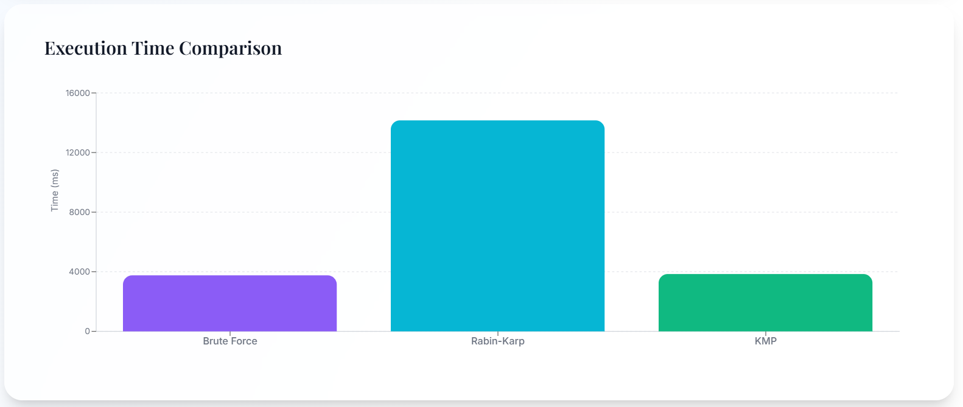
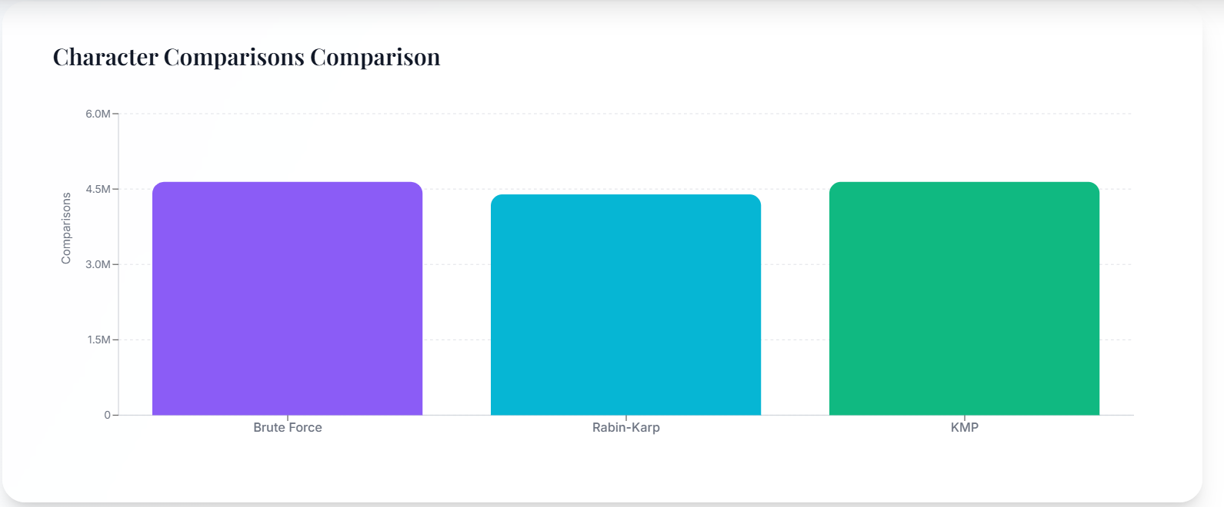
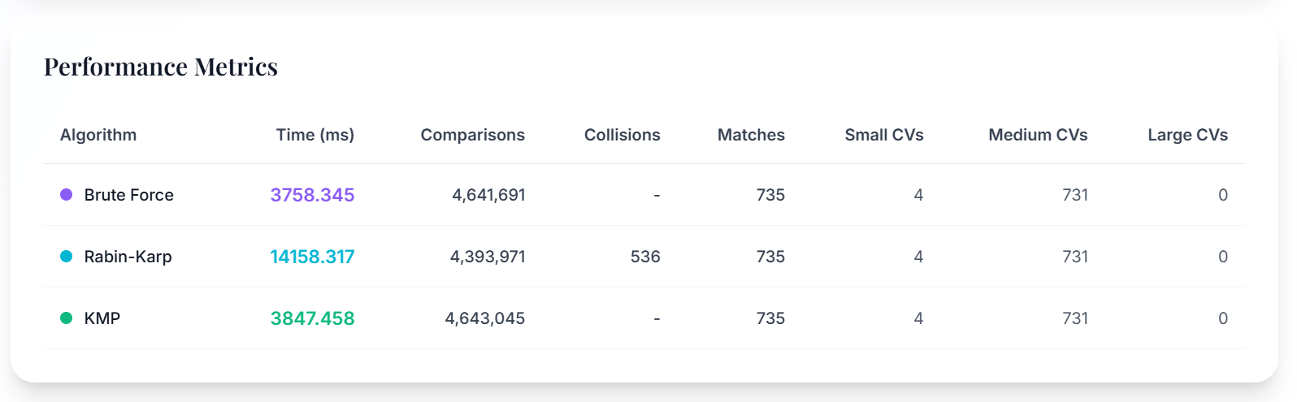

Observations:
- Brute Force was the fastest for this smaller keyword set.
- Rabin-Karp showed higher runtime due to hash calculations and collision handling.
- KMP achieved moderate runtime and comparable comparison count to Brute Force.
5.2 Results on Full Data Science Keyword Set
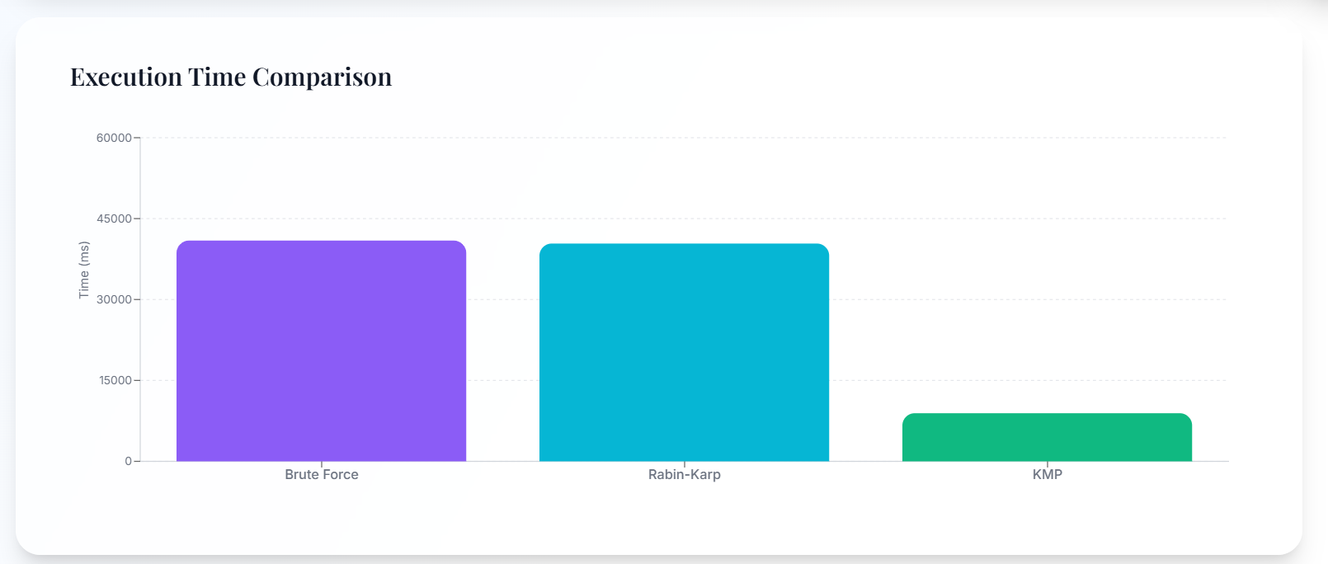
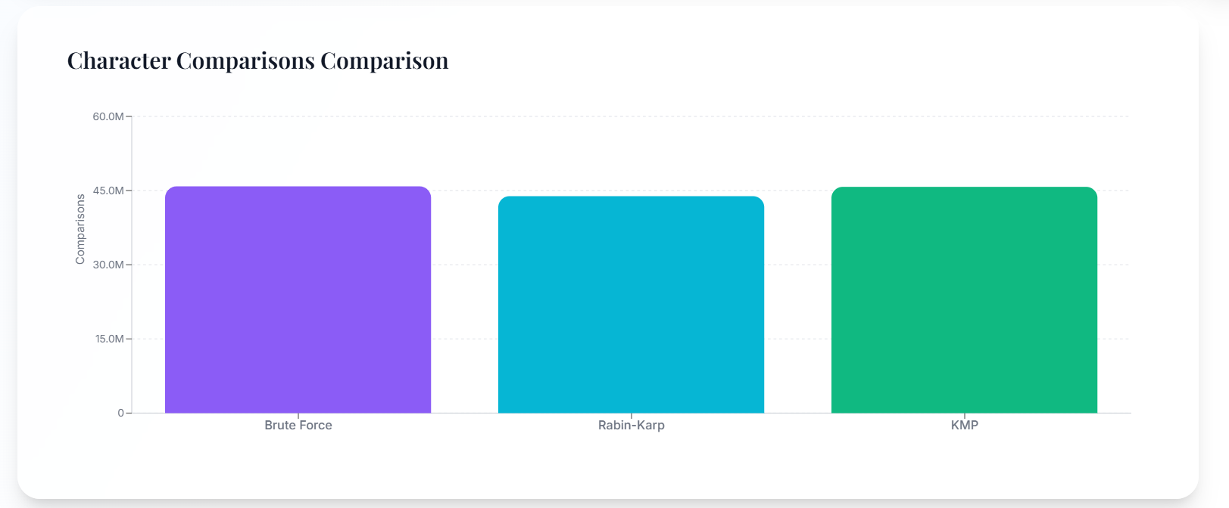
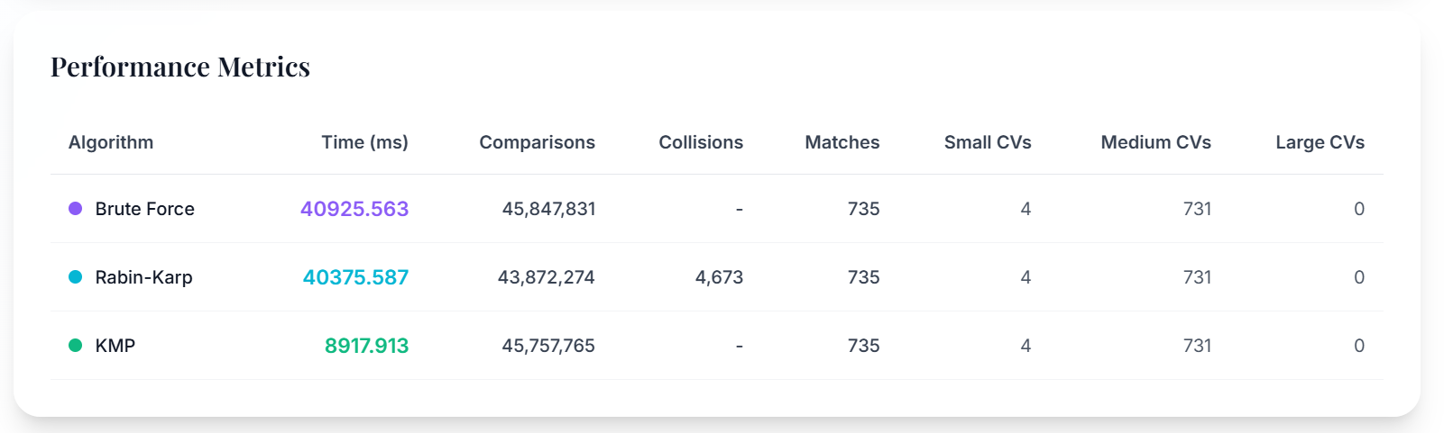

Observations:
- KMP outperformed both others with the lowest execution time for large-scale keyword searches.
- Rabin-Karp incurred significant overhead due to frequent hash collisions (4,673).
- Brute Force scaled poorly, taking nearly triple the time of KMP.
- Comparisons remained consistent across algorithms, confirming accurate implementation.
6. Comparative Analysis
Factor | Brute Force | Rabin-Karp | KMP
Time Efficiency | Moderate for small data | Slow with collisions | Best overall
Comparisons | High | Slightly lower | Similar to Brute Force
Collision Handling | - | Necessary | -
Implementation Complexity | Simple | Moderate | Complex
Scalability | Poor | Average | Excellent
Accuracy | 100% | 100% (with verification) | 100%

7. Discussion on Trade-offs
Aspect | Discussion
Speed | KMP is the most consistent performer across datasets. Rabin-Karp can be faster on average but degrades with collisions.
Accuracy | All algorithms achieved perfect match accuracy, with Rabin-Karp requiring explicit verification post-collision.
Collisions | Exclusive to Rabin-Karp due to hash dependence, leading to additional comparisons and higher time.
Preprocessing Overhead | Common to all - includes text extraction, normalization, and token filtering.
Scalability | KMP provides linear scalability, while Brute Force becomes impractical as data size grows.

8. Recommendation
Based on performance analysis:
- KMP (Knuth-Morris-Pratt) is the most practical algorithm for large-scale CV screening due to:
  - Linear time complexity (O(n + m))
  - No backtracking
  - Consistent performance across datasets
- Brute Force is viable for small datasets due to simplicity.
- Rabin-Karp is beneficial when searching multiple patterns simultaneously, but requires careful hash tuning.
Final Recommendation:
For real-world CV screening and document search systems, KMP offers the best trade-off between speed, accuracy, and reliability.

9. Conclusion & Future Work
This project successfully integrates classical string matching algorithms into a modern web-based CV analysis system. By combining algorithmic benchmarking with an interactive visualization interface, it bridges theory and application in the context of document search.
Future Improvements
- Extend support for multi-format documents (TXT, DOCX, etc.)
- Integrate AI-based semantic similarity (e.g., word embeddings)
- Implement parallelized search for high-volume datasets
- Develop an auto-recommendation feature that selects the optimal algorithm based on file size or keyword complexity
- Add export functionality (CSV/PDF) for HR analytics

