CDC COVID-19 Report

# Region 5 Daily COVID Report

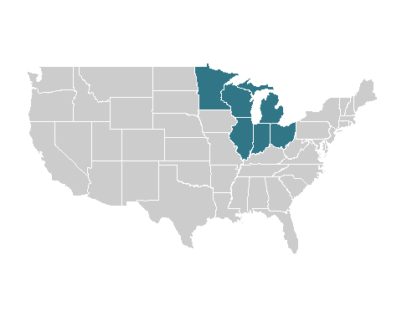

| indicator | cum | new | avg | change | 7cum |
| --- | --- | --- | --- | --- | --- |
| Cases^[] | 14954457 | 9619 | 12571 | -13.6% | 167.5 |
| Hospital Admissions^ | 748,626 | 13 | 200 | -26.2% | 2.7 |
| Deaths* | 170100 | 57 | 53 | -22.1% | 0.7 |
| Test Volume† | 155,671,047 | N/A | 75,956 | 3.9% | 1,086.2 |
| Test Positivity† | 9.2% | N/A | 13.9% | -9.1% | N/A |

### Daily Change in COVID-19 Cases, Region 5

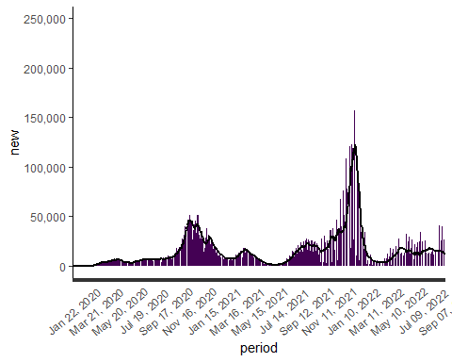

### Daily Change in COVID-19 Hospital Admissions, Region 5

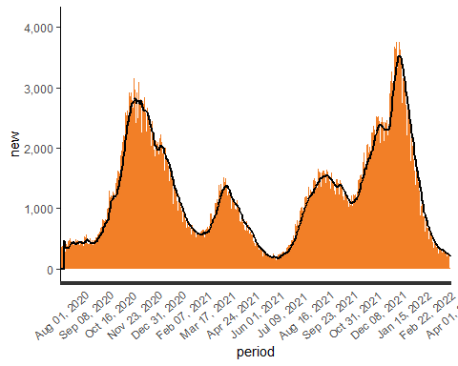

### Daily Change in COVID-19 Deaths, Region 5

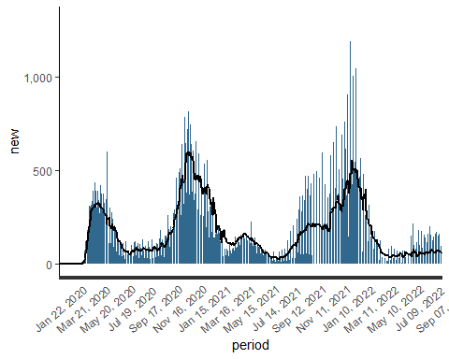

### Daily Change in COVID-19 Testing, Region 5

