|  |
| --- |
|  |
| IPAMS 3G  Deployment Guide v3.0 |
| |  |  |  | | --- | --- | --- | | Saad Ahmed | [Date] | [Course title] | |

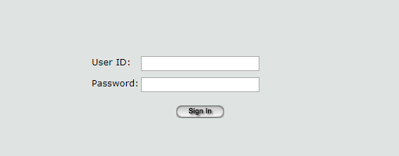

IPAMS 3G

Deployment Guide

Saad Ahmed | Tech Consultant | December 19, 2019

Table of Contents

1. Abstruct 3

2. Intended Readers 5

3. Disclaimer 6

3.1. IPAMS 3G Deployment Guide 7

3.1.1. Overview 7

1.1.1. Hardware Prerequisites 7

1.1.2. Software Prerequisites 8

1.1.3. IPAMS 3G Functional Document 9

1.1.4. Installation Guide 10

## Abstruct

|  |  |
| --- | --- |
| Document Abstract | |
| Product | Pams 3G |
| Document Title | Deployment Manual |
| Document Created Date | December 19, 2019 |
| Document Modified Date | December 20, 2019 |
| Organization | SHMA |

|  |  |
| --- | --- |
| Compiled By | |
| Name | Saad |
| Designation | Tech Consultant |

|  |  |
| --- | --- |
| Modified By | |
| Name | Saad |
| Designation | Tech Consultant |

|  |  |
| --- | --- |
| Reviewed By | |
| Name | Muhammad Noman Khan |
| Designation | Manager |

|  |  |
| --- | --- |
| Final Remarks | |
| Name |  |
| Designation |  |
| Comments |  |
| Signature |  |

IPAMS 3G

## Intended Readers

This user guide is intended for systems administrators and implementation consultants seeking information on the installation, configuration and maintenance of the IPAMS 3G application. Its focus is more technical in nature than the IPAMS 3G User manual - if you are looking for information on how to use IPAMS 3G Application user interface, please see the User manual.

While we have tried to make this document usable by readers with a basics of technical knowledge, it may be easy if you have some previous experience with installing web applications in Internet Information Server (IIS).

## Disclaimer

The information provided in this user manual is designed to provide helpful information on the subject discussed. The information in this manual is true and complete to the best of our knowledge. All recommendations are made without guarantee on the part of the author. Also please note that this document is not intended for public use and will only be used by the technical team of the organization, Reproducing, modifying and distributing of this document without department head consent will have serious consequences on the person or group of persons if found out.

## IPAMS 3G Deployment Guide

## Overview

This document guide will walk you through the deployment process of pams 3G web application. The web server used to deploy this application is Internet Information Service IIS and the Operating System is Windows 10 Enterprise 64-bit.

## Hardware Prerequisites

The hardware prerequisites for IPAMS Apps are defined below,

|  |  |  |
| --- | --- | --- |
| **DESCRIPTION** | **IPAMS FINANCIAL APPLICATION** | **BACKUP DATABASE & APPLICATION SERVER** |
| **Processor** | 2-Way Xeon DP processor 2.8 GHz | 2-Way Xeon DP processor 2.8 GHz |
| **Cache Memory** | 2-MB Level 3 Cache | 2-MB Level 3 Cache |
| **FSB (Front Side Bus)** | 800-MHz | 800-MHz |
| **Memory** | 4 GB DDR | 4 GB DDR |
| **Storage Controller** | Integrated Dual Channel Wide Ultra3 SCSI Adapter | Integrated Dual Channel Wide Ultra3 SCSI Adapter |
| **Storage** | 3 x 72 GB | 3 x 72 GB |
| **CD-Drive** | 48x, Internal | 48x, Internal |
| **Network Controller** | Dual integrated Gigabit | Dual integrated Gigabit |
| **Inter faces** | 1 x Parallel  1 x Serial  1 x Pointing Device (Mouse)  1 x Graphics  1 x Keyboard  2 x Network RJ-45  4 x USB | 1 x Parallel  1 x Serial  1 x Pointing Device (Mouse)  1 x Graphics  1 x Keyboard  2 x Network RJ-45  4 x USB |
| **Keyboard, Mouse** | Standard | Standard |
| **Antivirus** | Required | Required |
| **Form Factor** | 2 / 1 U | 2 / 1 U |

## Software Prerequisites

You should have below components installed before deploying IPAMS 3G on a client machine.

* IIS Manager (***inetmgr***)
* .Net Framework v2.0
* SAP Crystal Report Runtime v10.5
* Internet Explorer IE
* C++ Distribution Packages

## IPAMS 3G Functional Document

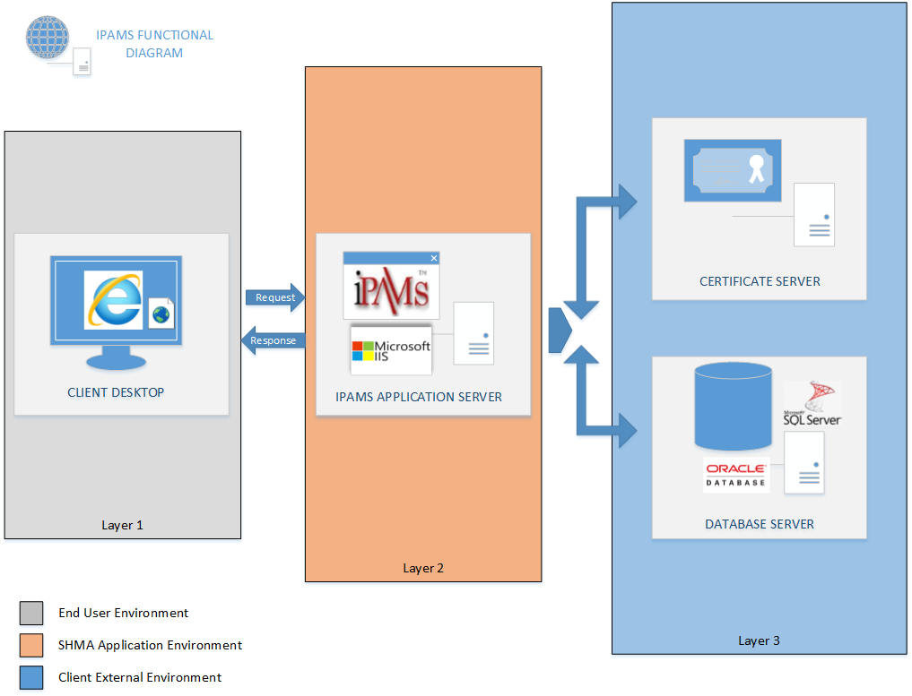

## IPAMS 3G Dataflow Diagram

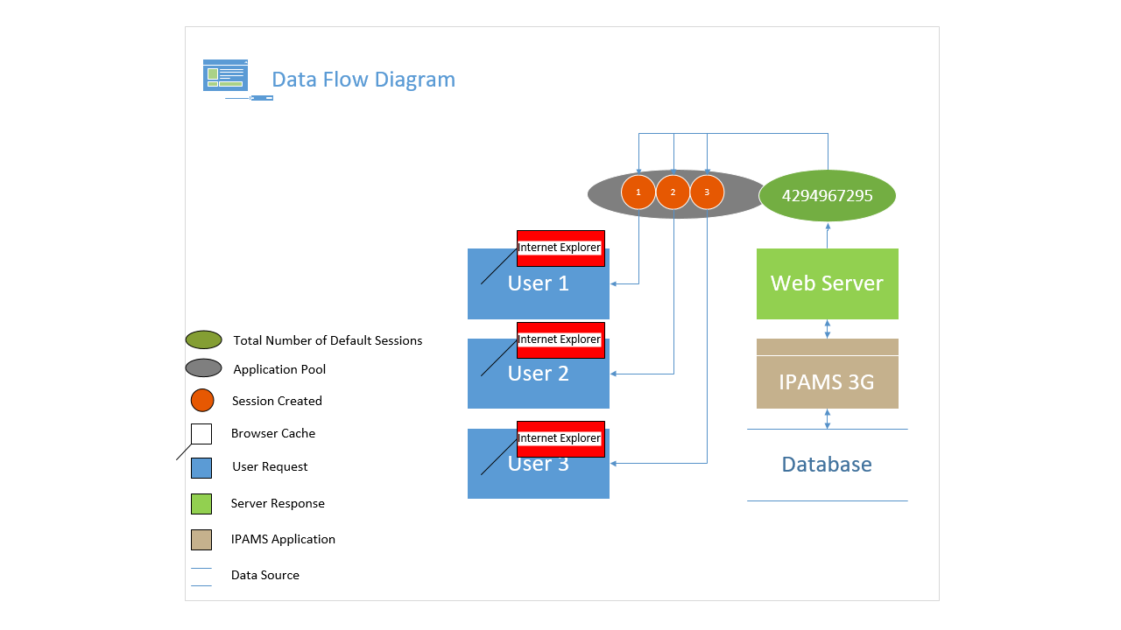

## Installation Guide

Follow below steps to deploy IPAMS app on a client PC,

1. Type inetmgr on the search bar or go to IIS Manager to deploy your app you can see a screen as shown in Figure 1.

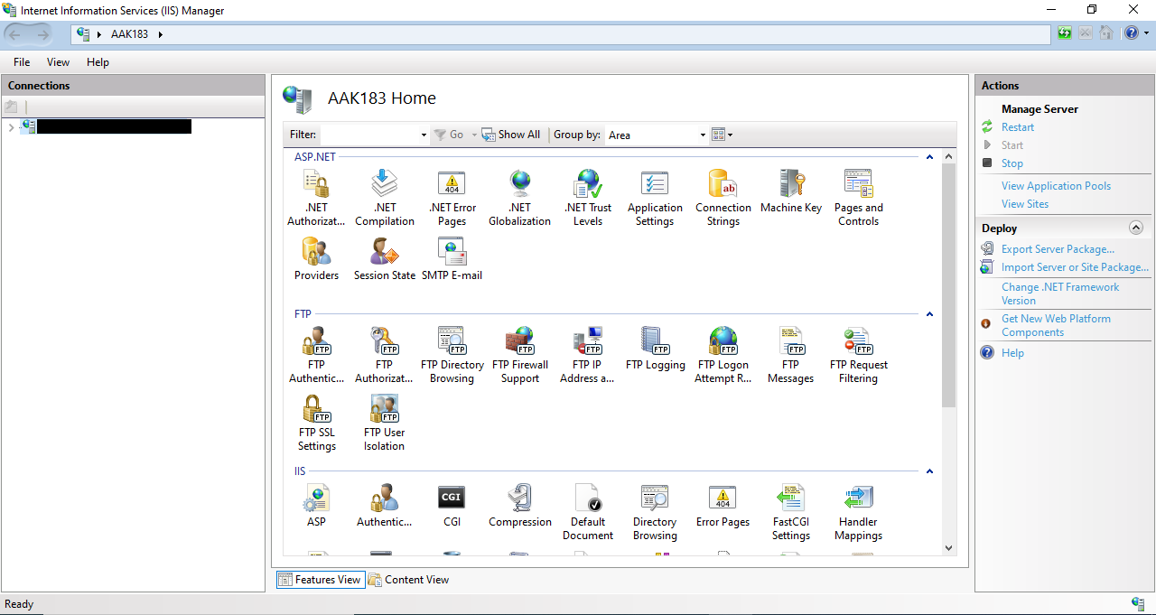

Figure 1

1. On the left you can see the Connection Panel as shown in Figure 2.

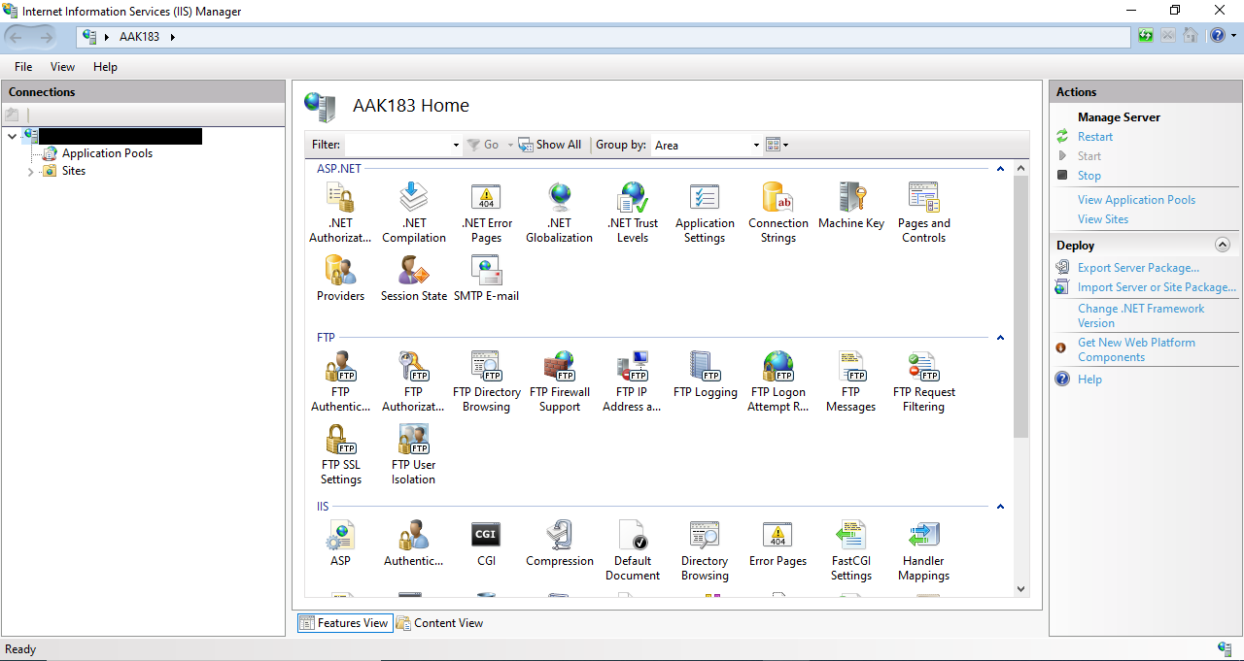

Figure 2

1. Inside Connection Panel, you can see the drop down menu. Click on the Drop Down button to make it expand. Now click on the Site Drop Down button you will see the screen similar to Figure 3.

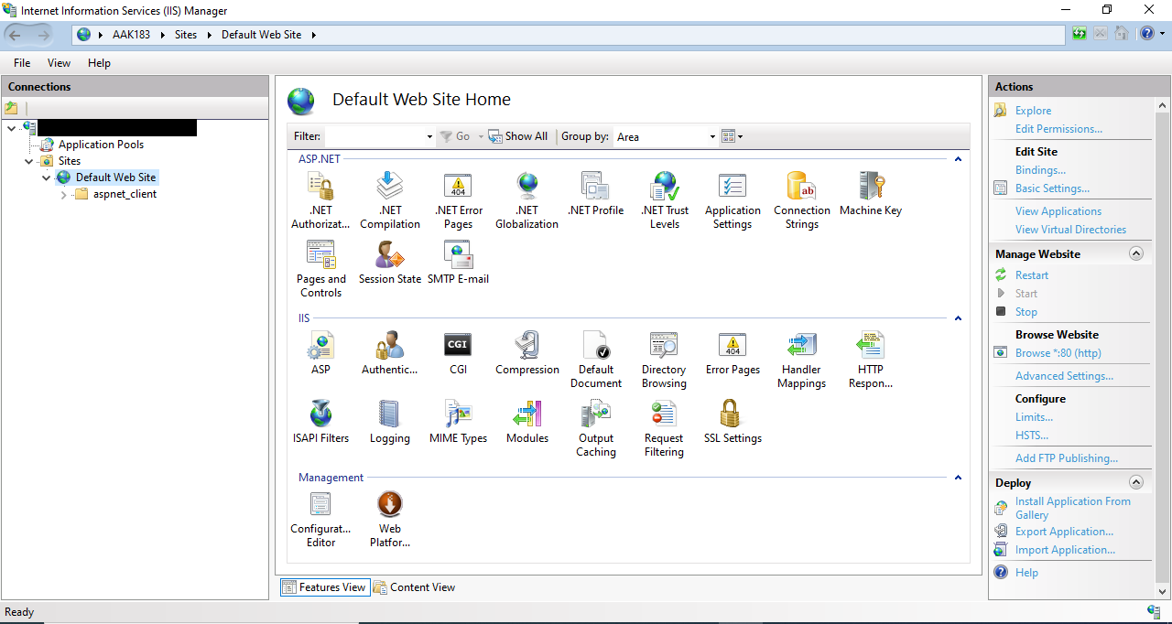

Figure 3

1. In the Connection Panel click on Drop Down Button of Default Web Site and then right click on Default Website and select Add Virtual Directory as shown in Figure 4.

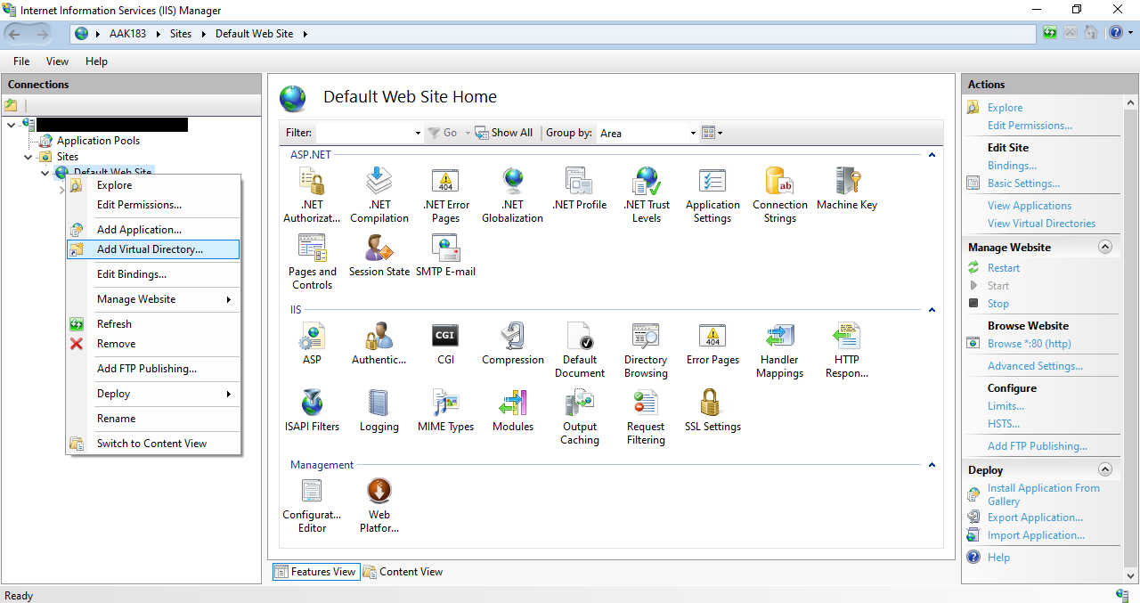

Figure 4

1. After selecting Add Virtual Directory Fill the Alias as  *IPAMS 3G*  and provide physical location path  *C:\inetpub\IPAMS_3G_ENV*  .

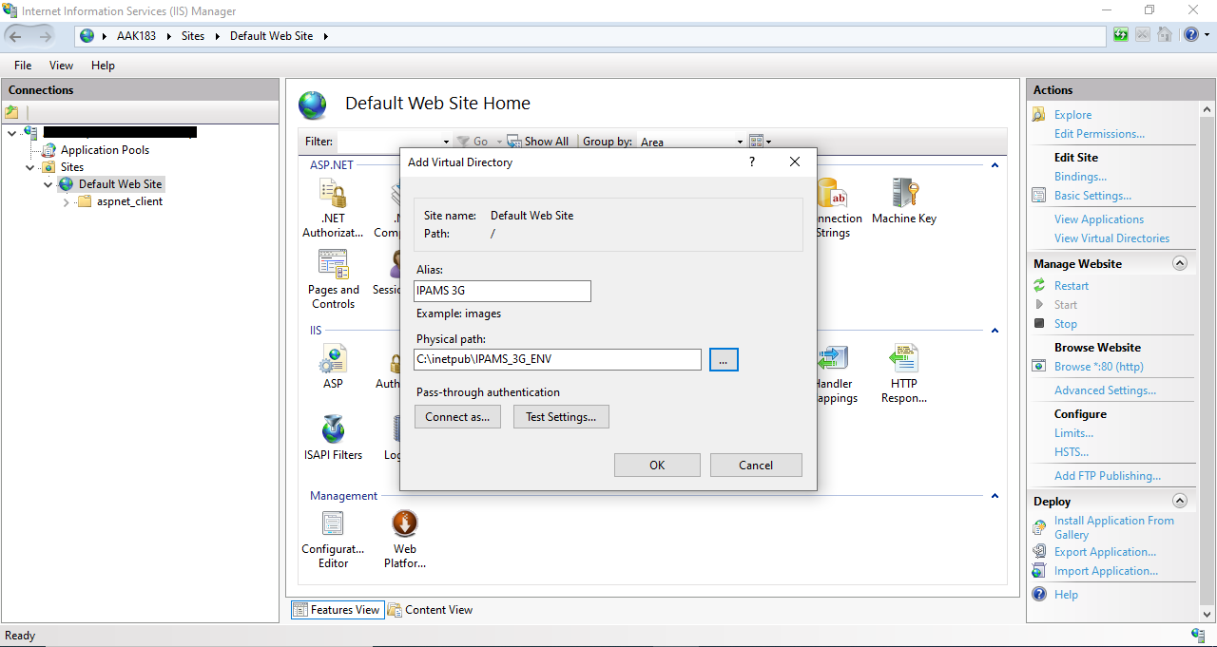

Figure 5

1. After filling the data and clicking on OK button you will see the new you will see the New Folder inside Connection Panel in the *Sites/Default Web Site/* Tree View as shown in Figure 6.

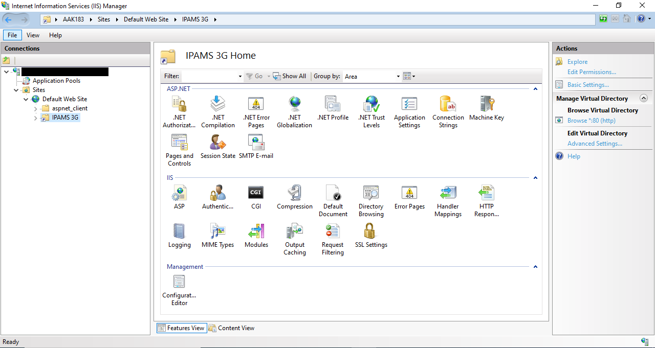

Figure 6

1. Right click on the new created folder in my case it is IPAMS 3G and select Convert to Application as shown in Figure 7.

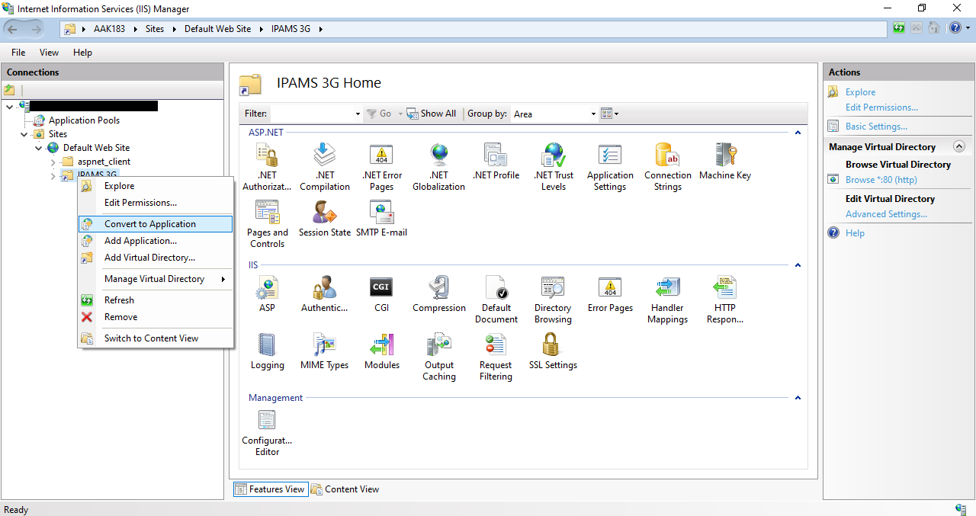

Figure 7

1. A new dialog box appears as shown in Figure 8 click OK.

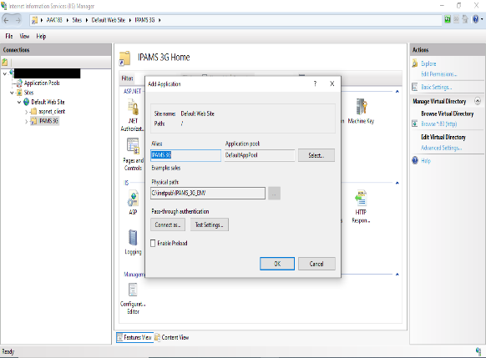

Figure 8

1. After that you will see the folder is not converted to the Application and you will see the IPAMS 3G folder icon is changed to Web Application similar to Figure 9.

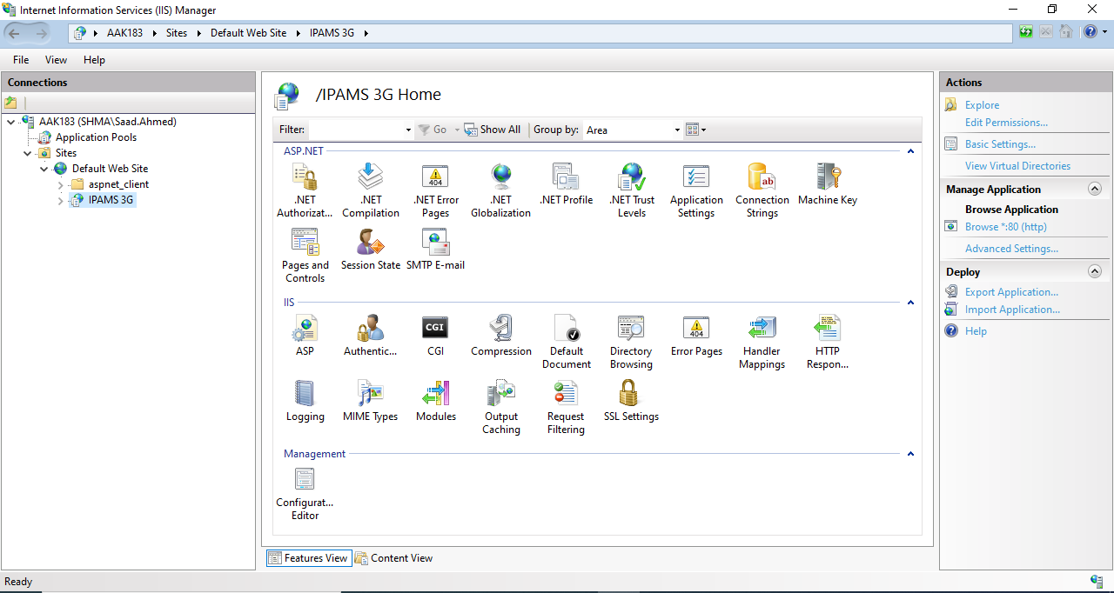

Figure 9

1. In Figure 9 in the middle bottom center you can see the Directory Browsing Folder option that has a magnifying glass icon click on it you will see the screen changes as shown in Figure 10.

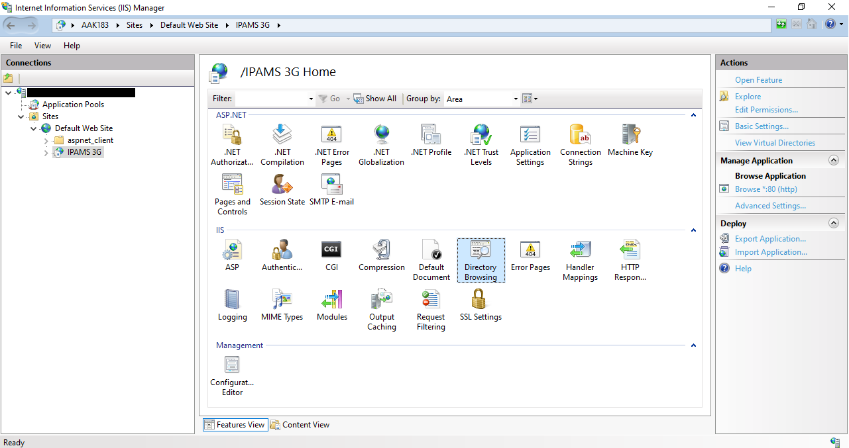

Figure 10

1. On the right side as shown in Figure 10 you can see the Action Panel. Inside this Action Panel click on Open Features you will see the screen similar to Figure 11. Here on right hand side click on Enable Link.

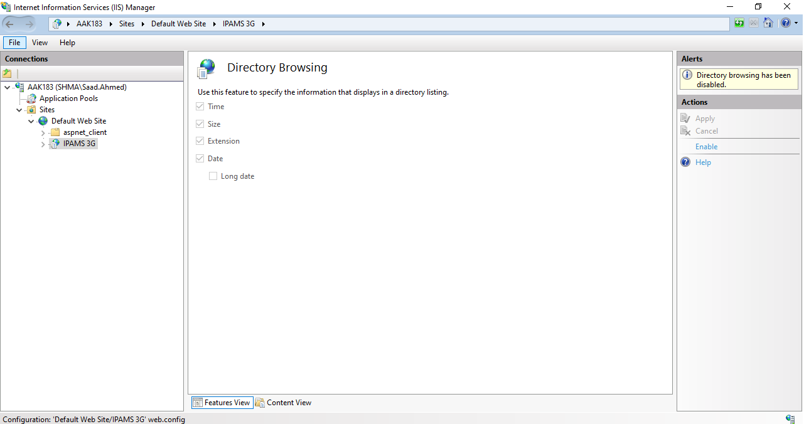

Figure 11

1. After Enabling from Directory Browsing you can see the screen similar to Figure 12.

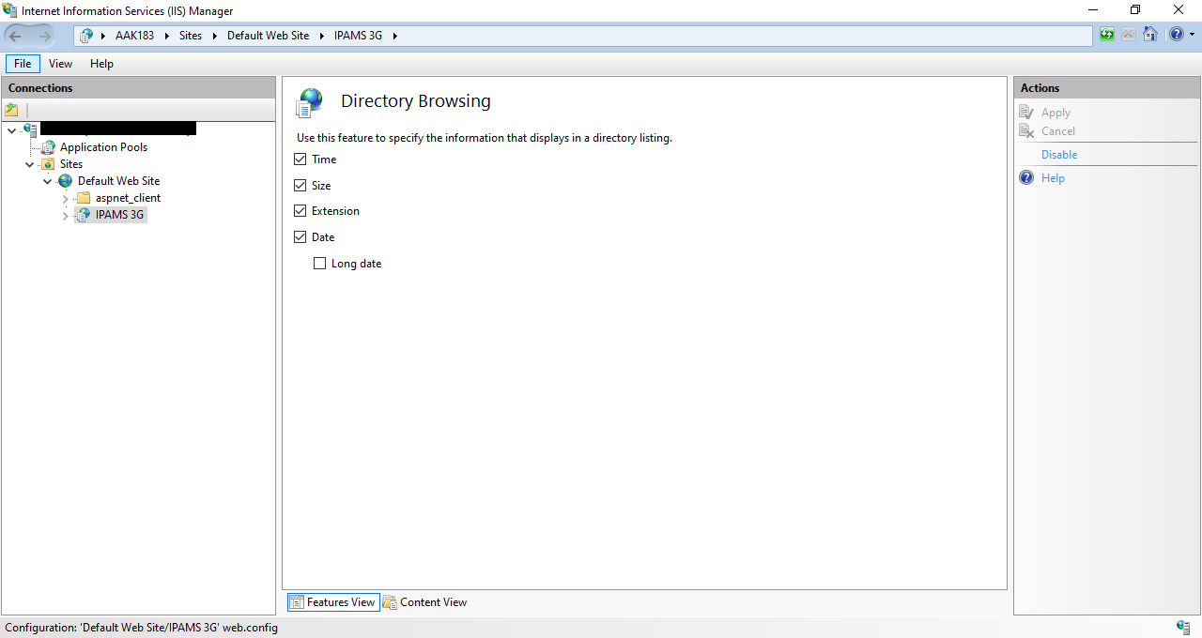

Figure 12

1. Now click on Application Pools you will see the screen as shown in Figure 13.

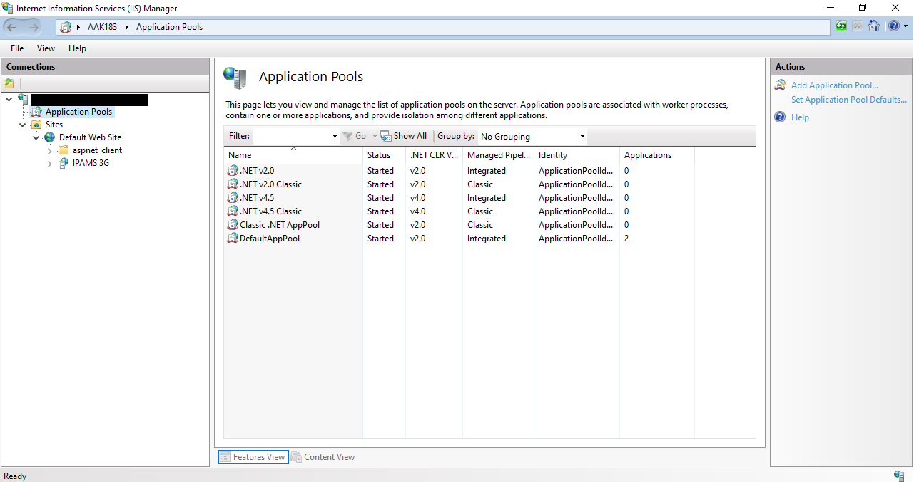

Figure 13

1. Change the .Net CLR Version to v2.0 by selecting v2.0 in the .Net Framework but first you have to select Advance Settings... Link in the Action Panel as shown in Figure 14.



Figure 14

1. Set .NET CLR Version to v2.0, Enable 32-Bit Applications to True and Set Identity to File System as shown in Figure 15 and 16.

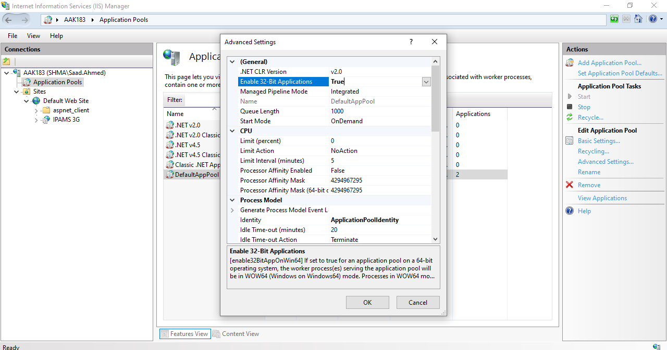

Figure 15

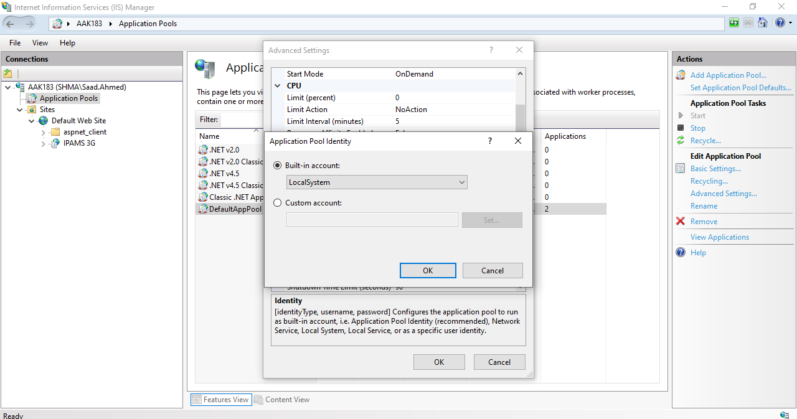

Figure 16

1. Your Advance Setting Dialog box will look like Figure 17.

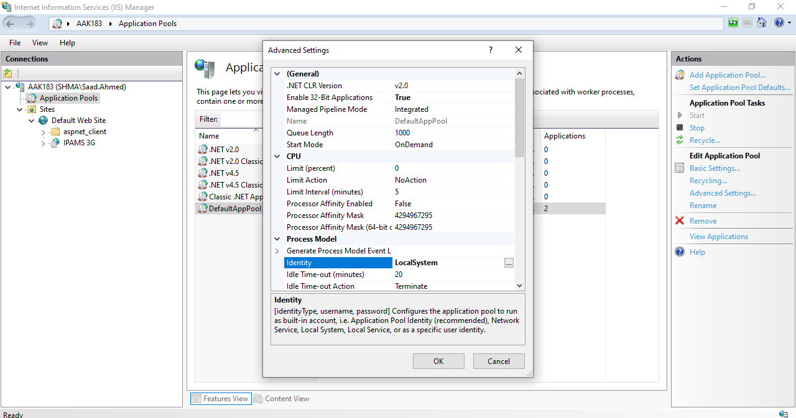

Figure 17

1. Now everything is setup you have to browse by selecting Managing

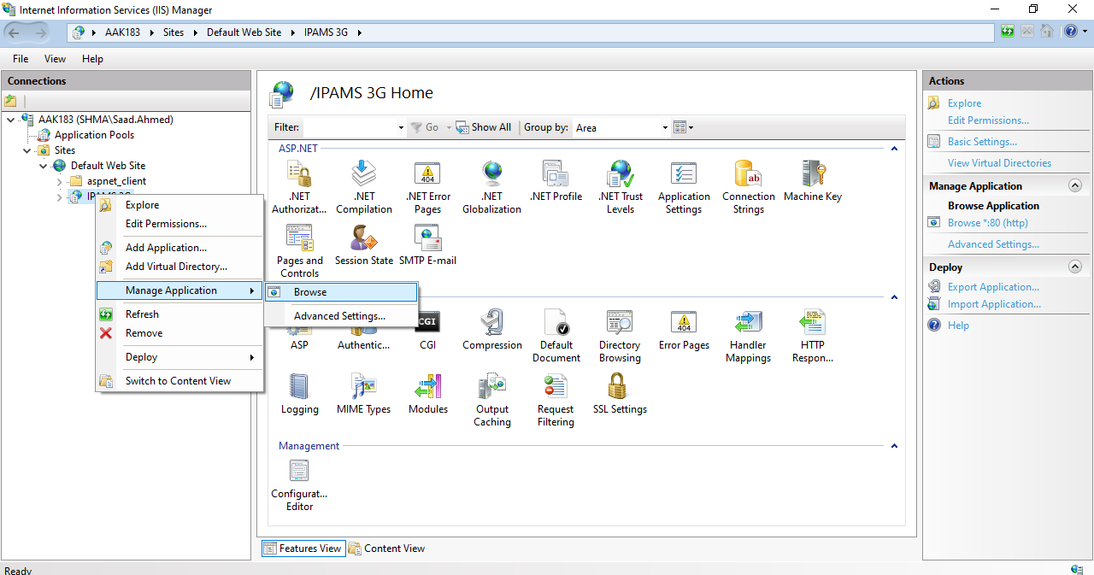

Figure 18

1. In the Internet Explorer Settings go to in the compatibility view setting as shown in Figure 19.

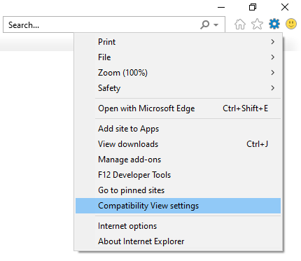

Figure 19

1. The Compatibility View Settings dialog box appeared as shown in Figure 17. Add localhost to the list in the Compatibility View Settings.

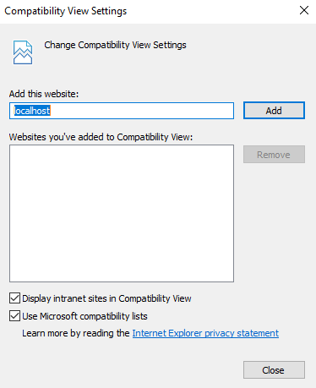

Figure 20

1. You can see the website up and running by typing localhost and you can see the first screen as shown in Figure 21 and 22.

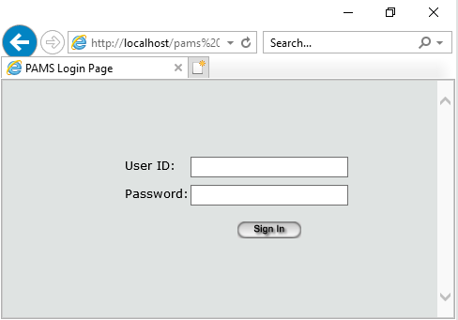

Figure 21

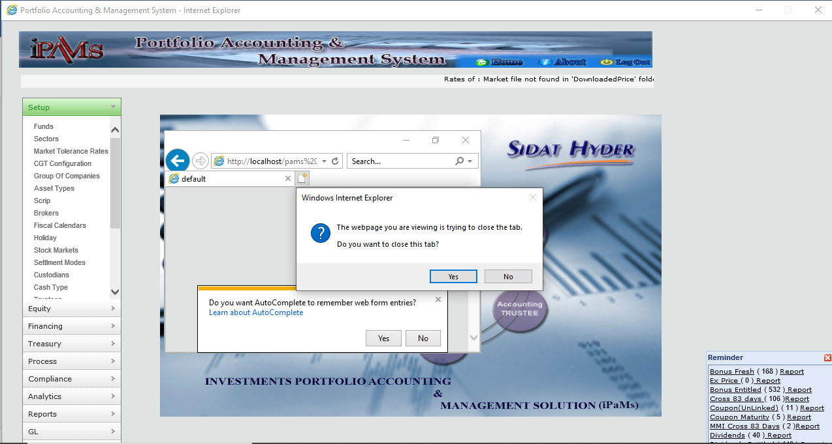

Figure 22

1. Points to be noted here is that IPAMS 3G will only run on Internet Explorer IE and If the dialog box appears as shown in Figure 17 click Yes.

That’s it you have successfully deployed the Pams 3G application on IIS Web Server.

End



