iPaMs Release Notes
Version 3.0.0.0_20100525

Table of Contents

- Introduction ………………………………………………………………. 3
1.1. Introducing the .NET Framework 3.5……………………………………. 3
1.2. Describing the .NET Framework 3.5……………….……………………. 3
1.3. Challenges of building the Modern Application…………………………. 3
1.4. Addressing the Challenges.. ………………………..……………………. 4
1.5. Changes to the release notes ………………………..……………………. 5
1.6. Scope ………………………………………………..…………………… 5
- System Requirements ……………………………………………………... 6
2.1. Operating systems supported …………………………………………… 6
2.2. System requirements …………………………………………………… 6
- Component included with IPAMs ………………………………………… 7
3.1. HelpDesk Software and Information Portal ……………………………. 7
3.2. File Transfer Protocol System …………………………………………. 7
- Additional Features ………………………………………………………… 8
- Dropped Features ………………………………………………………….. 20
- Crash Issues Addressed …………………………………………………….. 20
6.1. Included maintenance fixes ……………………………………………… 20
- Performance and Usability Issues Addressed …………………………….. 21
- Implementations …………………………………………………………….. 21
- Known Limitations & Restrictions ………………………………………… 22
9.1. Limitations ……………………………………………………………… 22
9.2. Restrictions ……………………………………………………………… 22

1. Introduction

1.1. Introducing the .NET Framework 3.5 

The goal in application development is always the same: create the best possible software in the least amount of time. Yet the bar is continually raised, as demands from customers increase. To meet these demands, the platforms developers build on and the tools they use must get better.

1.2. Describing the .NET Framework 3.5

The .NET Framework provides a clear example of this. First released in 2002, version 2.0 of the Framework appeared three years later. The .NET Framework 3.0, released in 2006, was a major update that added a number of new technologies, while the latest version, the .NET Framework 3.5, includes more useful additions. Alongside this evolution, Microsoft’s flagship tool for creating .NET applications has also moved forward. The latest release, Visual Studio 2008, offers a range of improvements for creating .NET applications. Every step in this path has been aimed at providing a better and more productive environment for the people who create Windows software.
1.3. Challenges of building the Modern Application

Creating a modern application is not a simple task—the requirements are substantial. Traditional concerns such as creating effective business logic and allowing access via a Web browser are still important, but they’re no longer enough. Modern applications present a range of new challenges, including the following:
- Users increasingly expect Web browser interfaces to act like installed Windows applications. Loading a new page whenever something has changed is no longer sufficient—it’s just too slow. What’s needed is better support for responsive browser applications.
- Data remains central to most applications. How that data can be represented, however, has expanded considerably. Relational data is still important, as is mapping between objects and relations. Yet the amount of data represented using XML continues to increase, a trend that’s not likely to change. And even though it’s not always viewed in this way, a running program’s objects also contain data. A technology that allowed consistent access to diverse data would help developers create applications in less time and with fewer errors.
- Applications commonly communicate with other applications, both inside and outside the organization. Modern applications also must often fit into a service-oriented architecture (SOA), exposing some of their functionality as interoperable services accessible by other software. Achieving these goals requires support for service-oriented applications.
- Organizations are increasingly taking a process-oriented view of what they do. Since most applications automate some part of a business process, it can be useful to make the steps in this process explicit in the code. An effective way to do this is by using workflow technology, an approach that requires support for workflow-based applications.
- The requirements for a modern user interface have grown significantly. Providing real business value can commonly require working with various kinds of documents, using two- and three-dimensional graphics, displaying video, and more. Meeting these needs requires a unified approach to diverse user interfaces.
- The people who use an application commonly need a way to convey information about who they are. Many different technologies for defining and using a digital identity are in use, and problems such as phishing are common. Given this, a modern application and the people who use it can benefit from consistent user control of digital identities.

1.4. Addressing the Challenges

The .NET Framework 3.5 contains a number of technologies that can help developers solve the problems just described. Some were part of the .NET Framework 3.0, while others are new with the 3.5 release. This section introduces the most important of these technologies.

ASP.NET AJAX: Support for Responsive Browser Applications
Web browsers are the most popular user interface for new applications. Still, they’ve traditionally suffered from a significant limitation: Each new request from a user requires a round-trip to the Web server, commonly resulting in loading a new page. A more intelligent—and faster—approach would be to access data in the background whenever possible, then update only those parts of the page that change. Users would see much more responsive applications, since they would spend less time waiting for new pages to be loaded.

Language-Integrated Query: Consistent Access to Diverse Data
Most applications work with data in some way. That data can be represented in a variety of ways, including as tables in a relational database, in XML documents, and in objects held in memory. Accessing each of these kinds of data has traditionally required using a different approach. It’s common to use SQL to work with relational data, for example, XQuery for XML data, and custom code for in-memory data.

Windows Communication Foundation: Support for Service-Oriented Applications
From the beginning, the .NET Framework has provided plenty of approaches to communication. Those choices include the following:
- ASP.NET Web Services (commonly known as ASMX), providing interoperable SOAP-based communication.
- .NET Remoting, focusing on communication between .NET applications.
- Enterprise Services, offering support for scalable, transactional applications.
- System.Messaging, supporting queued messaging via Microsoft Message Queuing (MSMQ).
- Web Services Enhancements (WSE), an extension to ASP.NET Web Services that provides support for more recent specifications such as WS-Security.
This is exactly what’s done by Windows Communication Foundation (WCF). Rather than requiring developers to use a different technology with a different application programming interface for each kind of communication, WCF provides a common approach using a common API. Originally released as part of the .NET Framework 3.0, WCF is now Microsoft’s recommended approach for communication. Most applications that might have used one of the technologies just listed should instead use WCF for communication.

Windows Workflow Foundation: Support for Workflow-Based Applications
A workflow is a simple idea: it’s just a series of steps performed in some order. Using workflow technology to implement process logic can be an effective way to address this problem. Rather than intertwining the logic in ordinary code, each step in the process is explicitly defined, then executed by a workflow engine. The result is a clean implementation of the process itself. With Windows Workflow Foundation (WF), Microsoft provides a common workflow technology for Windows, giving any workflow-based application a common foundation to build on. Since its release in the .NET Framework 3.0, WF has been used both in software provided by Microsoft, such as Windows SharePoint Services, and in applications created by other organizations.

Windows Presentation Foundation: A Unified Approach to Diverse User Interfaces
The user interface is an important part of nearly every application. Yet what users expect from those interfaces has advanced significantly. Traditional menu-driven GUIs are still required, of course, but applications may also need to display video, run animations, use two- and three-dimensional graphics, and work with various kinds of documents. And all of this must be possible whether the application is accessed from a standalone desktop client or via a Web browser.
1.5. Changes to the Release Notes
iPAMs release notes will cover new features, functional enhancements, exposures & constraints and related documentation, if any. Release notes will be issued as and when critical product relevant information needs to be relayed to customers, new features have been introduced, functional enhancements are made due to changing regulatory requirements or market dynamics and limitations have been overcome.
1.6. Scope
Investments Portfolio Management and Accounting Solution is a complete back office information solution for investment managers to help them manage financial assets and diversified portfolios. iPAMs caters to all types of investment markets and instruments floated in the local market. It has the capability to manage Equity market transactions, CFS and Futures market, Money Market Instruments and treasury requirements for investment organizations. Its comprehensive functionality and flexible business logic allows it to cater to any and all types of investment businesses, covering information requirements of the entire end-to-end process of investment management from portfolio management to order management to execution all the way to settlements and accounts.
iPAMs is in compliance with local regulations passed by the regulatory bodies, and its flexible application design allows it to adapt future regulatory enhancements with seamless ease. Integrated with Sidat Hyder Financials, iPAMs manages the accounting requirements of investment managers in close compliance with the International Accounting Standards.

2. System Requirements

2.1. Operating systems supported

- Microsoft Windows 2003 Server (Standard Edition)
- Microsoft Windows XP Professional
- MS SQL Server 2000/2005 Server (Standard Edition)
- Client Access License for Windows 2003 Server
- Client Access License for SQL Server 2000/2005
- Windows Terminal Services Licensing

2.2. System requirements

Table 1
DESCRIPTION | iPaMs & Financials  SERVER | BACKUP DATABASE /APPLICATION SERVER
Processor | 2-Way Xeon DP processor 2.8 GHz | 2-Way Xeon DP processor 2.8 GHz
Cache Memory | 2-MB Level 3 Cache | 2-MB Level 3 Cache
FSB (Front Side Bus) | 800-MHz | 800-MHz
Memory | 4 GB DDR | 4 GB DDR
Storage Controller | Integrated Dual Channel Wide Ultra3 SCSI Adapter | Integrated Dual Channel Wide Ultra3 SCSI Adapter
Storage | 3 x 72 GB | 3 x 72 GB
CD-Drive | 48x, Internal | 48x, Internal
Network Controller | Dual integrated Gigabit | Dual integrated Gigabit
Inter faces | 1 x Parallel  1 x Serial  1 x Pointing Device (Mouse)  1 x Graphics  1 x Keyboard  2 x Network RJ-45  4 x USB | 1 x Parallel  1 x Serial  1 x Pointing Device (Mouse)  1 x Graphics  1 x Keyboard  2 x Network RJ-45  4 x USB
Keyboard, Mouse | Standard | Standard
Antivirus | Required | Required
Form Factor | 2 / 1 U | 2 / 1 U

3. Component included with IPAMs
Following are the embedded systems offered with IPAMs.

3.1. The HelpDesk Software and Information Portal
Help desk is now a fundamental and core part of iPaMs service and operation. However, addressing the tricky issues, selecting the right tools, and managing the help desk correctly can actually be a very daunting task.
Essentially, the Help Desk is a central point through which problems/issues are reported and subsequently managed/co-ordinated. From a wider perspective, it is also seen as core part of the service function, responsible for bringing together multiple resources to address an issue.
3.2. File Transfer Protocol System

FTP is a fundamental and core part of iPaMs, it has commands that allow users to connect to a remote computer, provide authentication, find out what remote files are available, and to request file transfers. FTP software on iPaMs release server interacts with FTP software on another. However, it does not specify a user interface but it help updating files through web.
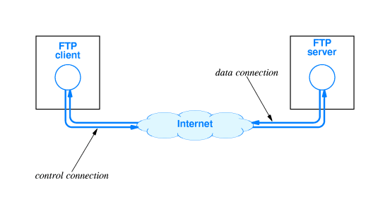

4. Additional Features
This release includes new features and enhancements in the following areas:
- Equity
- Compliance
- Bonds
- Placements
- Bank Fund Markup Module
- iPaMs with context of Global Market
- Exposure Limits
- More comprehensive Performance Monitoring Shell
- Internal Audit control Feature
- Capital Charge Specification
Equity
Equity Cost Adjustment Module will essentially being used for impairment purposes.

Compliance
Almost all NBFC Rules are now embedded in Pre-Trade Compliance mode.
Equity NCSS Trade Log Upload Module (Transfer data on trade basis or broker wise)

MUFAP Prices upload feature
- Treatment for Leap year as per SBP Circular
- Since MUFAP is publishing daily TFC prices that is being used as daily market rates. They are
averaging different rates available from different brokers and then publish the same at their website. They are now using iPaMs to average out TFC daily prices available from different brokers. They can also convert the same in text file format so that it can be easily uploaded into any system. Upload mechanism is already built into iPaMs

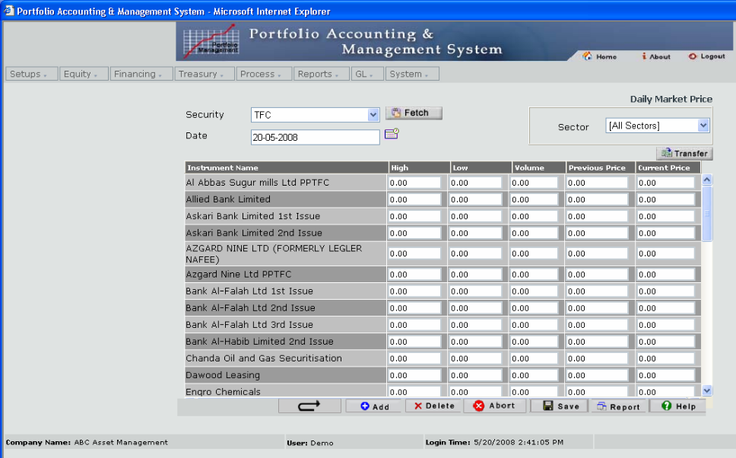

PKRV Upload Mechanism
User can input daily PKRV in given excel format and upload the same into the system like MUFAP price upload feature.
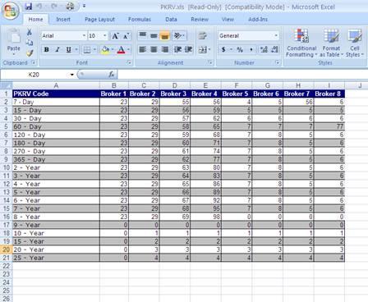

Bonds
PIB
Logic upgraded to use Interpolated PKRV while daily revaluation and placement borrowing
More Parameters to accommodate IAS Treatment
TFC
360 days accrual basis complete treatment
T-Bill
Provision for Sale on Lot basis
More Attributes added:
- One Settling Bank
- Multiple Depository Banks
- Primary Dealer
- SBP Price
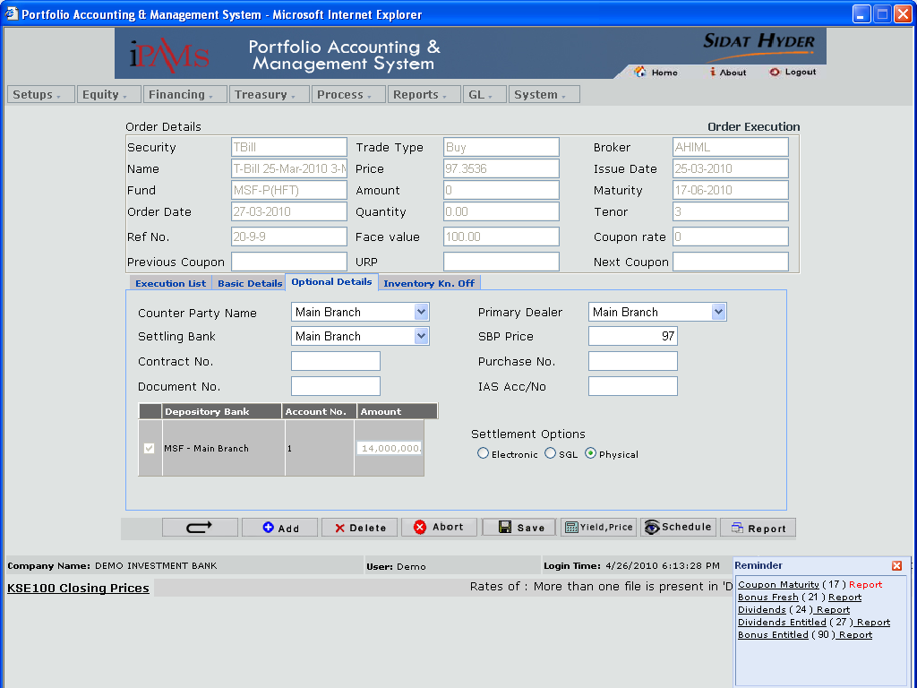

- T-Bill Purchase lot selection while sale
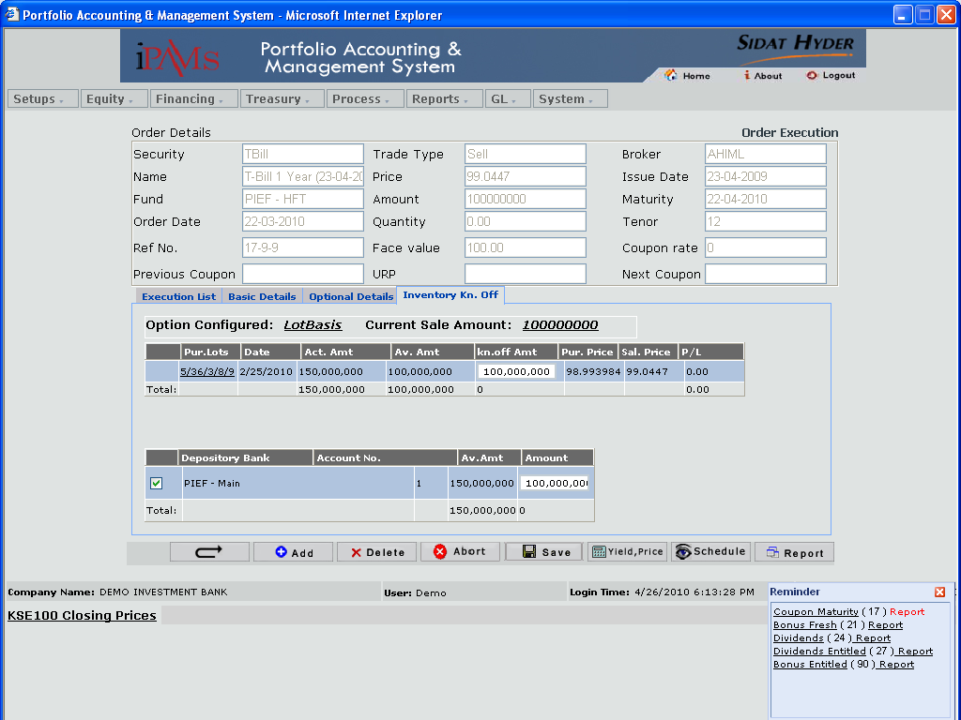

- Settling Bank Inventory Movement
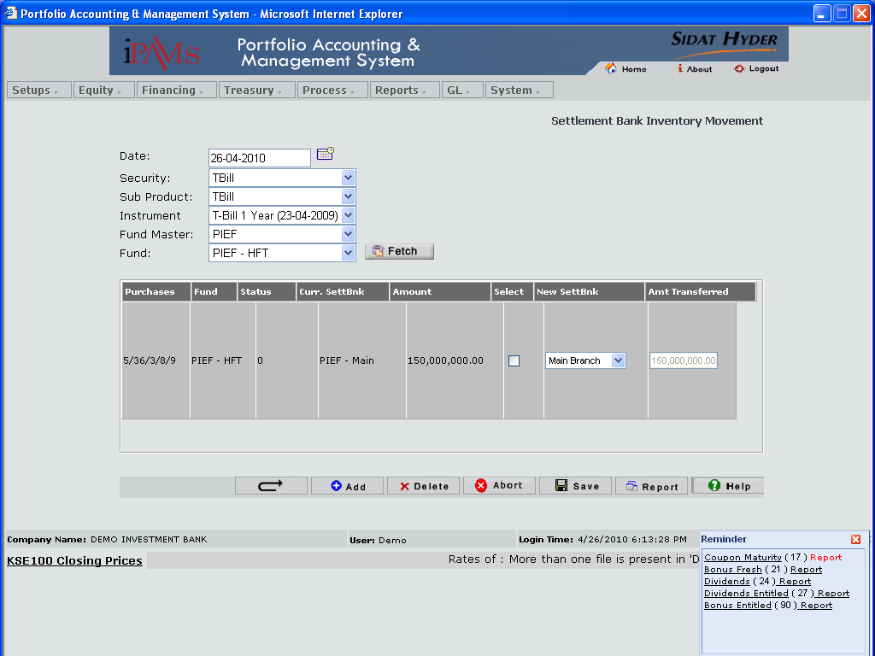

Reports
- Moving Average Lot wise
- Revaluation Lot wise
- Realized gain/loss Lot wise
- Daily Accrual Lot wise
- New T-Bill Report as sale amortized factor is same as of its purchase factor.

Placements
Add more types:
- Certificate of Mudaraba
- Certificate of Musharika
- Letter of Placement
- Certificate of Deposit

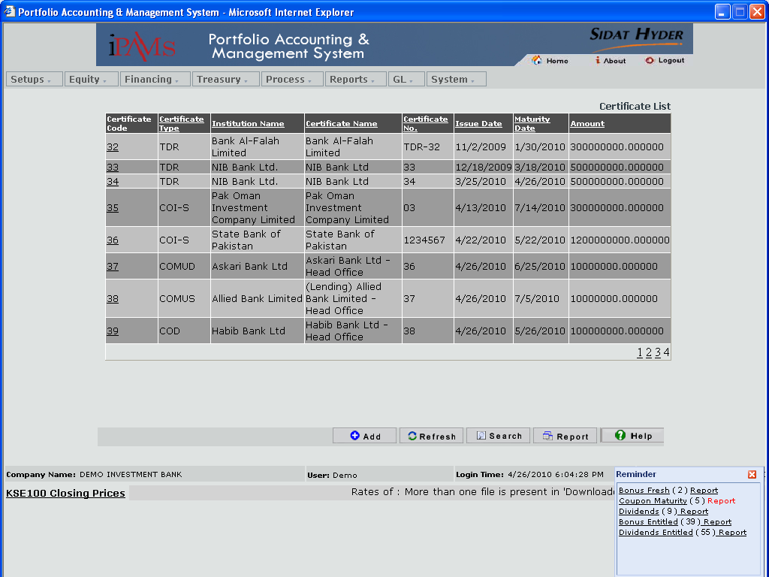

- Forward deals PKRV handling.
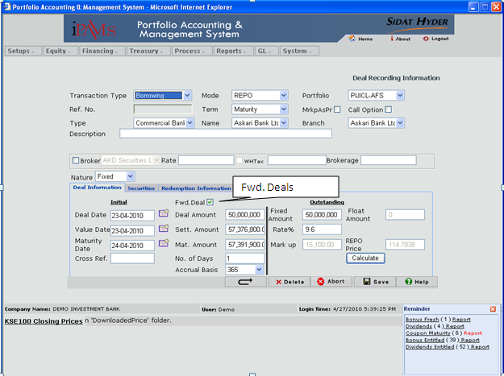

- Reports: Voucher status report against all placement & borrowing deals
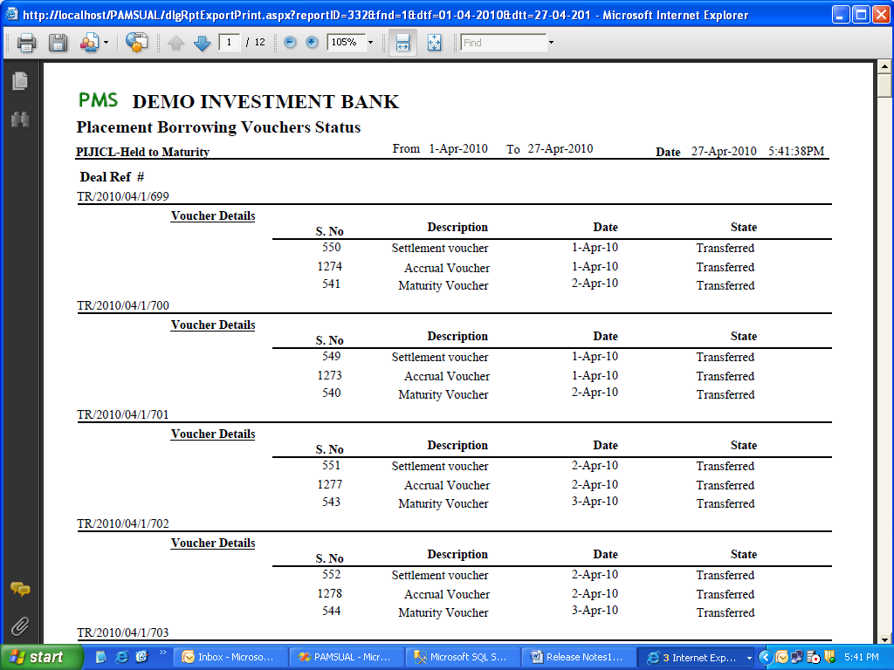

Bank Fund Markup Module
Bank closing balances will be fetched from GL, manual entry of rates for accruing profits on daily basis.
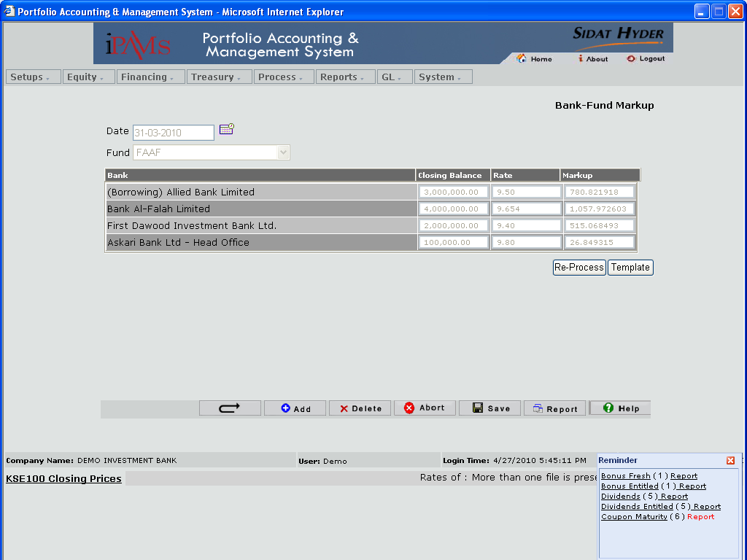

- Provision for daily bank markup voucher also embedded
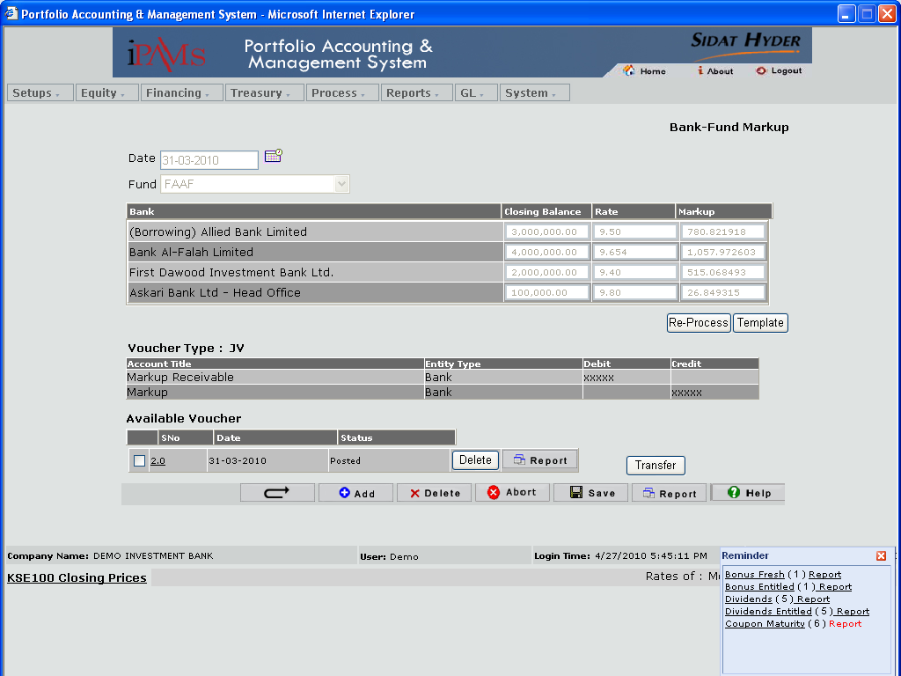

IPAMs with Context of Global Market
Setup Global Stock Markets
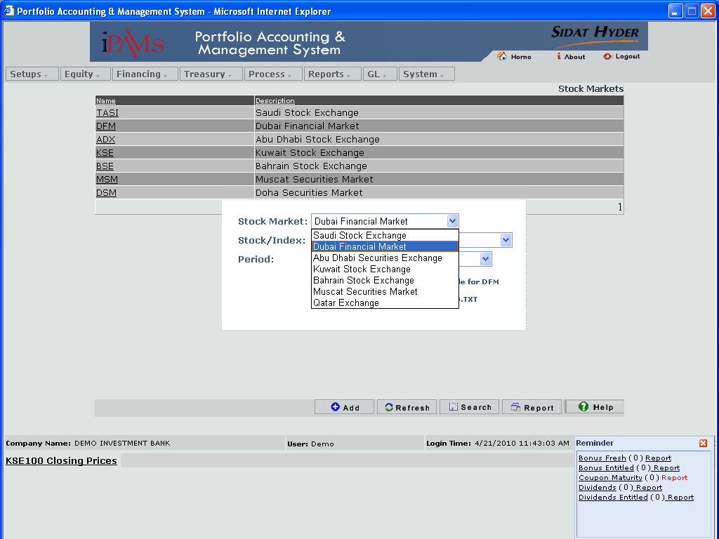

- Identify Scrip’s / Companies as listed in each Stock Market.
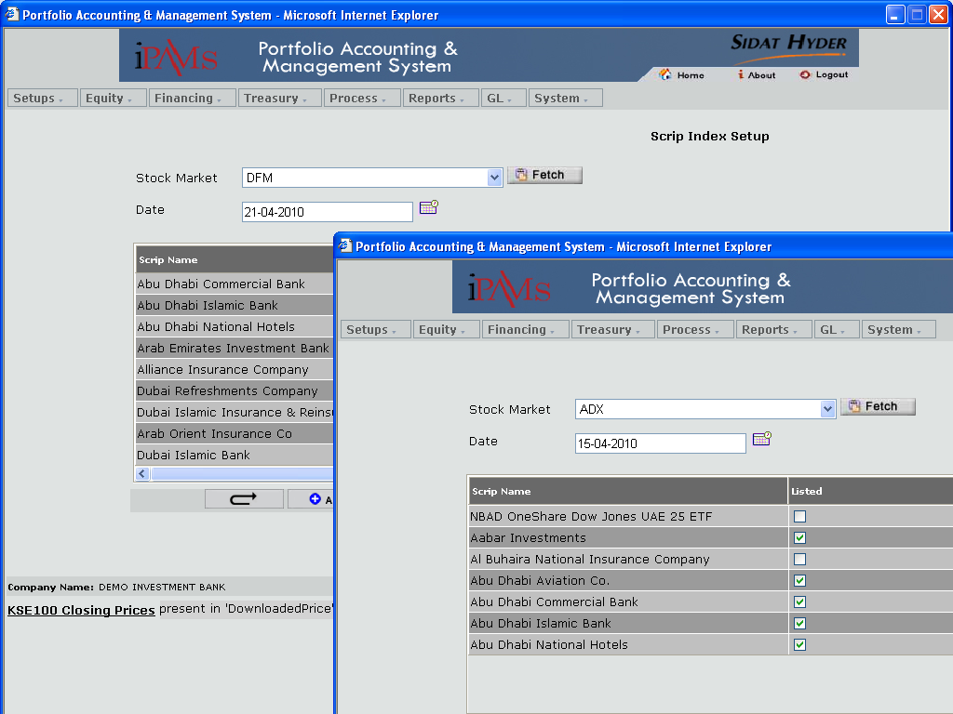

- Market pricing for each Stock Market with their respective Scrip’s / Companies.
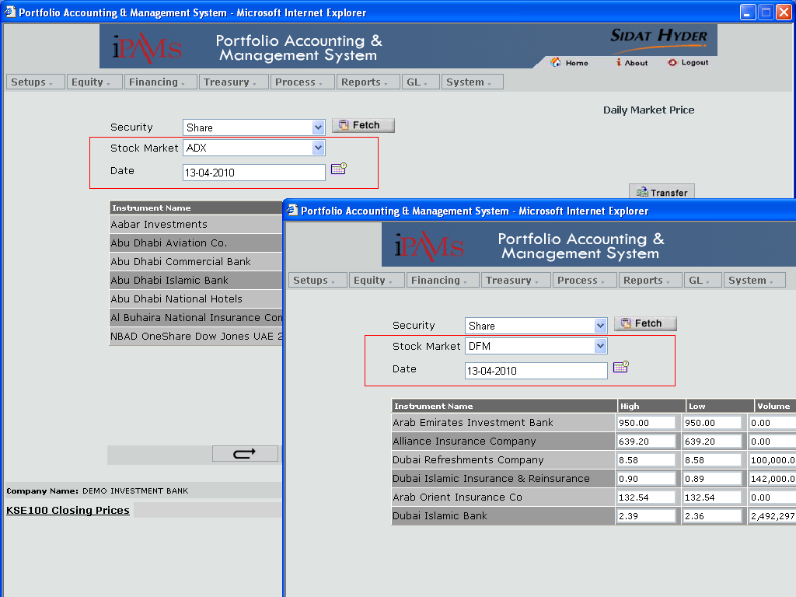

Exposure Limits
- Internal Exposure Limits for the system for more comprehensive analysis
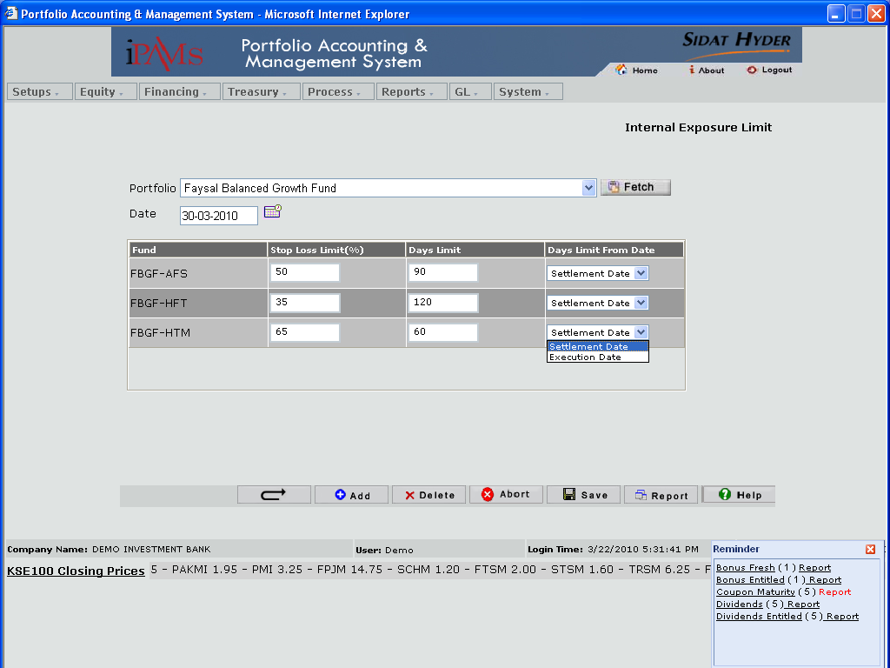

- Dealer specifications with limits
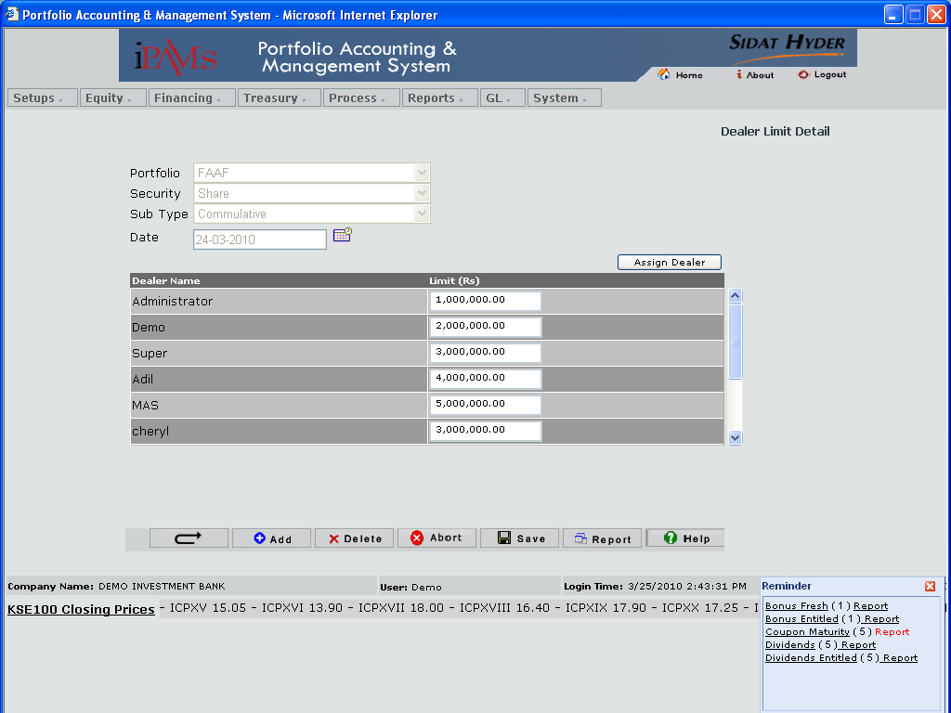

- Dealer Template to mark the active user.
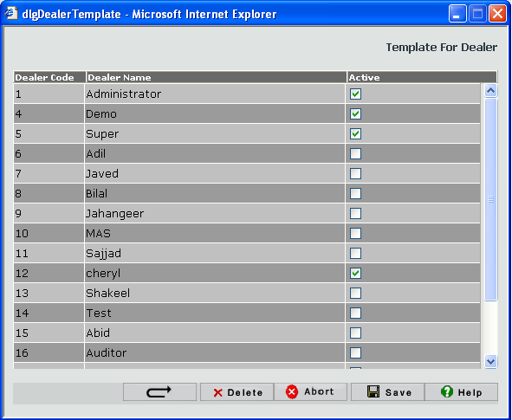
More ATTRIBUTES AGAINST SCRIPS
- Company Financial Data
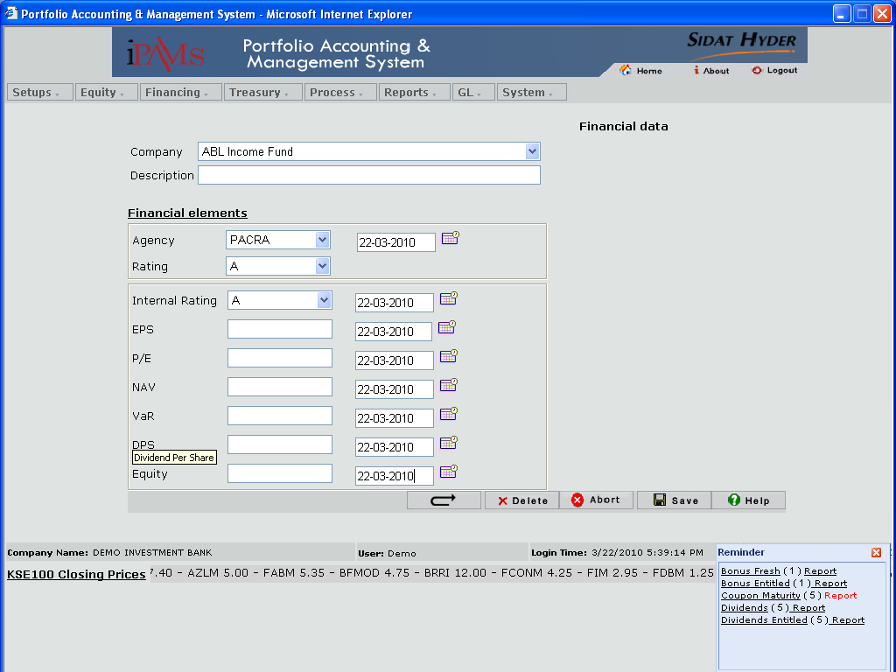
deffered tax
- A new type of tax introduced ‘Deffered Tax’

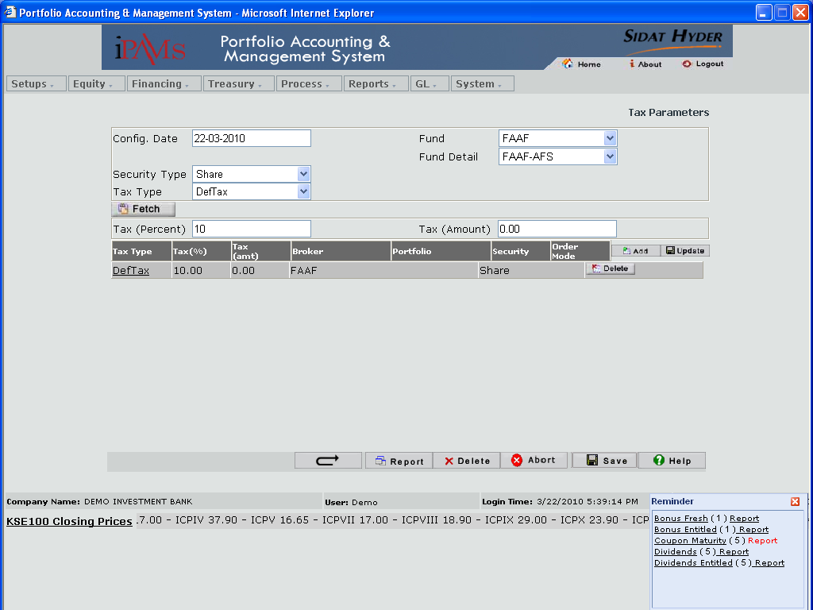

- Mark Scrip’s as approved for trading
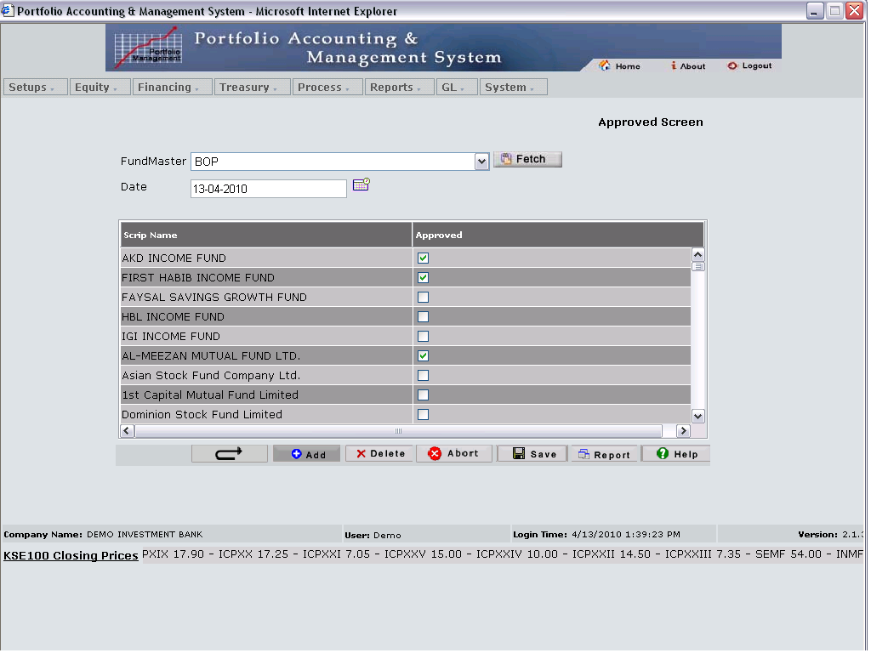

Capital Charge specification
Credit Risk
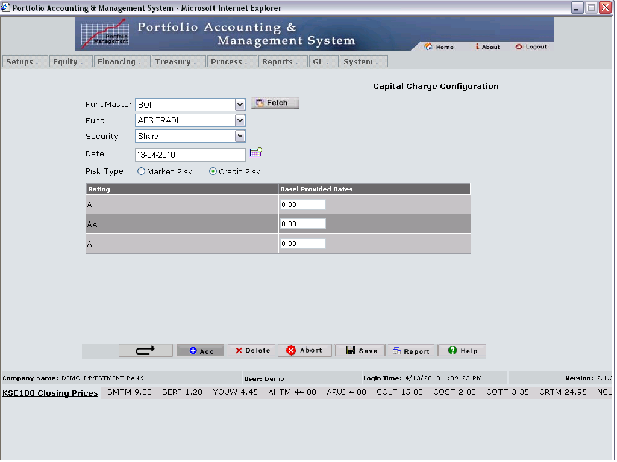

Market Risk
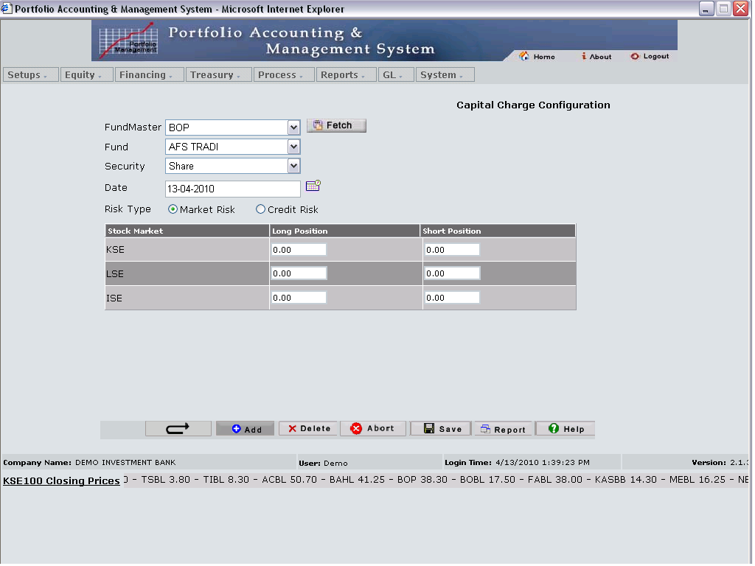

5. Dropped Features / Reports

Following reports are dropped from IPAMs to design them in Excel Add-in Tool with more grouping options, pivot tables and graphical representation.

Excel Add-in:
- Free Float Shares w.r.t Funds holding
- Gain Performance (Month wise, Scrip wise)
- Investments % change
- Investments Monthly
- Movement Summary
- Performance Summary
- Purchases
- Sales
- Sector wise exposure
- Broker wise exposure

6. Crash Issues Addressed

6.1. Included Maintenance Fixes

This release includes fixed issues (wish list of client) and enhancements in more comprehensive mode:
Table 2
Identifier | Component | Headline
Daily Processing | Application | Resolved by new functionality on the server side.
Reports/ Letters | Application | More Reports provided to accommodate End Users need.
Pricing PKRV | Application | Resolved by new functionality on the server side.
GL Interfacing | Application | More Voucher Formats Provided to accommodate End Users need.
Data Dictionary | Documentation | Provided – Mainly for Excel Add-In Tool.

Daily Processing
- More rules are added to ensure smooth daily processing
- More Parameters to accommodate IAS Treatment

GL Interfacing
- Configure accounts placement type wise e.g TDR,COI, LOP, etc
- Configure accounts collateral type wise e.g TFC,SUKUK, T-Bill, CPs, etc
- New formats for Money Market instruments.
- Cheque no. functionality has been introduced.

Reports / Letters
- More rules are added to ensure smooth daily processing
- More Comprehensive Valuation and Moving Average Reports
- More Parameters to accommodate IAS Treatment
- Initial Settlement/Placement Letter Party wise
- Initial Settlement/Placement Letter Trustee wise
- Maturity Letter Party wise
- Maturity Letter Trustee wise
- Outright Settlement Instructions Party wise
- Outright Settlement Instructions Trustee wise

7. Performance and Usability Issues Addressed
Performance was considered as important as stability for this release based on feedback from users. Performance was improved in many areas of the product:
- Numerous improvements to the Help content
- Processes time usability constrain have been improved
- Updated templates and samples to use latest components
- Moving a form within the Screen Outline no longer loses all data binding information for that form
8. Implementations of new modules/components
Table 3
Modules | Specialties | Implementations
Equity | NCCS Trade Log Upload | 4
Bonds | T-Bills Lot basis provision | 2
Excel Add-in | Equity/Bonds Reports Design | 4
Treasury | Bank Mark up Module | 1
NAV Module | NAV, SECP fee, Management fee and trustee fee and outstanding units automation | 1

9. Known Limitations And Restrictions

This topic describes known restrictions and limitations of iPaMs.

9.1. Limitations
Table 4
Log – In Issues | Details
Application does not handle invalid license file message. | Attempting to log in without or invalid license file causes the application failed to login.
iPaMs account setup fails with incorrect user ID | Verify that the user ID used to set up in the LMO account. Application does not send the correct credentials if the password is incorrect.
CAUTION:  iPaMs will not preserve existing session for more than 1 hour. This is a limitation of the development environment. | In order to preserve existing session do not set your application idle for at least 60 minutes.

  - Restrictions
Table 5
To Do Issues | Details
To Do or URL not synchronized with the naming convention specified for the virtual directory. | Application does not execute for the Active Users
To Do or Task documents are not synchronized with the naming convention or destination folder on the server | Application does not support Upload pricing utility of any type.

