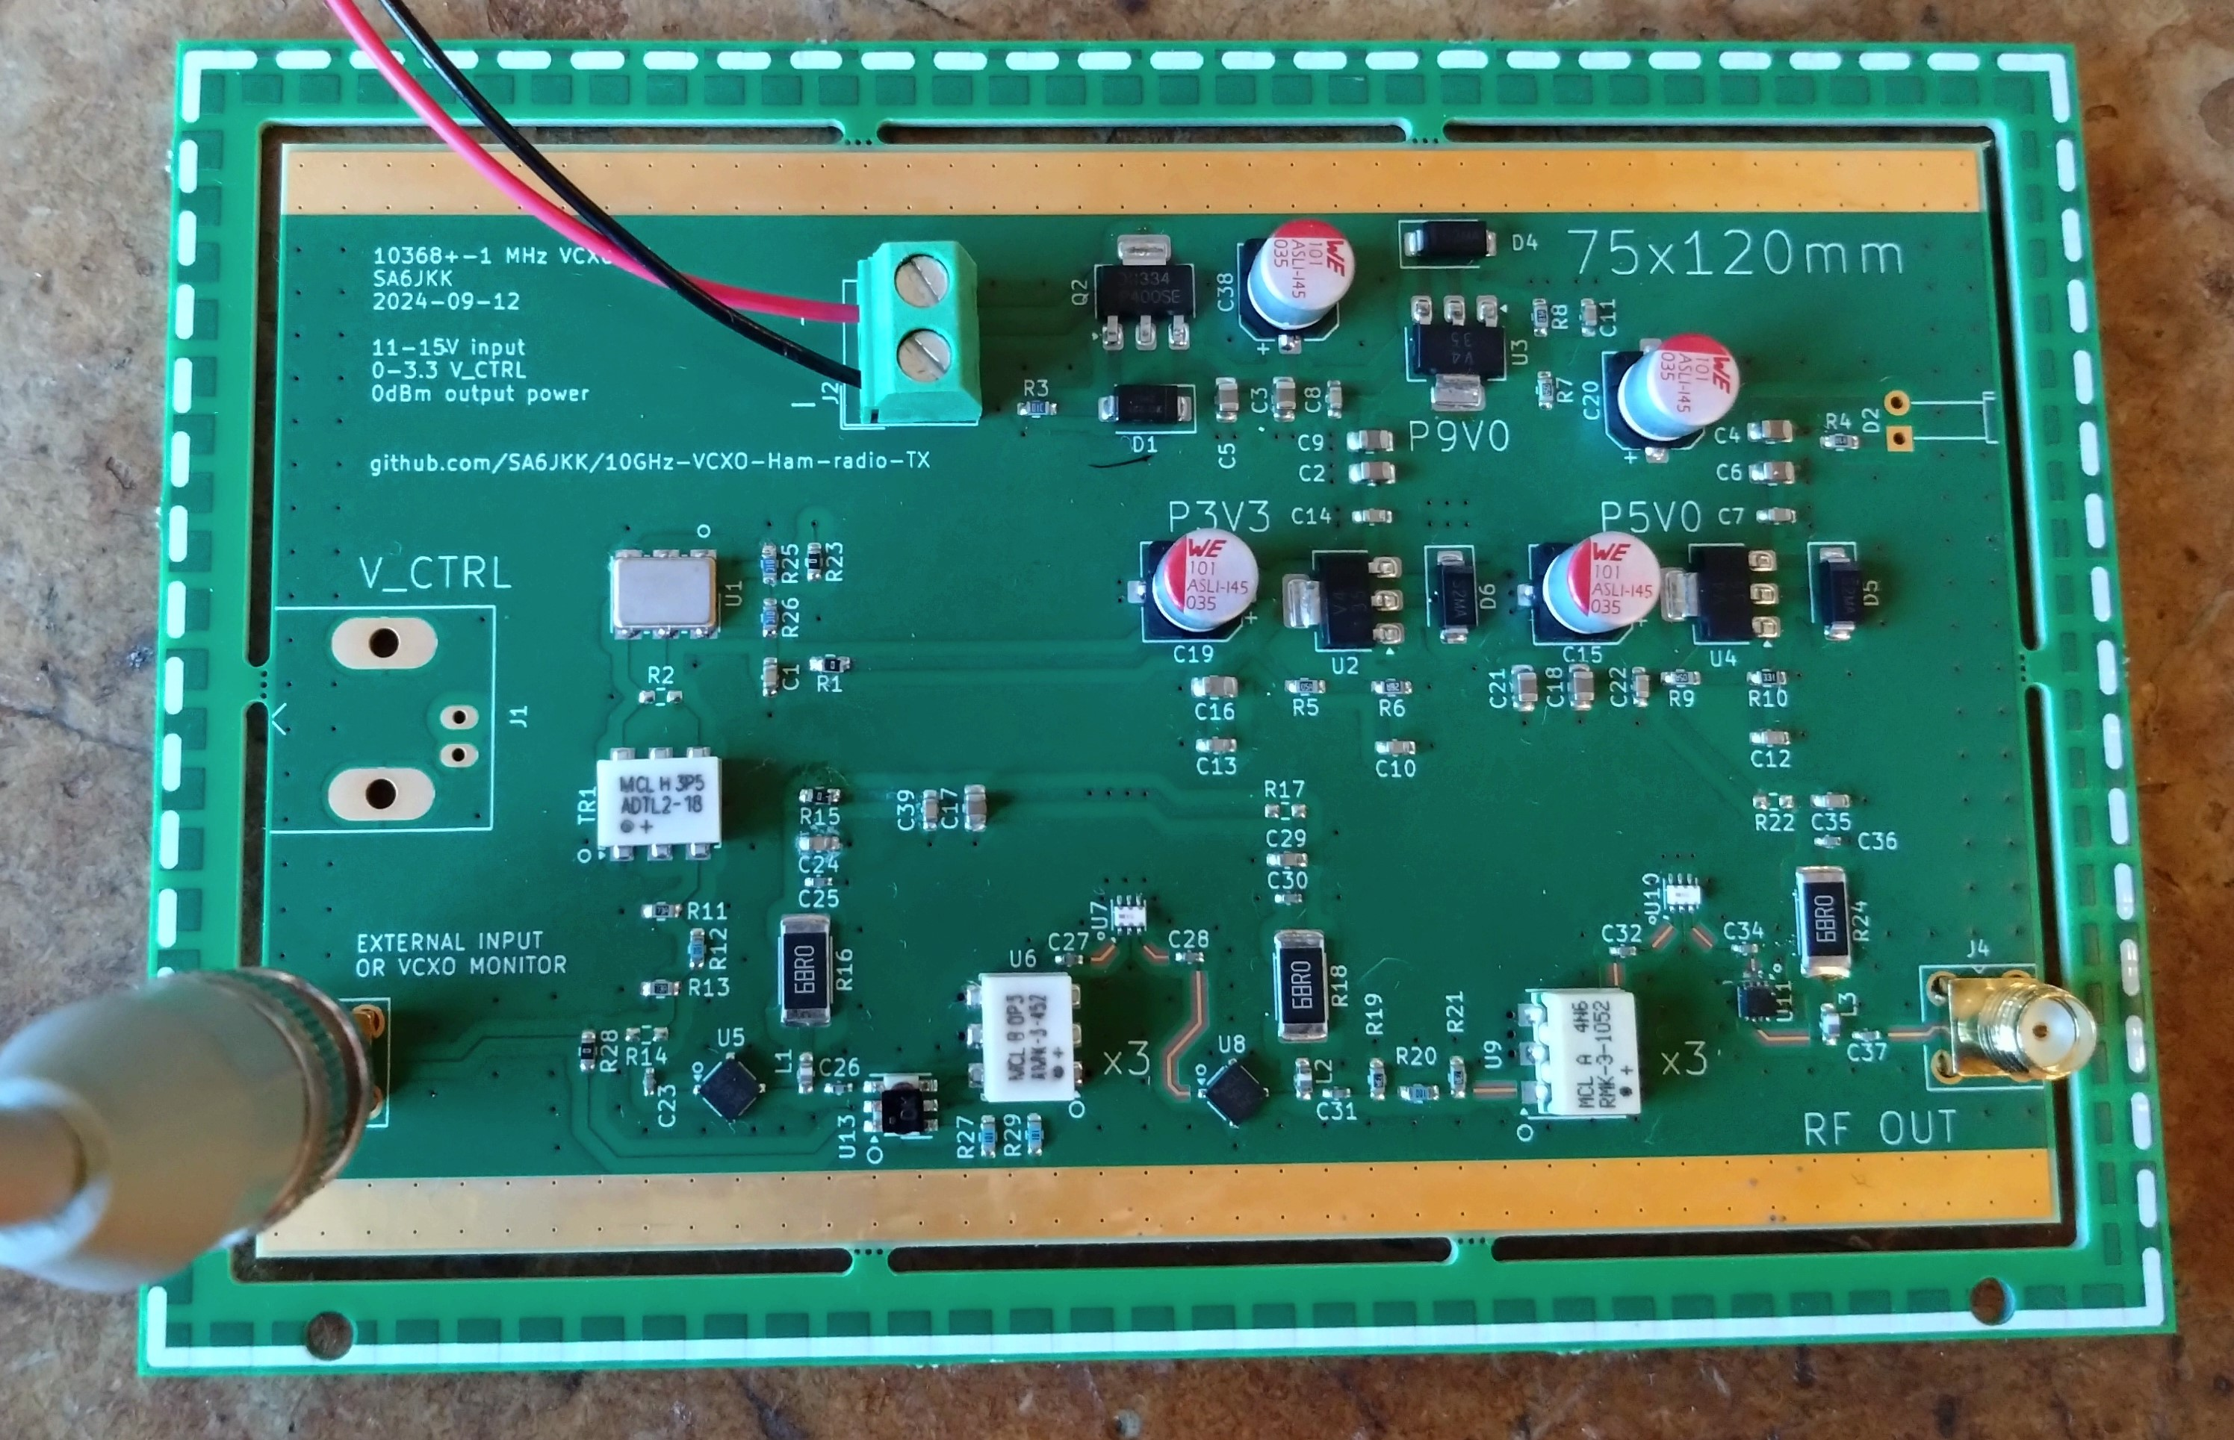

Power
12V 250(?) mA, greater than 12V 188 mA expected
P9V0 OK
P5V0 OK
P3V3 OK

TX_VCXO
Frequency OK, 1152 Mhz

X3_IF_Multiplier
Coupler output 8dBm, 4-5 dB more than expected
Update schematic R11, R12, R13 to lower power into U5.

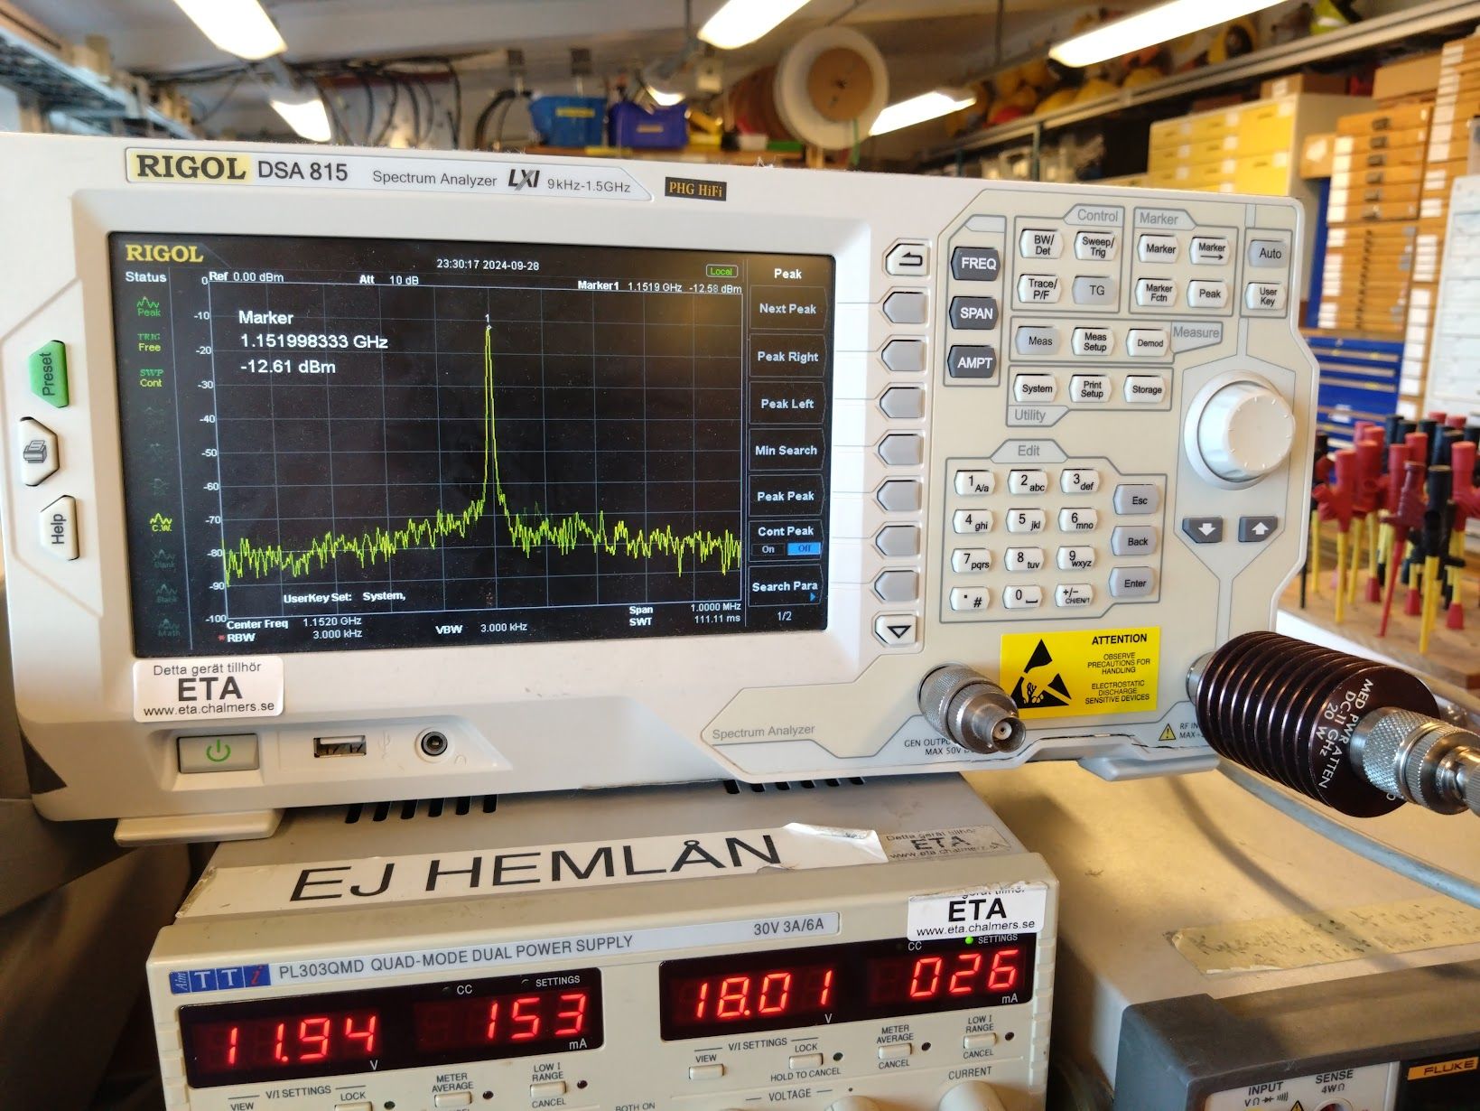

Spectrum after U6 OK
Check again with soldered SMA cable. Level uncertain

X3_Rf_Multiplier
Spectrum after U9 (RMK-3-1052+) OK
Check again with soldered SMA cable. Level uncertain

RF_PA
Output from U11 NOK!
  - GHz, 5.75 GHz etc. generated after U11
Looks like oscillation!
10.386 GHz 30 dB lower level than expected.
4.7V lower than expected, around 2.7V -> more power consumption than estimated

