Design Document

1. **Goal**
2. Promote understanding of the Seventh-Day Adventist faith
3. Use the Bible to back up beliefs so that they are just and found

**2. User Experience**

2.1 Audience Definition

2.2 Scenarios

Person 1:

Kelly is a 15 year old living in London, England. She is an only child. She was born into a Catholic family. She has a friend named Sasha, who is a Seventh-Day Adventist. Sasha's family attends church on Saturday, but Kelly's family attends church on Sunday. She doesn't understand why her friend doesn't attend church on Sunday. She doesn't want to embarrass herself by asking her friend or her friend’s family. So she gets on the internet to try and find some answers. She types in the search box "Why do Seventh-Day Adventists attend church on Saturday, instead of on Sunday like Catholics?" The link to my website comes up. Kelly looks at it and thinks it looks like a good website to try. She clicks on the link, and a page comes up, detailing why Seventh-Day Adventists attend church on Saturday. It even uses Bible verses to support the belief!

The next day, Kelly talks to her friend about it, asking if what the website was saying was true. Sasha was surprised, but said that the information was true. Kelly decided that she wanted her parents to know about this site. So she sent them the link. That night after dinner, Kelly's family sat down to talk about what they had learned from the site. The discussed what they should do. Kelly suggested, "How about we attend church on Saturday with Sasha's family?" The family agreed. On Friday, Kelly told Sasha that her family wanted to attend church with Sasha's family. Sasha said that her family would stop by Saturday morning so they could go to church together.

Saturday morning, Sasha's family stops by with the family van. There's enough room for both sets of parents and Sasha and Kelly. When they get to church, the lead pastor is at the door greeting people. "Ah. Guests! Welcome friends!" And shakes their hands. They walk in and sit down in the sanctuary. After church ended, Sasha's mom asked if Kelly's family wanted to come over for Sabbath lunch. Kelly's mom said, "We'd love to." After lunch, Kelly's family went home. They sat down in the living room, each deep in their own thoughts. "I think that we should attend Sasha's church again." Kelly said at last.

The family all agreed. They went again, and again, and again. Until Kelly was baptized on the same day as Sasha. Kelly's family also became Seventh-Day Adventist.

Person 2:

Becki

Becki is a California girl. She lives with her aunt and uncle. She has a brother named Jeffrey. Her aunt and uncle are Seventh-Day Adventist. Her brother is as well. Becki is as well, but she doesn't understand a lot of things. Like why her family doesn't eat meat. Or why they attend church on Saturday. Since there isn't an Adventist school close to where she lives, she attends a public school. All of her friends either attend church on Sunday, or don't attend church at all. They always ask her why she attends church on Saturday, or why she doesn't eat meat. She always answers with the same answer, "Because my family does. I don't question my aunt and uncle."

One day, she can't take it anymore. She gets on the internet to try and get some answers. She types into the search "Why do Adventists believe what they do?" A website link comes up for my website. 'Let's try this. It seems like a good site.' Over the next few hours, she poured over the site, finding answers to the questions that she had.

"Becki," Jeffrey knocked on her bedroom door, "dinner's ready." And walked away. Becki thought for a moment, then decided not to tell her aunt, uncle, and brother just yet. That night after dinner, she brought out her Bible and looked up the verses that the site gave in the explanations. She found the answers to be just and found! So every day afterwards, when she was asked why she believed this, or why she did or didn't do that, she always answered with the Bible.

Person 3:

Jack

Jack and Jenn are twins. Jack is the older twin. They have both graduated college and now they teach at a Seventh-Day Adventist school. Jack teaches 9th grade Bible, while Jenn teaches 10th grade Bible. On Friday, Jack tells his class to "Be prepared to discuss the Adventist faith on Monday when you come into class." On Sunday, Jack is trying to figure out how to go about teaching this subject. Jenn, since the twins share a flat together, comes into the living room to find Jack really stressed out.

"Jack, what's the matter?" She asks her twin.

"I don't know how to go about teaching my Bible class about the Adventist faith and why we believe and do certain things."

"Jack, you should have asked me earlier. I have to perfect solution. Someone showed this site to me. It's really handy, and the best thing is that it's completely Biblical."

Jack stared at her for a moment. "I didn't think to ask you." He said absentmindedly. Jenn's laughter rang throughout the house. "Ya, ya. Just give me the website."

Jenn gave Jack a paper with my website on it. All through the night and into the morning, Jack looked at the website. It had all the information he needed. The next day, Jack sat waiting for his class to come in. Once the class was seated, he clapped his hands for silence. “Alright class! Settle down! Today, we will be going into why Seventh-Day Adventist believe some of the things they do. Does anyone have anything that they want start with?"

The class went on in much the same matter. At the end the class period, Jack told his class, "The website that I found this information from is on the board." The bell rang, signaling that class was over. Jack was thankful for twin, even though he doesn't always say it to Becky.

2.3 Competitive Analysis Summary

**3. Site Content**

3.1 Content Grouping and Labeling

* Questions about the site
  + How to use this site
  + Ask the administration about the site
  + Why we use Bible verses
* Questions Adventists are frequently asked
  + Why don’t some Adventists eat meat, and if they do, why do they eat only certain animals?
* Discussion Forum
  + Discuss answers and questions with other people
    - Can be anonymous or with an account
  + Ask an Adventist a question if you have one
* Site terms of agreement/Members agreement
  + If you curious about the rules and terms of the site you can look
  + If you want to become a member, the terms and conditions of becoming a member
* Members log in/sign up
  + Members can sign back in
  + People can sign up
    - Giving e-mail is optional
      * Only if you want to get e-mails about new Q&A’s or if someone posted a new discussion (Optional about what you want to get e-mails about
    - Giving full name is optional
    - Username is required
      * Could be first name or a completely random name
    - Password is required
      * Password can be suggested or they could make up their own

If they do give their e-mail, it won’t be given away

3.2 Functional Requirements

- Open place for discussions

- AI or something of that sort that deletes comments or posts with offensive language or inappropriate comments

**4. Site Structure**

4.1 Metaphors (or summary)

A binder with dividers in it. The website as a whole is the binder, and the tabs are the dividers.

4.2 Site Structure

Site Questions

Frequently Asked Questions

Discussion Forum

Members Agreement

Site Terms of Agreement

Log in/Sign up

Date/Time

4.3 Global and Local Navigation Systems

Task bar at the top of page

Drop down menu

**5. Visual Design**

5.1 Layout Grids

5.2 Mood Boards

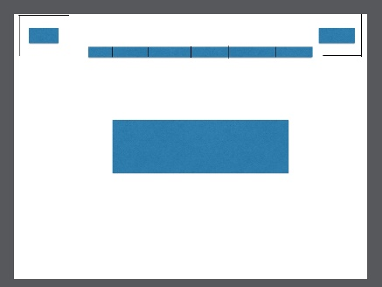

5.3 Page Mock-ups

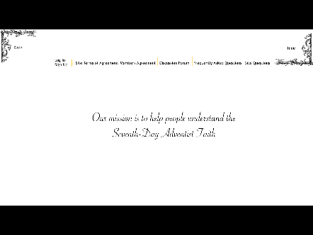

**Appendix A:** Competitive Analysis

**Appendix B:** Content Inventory

**Appendix C:** Site Structure Listing (optional)