1. Nathan C.‘s Design Document
2. Mission Statement:
3. The mission of *The Tree of Life* is to provide powerful yet relevant biblical lists that provide spiritual advice and encouragement to people who hunger for the word. Through our dedicated scholars, God's word can be seen in a simpler, more fruitful way.
4. #GOALS
   1. Finish by the end of Freshmen Year
   2. Have at least 25 lists
   3. At least 10 verses in each list (with explanation)
   4. At least 2 Ellen G. White Quotes in each list.
5. User Experience
   1. Audience Definition
      1. The audience for The Tree Of Life are diverse and different. Many young and brave evangelists will refer to this site for help when building their bible studies. People who are going through different problems such as sickness can search for encouragement in the lists based on emotions and healing.
   2. Scenarios
      1. Kyle, is a High School senior from Alabama. He has never spoke up front on the podium at church before but his pastor has asked him to speak at Friday night vesper. He is very lost. Although he’s not afraid of speaking, he just doesn’t know what verses and stories he should talk about, He doesn’t even know where to start. He then searches the web for some type of lead or idea and he happens to stumble upon a website called The Tree Of Life. He clicks the search bar at the top of the page. He types in Sabbath and clicks search. A list of topics on the Sabbath forms below the search bar. They range from proof that the Sabbath is eternal, to which day is the Sabbath. He ignores the bible sermon links and bible study pages on the Sabbath because he wants his sermon not to be too long. Below he sees related topics such as Church and worship. He scrolls back up and finds the topic on the day of the Sabbath, and is whisked to a page containing bible verses. He reads a short and general description of the Sabbath and ignores a link to a video sermon on the Sabbath. He is a little ticked off that the verses aren’t written out on the page but sees a “reveal all text” button near the search bar. He reads and writes in his notebook the verses that he thinks are essential to his sermon. Relieved that he found his inspiration, he is surprised to learn that there are Ellen G. White quotes to the side. He happily prepares for his short sermon with the advice the website gave him. Afterwards, he shares the help the website gave him on his twitter and Facebook.
      2. Jenna, a very beautiful college freshman from Tennessee, has been rejected by her boyfriend. He says that they should concentrate on their studies instead of relationships. She was so mad she slapped him and told her she never wanted to see him again. Looking for some sort of comfort, she surfs the web and scans through her twitter account. She finds a post by her distant cousin, Kyle from Alabama. She learns about a website called The Tree Of Life. She arrives on the page expecting it to be dull and boring but is greeted by a colorful illustration of a tree with its roots behind a search bar. She investigates the homepage first, skimming through the daily devotionals and verses. She is surprised to learn that there is a life problem link and curiously clicks the link. A list of problems show up with brief descriptions. She scrolls down to see a help button focused on relationships and clicks it. She is then shown a list of bible verses with a little paragraph of advice from the author. She never was into Christianity but something about what she read moved her. She started reading the bible verses listed on the page by clicking the show verse button. Hovering to the end of the list she finds a related topics section and is whisked to other topics like relationships and forgiveness. After a night full of soul searching and prayer, she called and asked her boyfriend for forgiveness. In the morning she clicks on a bible study guide to the side and is whisked to a different website based on bible studies. She then tells her family and friends of the website and tell them to use it often.
      3. Pete, a young child from Oklahoma, has just finished mourning for his dead father. He thinks about the subject of death, and starts trembling. He just doesn’t understand. Searching for help, he calls his cousin in college from Tennessee, Jenna. He breaks down on the phone but Jenna reassures him that she knows where to find some answers. She tells her about a website called The Tree Of Life and tells him to check out the topic on life after death. After his breakdown Pete does check out the website. He is greeted by a soothing picture of a tree and searches death in the search bar near the top of the screen. He is relieved to find the targeted subject right on top. He is greeted by a short sermon, and he holds back tears as he reads the powerful message. He opens his bible to the verses posted on the screen one by one down the bulleted lists. With every turn of the page, Pete starts seeing the light and the truth. When he is finished, he decides that he’ll need an in depth bible study. However, he doesn’t know where to start. He sees an online bible study list on the navigation sidebar on the left but decides he’ll need a personal bible study. He also sees a contact a pastor link and he clicks on the link. He is taken to a website where it tells him to give his relevant location and phone number. He finishes filling out the information and clicks for search a pastor. He is then shown several pastors with their email and phone numbers with the church they preach at. With the permission of his parents he contacted a nearby pastor with the info on the screen and started bible studies. From then on if he ever had a question about any topic, he referred back to the Tree of Life. He eventually became baptized in the faith and became a loyal Christian.
   3. Competitive Analysis
      1. Our website will be a useful bible study tool and source of encouragement. Our competitors lack a search bar to scan their topics and lack verses that the Christian is searching for. The rivals also do not contain quotes from Ellen G. White and also lack an efficient layout. Our website will bring the answers they need in a simple and instantaneous way.
6. Site Content
   1. Content Group and Labeling
      1. Tabs
         1. Sign in/Sign up
         2. About us
            1. Contact us
            2. Mission Statement
            3. Biography
            4. Webpage development
            5. Copyright claims
         3. Lists
            1. Life Problems
            2. Emotional Problems
            3. Spiritual Problems
            4. Physical Problems
            5. Theological Problems
            6. All lists
            7. Random
         4. Sharing
            1. Facebook
            2. Twitter
            3. Pinterest
         5. Other
            1. Online bible study
            2. Contact a pastor
            3. Prayer requests
            4. Forums
   2. Functional Requirements
      1. Content
      2. Membership rules (if registration by email)
      3. Bible study pages
      4. Copyright notices (Ellen G. White and bible versions.
      5. Privacy statement (If membership is required by email)
      6. Search bar (Needed)
      7. Functionality
      8. Log on pages
      9. Sign up pages
      10. Maps and directory
      11. Forum pages
      12. Contact us page
      13. Editing forums
7. Metaphor
   1. The metaphor of the website is the Tree Of Life. As we study and read the bible more often, we can see the Holy Spirit grow and bloom in our lives. In this way our lives become witnesses of God’s power and truth in the Word.
   2. Site Structure
      1. The Home page will contain an image of a tree with different link to the Fruits of the Spirit as the fruits on the tree. At the roots will be search bar. The linked pages will be a brownish color that has roots connecting back to the main tree, or the brand on the side bar. The design and structure may change as the project continues.
   3. Global and Local Navigational Systems.
      1. The main navigational scheme is the search bar on the home page and the search bar on the side bar. There also recommendation links as well as links on the sidebar.
8. Visual Design
   1. Design (Side bar Design)



* 1. Mood board

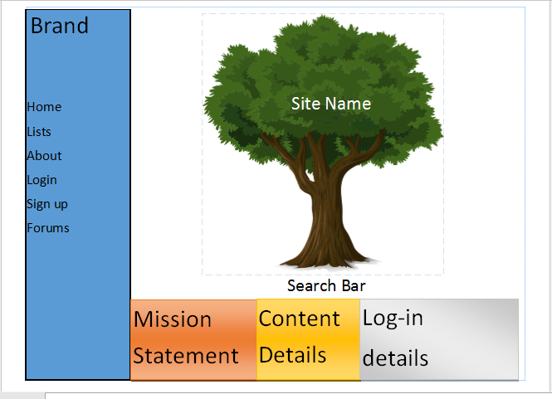

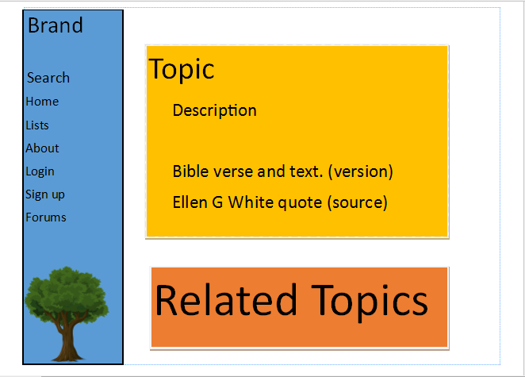

* 1. Mock-Up

