******** **GodsElephant.com**







**Things of the Day**

(Random stuff of the day, cool texts and popular stuff)

(Words continue to here)



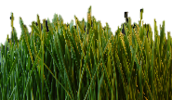**[](http://www.google.com/url?sa=i&rct=j&q=&esrc=s&source=images&cd=&cad=rja&uact=8&ved=0CAcQjRxqFQoTCOrGm-PN9scCFUnKPgodVEkF4w&url=http://forestry.about.com/od/treeidentification/tp/tree_key_id_hardwood.htm&bvm=bv.102537793,d.cWw&psig=AFQjCNFrhqw1_Lg_kC-k2vH2TmyUx3YTCw&ust=1442322929944333)[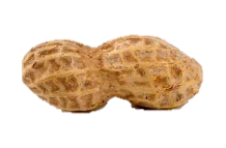](http://www.google.com/url?sa=i&rct=j&q=&esrc=s&source=images&cd=&cad=rja&uact=8&ved=0CAcQjRxqFQoTCM-BodbM9scCFQI5PgodT7EFow&url=http://www.midwestallergydrops.com/more-information-2/peanut-allergy-treatment-with-slit-coming-soon/&psig=AFQjCNE35GYAtlzbXsGwAOz4l5Jetu2mfQ&ust=1442322601597977)**



**Emotion App**

**Bible Reading**

(A small part of the Spiritual gifts page to interest the reader goes here and continues until we fill this tiny little box)

**Emotion App**

(A small part of the Emotion App page to interest the reader goes here and continues until we fill this tiny little box)

**Spiritual Gifts**

**Spiritual Gifts**

(A small part of the Spiritual gifts page to interest the reader goes here and continues until we fill this tiny little box)

********

(Random stuff and other stuff that has to fill this little bar down here)