# Team Activity 04

## Question 1

Team member leading this question: Saúl Abraham Arana Calderón

Description: List of customers with Gmail accounts.

SQL Query Used:

SELECT *  
FROM bike.customers  
WHERE bike.customer.email LIKE '%@gmail.com';

Query Results:

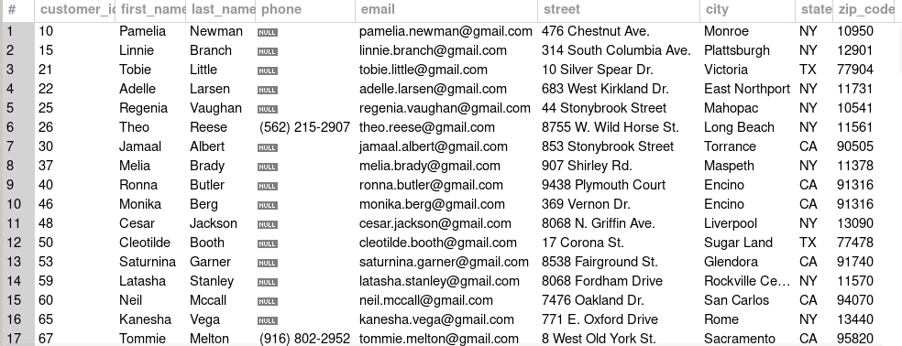

## Question 2

Team member leading this question: Saúl Abraham Arana Calderón

Description: List of bikes from brand Haro (brand_id = 2), showing the original price and a column with the sales price after a 20% discount.

SQL Query Used:

SELECT bike.product.product_name,bike.product.list_price, ROUND(bike.product.list_price * 0.8,2) as 'Sale_price'  
FROM bike.product  
WHERE bike.product.brand_id = 2;

Query Results:

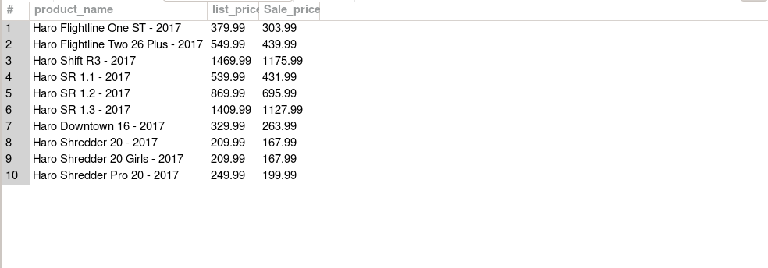

## Question 3

Team member leading this question: Saúl Abraham Arana Calderón

Description: Order numbers and dates from store Santa Cruz Bikes (store_id = 1), excluding orders made by Mireya Copeland (staff_id = 2).

SQL Query Used:

SELECT order_id, order_date  
FROM orders  
WHERE store_id = 1 AND staff_id != 2;

Query Results:

## Question 4

Team member leading this question: Saúl Abraham Arana Calderón

Description: All order numbers and dates for February 2017.

SQL Query Used:

SELECT order_id, order_date  
FROM orders  
WHERE order_date BETWEEN '2017-02-01' AND '2017-02-28';

Query Results:

## Question 5

Team member leading this question: Saúl Abraham Arana Calderón

Description: Find product names with 'Frame', 'Frameset', or 'Women's' in the name.

SQL Query Used:

SELECT product_name  
FROM products  
WHERE product_name LIKE '%Frame%'  
 OR product_name LIKE '%Frameset%'  
 OR product_name LIKE '%Women%';

Query Results:

## Question 6

Team member leading this question: Saúl Abraham Arana Calderón

Description: Products starting with A-H and priced at or above $299.99, sorted by name.

SQL Query Used:

SELECT product_name, list_price  
FROM products  
WHERE product_name REGEXP '^[A-Ha-h]'  
 AND list_price >= 299.99  
ORDER BY product_name;

Query Results: