# Name

Saúl Abraham Arana Calderón

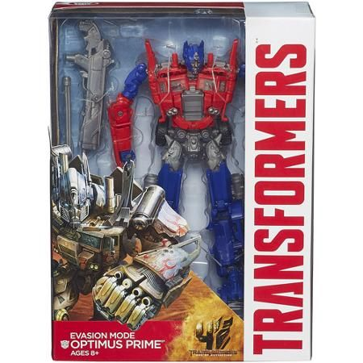

# Location

In my house

Laptop Computer

# Date

August 8th, 2025