# Project #8: Remote Access Technologies

**Student Name:** Saul Abraham Arana Calderón

**Class:** ITPC102: PC Hardware Technician

**Date and Time of Remote Session:** August 8, 2025 — 7:00 PM (Guatemala Time, UTC−06:00)

## Introduction

**Scope:** The purpose of this project is to demonstrate the ability to establish a remote connection between two computers with bidirectional file-transfer capability, explore the remote system, and retrieve a file from the remote computer.

**Software used:** AnyDesk (installed and run with administrator privileges on both computers).

**Session date & time:** August 8, 2025 at 7:00 PM (Guatemala Time).

## Remote Access Software

**Selected software:** AnyDesk.

**Reasons for selection and main features:**

* Familiarity and prior use: I have used AnyDesk previously and find it fast and easy to set up.
* Bidirectional file transfer: Allows sending and receiving files during the session.
* Remote control with elevated privileges: Can run with administrative rights to perform installations or change system settings when the remote user grants permission.
* Simple connection flow: Connect using the remote machine’s AnyDesk address/code.

These features made AnyDesk an appropriate choice for completing the project requirements.

## Project Steps (Reproducible)

1. Downloaded AnyDesk from the official website on both computers.
2. Installed AnyDesk on both machines and launched the application with administrator privileges.
3. On the remote (target) computer, opened AnyDesk and noted the AnyDesk address/code.
4. On the local (controlling) computer, entered the remote AnyDesk address and initiated the connection.
5. The remote user accepted the incoming connection request and, when needed, granted permission for administrative actions.
6. Located the prepared document on the remote computer (file contained student name, image, location, and date).
7. Used AnyDesk’s file transfer feature to download the remote document to the local computer. (If the software did not allow file transfer, the roles would have been reversed so the remote user could initiate the transfer to the controller.)
8. Saved a screenshot of the remote desktop showing the document (included below).
9. Compiled this executive summary and embedded a copy (or screenshot) of the downloaded file.

## Project File Download

**Contents of the downloaded file:**

* Student name.
* An image (photo of favorite character).
* Location of the computer where the file was created.
* Date of creation (August 8, 2025).

**Evidence:** A screenshot of the remote desktop session is included below to document the successful download and the presence of the requested data.

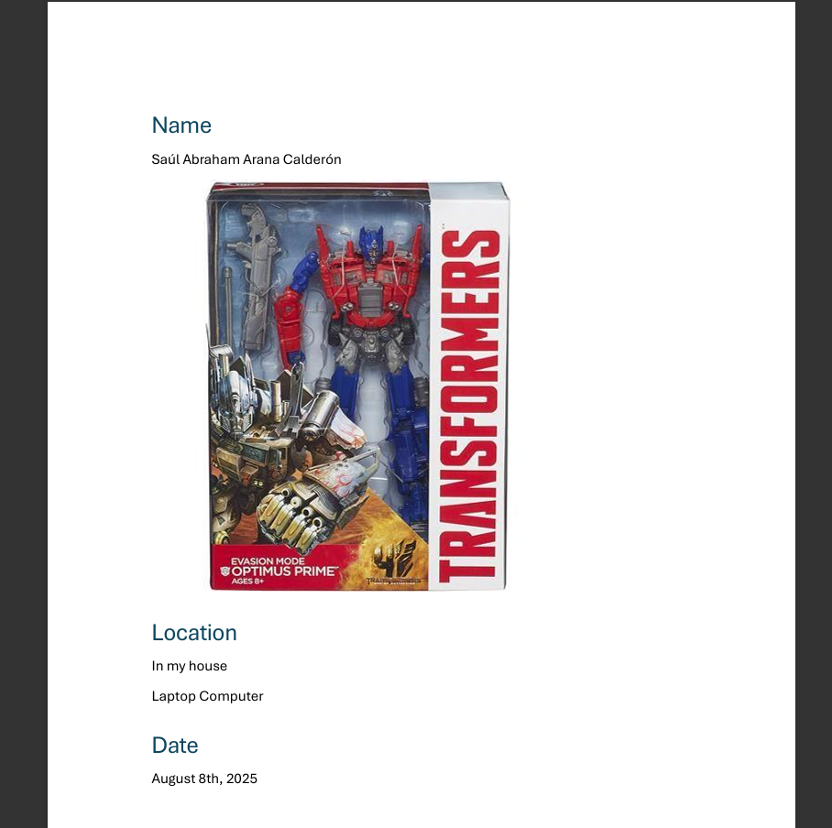

**Downloaded file placeholder:** _Attach the downloaded document

## Problems Encountered & Resolution

**Problems encountered:**

* Administrative permissions: Some administrative actions required approval from the remote user or the application to run with elevated privileges.
* Variable transfer speed: File transfer speed varied depending on the internet connection quality of each end.

**How problems were resolved:**

* Administrative permissions were requested and granted by the remote user through AnyDesk’s permission prompts. When an elevated action was necessary, I asked the remote user to accept the prompt or temporarily run AnyDesk as administrator on their side.
* For slow transfer speeds, I waited for the transfer to complete and, when needed, transferred smaller files or compressed the file to reduce transfer time.

## Conclusion & Recommendations

**Conclusion:** AnyDesk successfully provided a reliable and practical remote access solution that met the project requirements. The connection was established, the remote machine was explored, and the required file was transferred successfully. As an IT technician, I find AnyDesk an effective tool for remote support because of its ease of use, file-transfer capability, and support for administrative tasks.

**Recommendations:**

* When performing administrative tasks remotely, coordinate with the remote user beforehand so permission prompts can be accepted promptly.
* If large files must be transferred over slow connections, compress files or use a cloud-sharing link as an alternative.
* Keep AnyDesk updated to the latest version for security and stability improvements.

## Appendix — Evidence & Attachments

1. **Screenshot(s)** of the remote session showing the downloaded file and its contents. (Please paste your screenshot(s) into this section.)



1. **Copy of the downloaded file:** Attach the file you downloaded via AnyDesk here.