BankAssist — Interface Screenshots
HCI Assignment #2 | Prototype evidence
12 screenshots captured from the functioning BankAssist website. All transaction data shown is simulated.
Screenshots captured from the redesigned desktop and mobile interface. These are prototype evidence, not real-user evaluation results.
Figure 1. Welcome screen and navigation
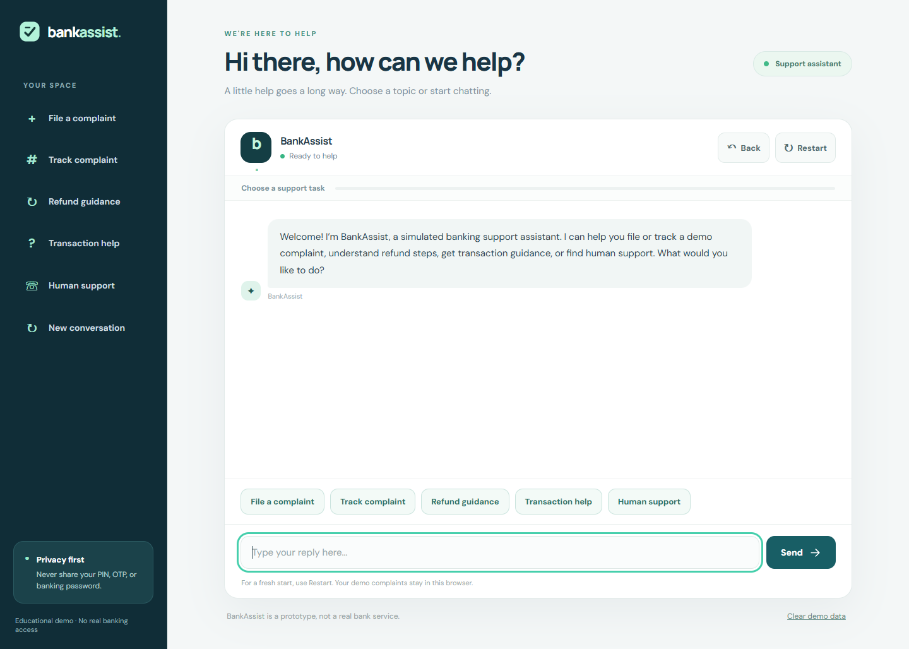
Source: BankAssist interactive web prototype.

Figure 2. Choose a complaint category
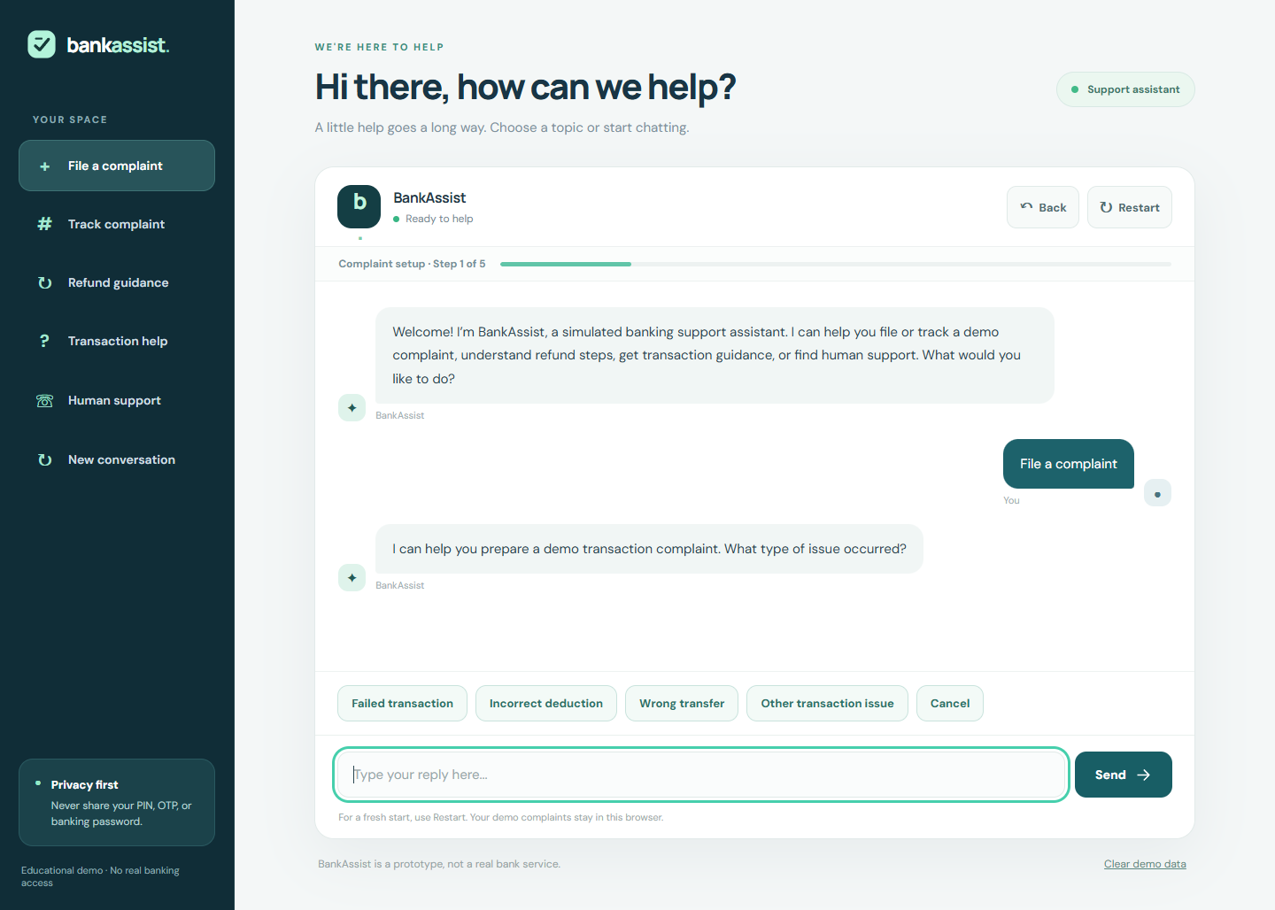
Source: BankAssist interactive web prototype.

Figure 3. Input validation and recovery
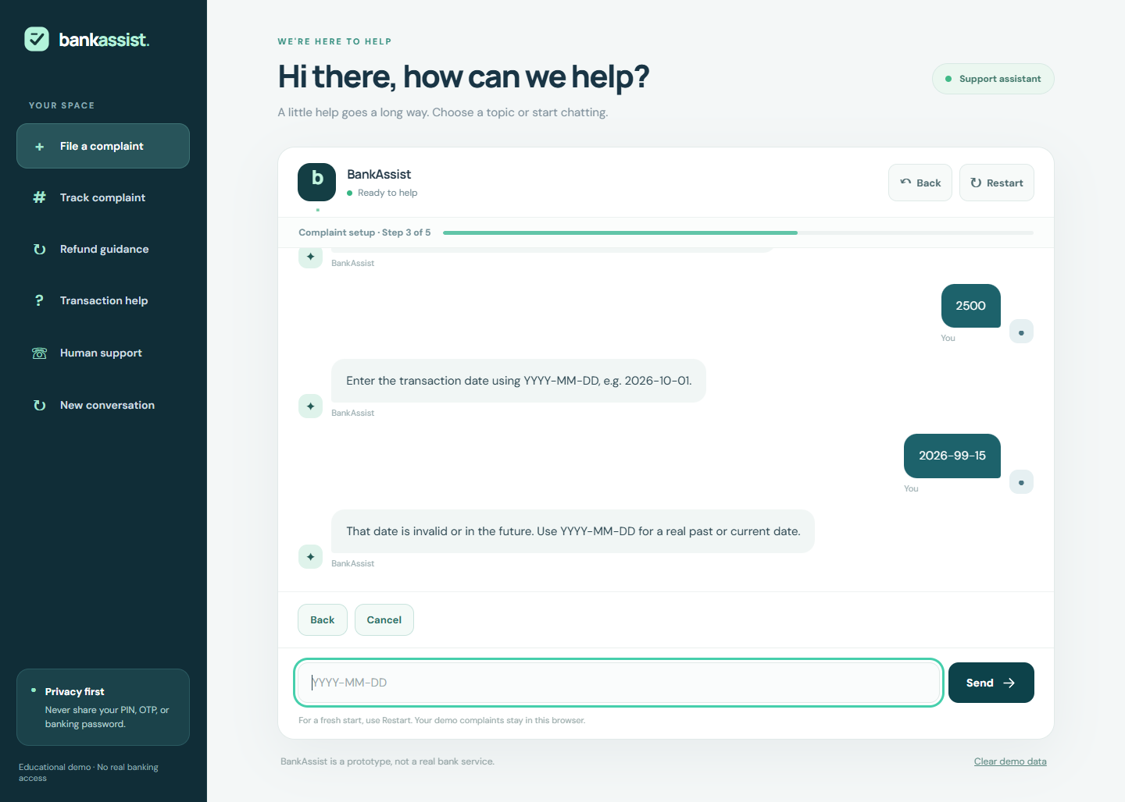
Source: BankAssist interactive web prototype.

Figure 4. Review details before submission
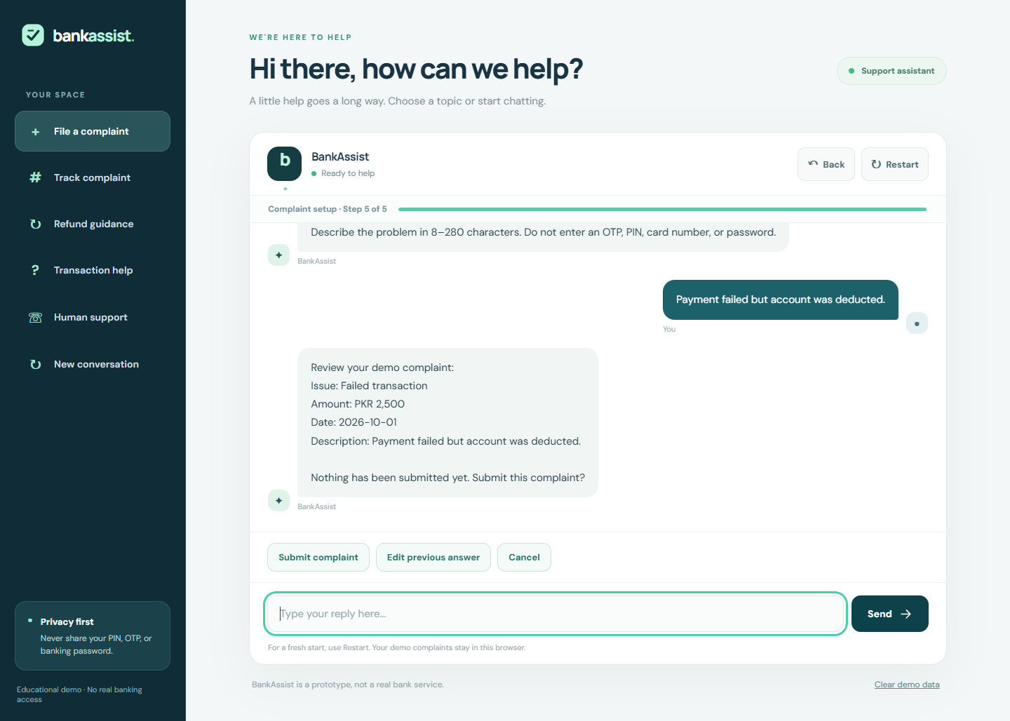
Source: BankAssist interactive web prototype.

Figure 5. Complaint reference and confirmation
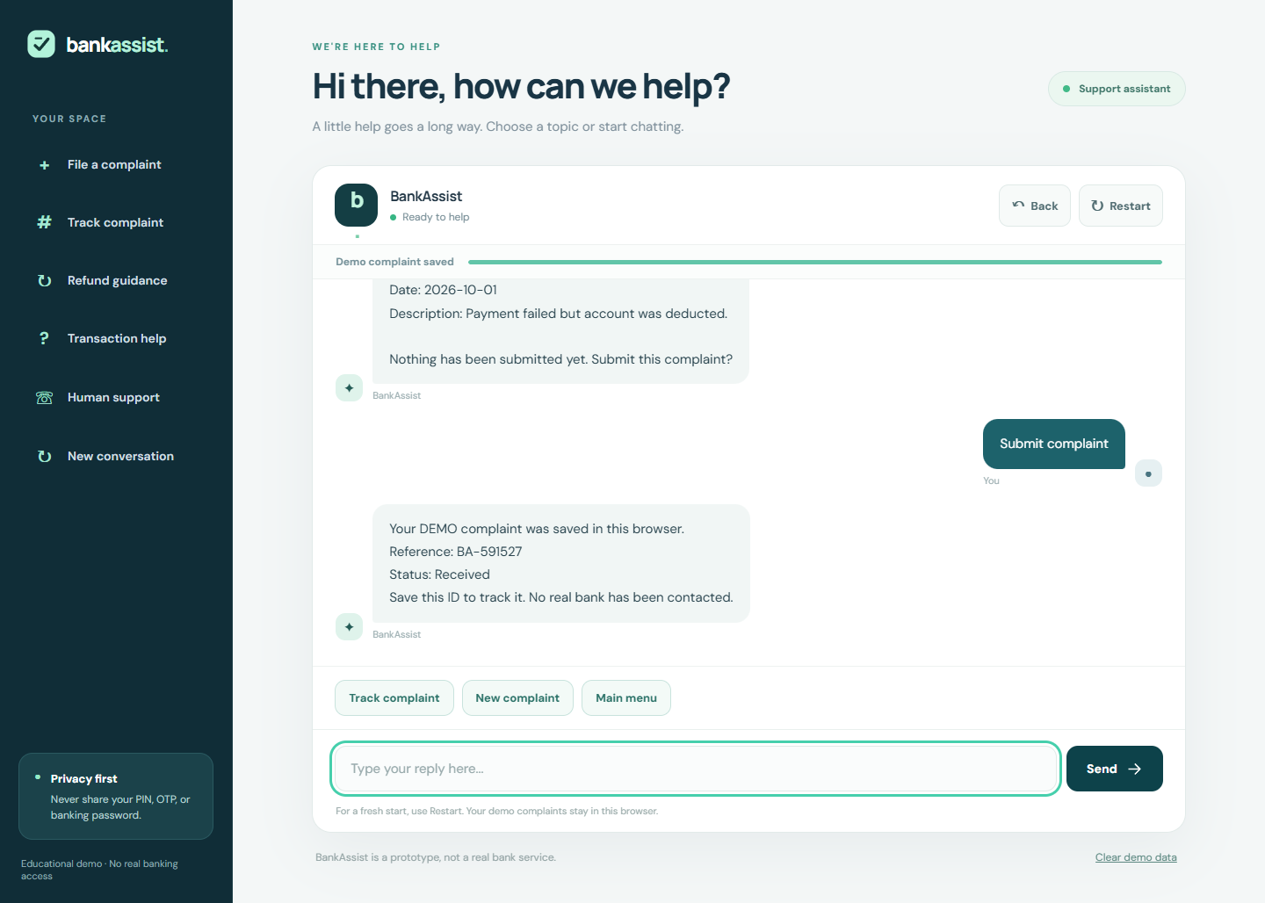
Source: BankAssist interactive web prototype.

Figure 6. Track a simulated complaint
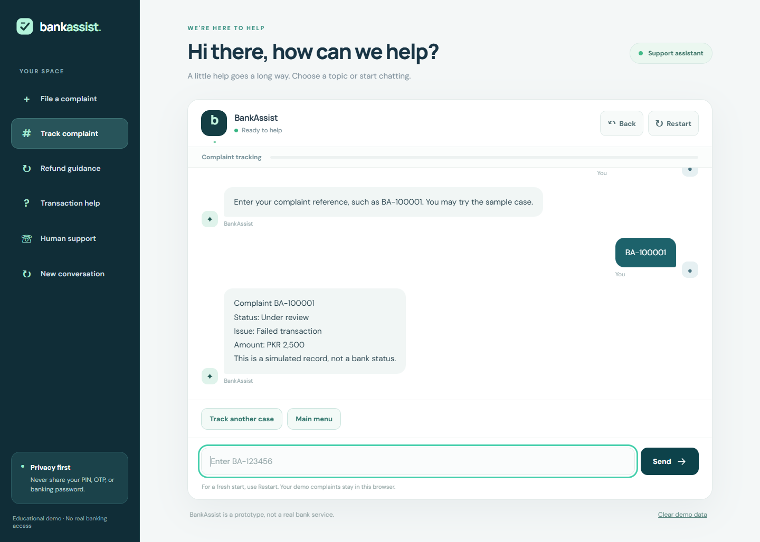
Source: BankAssist interactive web prototype.

Figure 7. Refund issue selection
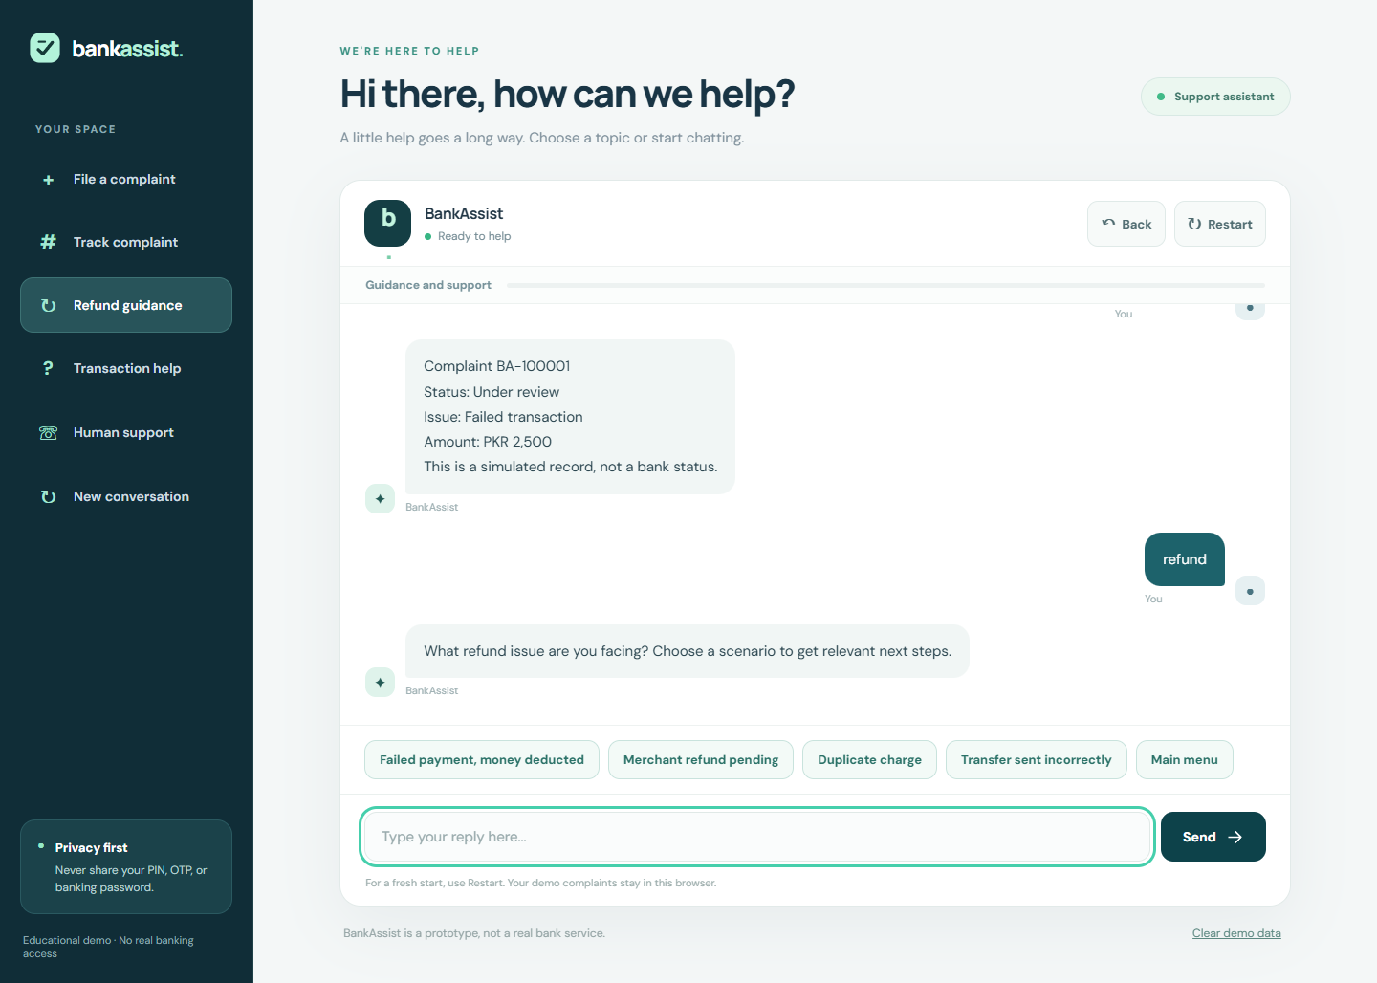
Source: BankAssist interactive web prototype.

Figure 8. Refund guidance conversation
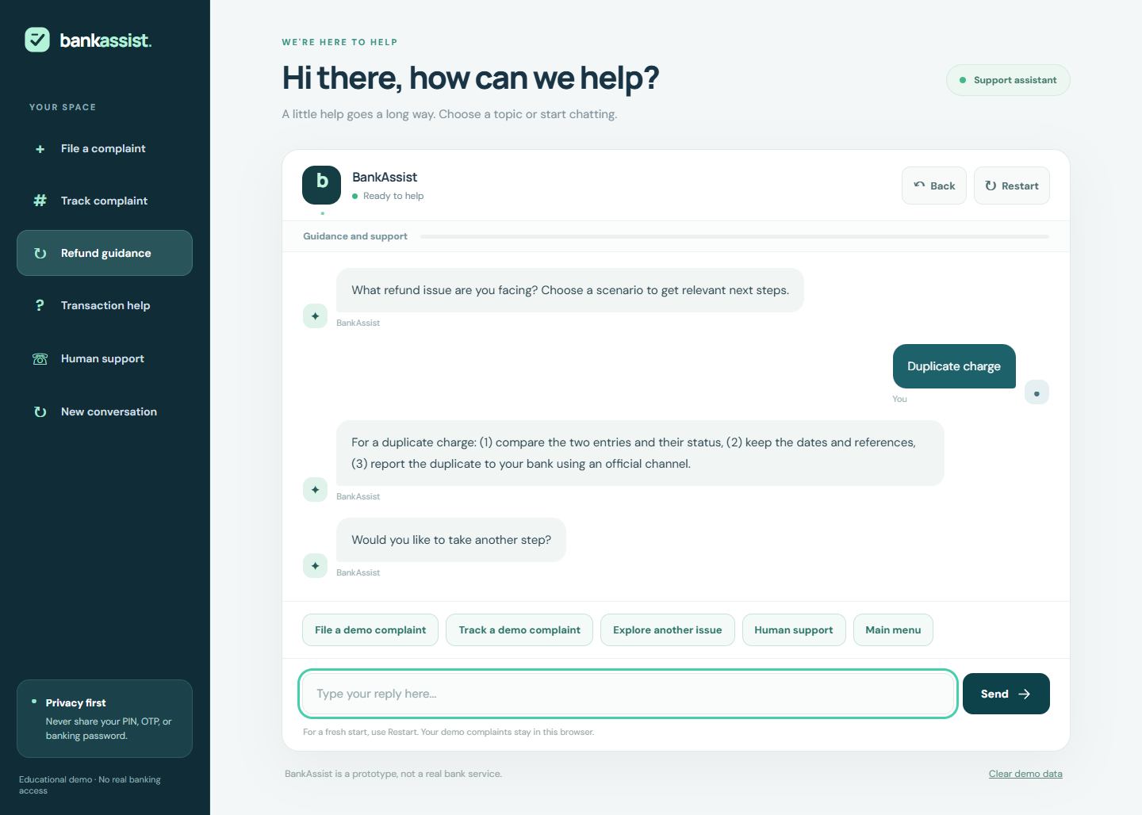
Source: BankAssist interactive web prototype.

Figure 9. Transaction help conversation
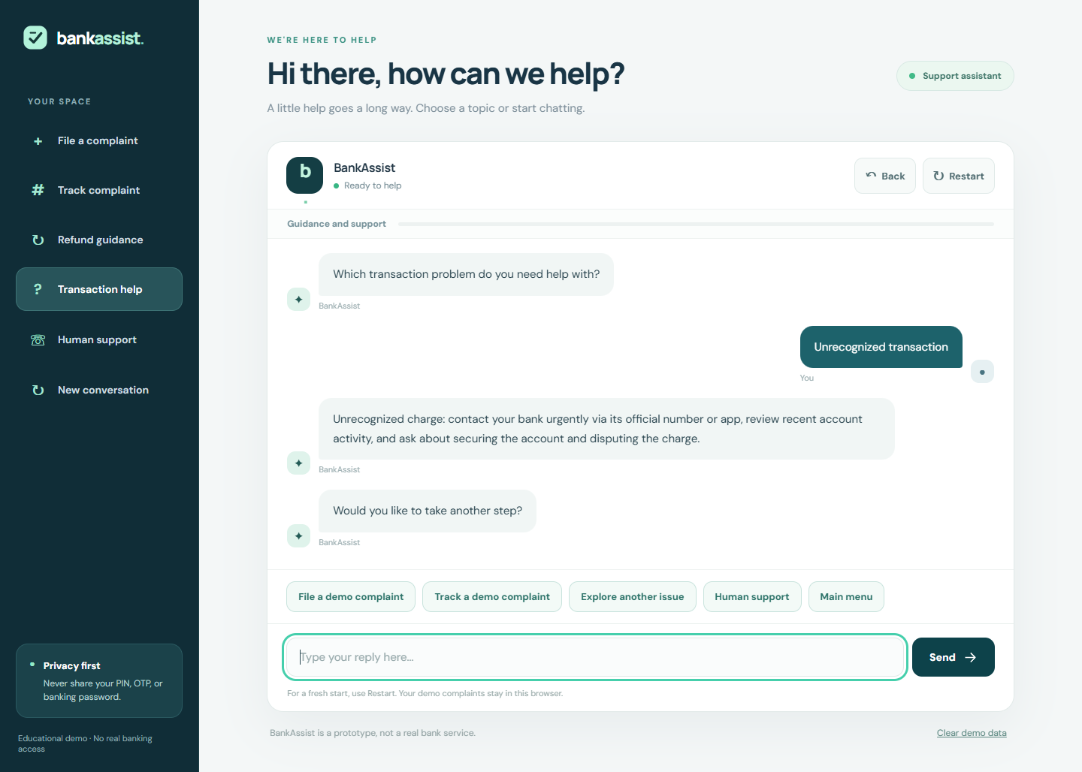
Source: BankAssist interactive web prototype.

Figure 10. Human support and safety advice
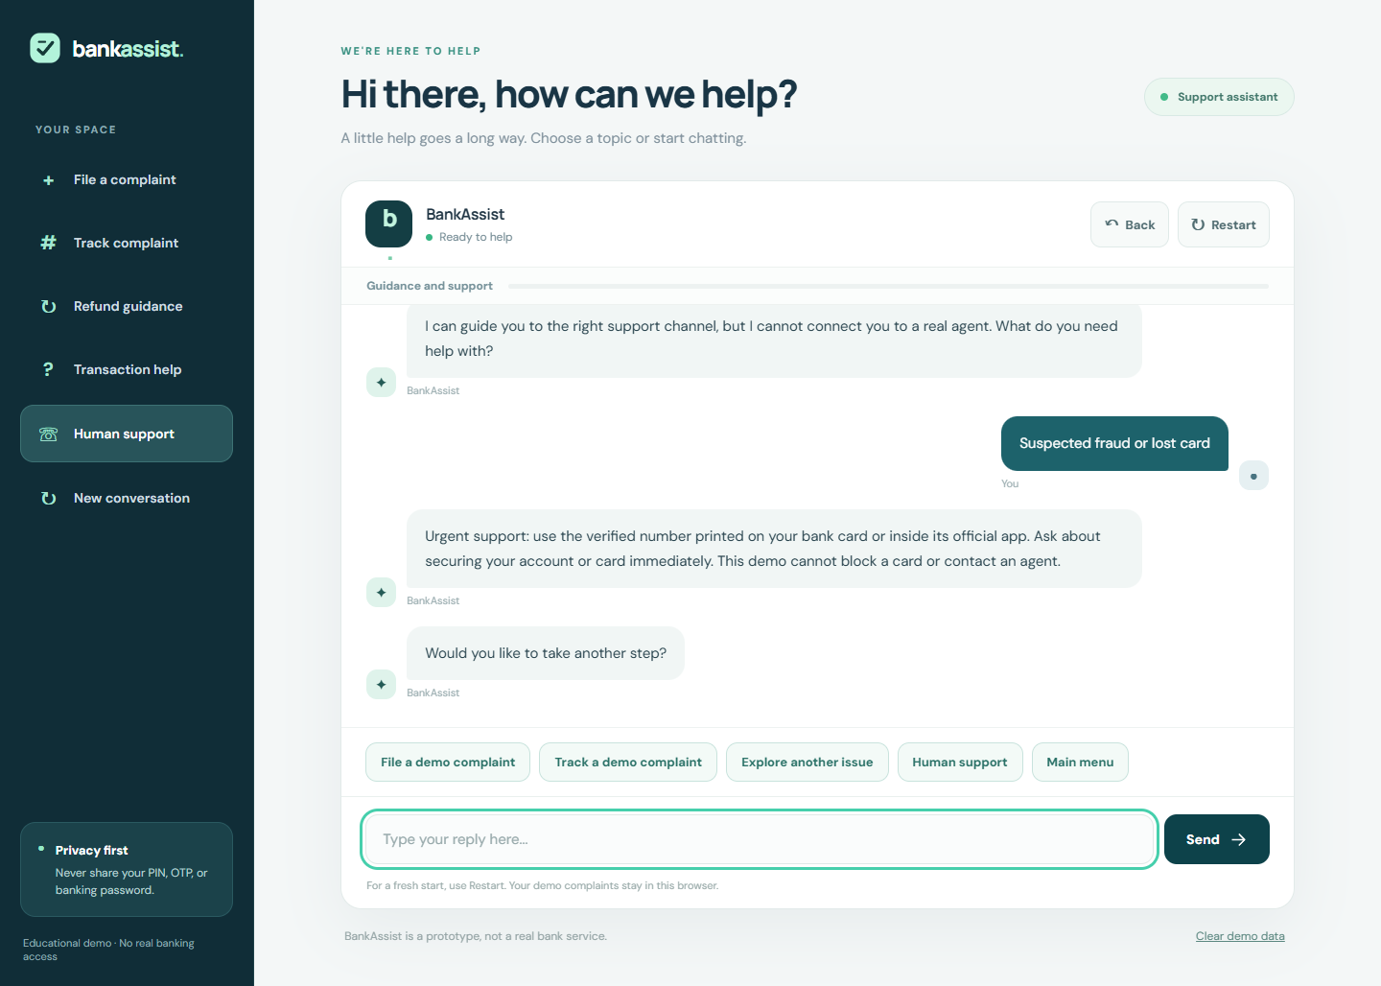
Source: BankAssist interactive web prototype.

Figure 11. Unrecognized input recovery
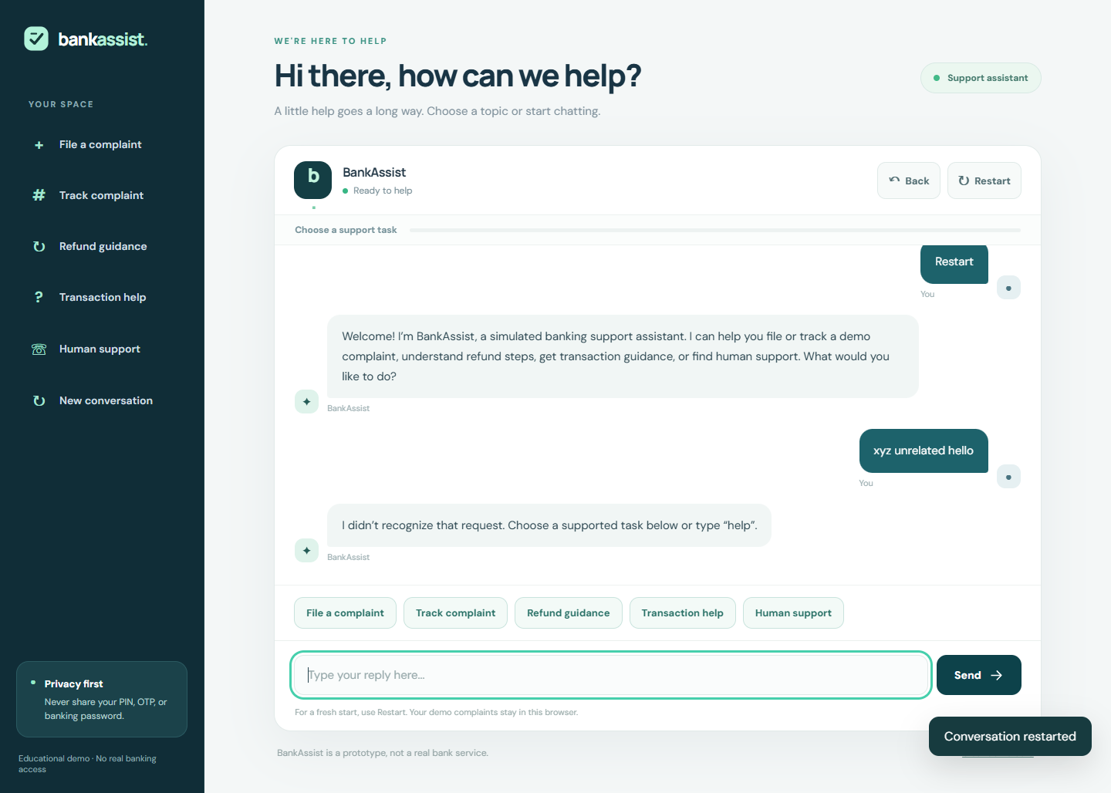
Source: BankAssist interactive web prototype.

Figure 12. Responsive mobile interface
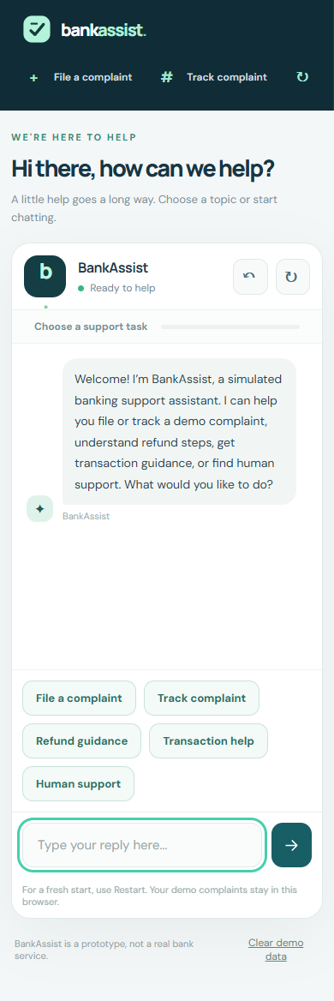
Source: BankAssist interactive web prototype.

