ITA 0435 – STATISTICS WITH R PROGRAMMING

CALCULATOR PROGRAMMING
calc <- function() {
num1 <- as.numeric(readline("Enter first number: "))
num2 <- as.numeric(readline("Enter second number: "))
op <- readline("Choose operation (+, -, *, /): ")

switch(op,
"+" = print(num1 + num2),
"-" = print(num1 - num2),
"*" = print(num1 * num2),
"/" = if(num2 != 0) print(num1 / num2) else print("Cannot divide by zero!"),
print("Invalid operation!"))
}

calc()

OUTPUT:
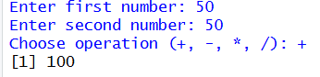
ADDITION :

SUBTRACTION :
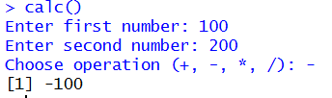

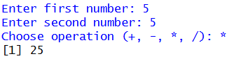
MULTIPLICATION :

DIVISION :
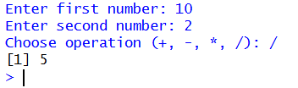

SCIENTIFIC CALCULATOR :
# Function to perform scientific operations
scientific_calculator <- function() {
cat("Select an operation:\n")
cat("1: Addition\n")
cat("2: Subtraction\n")
cat("3: Multiplication\n")
cat("4: Division\n")
cat("5: Exponentiation\n")
cat("6: Square Root\n")
cat("7: Sine\n")
cat("8: Cosine\n")
cat("9: Tangent\n")
cat("10: Logarithm\n")

operation <- as.integer(readline(prompt = "Enter the number corresponding to the operation: "))

if (operation %in% 1:10) {
if (operation < 7) {
num1 <- as.numeric(readline(prompt = "Enter the first number: "))
num2 <- ifelse(operation == 1 | operation == 2 | operation == 3 | operation == 4,
as.numeric(readline(prompt = "Enter the second number: ")), NA)
} else {
num1 <- as.numeric(readline(prompt = "Enter the angle in degrees: "))
num2 <- NA
}

result <- switch(operation,
`1` = num1 + num2,
`2` = num1 - num2,
`3` = num1 * num2,
`4` = num1 / num2,
`5` = num1 ^ num2,
`6` = sqrt(num1),
`7` = sin(pi * num1 / 180),
`8` = cos(pi * num1 / 180),
`9` = tan(pi * num1 / 180),
`10` = log(num1))

cat("The result is:", result, "\n")
} else {
cat("Invalid operation selected.\n")
}
}

# Run the calculator
scientific_calculator()
OUTPUT:
