ITA 0435 – STATISTICS WITH R PROGRAMMING

CALCULATOR PROGRAMMING
calc <- function() {
num1 <- as.numeric(readline("Enter first number: "))
num2 <- as.numeric(readline("Enter second number: "))
op <- readline("Choose operation (+, -, *, /): ")

switch(op,
"+" = print(num1 + num2),
"-" = print(num1 - num2),
"*" = print(num1 * num2),
"/" = if(num2 != 0) print(num1 / num2) else print("Cannot divide by zero!"),
print("Invalid operation!"))
}

calc()

OUTPUT:
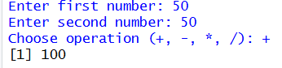
ADDITION :

SUBTRACTION :
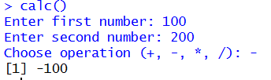

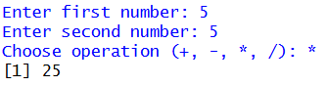
MULTIPLICATION :

DIVISION :
