CO2 – AT1 Database Design and Connectivity
This document contains 10 Python + SQLite programs based on the uploaded assignment.

1. Student Database
Template Python Code:
#Q1
import sqlite3
conn = sqlite3.connect("student.db")
cursor = conn.cursor()
cursor.execute("""
CREATE TABLE IF NOT EXISTS Student(
Student_ID INTEGER PRIMARY KEY,
Name TEXT NOT NULL,
Department TEXT,
Year INTEGER,
Email TEXT UNIQUE
)
students = [
(1, "Arun", "AI&DS", 3, "arun@gmail.com"),
(2, "Bala", "CSE", 2, "bala@gmail.com"),
(3, "Charan", "ECE", 3, "charan@gmail.com"),
(4, "Divya", "IT", 1, "divya@gmail.com"),
(5, "Esha", "AI&DS", 4, "esha@gmail.com")
]

cursor.executemany("""
INSERT OR IGNORE INTO Student
VALUES(?,?,?,?,?)
""", students)
conn.commit()

print("Student Records\n")
cursor.execute("SELECT * FROM Student")
for row in cursor.fetchall():
print(row)
conn.close()
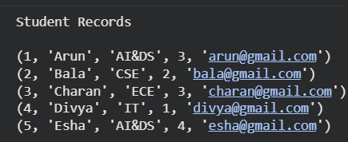

2. Library Management
Template Python Code:
import sqlite3
conn = sqlite3.connect("library.db")
cursor = conn.cursor()
cursor.execute("""
CREATE TABLE IF NOT EXISTS Book(
Book_ID INTEGER PRIMARY KEY,
Title TEXT,
Author TEXT,
Publisher TEXT,
Price REAL)
books = [
(1,"Python","John","ABC",450),
(2,"Database","James","XYZ",600),
(3,"Machine Learning","Andrew","AI Books",700),
(4,"Statistics","David","Math Pub",550)
]
cursor.executemany("""
INSERT OR IGNORE INTO Book
VALUES(?,?,?,?,?)
""", books)
conn.commit()
cursor.execute("""
UPDATE Book
SET Price=650
WHERE Book_ID=2
""")
conn.commit()
print("Updated Book Details\n")
cursor.execute("""
SELECT * FROM Book
WHERE Book_ID=2
""")
print(cursor.fetchone())
conn.close()
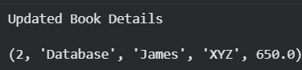

3. Employee & Department
Template Python Code:
import sqlite3

conn=sqlite3.connect("company.db")
cursor=conn.cursor()

cursor.execute("PRAGMA foreign_keys=ON")

cursor.execute("""
CREATE TABLE IF NOT EXISTS Department(
Dept_ID INTEGER PRIMARY KEY,
Dept_Name TEXT)
""")

cursor.execute("""
CREATE TABLE IF NOT EXISTS Employee(
Emp_ID INTEGER PRIMARY KEY,
Emp_Name TEXT,
Salary REAL,
Dept_ID INTEGER,
FOREIGN KEY(Dept_ID) REFERENCES Department(Dept_ID))
""")

departments=[
(1,"IT"),
(2,"HR"),
(3,"Finance")
]

cursor.executemany("INSERT OR IGNORE INTO Department VALUES(?,?)",departments)

employees=[
(101,"Arun",50000,1),
(102,"Bala",45000,2),
(103,"Charan",55000,1),
(104,"Divya",60000,3)
]

cursor.executemany("INSERT OR IGNORE INTO Employee VALUES(?,?,?,?)",employees)

conn.commit()

cursor.execute("""
SELECT Employee.Emp_Name,Department.Dept_Name
FROM Employee
INNER JOIN Department
ON Employee.Dept_ID=Department.Dept_ID
""")

print("Employee Details with Department")

for row in cursor.fetchall():
print(row)

conn.close()
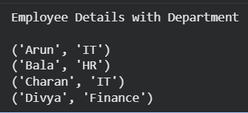

4. Hospital Patient
Template Python Code:
import sqlite3

conn=sqlite3.connect("hospital.db")
cursor=conn.cursor()

cursor.execute("""
CREATE TABLE IF NOT EXISTS Patient(
Patient_ID INTEGER PRIMARY KEY,
Name TEXT,
Age INTEGER,
Gender TEXT,
Contact TEXT,
Disease TEXT)
""")

patients=[
(1,"Ravi",45,"Male","9876543210","Fever"),
(2,"Priya",30,"Female","9876543211","Diabetes"),
(3,"Kiran",55,"Male","9876543212","BP"),
(4,"Meena",28,"Female","9876543213","Cold")
]

cursor.executemany("INSERT OR IGNORE INTO Patient VALUES(?,?,?,?,?,?)",patients)

conn.commit()

cursor.execute("UPDATE Patient SET Contact='9999999999' WHERE Patient_ID=2")
cursor.execute("DELETE FROM Patient WHERE Patient_ID=4")

conn.commit()

cursor.execute("SELECT * FROM Patient")

print("Remaining Patient Records")

for row in cursor.fetchall():
print(row)

conn.close()
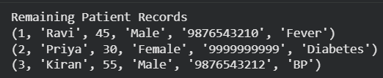
5. Online Course Registration
Template Python Code:
import sqlite3

conn=sqlite3.connect("course.db")
cursor=conn.cursor()

cursor.execute("PRAGMA foreign_keys=ON")

cursor.execute("""
CREATE TABLE IF NOT EXISTS Student(
Student_ID INTEGER PRIMARY KEY,
Student_Name TEXT)
""")

cursor.execute("""
CREATE TABLE IF NOT EXISTS Course_Registration(
Registration_ID INTEGER PRIMARY KEY,
Student_ID INTEGER,
Course_Name TEXT,
FOREIGN KEY(Student_ID) REFERENCES Student(Student_ID))
""")

students=[
(1,"Arun"),
(2,"Bala"),
(3,"Charan"),
(4,"Divya")
]

cursor.executemany("INSERT OR IGNORE INTO Student VALUES(?,?)",students)

courses=[
(101,1,"Python"),
(102,2,"Data Science"),
(103,3,"Machine Learning"),
(104,4,"Database")
]

cursor.executemany("INSERT OR IGNORE INTO Course_Registration VALUES(?,?,?)",courses)

conn.commit()

cursor.execute("""
SELECT Student.Student_Name,Course_Registration.Course_Name
FROM Student
INNER JOIN Course_Registration
ON Student.Student_ID=Course_Registration.Student_ID
""")

print("Student Course Details")

for row in cursor.fetchall():
print(row)

conn.close()
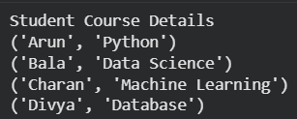
6. Banking Account
Template Python Code:
import sqlite3

conn=sqlite3.connect("bank.db")
cursor=conn.cursor()

cursor.execute("""
CREATE TABLE IF NOT EXISTS Account(
Account_ID INTEGER PRIMARY KEY,
Customer_Name TEXT,
Account_Type TEXT,
Balance REAL,
Phone TEXT)
""")

accounts=[
(101,"Arun","Savings",25000,"9876500001"),
(102,"Bala","Current",50000,"9876500002"),
(103,"Charan","Savings",30000,"9876500003"),
(104,"Divya","Savings",45000,"9876500004")
]

cursor.executemany("INSERT OR IGNORE INTO Account VALUES(?,?,?,?,?)",accounts)

conn.commit()

cursor.execute("UPDATE Account SET Balance=60000 WHERE Account_ID=102")

conn.commit()

cursor.execute("SELECT * FROM Account")

print("Customer Records")

for row in cursor.fetchall():
print(row)

conn.close()
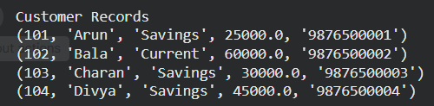

7. Inventory Management
Template Python Code:
import sqlite3

conn=sqlite3.connect("inventory.db")
cursor=conn.cursor()

cursor.execute("""
CREATE TABLE IF NOT EXISTS Product(
Product_ID INTEGER PRIMARY KEY,
Product_Name TEXT,
Category TEXT,
Quantity INTEGER,
Unit_Price REAL)
""")

products=[
(1,"Keyboard","Computer",5,800),
(2,"Mouse","Computer",15,400),
(3,"Monitor","Computer",7,7500),
(4,"USB Cable","Accessories",20,250),
(5,"Webcam","Computer",4,1800)
]

cursor.executemany("INSERT OR IGNORE INTO Product VALUES(?,?,?,?,?)",products)

conn.commit()

cursor.execute("SELECT * FROM Product WHERE Quantity<10")

print("Low Stock Products")

for row in cursor.fetchall():
print(row)

cursor.execute("UPDATE Product SET Quantity=Quantity+20 WHERE Quantity<10")

conn.commit()

cursor.execute("SELECT * FROM Product")

print("Updated Inventory")

for row in cursor.fetchall():
print(row)

conn.close()
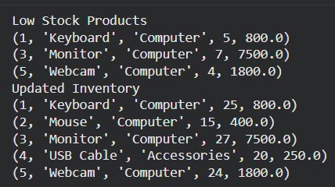

8. Faculty & Course
Template Python Code:
import sqlite3

conn=sqlite3.connect("faculty.db")
cursor=conn.cursor()

cursor.execute("PRAGMA foreign_keys=ON")

cursor.execute("""
CREATE TABLE IF NOT EXISTS Faculty(
Faculty_ID INTEGER PRIMARY KEY,
Faculty_Name TEXT,
Department TEXT)
""")

cursor.execute("""
CREATE TABLE IF NOT EXISTS Course(
Course_ID INTEGER PRIMARY KEY,
Course_Name TEXT,
Faculty_ID INTEGER,
FOREIGN KEY(Faculty_ID) REFERENCES Faculty(Faculty_ID))
""")

faculty=[
(1,"Dr.Kumar","CSE"),
(2,"Dr.Priya","AI&DS"),
(3,"Dr.Ravi","Maths")
]

cursor.executemany("INSERT OR IGNORE INTO Faculty VALUES(?,?,?)",faculty)

courses=[
(101,"Python",1),
(102,"Machine Learning",2),
(103,"Statistics",3),
(104,"Database",1)
]

cursor.executemany("INSERT OR IGNORE INTO Course VALUES(?,?,?)",courses)

conn.commit()

cursor.execute("""
SELECT Faculty.Faculty_Name,Course.Course_Name
FROM Faculty
INNER JOIN Course
ON Faculty.Faculty_ID=Course.Faculty_ID
""")

print("Faculty and Courses")

for row in cursor.fetchall():
print(row)

conn.close()
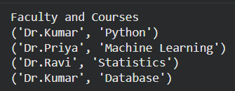

9. Vehicle Registration
Template Python Code:
import sqlite3

conn=sqlite3.connect("vehicle.db")
cursor=conn.cursor()

cursor.execute("""
CREATE TABLE IF NOT EXISTS Vehicle(
Vehicle_ID INTEGER PRIMARY KEY,
Registration_No TEXT UNIQUE,
Owner_Name TEXT,
Vehicle_Type TEXT,
Model TEXT,
Year INTEGER)
""")

vehicles=[
(1,"TN01AB1234","Arun","Car","Hyundai",2022),
(2,"TN02CD5678","Bala","Bike","Yamaha",2023),
(3,"TN03EF9012","Charan","Car","Honda",2021),
(4,"TN04GH3456","Divya","Bike","TVS",2024)
]

cursor.executemany("INSERT OR IGNORE INTO Vehicle VALUES(?,?,?,?,?,?)",vehicles)

conn.commit()

reg="TN02CD5678"

cursor.execute("SELECT * FROM Vehicle WHERE Registration_No=?",(reg,))

print("Vehicle Details")

print(cursor.fetchone())

conn.close()
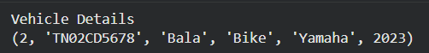

10. Hospital Appointment
Template Python Code:
import sqlite3

conn=sqlite3.connect("appointment.db")
cursor=conn.cursor()

cursor.execute("PRAGMA foreign_keys=ON")

cursor.execute("""
CREATE TABLE IF NOT EXISTS Doctor(
Doctor_ID INTEGER PRIMARY KEY,
Doctor_Name TEXT,
Specialization TEXT)
""")

cursor.execute("""
CREATE TABLE IF NOT EXISTS Appointment(
Appointment_ID INTEGER PRIMARY KEY,
Doctor_ID INTEGER,
Patient_Name TEXT,
Appointment_Date TEXT,
FOREIGN KEY(Doctor_ID) REFERENCES Doctor(Doctor_ID))
""")

doctors=[
(1,"Dr.Kumar","Cardiology"),
(2,"Dr.Priya","Dermatology"),
(3,"Dr.Ravi","Neurology")
]

cursor.executemany("INSERT OR IGNORE INTO Doctor VALUES(?,?,?)",doctors)

appointments=[
(101,1,"Arun","2026-08-01"),
(102,2,"Bala","2026-08-02"),
(103,3,"Charan","2026-08-03"),
(104,1,"Divya","2026-08-04")
]

cursor.executemany("INSERT OR IGNORE INTO Appointment VALUES(?,?,?,?)",appointments)

conn.commit()

cursor.execute("""
SELECT Doctor.Doctor_Name,Appointment.Patient_Name,Appointment.Appointment_Date
FROM Doctor
INNER JOIN Appointment
ON Doctor.Doctor_ID=Appointment.Doctor_ID
""")

print("Appointment Details")

for row in cursor.fetchall():
print(row)

conn.close()
