
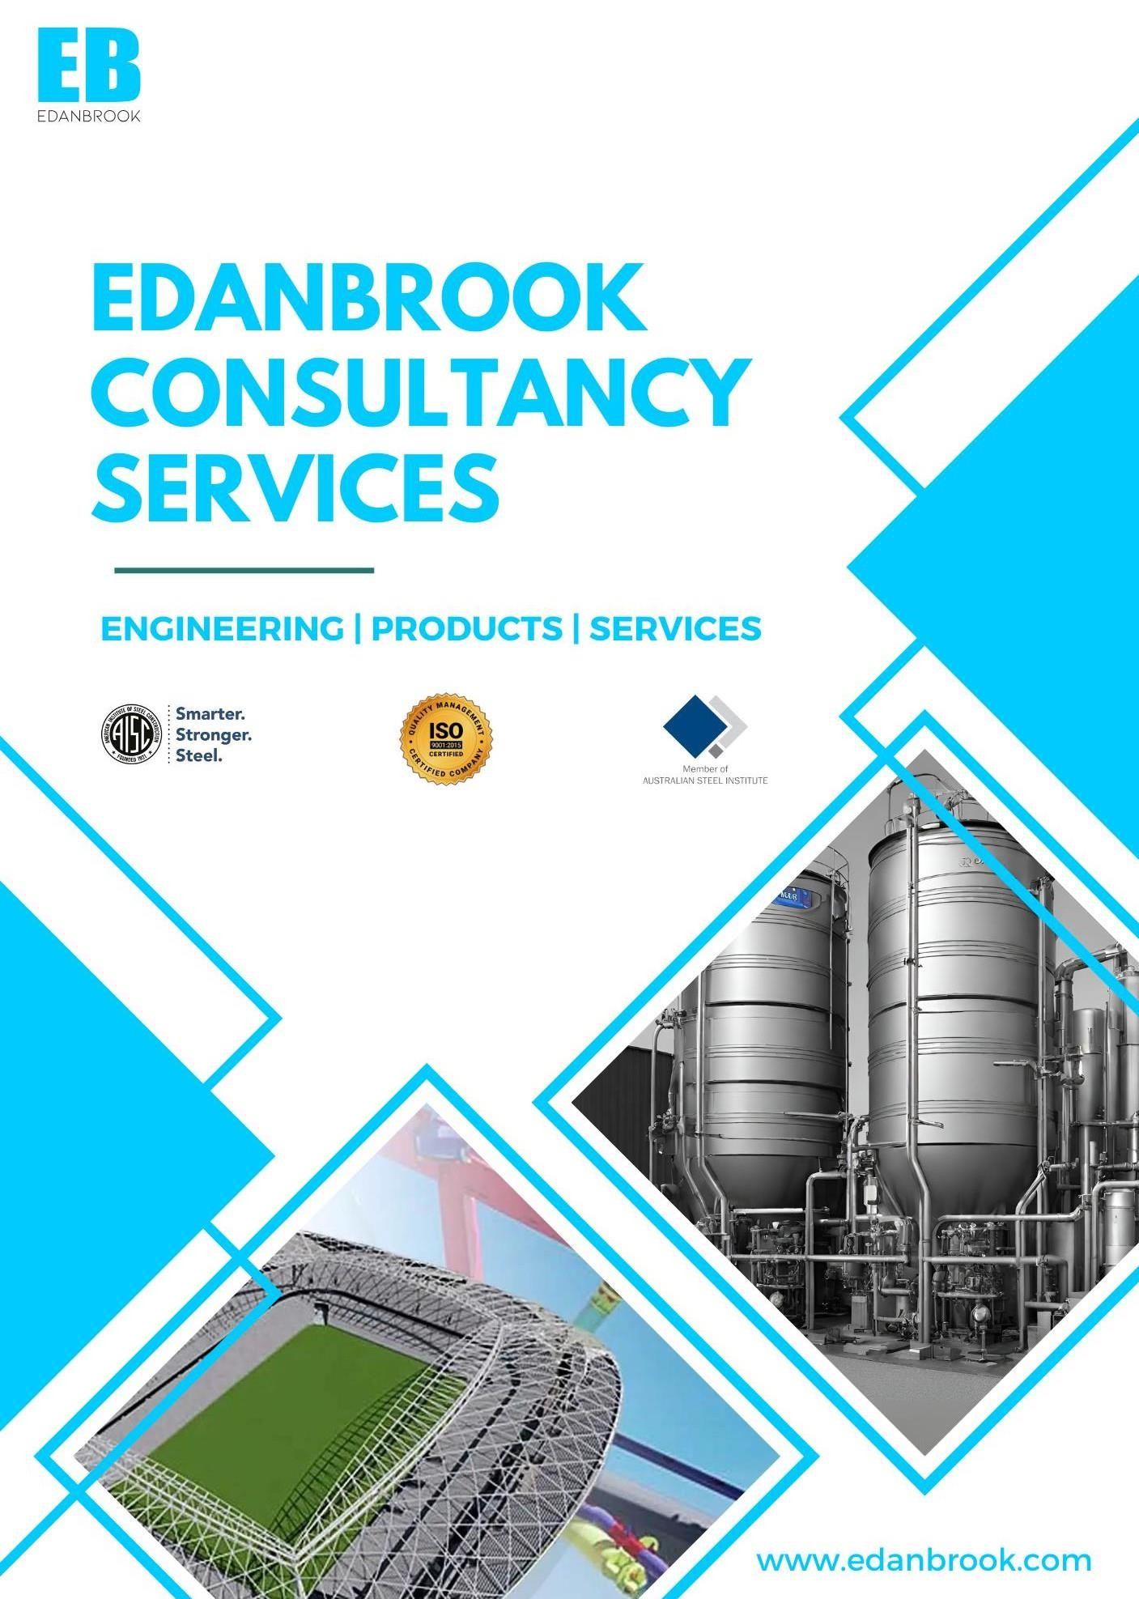
PROPOSAL

Quote No: {quote_no}
Project: {project_name}

Cover Letter

Attn:

Mr. {client_name}
{client_company}

Quote No: {quote_no}
Date: {date}

Sub: {quote_no}_ {project_name}

Thank you for the opportunity to submit the pricing on this project.

Edanbrook has delivered shop details on many projects in mining, oil & gas, new energy, power, solar, and nuclear sectors globally with great success. We look forward to working with Structural Systems Inc. on this Project.

Why Us:

Our People: Our team is recognized as design and detailed engineering leaders in multiple industries. We assign a project manager for each Project and offer end-to-end support.
Use of Technology: We purchase legitimate design and detailing software (Tekla, AutoCAD, Staad Pro, SDS2, Revit, Navisworks, etc.) and subscribe to the best technologies available.
Experience: Over 23 years in existence and a few hundred years of combined experience, our team has successfully delivered engineering service equivalent to ~200,000 MT of steel every year globally.

We aim to offer a final product and service that we will be proud of together! Please review our proposal and contact us with any queries.

Sincerely,

Sabin

Business Development Manager
Edanbrook Consultancy Services INC

Service Summary
The services that Edanbrook will be providing include:

☒ | Steel Detailing | ☒ | Miscellaneous Steel Detailing
☐ | Connection Design | ☐ | PE Stamping
☐ | Joist Detailing | ☐ | As-built Drawings

Pricing Summary

Item | Description | Price (USD) | Comments
1 | Steel Detailing | $ {item_price} | Lump sum
 | Total (Ex. Taxes) | $ {price_value}

Variation Rates:
{services_list}: $ {hourly_rate} per hour

- Delivery Schedule

Item | Description | Lead Time
1 | Steel Detailing | {lead_time}
 | Total | 1 week

Deliverables

  - Shop drawings, Erection drawings with sections and details, and part drawings.
  - 3D Model
  - MTO & Reports
  - NC & DXF Data
  - DSTV and KSS files as per client requirements.
  - Bolt lists as per client requirements

Exclusions

  - CAD Conforming
  - Site Visits
  - As-Built Drawings
  - Any item specifically not mentioned above.
  - Field measurements of any kind
  - Joist & Joist bridging
  - Gauge materials framing
  - Alternates as Noted
  - Any precast supporting clips
  - Progressive Collapse Provisions currently
  - Engineering Design Calculations & PE Stamping Report

Requirements from the Client to Start the Project
  - Letter of Intent or PO.
  - Detailing standards if any.
  - Design standard if any.

Lead-time and Milestone
Upon receipt of the signed Purchase Order, EDANBROOK will perform detailing activities and deliver drawings as per the schedule below (but the delivery schedule will be mutually agreed upon once the job is awarded):

Note: The delivery schedule is contingent on the following:

  - The schedule becomes effective only upon receipt of items listed in "Requirements from the Client to Start the Project".
  - The delivery schedule will be mutually agreed upon once the job is awarded to EDANBROOK.
  - Complete and correct design documents, drawings, and specifications.
  - Timely receipt of RFI answers. We require the RFI's to be addressed and answered within 48 hours to maintain the schedule. Any delay in the RFI response will affect the delivery schedule.
  - The delivery schedule may be altered if customer changes or revisions are made during the project.
  - We will use all reasonable endeavours to complete the Project by the relevant Milestone specified by the customer in the Project Plan.
  - The customer recognizes that our performance on the project plan depends upon the Customer’s cooperation and the provision by the Customer of its personnel and assistance as and when required.
  - The completion dates will be extended by a reasonable period if any delay or stoppage is caused by an act or omission of the Customer or its Clients or is caused by factors beyond the reasonable control of EDANBROOK.
  - We expect the drawings to be back from approval two weeks after submission. Any delay in the approval process may hinder our ability to scrub the drawings immediately, as the team members may be assigned to different projects during the waiting period. Customers will be informed in writing every week about our schedule and possible impact due to the delay in the approval process.

Out-of-Pocket Expenses:

The price quoted above does not include travel and lodging expenses to attend any customer or other on-site meetings. The Customer shall reimburse EDANBROOK for the cost of travel (air and cab fare, lodging, auto rental, standard per-diem, etc.) when such expenses are required by and pre-approved by the Customer.

Payment Terms & Billing:

  - Upon the customer's release of the Purchase Order, this proposal becomes a binding agreement between the Customer and EDANBROOK to provide Structural Steel Detailing Services for the project as per this proposal. EDANBROOK, on or before the 20th of every month, will invoice the customer for the work expected to be completed that month. The customer shall pay all the invoices within fourteen (14) days of the invoice date.

  - Invoices will be submitted based on the percentage of completed work.

On Submission of Fabrication package approval | 80% of the Total Amount
On Submission of IFC Package | 20% of the Total Amount
  - Changes, omissions, or revisions made to detail drawings, either before or after issuing of drawings, for any reason whatsoever, are not included and will be priced separately as Variation.
  - Variations are to be approved in writing before issuing detailed drawings. Detail drawings will only be issued if written approval is received.
  - Unanswered technical queries will delay the final delivery of drawings and will not be the responsibility of Edanbrook Consultancy Services.
  - Edanbrook Consultancy Services are entitled to cease work on any project in which payment terms are not adhered to by the client and will only be obliged to recommence work on such Project if the parties reach an agreement.
  - Where applicable, a Goods and Services Tax will be added to all relevant costs (including Edanbrook Consultancy Services' fees).
  - No retention monies or liquidation damages apply to Edanbrook Consultancy Services.
  - Back charges shall be limited to 3% of the original quotation price, excluding GST.
  - All 3D models produced by Edanbrook Consultancy Services to generate detailed drawings remain the sole property of Edanbrook Consultancy Services.
  - This quotation is valid for 14 days from the above date.
  - This agreement shall be construed and governed by the laws of Maryland, and the parties hereto submit to the jurisdiction of Maryland.
  - This agreement shall be deemed effective on and from the date of a purchase order or commencement of the Services by Edanbrook Consultancy Services.

Change Control Notice/Additional Work/Variation:
Any additional changes during the Project will be recorded in the form of a Change Control Notice (CCN) and sent to the Customer for review. As a result, the additional work we undertake may increase the Project's total cost. We shall notify the Customer through CCN before the commencement of such work. Failure to respond or advise objection in writing within five days will be considered acceptance of this CCN.
TQ/RFI Allowance Policy
The total allowance for Technical Queries (TQs) or Requests for Information (RFIs) is limited to 10 entries. Each TQ must contain only one question. Every TQ submitted after the allowed 10 entries will be charged at a rate of 0.5 hours per query and as per the variation rate specified.

Liability:
  - We shall not be contractually obligated to any party other than Customer, regardless of Customer's agreements or contracts with third parties. The back charges are limited to a maximum of three (3) per cent of the contract amount. However, we are not liable for any back costs unless the errors were notified in writing and sufficient time was given to rectify the mistakes. Shop drawings and plans remain our property until final payment is received in total, and we reserve the right to hold any shop drawings and documents pending receipt of final payment. The Customer agrees to hold EDANBROOK and its officers harmless of any litigation, back charges, damages, rework, etc., resulting directly or indirectly from documents provided by EDANBROOK.
  - EDANBROOK's liability for damage to the Customer for any cause whatsoever and regardless of the form of action shall not exceed three (3) per cent of the amount paid by the Customer. Oral commitments made by EDANBROOK are only valid if followed by a written email/fax.

  - We reserve the right to stop our work due to non-payment for the work already performed. Should any conflict arise between the express terms of this proposal and the terms of any contract by which either or both of the parties hereto are bound, the express terms of this proposal shall be controlled. They shall take precedence over any such conflicting contractual terms.

  - To help EDANBROOK ensure that its services meet the highest quality standards, the fabricator/GC/client will notify EDANBROOK of any material failure, malfunction, or error that the fabricator/GC detects in the product/services (including detailing, drawings, and designs), within 15 days of detection and will provide EDANBROOK with information to assist with determination and analysis of the problem. EDANBROOK will not be held responsible for any material failure, malfunction, or error detected after the 15-day window.

  - This agreement shall be construed and governed by the laws of the United States, and the parties hereto submit to the jurisdiction of Maryland.

We look forward to working with you on this Project.

Regards,

{bdm_name}

{bdm_role}
Edanbrook Consultancy Services


Expiration Date: This proposal is valid for 14 days from the submission date.

Acceptance:

Please sign below and return the copy of this quote as acceptance of the price and terms & conditions.

Accepted By: Date:

PO NO.: PO Date:

Note: Along with this proposal we have attached the snapshot with highlighted section as our scope of work.

