

Project for the Degree of B.Sc. Engineering

**Project On: Movie Schedule**

**Student Name: Umma Sabikun Nahar**

**Student ID: 17CSE006**

Supervised By

**Sakifa Aktar**

Lecturer,

Department of Computer Science and Engineering

Bangabandhu Sheikh Mujibur Rahman Science and Technology University

Gopalganj, Bangladesh.

19 May, 2022

**Abstract**

We are stuck with technology when what we really want is just stuff that works. With the current paradigm shift in technological field, there is an urgent need to embrace and appreciate the power of technology. The purpose of movie schedule is to automate the existing manual system by the help of computerized equipment and full-fledged computer software, fulfilling their requirements, so that their valuable data/information can be stored for a longer period with easy accessing and manipulation of the same. The required software and hardware are easily available and easy to work with.

**Acknowledgment**

In this very special moment, first and foremost I would like to express my heartiest gratitude to the almighty God for allowing me to accomplish this project successfully. It is my third project. I am really thankful for the enormous blessings that the Almighty has bestowed upon me not only my student life but also throughout my whole life. Then I like to give many thanks to my project supervisor Sakifa Aktar, Lecturer, Department of Computer Science and Engineering, who encouraged, supervised and supplied necessary requirements and guideline in performing this work. In achieving the gigantic goal, I have gone through the interactions with and help from internet and would like to extend my deepest appreciation to those who have contributed to this dissertation itself in an essential way.

**Umma Sabikun Nahar**

**17CSE006**

**TABLE OF CONTENTS**

|  |  |  |  |
| --- | --- | --- | --- |
| **Abstract** | |  | **VII** |
| **Acknowledgement** | |  | **VII** |
|  |  | |  |
| **Chapter 1** | **Introduction & Overview** | | **X** |
| 1.1 | Introduction | | X |
| 1.2 | Problem Overview | | X |
| 1.3 | Aims and objective | | X |
|  |  | |  |
| **Chapter 2** | **Related Work** | | **1** |
|  |  | |  |
| **Chapter 3** | **Project Design** | | **2** |
| 3.1 | Description | | 2 |
| 3.2 | Web Pages details | | 2 |
| 3.3 | Data Model | | 3 |
| 3.3.1 | Entity Relationship Diagram | | 3 |
| 3.3.2 | Database Design | | 4 |
| 3.4 | Process Model | | 7 |
| 3.4.1 | Data Flow Diagram (DFD) | | 8 |
|  |  | |  |
| **Chapter 4** | **Implementation Details** | | **10** |
|  |  | |  |
| **Chapter 5** | **Limitation and Discussion** | | **14** |
| 6.1 | Limitation | | 14 |
| 6.2 | Discussion | | 14 |
|  |  | |  |
| **Chapter** | **Conclusion and Future Scope** | | **15** |
| 7.1 | Conclusion | | 15 |
| 7.2 | Future Work | | 15 |
|  |  | |  |
| **References** |  | | **16** |

**Chapter 1: Introduction & Overview**

**1.1 Introduction**

The Movie Schedule has been developed to override the problems prevailing in the practicing in the manual system. This software is supported to eliminate and, in some cases, reduce the hardship faced by this existing system. Moreover, this system is designed for the particular need of the company to carry out operations in a smooth and effective manner.

**1.2 Problem Overview**

Movie schedule is a Star Cineplex schedule that can be used people to know whom movie can running this time. The individual who want to watch movie and they check this schedule to know their movie list. This system increases customer.

.

**1.3 Aims and objective**

The main objective of the project on movie schedule is to manage the details of the movie. It manages all the information about movie, movie type, movie language, movie. The project is totally built at administrative end and thus only the administrator is guaranteed the access. The purpose of the project is to build an application program to reduce the manual work for managing the movie, movie type. It tracks all the details about the movie and show time. To produce the documentation such as Software Requirement specification, Software Design Description and Software Development References.

**Chapter 2: Related Work**

There are many websites like movie schedule, that website are given below:

* Blockbuster Movie schedule
* Star Cineplex Movie Schedule
* Shyamoli cinema Movie Schedule

From these website ideas, anyone can develop this website. Admin can develop this website easily. Also, all people can use this website for enjoy their movie timing.

**Chapter 3: Project Design**

It may help collecting perfect management in details. In a very short time, the collection will be obvious, simple and sensible. It will help a person to know the Star Cineplex movie and show time perfectly. It will also reduced the cost of collecting information.

**2.1 Description**

Database is an organized collection of data. It is the collection of schemas, tables, queries, reports, views, and other objects. The data are typically organized to model aspects of reality in a way that supports processes requiring information, such as modelling the availability of movie show time with vacancies.

1. Only registered member can post advertise.

2. There are three roles available: Visitor, User and Organization.

**2.2 Web Pages details**

A web page (US spelling webpage or Web page) is a document that is suitable for the World Wide Web and web browsers. The web page is what displays, but the term also refers to a computer file, usually written in HTML or comparable markup language. Web browsers coordinate the various web resource elements for the written web page, such as style sheets, scripts, and images, to present the web page.

1. Home Page
2. Show time
3. Buy Tickets
4. Admin Access
5. Logout

**2.3 Data Model**

A data model is a conceptual representation of the data structures that are required by a database. The first step in designing a database is to develop an Entity-Relation Diagram (ERD). The ERD serves as a blue print from which a relational database maybe deduced. Figure 1 shows the ERD for the project and later we will show the transformation from ERD to the Relational model.

**2.3.1 Entity Relationship Diagram**

An entity-relationship model (ER model) describes inter-related things of interest in a specific domain of knowledge. An ER model is composed of entity types (which classify the things of interest) and specifies relationships that can exist between instances of those entity types. In software engineering an ER model is commonly formed to represent things that a business needs to remember in order to perform business processes. Consequently, the ER model becomes an abstract data model that defines a data or information structure that can be implemented in a database, typically a relational database. In this **figure 2.1** show ER model about my project.

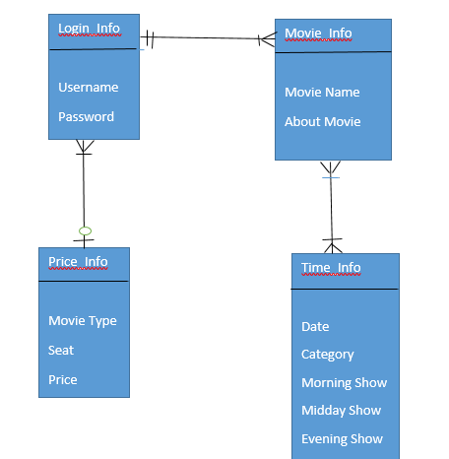

**Figure 2.1: Entity Relationship Diagram**

**2.3.2 Database Design**

Database design is the process of producing a detailed data model of database. This data model contains all the needed logical and physical design choices and physical storage parameters needed to generate a design in a data definition language, which can then be used to create a database. A fully attributed data model contains detailed attributes for each entity. The term database design can be used to describe many different parts of the design of an overall database system. Principally, and most correctly, i can be thought of as the logical design of the base data structures used to store the data. In the relational model these are the tables and views. In an object database the entities and relationships map directly be used to apply to the overall process of designing, not just the base data structure but also the forms and queries used as part of the overall database application within the database management system (DBMS).

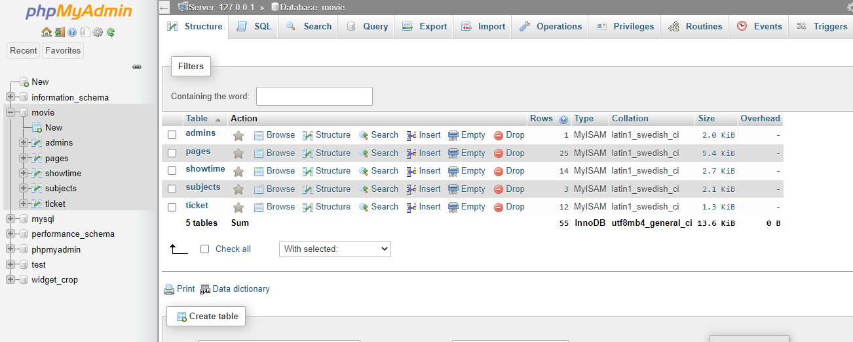

**Figure 2.2: rent Info Table from Database**

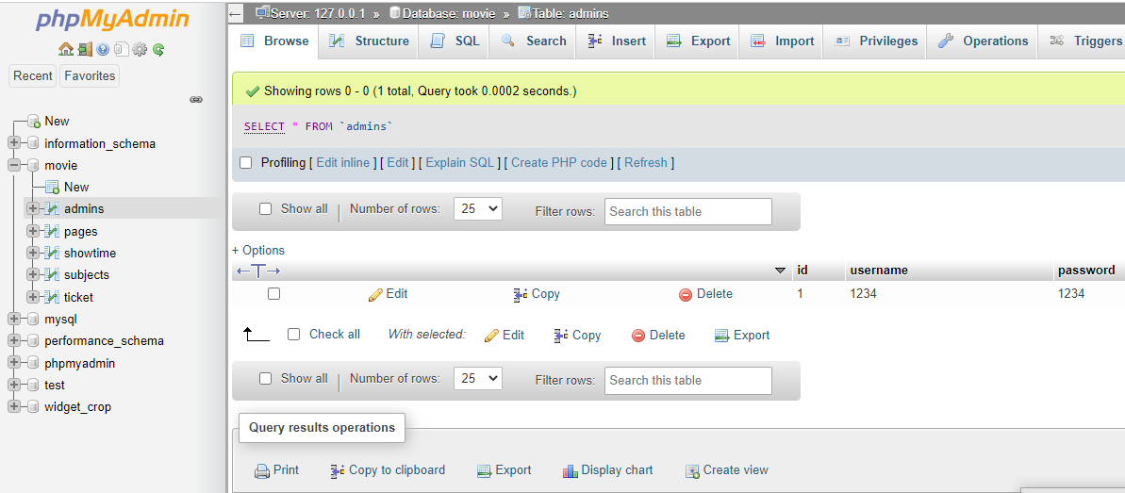

**Figure 2.3: Admin Info Table from Database**

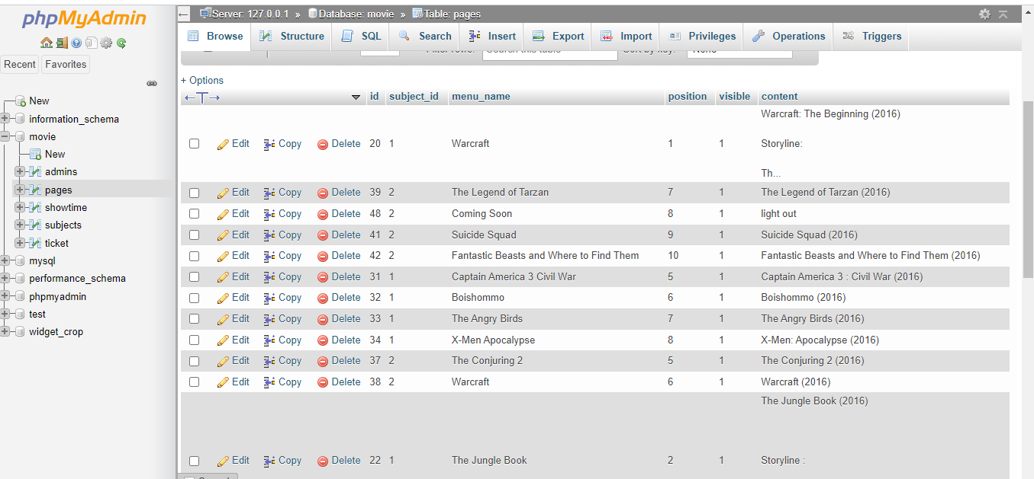

**Figure 2.4: Pages Info Table from Database**

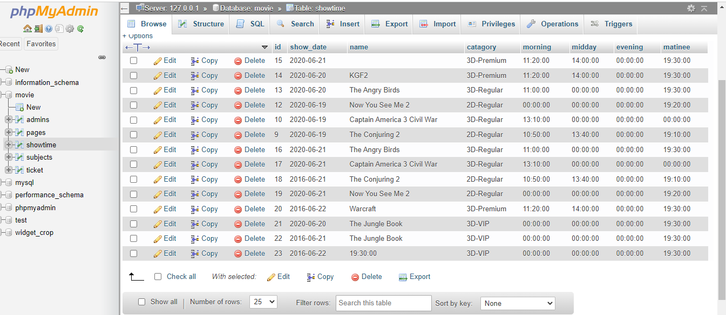

**Figure 2.5: Showtime Info Table from Database**

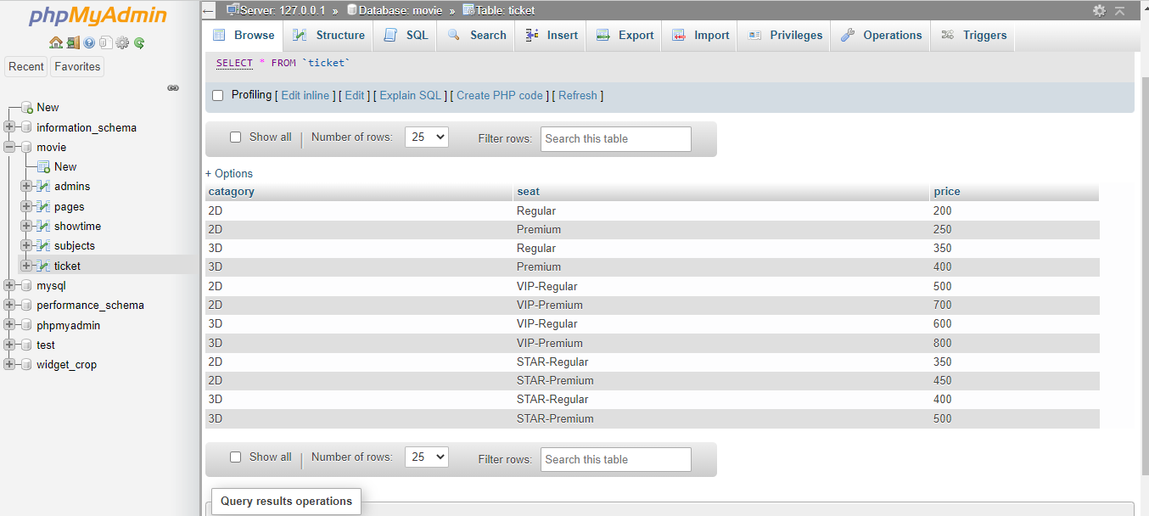

**Figure 2.6: Ticket Table from Database**

**2.4 Process Model:**

A Process Model tells us about how the data is processed and how the data flows from one table to another to gather the required information. This model consists of the Functional Decomposition Diagram and Data Flow Diagram.

**2.4.1 Data Flow Diagram (DFD)**

Data Flow Diagrams show the flow of data from external entities into the system, and from one process to another within the system. Data flow diagrams (DFDs) reveal relationships among and between the various components in a program or system. DFDs are an important technique for modeling a system's high-level detail by showing how input data is transformed to output results through a sequence of functional transformations. There are four symbols for drawing a DFD. Rectangles representing external entities, which are sources or destinations of data. Ellipses representing processes, which take data as input, validate and process it and output it. Arrows representing the data flows, which can either, be electronic data or physical items. Open-ended rectangles or a Disk symbol representing data stores, including electronic stores such as databases or XML files and physical stores such as filing cabinets or stacks of paper. Figures are the Data Flow Diagrams for the current system. Each process within the system is first shown as a Context Level DFD and later as a Detailed DFD. The Context Level DFD provides a conceptual view of the process and its surrounding input, output and data stores The Detailed the sub-processes within the system.

## Examples of how DFDs can be used

Data flow diagrams are well suited for analysis or modeling of various types of systems in different fields.

**DFD in software engineering:** This is where data flow diagrams got their main start in the 1970s. DFDs can provide a focused approached to technical development, in which more research is done up front to get to coding.

**DFD in business analysis**: Business analysts use DFDs to analyze existing systems and find inefficiencies. Diagramming the process can uncover steps that might otherwise be missed or not fully understood.

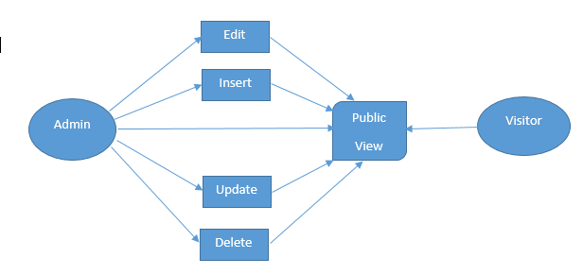

**Figure 2.7: Data Flow Diagram**

**Chapter 3: Implementation**

Here the project implementation:

**Home Page:**

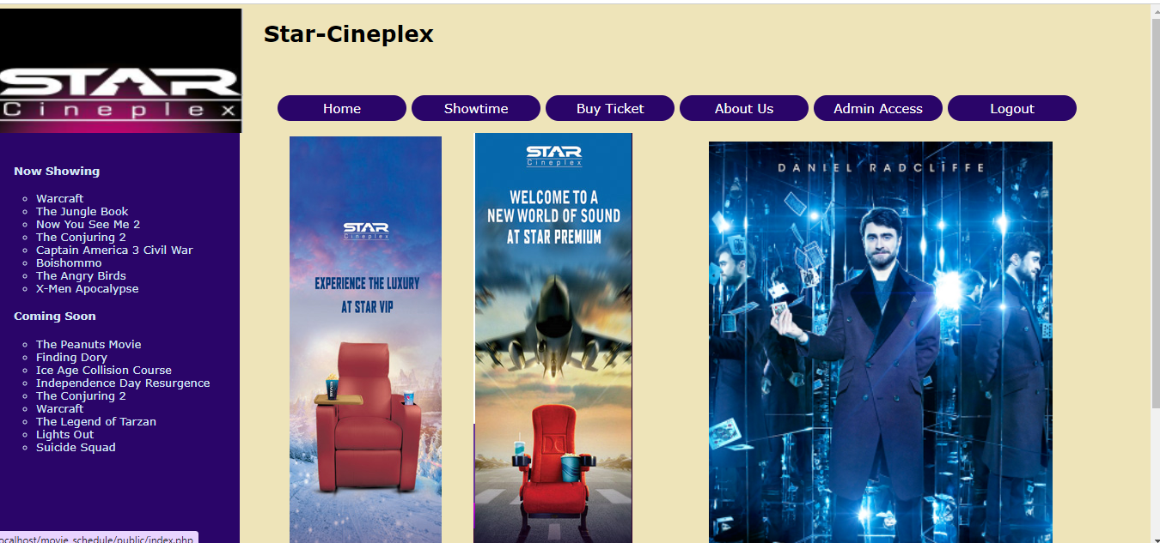

**Figure 2.8: Home Page**

**Show time:**

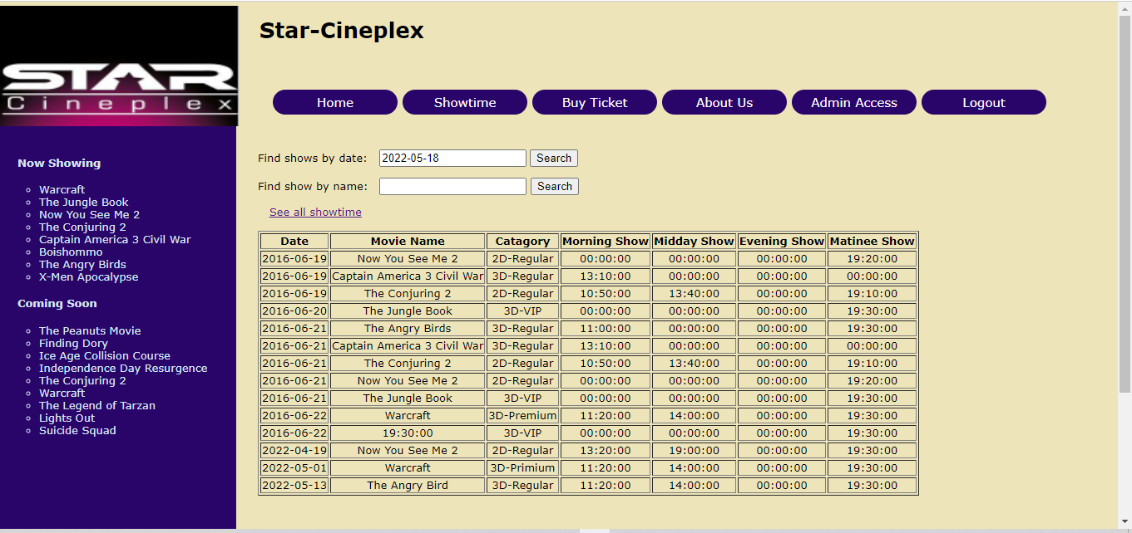

**Figure 2.9: Show time**

**Buy Ticket:**

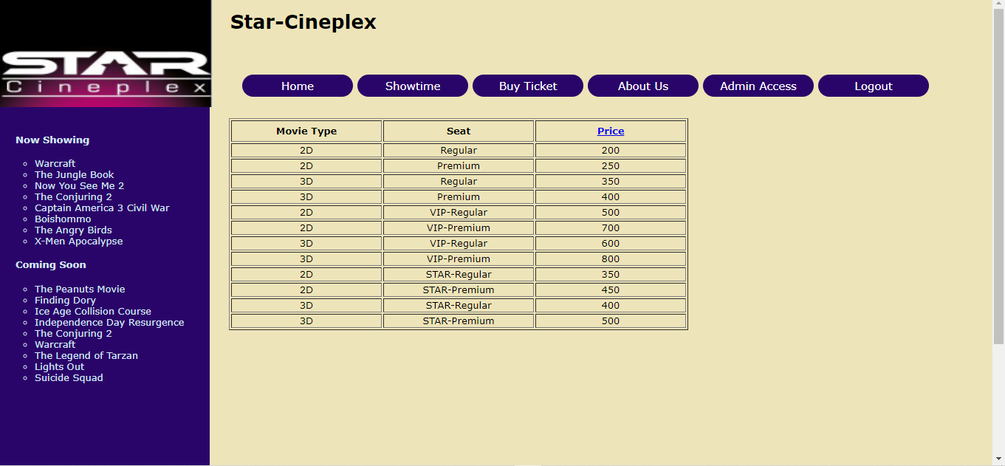

**Figure 2.10: Buy Ticket**

**Admin Login:**

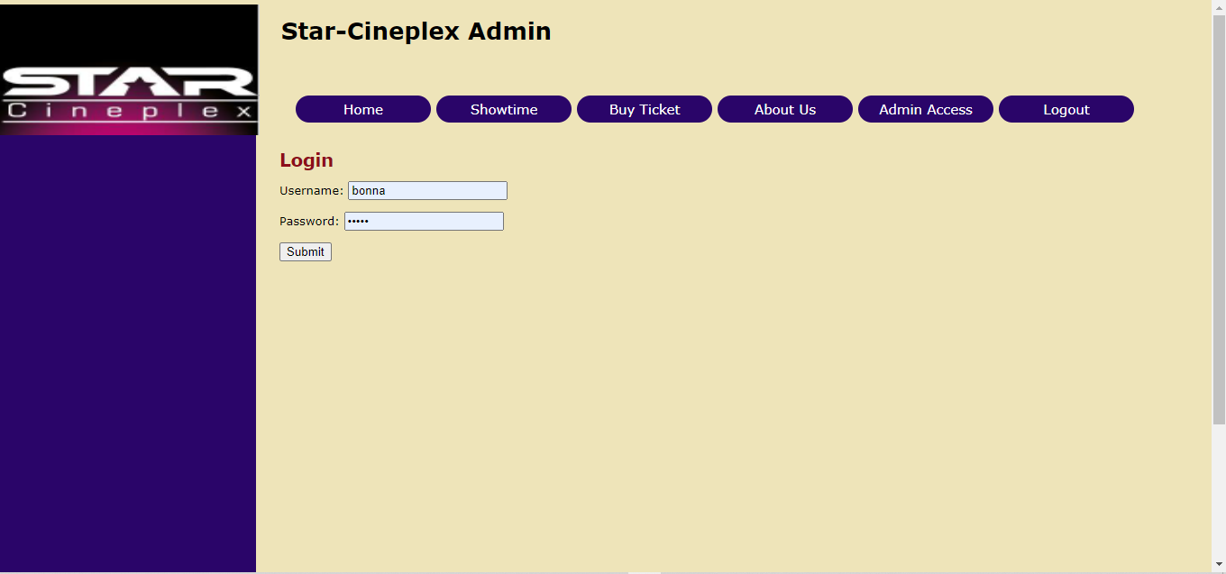

**Figure 2.11: Log in**

**Admin Menu:**

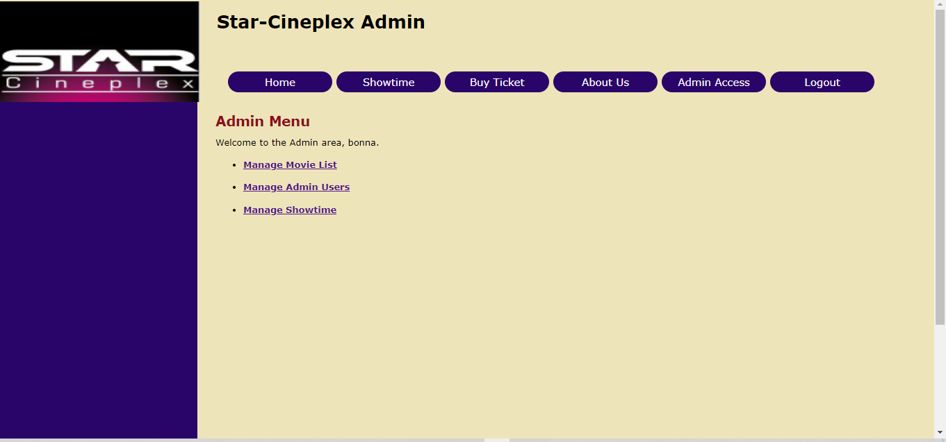

**Figure 2.12: Admin Menu**

**Manage Movie List:**

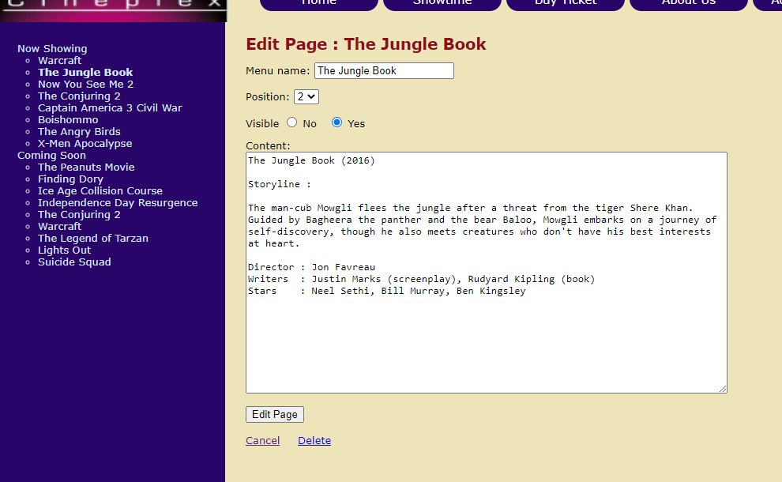

**Figure 2.13: Manage Movie List**

**Manage Admin User:**

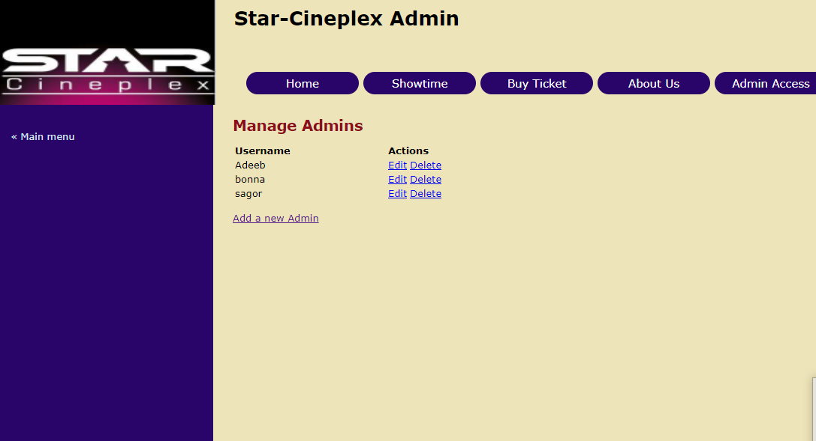

**Figure 2.14: Manage Admin User**

**Manage Movie Showtime:**

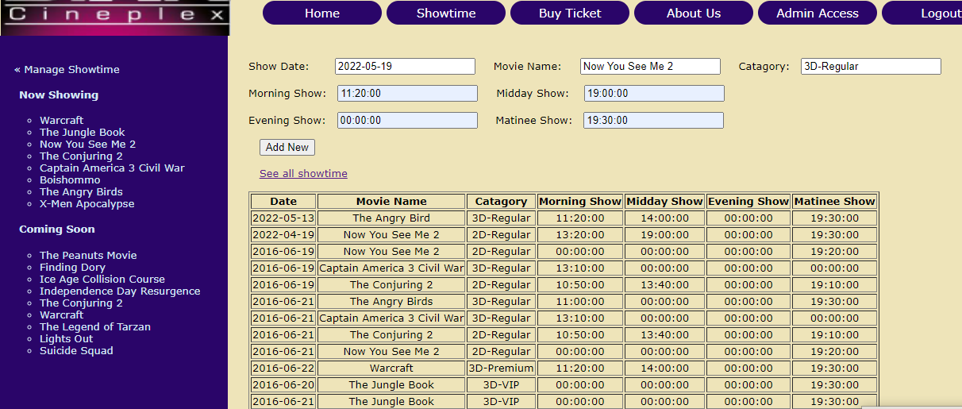

**Figure 2.15: Manage Movie Showtime**

**Chapter 4: Limitation and Discussion**

This application is web based application and it is my first web based application. With expecting a best web application there has some limitations. There are many individuals that are looking for other amazing alternatives home or land is just the fix for that.

**4.1 Limitation**

I have tried my best effort to complete the project successfully but there are some limitations in my project and the limitations are following:

The system at present does not take care of the money payment methods, as the consolidated constructs need SSL standards and are critically to be initiated in the first face, the application of the credit card transactions is applied as a developmental phase in the coming days. The system needs more elaborative technicality for its inception and evolution. For money problem I can not buy domain to access google map. I use embedded map to google map share.

**4.2 Discussion**

Internet has become a major resource in modern business, thus electronic searching has gained. The significance not only from the entrepreneur's but also from the customer's point of view. Hence we have designed the project to provide the user with easy navigation, retrieval of data and necessary feedback as much as possible. In this project, the user is provided with web site that can be used to suitable home or land from online.

**Chapter 5: Conclusion and Future Scopes**

**5.1 Conclusion**

Our project is only a humble venture to satisfy the needs to mangae their project work. Several user friendly coding have also adopted. This package shall prove to be a powerful package in satisfying all the requirements. People who interested to watch movie in star Cineplex this website is helpful to them.

**5.2 Future Scopes**

I will make the website more attractive can add printer. I will add chat option that’s why customer can chat with Organization. I will add more information about movie.

**Reference**

**Books Used**:

1. Software Engineering - R.S. Pressman
2. PHP for Dummies
3. PHP Beginners Guide by McGraw-Hill Publication
4. JavaScript by McGraw-Hill Publication

**References Used:**

1. [**https://www.moviestvnetwork.com/schedule/?...**](https://www.moviestvnetwork.com/schedule/?...)
2. [**https://www.fandango.com**](https://www.fandango.com/)
3. [**https://www.moviefone.com/showtimes**](https://www.moviefone.com/showtimes/)
4. [**https://www.ontvtonight.com/guide/listings/channel/69045539/movies.html**](https://www.ontvtonight.com/guide/listings/channel/69045539/movies.html)