**Bellman-Ford Algorithm**

* A **Bellman-Ford**algorithm is also guaranteed to find the shortest path in a graph
* Bellman-Ford is slower than **Dijkstra’s algorithm**.
* handling graphs with **negative edge weights.**
* detecting **negative cycles.**

## The idea behind Bellman Ford Algorithm:

* starts with a single source.
* calculates the distance to each node.
* The distance is initially unknown and assumed to be infinite.
* the algorithm relaxes those paths by identifying a few shorter paths. Hence it is said that Bellman-Ford is based on “Principle of Relaxation“.

## Principle of Relaxation of Edges for Bellman-Ford:

* if we relax the edges **N** times, and there is any change in the shortest distance of any node between the **N-1th** and **Nth** relaxation than a negative cycle exists, otherwise not exist.

## Working of Bellman-Ford Algorithm to Detect the Negative cycle in the graph

## 

*Initial Graph*

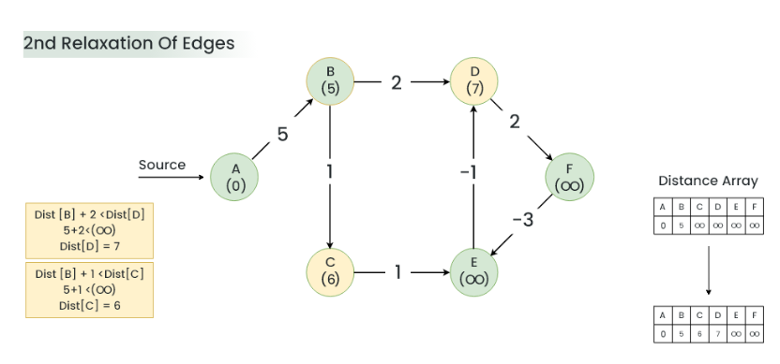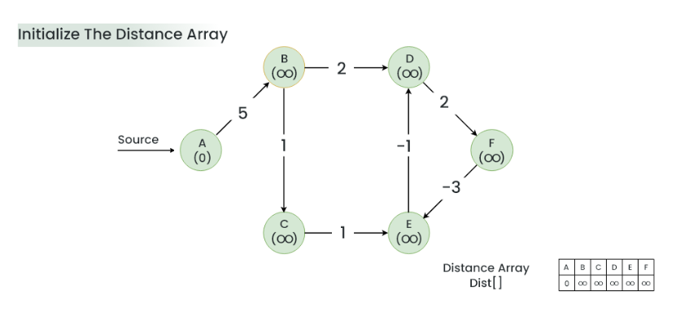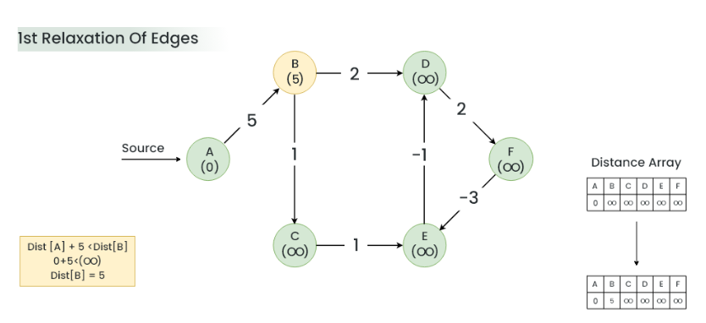

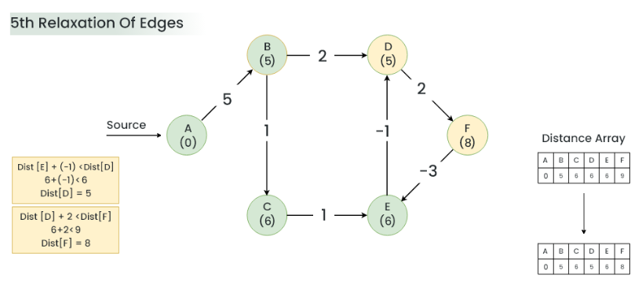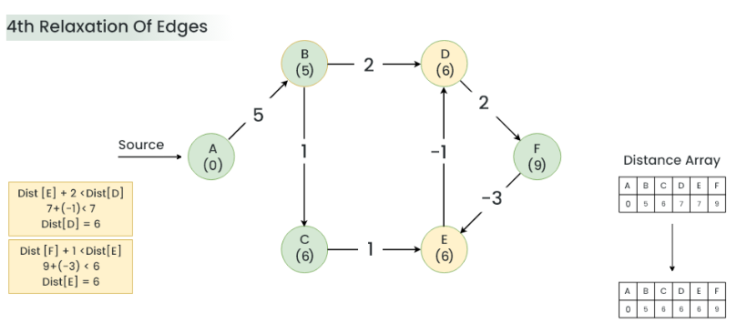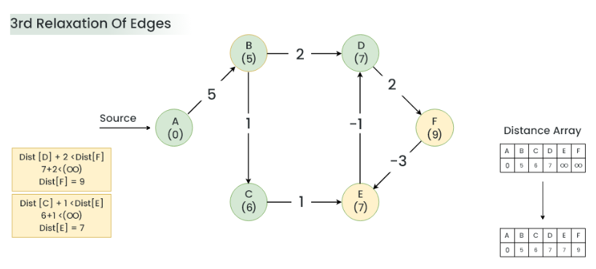

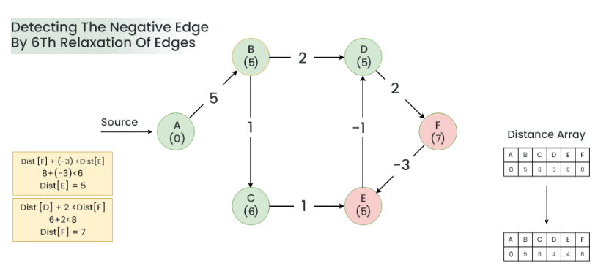

***Result:****A negative cycle (D->F->E) exists in the graph.*

## Algorithm

* Initialize distance array **dist[]** for each vertex ‘v‘ as **dist[v] = INFINITY**
* Assume any vertex (let’s say ‘0’) as source and assign **dist = 0.**
* Relax all the edges(u,v,weight) N-1 times as per the below condition:
  + **dist[v] = minimum(dist[v], distance[u] + weight)**
* Now, Relax all the edges one more time i.e. the Nth time and based on the below two cases we can detect the negative cycle:
  + **Case 1** (Negative cycle exists): For any edge(u, v, weight), if dist[u] + weight < dist[v]
  + **Case 2** (No Negative cycle) : case 1 fails for all the edges.

# **Detect Cycle in a Directed Graph**

* It is based on the idea that there is a cycle in a graph only if there is a back edge present in the graph.
* To find cycle in a directed graph we can use the Depth First Traversal (**DFS**) technique.
* If during recursion, we reach a node that is already in the **recursion stack**, there is a cycle present in the graph.

**steps to Implement the idea**

Create a recursive **DFS** function that has the following parameters – **current vertex**, **visited array**, and **recursion stack**.

Mark the **current node as visited** and also mark the index in the recursion stack.

**Iterate a loop** for all the vertices and for each vertex, call the recursive function if it is not yet visited

* + In each recursion call, Find all the adjacent vertices of the current

vertex which are not visited:

* + - If an adjacent vertex is already marked in the recursion stack then

return true.

* + - Otherwise, call the recursive function for that adjacent vertex.

