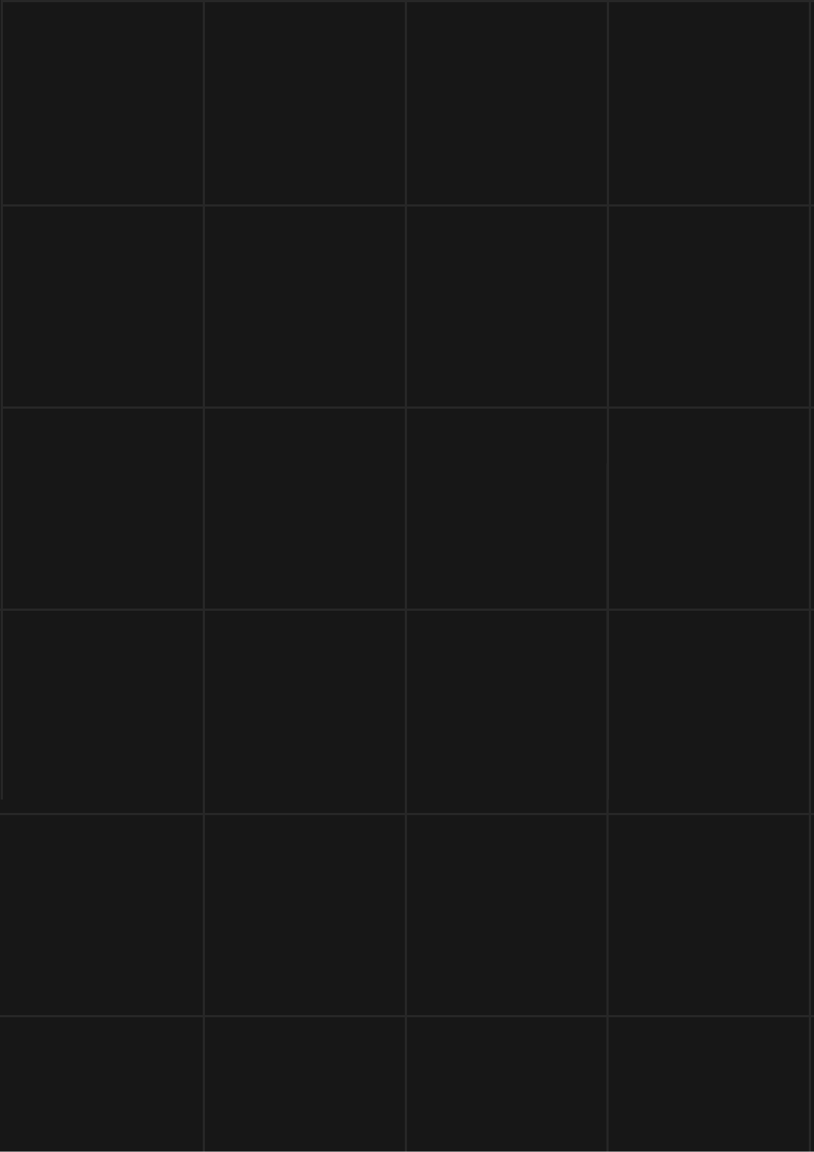

StellarSync

Flutter Project



**MADE BY**

Simeon Boev

**PROJECT ON**

GITHUB

**REPOSITORY**

SABoev20/flutter-project

Table of content

IDEA OF THE PROJECT 3

AUTHOR 3

PROJECT DESCRIPTION 3

PERFORMED TASKS 4

FUNCTIONS 5

BLOCK DIAGRAM 5

IDEA OF THE PROJECT

The idea of the project is to create an application that shows daily space related blogs, news and photos using the **NASA API**.

AUTHOR

Simeon Boev – Student from PGKPI, 10th Grade

<https://github.com/SABoev20/>

PROJECT DESCRIPTION

|  |  |
| --- | --- |
|  | Description |
|  | Application in general.  The app is displaying NASA’s daily block from a selected date |
|  | How can you access the project?  You can find our project on GitHub. You can access the files by installing the repository or paste this to your console - https://github.com/SABoev20/flutter-project. |
|  | How it works?  The app is using the official NASA API so it can fetch the data and display it. |
|  | What technologies were used?  The technologies that were used are **Android Studio** as code editor, **GitHub** for collaborative work, **Git** for source control, **PowerPoint** for preparing a Presentation, **Word** for preparing Documentation, **Figma** for the design. |

PERFORMED TASKS

|  |  |
| --- | --- |
|  | Performed tasks |
| 1 | Brainstorm an idea  The main part of the project is the original idea. After many tries I decided to choose this. |
| 2 | Create design  The design was created with the idea to be interesting and eye catching while still being able to look good with almost any cosmic picture. |
| 3 | Set up environment  I had to install all the needed technologies, set the repo and android studio and start working. |
| 4 | Learn Flutter and Dart  To start working on the project I had to get familiar with the project technologies. |
| 5 | Development  I started by writing the code to get the needed information from the API. Then I worked on the frontend. |
| 6 | Create README  In the readme you can get a quick overview of the project and see all the languages and tools I have used. |
| 7 | Create documentation  By reading the documentation you can learn almost everything about my project. |
| 8 | Create design documentation  Just by looking at our design documentation you can get the basic idea of our website and see the colors we have used. |
| 9 | Create presentation  We have created a presentation, which helps us introduce our project. |
| 10 | Deploy the App  The app will be deployed as soon as it’s finished so it can be used in real life. |