RedHat NFS Project

🎯 Objective:
Set up an NFS Server to share a directory and mount it on one or more NFS Clients. NFS allows users to access shared directories and files over a network.

🧱 STEP 1: NFS Server Installation (on Server Machine)
- Install NFS utilities:
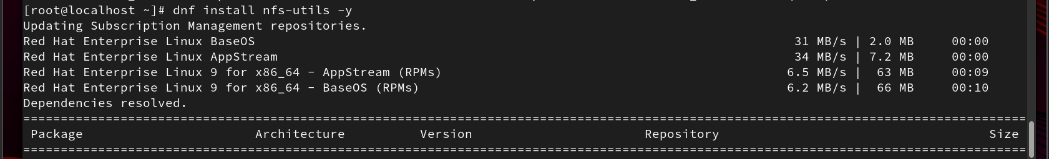
sudo dnf install nfs-utils -y

- Enable and start NFS services:
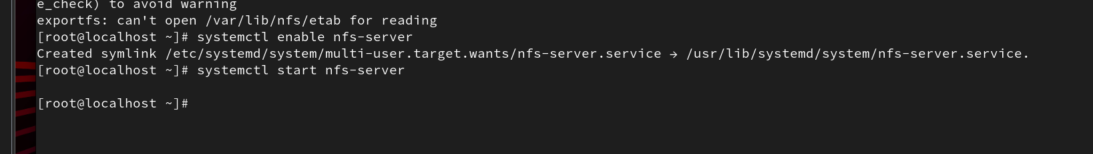
sudo systemctl enable nfs-server
sudo systemctl start nfs-server
sudo systemctl status nfs-server

📁 STEP 2: Create and Export a Shared Directory
- Create and set permissions:
sudo mkdir -p /mnt/nfs_share
sudo chown -R nobody:nogroup /mnt/nfs_share
sudo chmod 777 /mnt/nfs_share
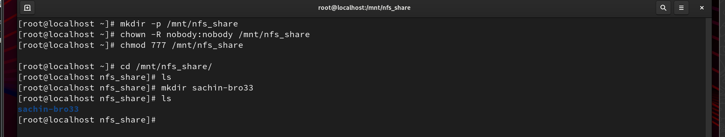
Cd /mnt/nfs_share/ —> make (mkdir) sachin-bro33
- Configure /etc/exports:
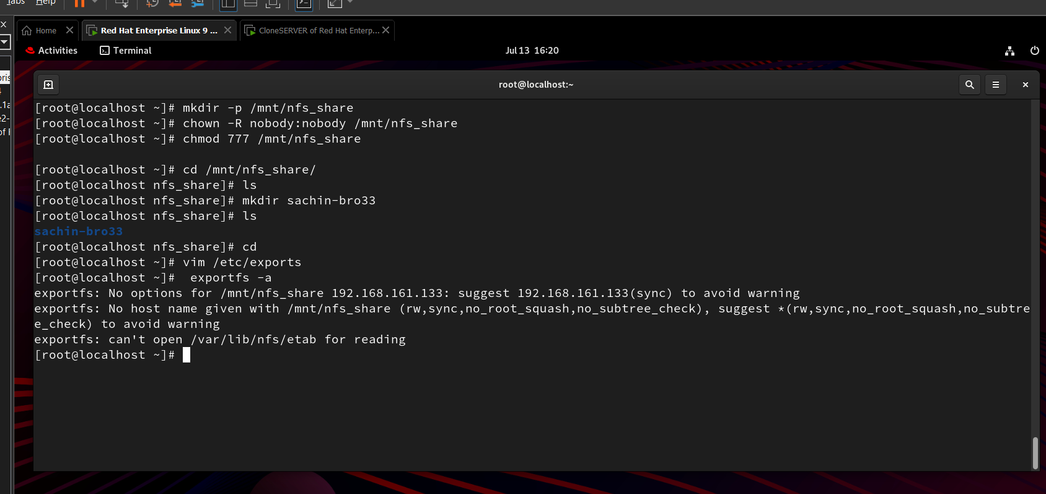
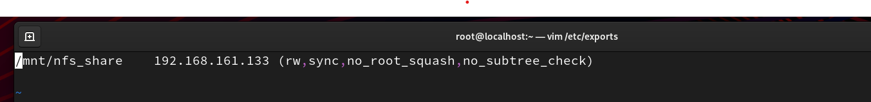
sudo vim /etc/exports
Add: /mnt/nfs_share 192.168.161.133:(rw,sync,no_root_squash,no_subtree_check)
sudo exportfs -a

🔥 STEP 3: Configure Firewall (on Server)
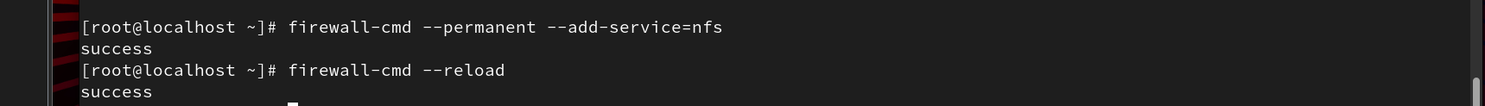
sudo firewall-cmd --permanent --add-service=nfs
sudo firewall-cmd --reload

💻 STEP 5: NFS Client Configuration (on Client Machine)
- Install NFS utilities:
sudo dnf install nfs-utils -y
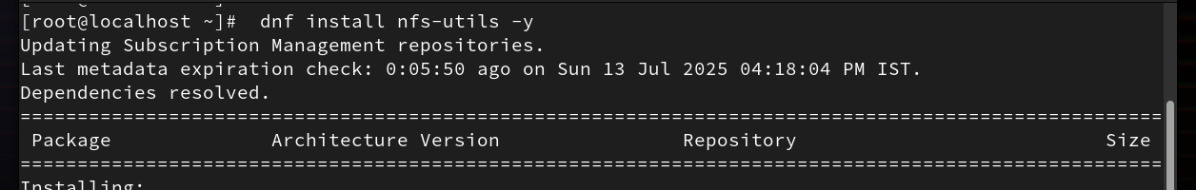
→ Create a mount point and mount:
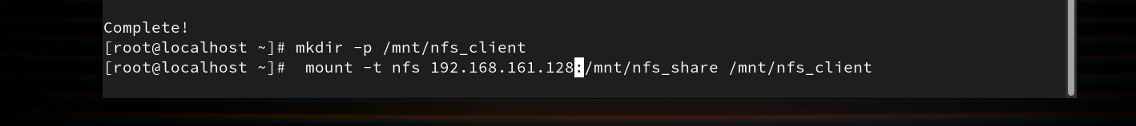
sudo mkdir -p /mnt/nfs_client
sudo mount -t nfs 192.168.161.128:/mnt/nfs_share /mnt/nfs_client

📌 STEP 6: Test Access // Verify Mount
cd /mnt/nfs_client
ls -l
This is the same directory that we have created on the server pc, and now this is on the client pc

