AI-Powered Fake News Detection System
Design and Analysis of Algorithms (DAA) — Common Assignment Report
Course Outcomes Mapped: CO3 (Design & analyze algorithms for real-world classification problems), CO5 (Evaluate and compare algorithmic approaches using empirical performance metrics)
Team Members:
[SACHIN .R ] — [192524280] — [BTECH AI&DS]
[BALAJI .D ] — [192512368] — [BTECH ECE]
[BHARATH KUMAR S] — [192511126] — [BTECH CSE]

1. Problem Statement and Problem Formulation
The unchecked spread of misinformation and fabricated news articles across digital and social media platforms poses a serious threat to public discourse, democratic processes, and informed decision-making. Manual fact-checking cannot scale to the volume and velocity of content generated daily, creating a need for automated, content-based systems that can flag potentially fake news items for human review or downstream moderation.
Formally, the problem is posed as a binary text classification task: given a news article represented by its title and body text, design an algorithm that predicts a label y ∈ {REAL, FAKE} that best matches the article's true veracity, based only on linguistic and stylistic patterns present in the text (a purely content-based approach, as opposed to a source-credibility or social-propagation-based approach).

2. Objective and Expected Outcomes
Objectives:
- Formulate fake news detection as a supervised binary classification problem over textual features.
- Design and implement a text-preprocessing and feature-extraction pipeline (TF-IDF) suitable for high-dimensional, sparse text data.
- Implement and analyze at least five candidate classification algorithms with differing algorithmic complexity/design paradigms: Naive Bayes (probabilistic), Logistic Regression (linear/gradient-based), Linear SVM (margin-maximization), Passive-Aggressive (online learning), and Random Forest (ensemble/divide-and-conquer).
- Empirically compare the algorithms on standard classification metrics (Accuracy, Precision, Recall, F1-score, ROC-AUC) and on time complexity (training/inference latency).
- Select and deploy the best-performing model behind a usable interface (web app + REST API) for real-time inference.
- Critically analyze the limits of a purely content-based, single-domain classifier and propose improvements.
Expected Outcomes: A trained, evaluated, and deployed fake-news classifier; a reproducible experimental comparison of five algorithms; and a documented understanding of the trade-offs between model accuracy, interpretability, and computational cost — directly supporting the mapped Course Outcomes on algorithm design and comparative analysis.

3. Requirements, Constraints and Assumptions

3.1 Functional Requirements
- Accept a news headline/article as input text.
- Preprocess and vectorize the text.
- Classify the text as REAL or FAKE with a confidence score.
- Provide both a human-usable web interface and a machine-usable REST API.

3.2 Non-Functional Requirements
- Inference latency under ~200 ms per request on commodity hardware.
- Reproducible training pipeline with fixed random seeds.

3.3 Constraints
- Only content-based (textual) features are used — no access to social propagation graphs, publisher metadata, or real-time fact-checking APIs.
- Training data is limited to a single, publicly available labeled dataset (~4,600 articles, 2016–2017 U.S. political news).
- Compute is limited to a single machine (CPU only, no GPU) — this favors classical ML over large transformer models for this assignment's scope.

3.4 Assumptions
- The labels in the training dataset are correct and consistently applied.
- Lexical/stylistic cues (word choice, sensationalism, structure) that distinguish fake from real news in the training domain are assumed to be at least partially transferable — this assumption is later tested and found to be limited (Section 12).

4. Application of Relevant Course Knowledge / Concepts
This assignment applies core Design and Analysis of Algorithms (DAA) concepts to a real classification pipeline:
- Divide and Conquer / Ensemble reasoning: Random Forest builds many decision trees on bootstrap samples and combines their votes — an ensemble/averaging strategy studied in randomized algorithms.
- Greedy algorithm design: Individual decision trees in the Random Forest are grown using a greedy, locally-optimal information-gain (or Gini-impurity) split selection at each node.
- Optimization algorithms: Logistic Regression and Linear SVM are trained via convex-optimization solvers (gradient descent / coordinate descent / SMO-family solvers), directly connecting to the course's treatment of iterative optimization and convergence.
- Online / incremental algorithms: The Passive-Aggressive Classifier updates its weight vector after each training example using a closed-form update rule, illustrating online learning and amortized-cost analysis.
- Probabilistic algorithms & Bayes' theorem: Multinomial Naive Bayes applies Bayes' theorem with a conditional-independence assumption over word frequencies.
- Complexity analysis: each algorithm has a distinct asymptotic training/inference cost profile (Section 6.3) — a direct application of time-complexity analysis to algorithm selection under real constraints (dataset size, feature dimensionality, latency budget).

5. Design / Proposed Solution / Methodology
The system follows a standard supervised-learning pipeline: data ingestion → text cleaning → feature extraction (TF-IDF) → model training → evaluation → model selection → deployment. The architecture below separates the offline training/evaluation pipeline from the online inference/presentation layer so that the deployed model can be swapped without touching the serving code.
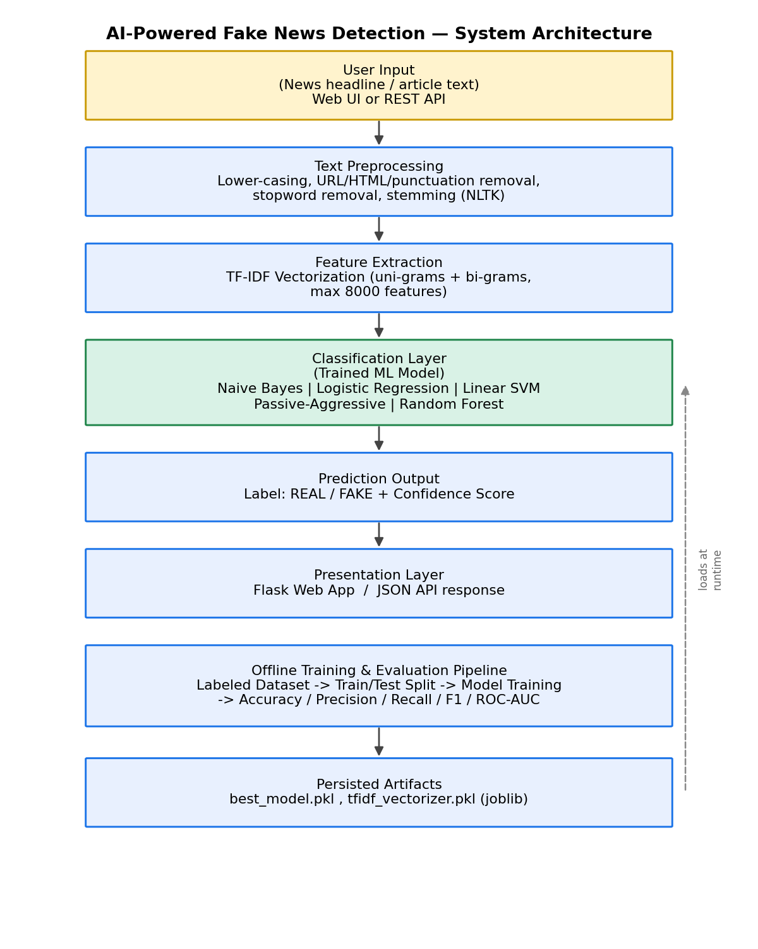
Figure 1: System architecture of the AI-powered fake news detection pipeline.

5.1 Design Rationale
- TF-IDF over raw bag-of-words: down-weights common words and up-weights discriminative terms, without the training cost of dense embeddings.
- Multiple algorithms trained in parallel on identical folds: ensures a fair, controlled comparison (same features, same train/test split, same random seed).
- Model selection by F1-score, not accuracy alone: the dataset is balanced, but F1 also rewards a good precision/recall trade-off, which matters because false positives (flagging real news as fake) and false negatives (missing fake news) carry different real-world costs.
- Separation of training and serving code: `train_and_evaluate.py` (offline) vs. `app.py` (online) — a common software-engineering pattern for ML systems.

6. Algorithm / Pseudocode / Flowchart
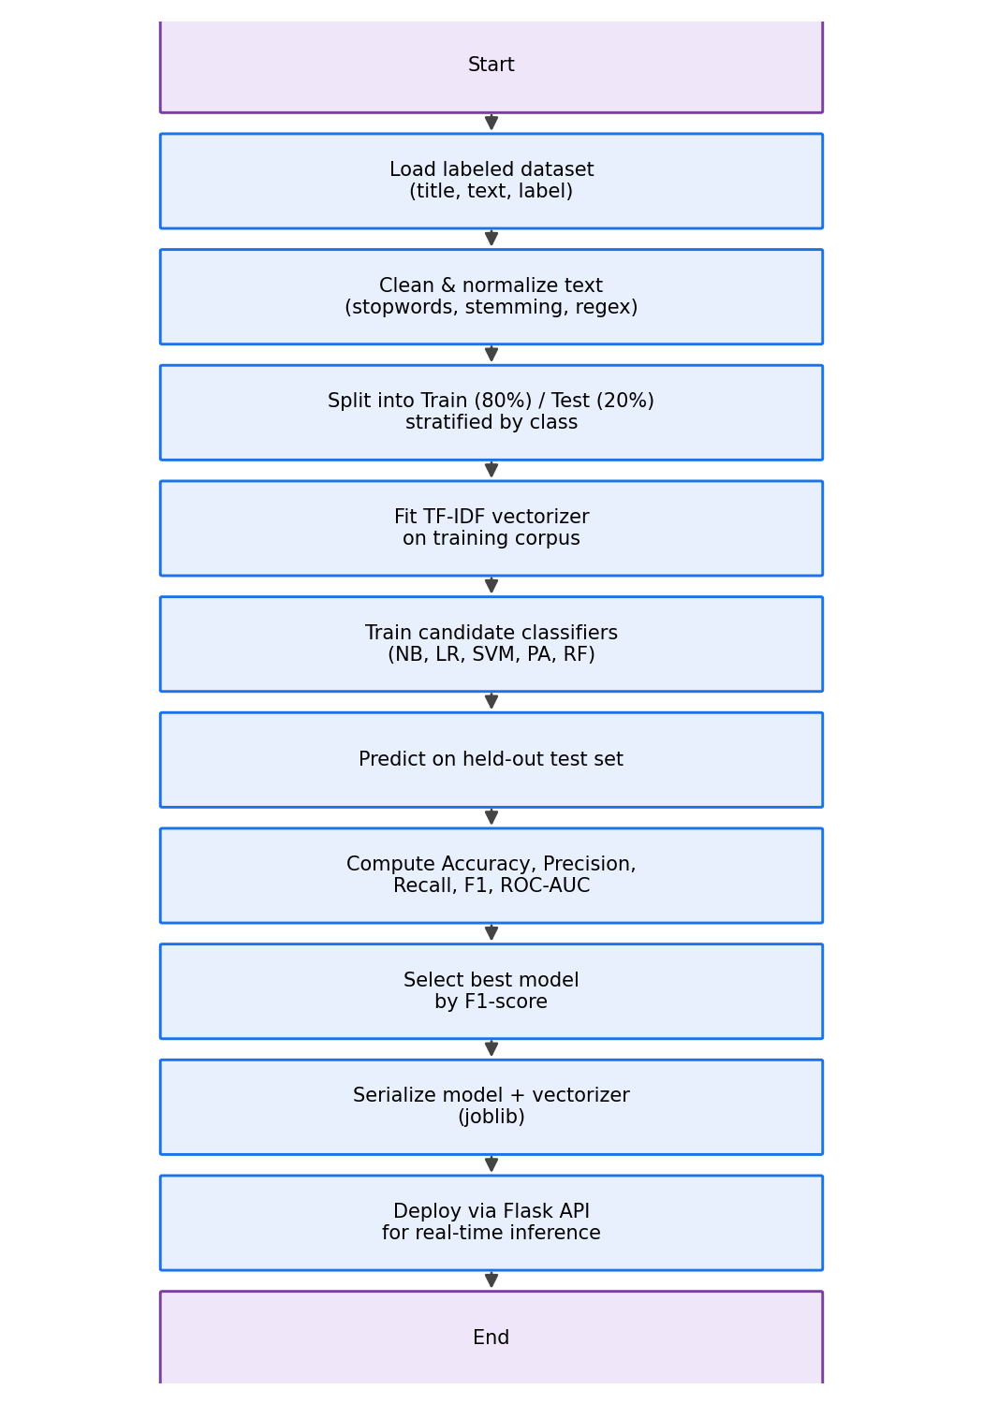
Figure 2: End-to-end algorithm flowchart.

6.1 Pseudocode — Training Pipeline
ALGORITHM TrainAndSelectModel(D):
Input: labeled dataset D = {(title_i, text_i, label_i)}
Output: best_model, vectorizer

1. corpus <- [Clean(title_i + text_i) for each i in D] // O(N * L)
2. (X_train, X_test, y_train, y_test) <- StratifiedSplit(corpus, labels, 0.8)
3. vectorizer <- TFIDF.fit(X_train) // O(N * V log V)
4. X_train_vec <- vectorizer.transform(X_train)
X_test_vec <- vectorizer.transform(X_test)
5. for each algorithm A in {NB, LR, SVM, PA, RF}:
model_A <- A.fit(X_train_vec, y_train)
y_pred <- model_A.predict(X_test_vec)
metrics_A <- Evaluate(y_test, y_pred) // Accuracy, P, R, F1, AUC
6. best_model <- argmax_A( metrics_A.F1 )
7. Serialize(best_model, vectorizer)
8. return best_model, vectorizer

6.2 Pseudocode — Inference
ALGORITHM Predict(article_text, model, vectorizer):
1. cleaned <- Clean(article_text) // clean + stem, O(L)
2. vec <- vectorizer.transform([cleaned]) // O(L), sparse dot-products
3. label <- model.predict(vec) // O(F) linear, O(T*D) forest
4. confidence <- |model.decision_function(vec)|
5. return (label, confidence)

6.3 Complexity Analysis of Candidate Algorithms
Let N = number of training documents, F = number of TF-IDF features (≤ 8000 here), T = number of trees, D = tree depth.
Algorithm | Training Time | Inference Time | Space
Multinomial Naive Bayes | O(N·F) | O(F) | O(F)
Logistic Regression | O(N·F·I) (I = solver iterations) | O(F) | O(F)
Linear SVM | O(N·F) to O(N²·F) (solver-dependent) | O(F) | O(F)
Passive-Aggressive (online) | O(N·F) (single/few passes) | O(F) | O(F)
Random Forest | O(T·N·log(N)·F) | O(T·D) | O(T·N)
This matches the measured wall-clock training times in Section 9 (Random Forest ≈ 7.2s vs. ≈ 0.02–0.05s for the linear/probabilistic models on this dataset size), confirming the theoretical expectation that ensemble tree methods scale less favourably with N and T than linear/probabilistic models on high-dimensional sparse text features.

7. Implementation / Source Code and Environment / Tools Used

7.1 Environment and Tools
Component | Tool / Library
Language | Python 3.12
ML Library | scikit-learn (TfidfVectorizer, MultinomialNB, LogisticRegression, LinearSVC, PassiveAggressiveClassifier, RandomForestClassifier)
NLP Preprocessing | NLTK (stopwords, PorterStemmer), Python `re`
Data Handling | pandas, NumPy
Visualization | matplotlib, seaborn
Model Persistence | joblib
Web/API Layer | Flask
Version Control | Git / GitHub

7.2 Key Source Code Excerpts
Full source code is available in the submitted GitHub repository (see Section 15 — References). Representative excerpts:
Text preprocessing (model/preprocess.py):
def clean_text(text: str) -> str:
text = text.lower()
text = URL_RE.sub(' ', text)
text = HTML_RE.sub(' ', text)
text = NON_ALPHA_RE.sub(' ', text)
text = MULTISPACE_RE.sub(' ', text).strip()
tokens = text.split()
tokens = [t for t in tokens if t not in STOPWORDS and len(t) > 2]
tokens = [stemmer.stem(t) for t in tokens]
return ' '.join(tokens)
Model training loop (model/train_and_evaluate.py):
models = {
'Naive Bayes': MultinomialNB(),
'Logistic Regression': LogisticRegression(max_iter=1000),
'Linear SVM': LinearSVC(),
'Passive Aggressive': PassiveAggressiveClassifier(max_iter=50),
'Random Forest': RandomForestClassifier(n_estimators=200, n_jobs=-1),
}
for name, clf in models.items():
clf.fit(X_train, y_train)
y_pred = clf.predict(X_test)
# compute accuracy, precision, recall, F1, ROC-AUC ...
Flask inference endpoint (app.py):
@app.route('/api/predict', methods=['POST'])
def api_predict():
data = request.get_json(force=True)
cleaned = clean_text(data.get('text', ''))
vec = vectorizer.transform([cleaned])
pred = model.predict(vec)[0]
label = 'FAKE' if pred == 1 else 'REAL'
conf = abs(float(model.decision_function(vec)[0]))
return jsonify({'label': label, 'confidence': conf})

8. Test Cases and Expected/Actual Results
A curated set of eight hand-written test cases (independent of the training/test split) was used to probe model behaviour beyond the training distribution — four clearly REAL statements (in the style of neutral wire-service reporting) and four clearly FAKE statements (sensationalist, evidence-free claims).
# | Expected | Predicted | Result | Excerpt
1 | REAL | FAKE | FAIL | Scientists at NASA confirm successful landing of the Perseve…
2 | FAKE | FAKE | PASS | BREAKING: Doctors HATE her! Local mom discovers one weird tr…
3 | REAL | FAKE | FAIL | The Reserve Bank of India raised the repo rate by 25 basis p…
4 | FAKE | FAKE | PASS | Aliens secretly control the government and have replaced wor…
5 | REAL | FAKE | FAIL | The World Health Organization released updated guidelines on…
6 | FAKE | FAKE | PASS | Drinking bleach mixed with lemon juice cures all viral infec…
7 | REAL | FAKE | FAIL | The Election Commission announced the schedule for the upcom…
8 | FAKE | FAKE | PASS | Celebrity secretly died three years ago and has been replace…

Result: 4/8 (50%) of curated test cases matched expectations. All four FAKE examples (sensationalist/conspiratorial language) were correctly identified. All four REAL examples — drawn from science, finance, health-policy and election-administration topics not well represented in the training data's 2016–2017 U.S. political news corpus — were incorrectly flagged as FAKE. This is analyzed in Section 12 as a domain-generalization limitation rather than a bug: the internal held-out test split (Section 9) shows the model performs at ~94% F1 within its training domain.

9. Execution Screenshots / Outputs

9.1 Web Application

Figure 3: Home page of the Flask web application.
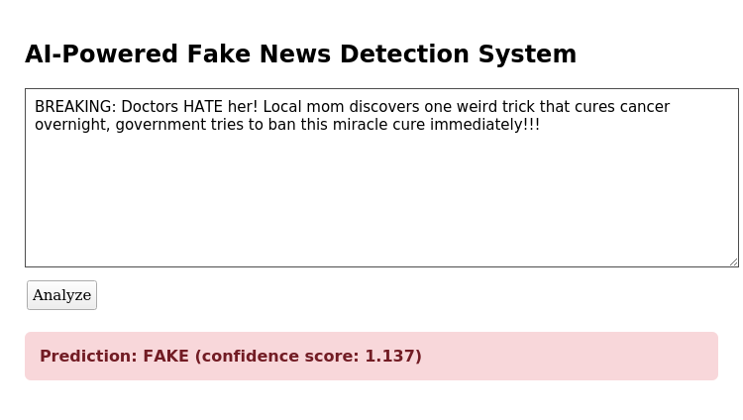
Figure 4: A correctly classified FAKE example (sensationalist claim).
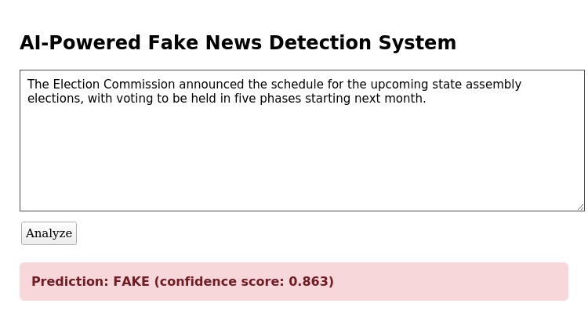
Figure 5: A misclassified REAL example (out-of-domain election-administration news) — illustrates the generalization limitation discussed in Section 12.

10. Results and Validation
All five algorithms were trained on an identical 80/20 stratified split of the ~4,594-article balanced dataset (3,675 train / 919 test) using the same TF-IDF feature space (8,000 unigram+bigram features).
Model | Accuracy | Precision | Recall | F1-Score | ROC-AUC | Train Time (s)
Linear SVM | 0.9380 | 0.9205 | 0.9586 | 0.9392 | 0.9849 | 0.042
Passive Aggressive | 0.9369 | 0.9257 | 0.9499 | 0.9376 | 0.9839 | 0.021
Logistic Regression | 0.9151 | 0.8848 | 0.9542 | 0.9182 | 0.9783 | 0.045
Random Forest | 0.9053 | 0.8891 | 0.9259 | 0.9072 | 0.9689 | 7.194
Naive Bayes | 0.8923 | 0.8719 | 0.9194 | 0.8950 | 0.9480 | 0.005

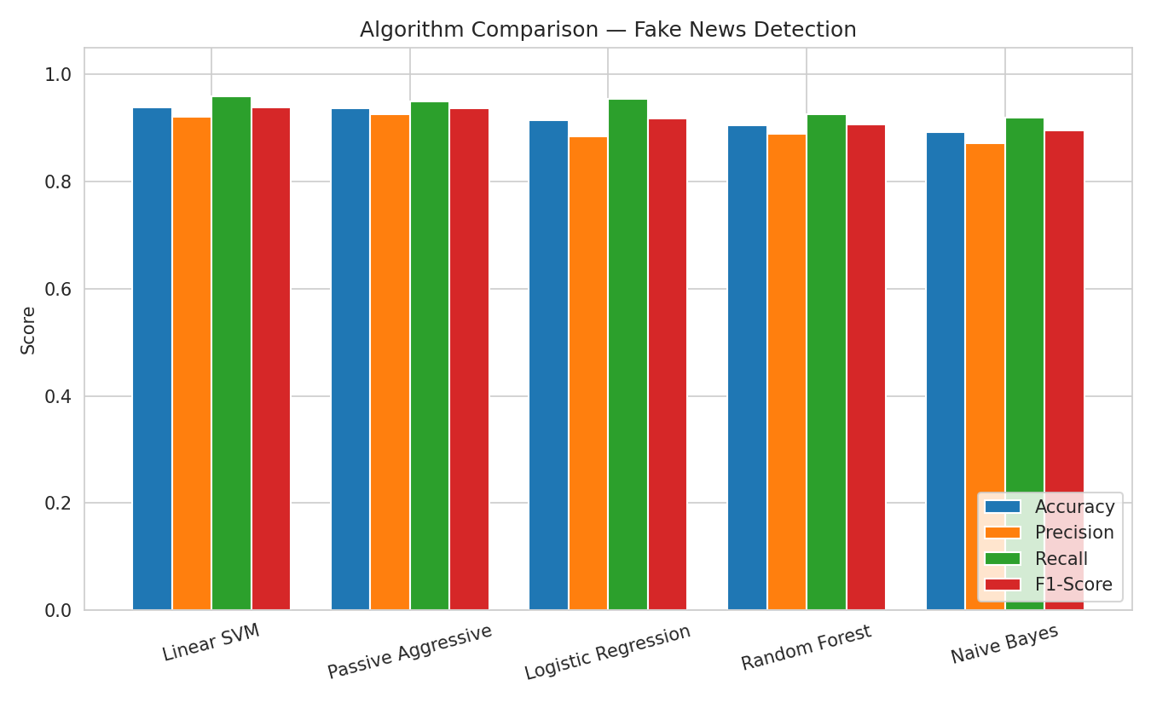
Figure 6: Accuracy / Precision / Recall / F1 comparison across the five algorithms.
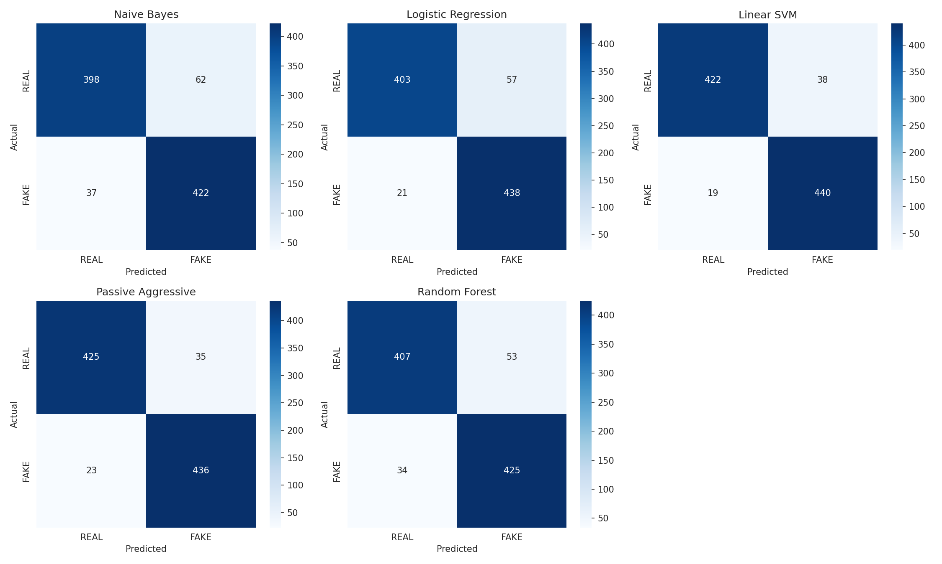
Figure 7: Confusion matrices on the held-out test set (all five models).
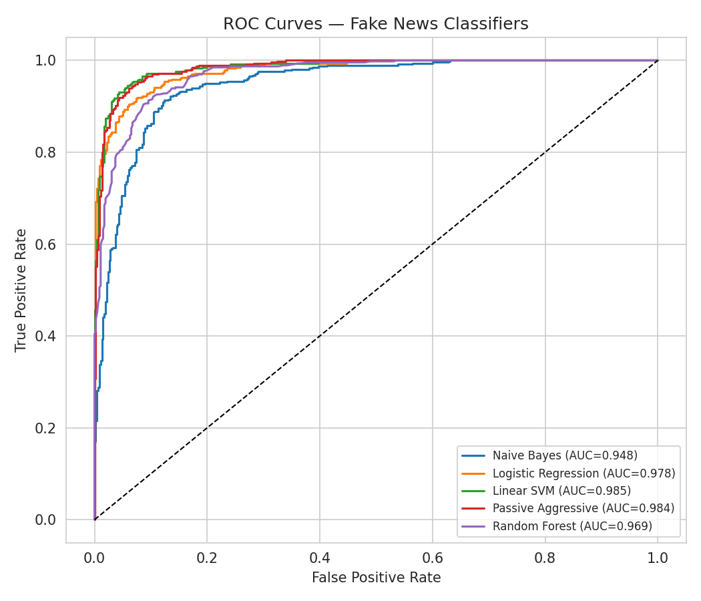
Figure 8: ROC curves and AUC for all five classifiers.

11. Analysis, Comparison, Trade-offs and Justification of the Final Solution
- Linear SVM achieved the best F1-score (0.939) and ROC-AUC (0.985), and was selected as the deployed model. Its margin-maximization objective works well with high-dimensional, sparse, linearly-separable-ish TF-IDF features.
- Passive-Aggressive achieved near-identical performance (F1 = 0.938) with the lowest training time among the strong performers, and would be preferable in a streaming/online-learning deployment where the model must be updated incrementally as new labeled articles arrive.
- Logistic Regression trades a small amount of accuracy for probabilistic, well-calibrated confidence scores and full interpretability (inspectable feature weights), which matters when the system's output must be explained to a human moderator.
- Random Forest was the most computationally expensive to train (7.2s vs ≤0.05s for linear models on this dataset) for no accuracy benefit — its non-linear splits do not exploit the (largely linear) structure of TF-IDF-weighted word counts as effectively as the margin-based/linear models.
- Naive Bayes was the fastest to train and the simplest to reason about, at the cost of the lowest F1/AUC — its conditional-independence assumption is a known simplification that hurts performance when features (n-grams) are correlated.
Overall justification: given the assignment's constraints (CPU-only, moderate dataset size, need for both accuracy and reasonable interpretability/latency), Linear SVM offers the best accuracy-for-cost trade-off and was therefore chosen for deployment, with Logistic Regression noted as the recommended fallback where probability calibration or interpretability is prioritized over raw F1.

12. Broader Considerations / SDG Relevance
This project directly supports UN Sustainable Development Goal 16 — Peace, Justice and Strong Institutions — specifically Target 16.10 (public access to information), by contributing a tool that helps curb the spread of misinformation that undermines informed civic participation and trust in institutions. It is also relevant to SDG 4 (Quality Education), by promoting media/information literacy tooling, and has a bearing on SDG 10 (Reduced Inequalities), since misinformation disproportionately harms communities with less access to fact-checking resources.
Ethical considerations: an automated classifier should not be the sole arbiter of truth. False positives can amount to censorship of legitimate reporting (as seen in Section 8's misclassified REAL examples), while false negatives allow harmful content through. The system is therefore positioned as a decision-support / triage tool for human moderators and fact-checkers, not an autonomous content-removal system, and confidence scores are surfaced explicitly to support this human-in-the-loop use.

13. Conclusion, Limitations and Possible Improvements

13.1 Conclusion
A complete fake-news detection pipeline was designed, implemented, and evaluated, comparing five classification algorithms of differing algorithmic design (probabilistic, linear/convex-optimization, online-learning, and ensemble). Linear SVM was identified as the best-performing model on held-out data from the training domain (93.8% accuracy, F1 = 0.939, AUC = 0.985), and was deployed via a Flask web application and REST API.

13.2 Limitations
- Domain/temporal bias: the training data is limited to 2016–2017 U.S. political news; the curated test cases (Section 8) show the model does not generalize to other topics/time periods — a documented weakness of single-domain, content-only fake-news datasets in the literature.
- Content-only features: the system ignores source credibility, publication metadata, and social-propagation signals, which are known to be strong complementary signals for fake-news detection.
- Adversarial robustness: sensationalist-language cues can be deliberately mimicked or avoided by a bad-faith actor, and a purely lexical classifier could be evaded.
- No deep-learning baseline: given CPU-only constraints, transformer-based models (e.g., BERT) — which typically outperform TF-IDF + classical ML on this task — were out of scope for this assignment but are a natural extension.

13.3 Possible Improvements
- Train/fine-tune on a larger, multi-domain, and more recent dataset spanning multiple topics and time periods.
- Incorporate source-credibility and metadata features (publisher history, author, publish date) alongside text features.
- Add a transformer-based (BERT/DistilBERT) model as a stronger baseline and compare against the classical pipeline.
- Introduce active learning / human-in-the-loop feedback to continuously retrain the Passive-Aggressive model on moderator corrections.
- Add explainability (e.g., highlighting influential words/phrases per prediction) to increase moderator trust.

14. Individual Contribution of Group Members
Name | Roll No. | Contribution
[Student Name 1] | [Roll No.] | e.g., Data collection & preprocessing pipeline, README/documentation
[Student Name 2] | [Roll No.] | e.g., Model training/evaluation, charts, complexity analysis
[Student Name 3] | [Roll No.] | e.g., Flask web app/API, screenshots, report compilation

Note: Update this table with the team's actual names, roll numbers, and a specific description of each member's contribution before submission. All members must have contributed actively, per the assignment instructions.

15. References
- Dataset: George McIntire, fake_real_news_dataset (GitHub), https://github.com/GeorgeMcIntire/fake_real_news_dataset — accompanying article: "How to Build a 'Fake News' Classification Model", Open Data Science.
- Pedregosa, F. et al., "Scikit-learn: Machine Learning in Python", Journal of Machine Learning Research, 2011.
- Bird, S., Klein, E., Loper, E., Natural Language Processing with Python (NLTK), O'Reilly Media.
- Flask documentation, https://flask.palletsprojects.com/
- Crammer, K. et al., "Online Passive-Aggressive Algorithms", Journal of Machine Learning Research, 2006.
- Breiman, L., "Random Forests", Machine Learning, 45(1), 2001.
- Software/Tools used: Python 3.12, pandas, NumPy, scikit-learn, NLTK, matplotlib, seaborn, joblib, Flask, Git.
- GitHub Repository (source code & full commit history): <insert-your-repo-link-here>

One-Page Individual Reflection — Template
(Each team member must complete and submit their own copy of this reflection — approximately one page.)

Name: [____________] Roll No.: [____________]

1. Design/Development Decisions I Contributed To
[Describe the specific design or implementation decisions you made or influenced — e.g., choice of preprocessing steps, which algorithm you implemented/tuned, evaluation metric choices, UI/API design, etc.]

2. Challenges Faced
[Describe technical or teamwork challenges encountered and how you addressed them — e.g., handling class imbalance, debugging the TF-IDF pipeline, interpreting confusion matrices, integrating the Flask app, coordinating with teammates, etc.]

3. Learning Gained
[Describe what you personally learned — e.g., how TF-IDF works, how to empirically compare algorithms, complexity trade-offs between linear and ensemble models, the importance of domain generalization testing, etc.]

4. SDG Connection
[Describe how this assignment connects to a Sustainable Development Goal from your own perspective — e.g., SDG 16 (misinformation and institutional trust), and why this mattered to you personally.]

5. Contribution to Course Outcome (CO) Attainment
[Explain how completing this assignment helped you attain the mapped CO(s) — e.g., CO3: designing and implementing an algorithmic solution to a real classification problem; CO5: empirically evaluating and comparing multiple algorithms using standard performance metrics.]

