/////////////Program1///////////////

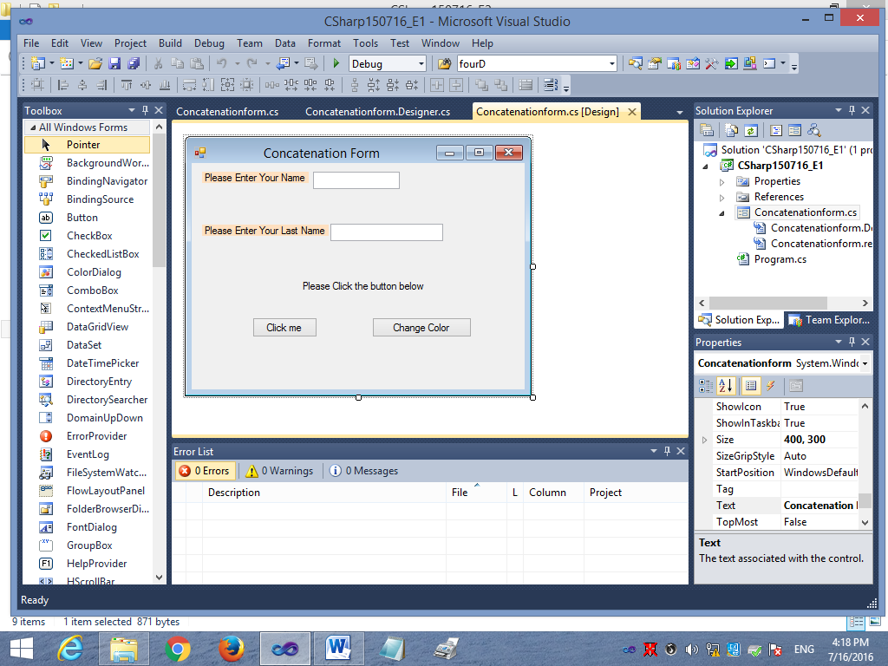

using System;

using System.Collections.Generic;

using System.ComponentModel;

using System.Data;

using System.Drawing;

using System.Linq;

using System.Text;

using System.Windows.Forms;

namespace CSharp150716_E1

{

public partial class Concatenationform : Form

{

public Concatenationform()

{

InitializeComponent();

}

private void button1_Click(object sender, EventArgs e)

{

String x;

x = "Welcome ";

x = x + txtUserFirstName.Text + " ";

x = x + txtUserLastName.Text;

MessageBox.Show(x, "Displaying Message");

}

private void btnChangeColor_Click(object sender, EventArgs e)

{

this.label1.BackColor = System.Drawing.Color.FromArgb(((int)(((byte)(191)))), ((int)(((byte)(230)))), ((int)(((byte)(36)))));

this.label2.BackColor = System.Drawing.Color.Azure;

}

}

}

/////////////Program2///////////////

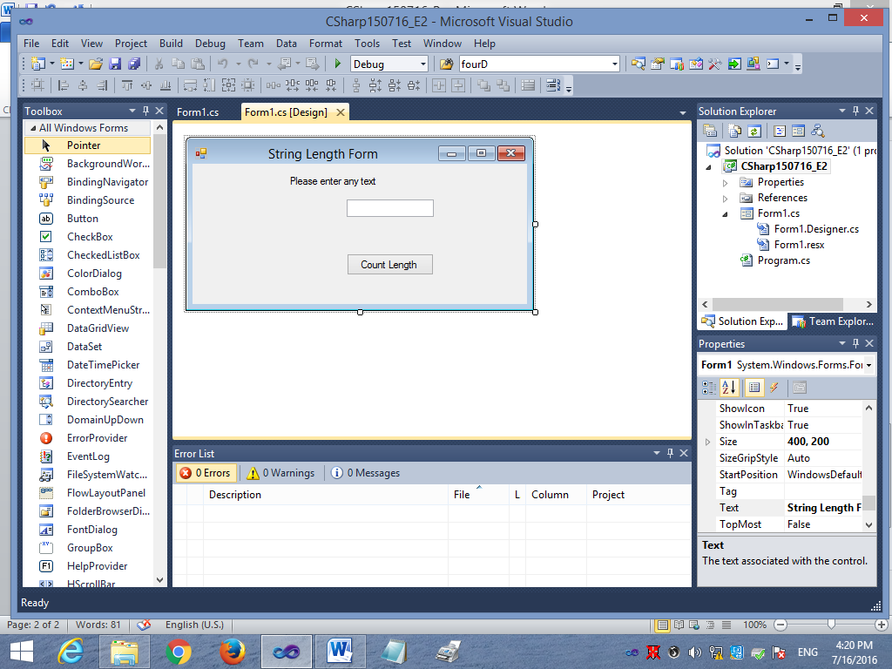

using System;

using System.Collections.Generic;

using System.ComponentModel;

using System.Data;

using System.Drawing;

using System.Linq;

using System.Text;

using System.Windows.Forms;

namespace CSharp150716_E2

{

public partial class Form1 : Form

{

public Form1()

{

InitializeComponent();

}

private void button1_Click(object sender, EventArgs e)

{

String x;

x = txtText.Text;

int y;

y = x.Length;

String lengthDisplay;

lengthDisplay = "Length:= " + y;

MessageBox.Show(lengthDisplay, "Displaying Length");

}

}

}

/////////////Program3///////////////

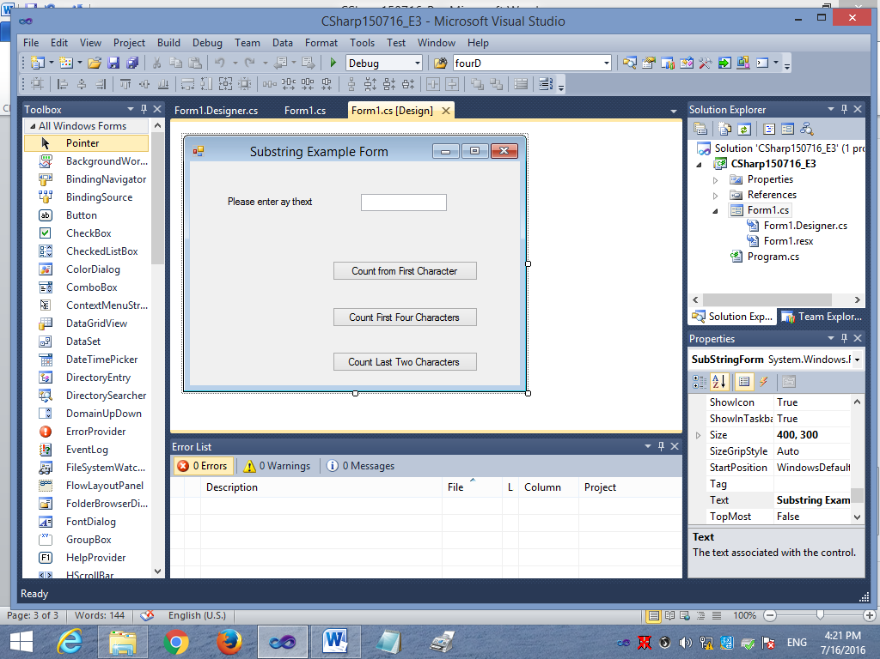

using System;

using System.Collections.Generic;

using System.ComponentModel;

using System.Data;

using System.Drawing;

using System.Linq;

using System.Text;

using System.Windows.Forms;

namespace CSharp150716_E3

{

public partial class SubStringForm : Form

{

public SubStringForm()

{

InitializeComponent();

}

private void button1_Click(object sender, EventArgs e)

{

String inputdata;

inputdata = txtText.Text;

String FromFirstChar;

FromFirstChar = inputdata.Substring(0);

MessageBox.Show(FromFirstChar, "From First Character");

}

private void button2_Click(object sender, EventArgs e)

{

String inputdata;

inputdata = txtText.Text;

int countLength;

countLength = inputdata.Length;

String FirstFourChars;

if (countLength < 4)

{

MessageBox.Show("Plesase Enter atleast 4 characters");

}

else

{

FirstFourChars = inputdata.Substring(0, 4);

MessageBox.Show(FirstFourChars, "First Four Characters");

}

}

private void button3_Click(object sender, EventArgs e)

{

String inputdata;

inputdata = txtText.Text;

int countLength;

countLength = inputdata.Length;

String LastTwoChars;

if (countLength > 2)

{

LastTwoChars = inputdata.Substring(countLength - 2);

MessageBox.Show(LastTwoChars, "Last Two Character");

}

else

{

MessageBox.Show("Plesase Enter string of more than two characters");

}

}

}

}